CPE301 – SPRING 2019

Design Assignment 4, Part 2

Student Name: James Skelly

Student #: 2000945485

Student Email: skellj1@unlv.nevada.edu

Primary Github address: <https://github.com/skellj1/submission_da>

Directory: skellj1/submission_da

Submit the following for all Labs:

1. In the document, for each task submit the modified or included code (only) with highlights and justifications of the modifications. Also, include the comments.
2. Use the previously create a Github repository with a random name (no CPE/301, Lastname, Firstname). Place all labs under the root folder ESD301/DA, sub-folder named LABXX, with one document and one video link file for each lab, place modified asm/c files named as LabXX-TYY.asm/c.
3. If multiple asm/c files or other libraries are used, create a folder LabXX-TYY and place these files inside the folder.
4. The folder should have a) Word document (see template), b) source code file(s) and other include files, c) text file with youtube video links (see template).
5. **COMPONENTS LIST AND CONNECTION BLOCK DIAGRAM w/ PINS**

Components used include Atmel Studio 7, stepper motor, servo motor, jumper wire, atmega328p, screwdriver, multifunction shield, iphone camera, driver module for stepper.

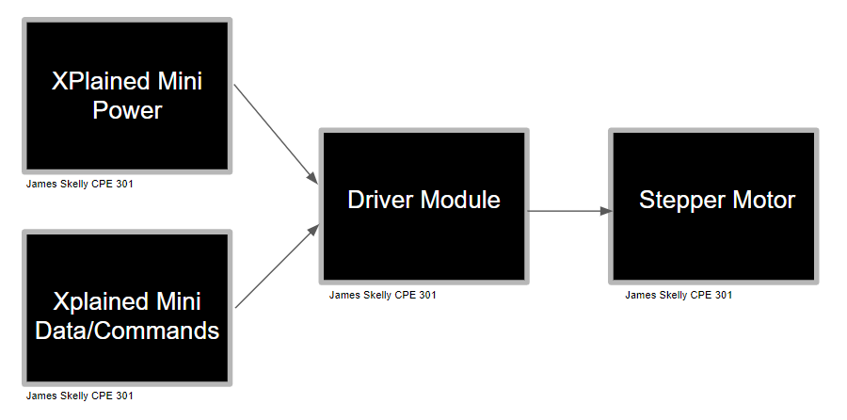

1. **INITIAL/MODIFIED/DEVELOPED CODE OF TASK 1/A**

/*

* DA4A_JS.c

* Created: 4/11/2019 10:54:25 AM

* Author : James Skelly

*/

// define clock for delay function, include headers

#define *F_CPU* 16000000UL

#include <avr/io.h>

#include <avr/interrupt.h>

#include <util/delay.h>

int adcVal; // holds value of ADC

char toggle = 0; // initialize toggle variable

int main(void)

{

DDRB = 0xFF; // PORTB as output

DDRC = 0x00; // PORTC as input

PORTB |= 0xFF; // Set all of PORTB high initially

// set timer1 operation mode and prescaler

TCCR1A |= (1<<COM1A1)|(1<<COM1B1)|(1<<WGM11); // use PWM for output compare pins

// OC1A/B, Fast PWM, Non-inverted mode

TCCR1B |= (1<<WGM13)|(1<<WGM12)|(1<<CS11); // timer1 pre-scaler set to 8

ICR1 = 10000; // set TOP value

PORTC |= (1<<PORTC1); // set portc initially high to wait for button press

PCICR = (1<<PCIE1); // set portc input capture enable bit

PCMSK1 = (1<<PCINT9); // enable pin change interrupt

// Initialize ADC

DIDR0 = 0x1; // disable the digital input on ADC0 pin

ADMUX = (1<<REFS0); // set ADC reference pin to PC0 (Potentiometer)

ADCSRA |= (1<<ADEN) | (1<<ADPS2) | (1<<ADPS1) | (1<<ADPS0); // enable ADC using system clock

ADCSRB = 0x0; // free running mode

sei(); // globally enable interrupts

while(1) // wait for pin change interrupt request

{

}

}

ISR(PCINT1_vect){

if(!(PINC & (1 << PINC2))) // if button is pressed...

{

*_delay_ms*(200); // debounce button pressed

while(!(PINC & (1 << PINC2)));

if(toggle == 1){

PORTB |= (1 << PORTB1); // set PB1 high

PORTB &= ~(1 << PORTB5); // turn on LED D1

ADCSRA |= (1 << ADSC); // start conversion

while((ADCSRA&(1<<ADIF))==0); // wait for conversion to finish

adcVal = ADC & 0x03FF; // extract right 10-bits of ADC register

OCR1A = 10*adcVal; // OCR1A value for duty cycle

}

else if(toggle == 0){

OCR1A = 0; // set output compare value to 0

PORTB &= ~(1 << PORTB1); // set PB1 low

PORTB |= (1 << PORTB5); // turn of LED D1

}

toggle ^= 1; // toggle the variable used to toggle

}

}

1. **DEVELOPED MODIFIED CODE OF TASK 2/A from TASK 1/A**

**PART 1: Stepper Motor**

/*

* Stepper_PART1.c

*

* Created: 4/18/2019 6:22:27 PM

* Author : James Skelly

*/

#define *F_CPU* 16000000UL

#include <avr/io.h>

#include <util/delay.h>

// Function Prototypes

void timer_init(void);

void adc_init(void);

int main(void)

{

int period; // integer used to set the period

while (1)

{

timer_init(); // initialize and set up timer to be used

adc_init(); // initialize and set up ADC

DDRB=0x0F; // Port B low bits to output

OCR0A = ADC; // set value of ADC data registers as compare value for timer

// The following if statements each contain the same code with a different period,

// depending on the voltage read out of the potentiometer at PC0. The values that

// PORTB is set to (i.e. 0x09, 0x03, 0x06, and 0x0C) allow the motor to make steps

// and rotate at a speed specified by the potentiometer. Since all of this is inside

// the while(1) loop, the motor will keep spinning until OCR0A satisfies a different

// condition, in which case the motor will spin at a different speed.

if ((OCR0A>=0)&&(OCR0A<=50))

{

period =2 ;

PORTB = 0x09;

*_delay_ms*(period);

PORTB = 0x03;

*_delay_ms*(period);

PORTB = 0x06;

*_delay_ms*(period);

PORTB = 0x0c;

*_delay_ms*(period);

OCR0A = ADC;

}

else if ((OCR0A>50)&&(OCR0A<=120))

{

period=30;

PORTB = 0x09;

*_delay_ms*(period);

PORTB = 0x03;

*_delay_ms*(period);

PORTB = 0x06;

*_delay_ms*(period);

PORTB = 0x0c;

*_delay_ms*(period);

OCR0A = ADC;

}

else if ((OCR0A>120)&&(OCR0A<=150))

{

period=100;

PORTB = 0x09;

*_delay_ms*(period);

PORTB = 0x03;

*_delay_ms*(period);

PORTB = 0x06;

*_delay_ms*(period);

PORTB = 0x0c;

*_delay_ms*(period);

OCR0A = ADC;

}

else if ((OCR0A>150)&&(OCR0A<=200))

{

period=200;

PORTB = 0x09;

*_delay_ms*(period);

PORTB = 0x03;

*_delay_ms*(period);

PORTB = 0x06;

*_delay_ms*(period);

PORTB = 0x0c;

*_delay_ms*(period);

OCR0A = ADC;

}

else if (OCR0A>200)

{

PORTB = 0; // turn motor off when OCR0A approaches max value

OCR0A = ADC;

}

}

}

void timer_init(void)

{

// Clear OC0A on compare match, CTC mode, prescaler 256

TCCR0A |= (1<<COM0A1)|(1<<WGM01);

TCCR0B |= (1<<CS02);

}

void adc_init(void)

{

ADCSRA |= ((1<<ADEN)|(1<<ADSC)|(1<<ADPS1)|(1<<ADPS0));

ADMUX |= (1<<REFS0);

}

**PART 2: Servo Motor**

/*

* Servo.c

*

* Created: 4/18/2019 9:13:12 PM

* Author : James Skelly

*/

#define *F_CPU* 16000000UL

#include <avr/io.h>

#include <util/delay.h>

// Function Prototypes

void timer_init(void); // timer1 setup function

void adc_init(void); // ADC setup function

int main(void)

{

while (1)

{

timer_init(); // initialize timer1

adc_init(); // initialize ADC

ICR1=5000; // ICR is TOP for FAST PWM mode 14; set top to 5000

DDRB |= (1<<PB1); // PB1 output mode, because OC1A is internally tied to PB1

OCR1A=ADC; // set ADC output value as compare register value

*_delay_ms*(500); // call for delay as motor moves from adjusting pot value

}

}

// Clear OC1A & OC1B on compare match, FAST PWM mode, prescaler of 64

void timer_init(void)

{

TCCR1A |= (1<<COM1A1)|(1<<COM1B1)|(1<<WGM11);

TCCR1B |= (1<<WGM13)|(1<<WGM12)|(1<<CS11)|(1<<CS10);

}

void adc_init(void)

{

ADCSRA |= ((1<<ADEN)|(1<<ADSC)|(1<<ADPS1)|(1<<ADPS0));

ADMUX |= (1<<REFS0);

}

1. **SCHEMATICS**

**STEPPER MOTOR PART 1**

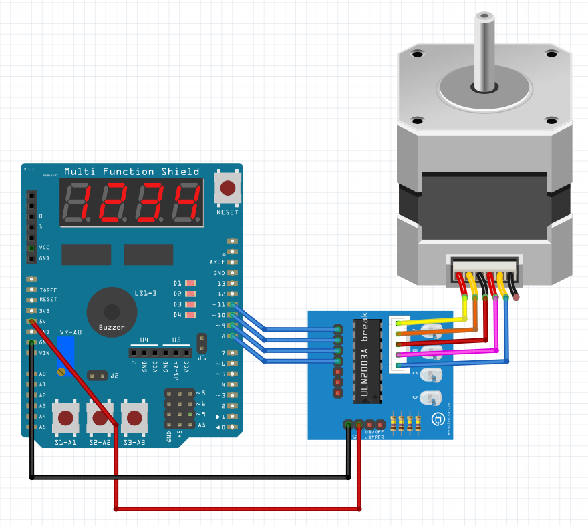

**SERVO MOTOR PART 2**

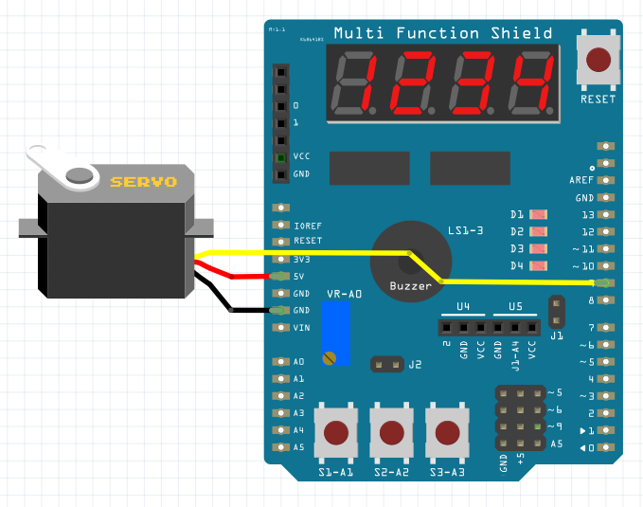

1. **SCREENSHOTS OF EACH TASK OUTPUT (ATMEL STUDIO OUTPUT)**

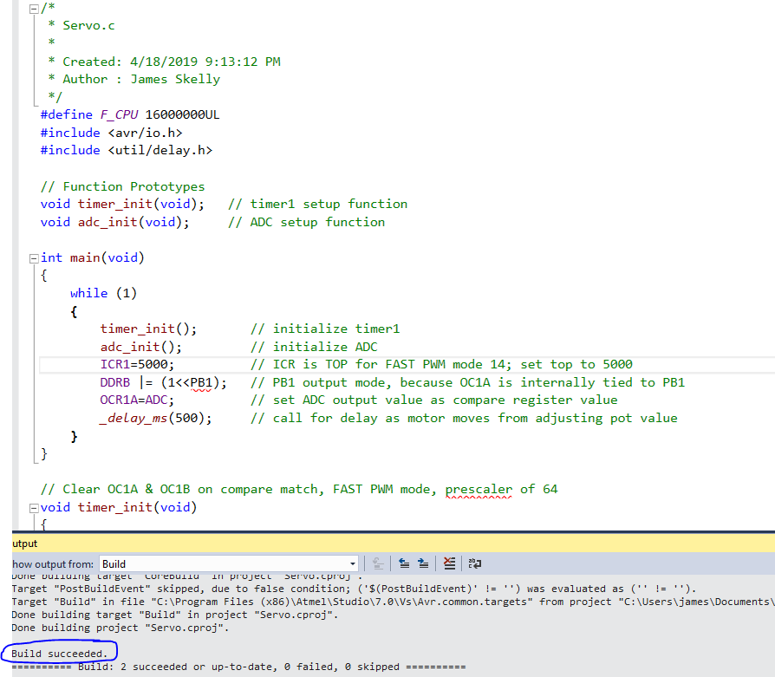

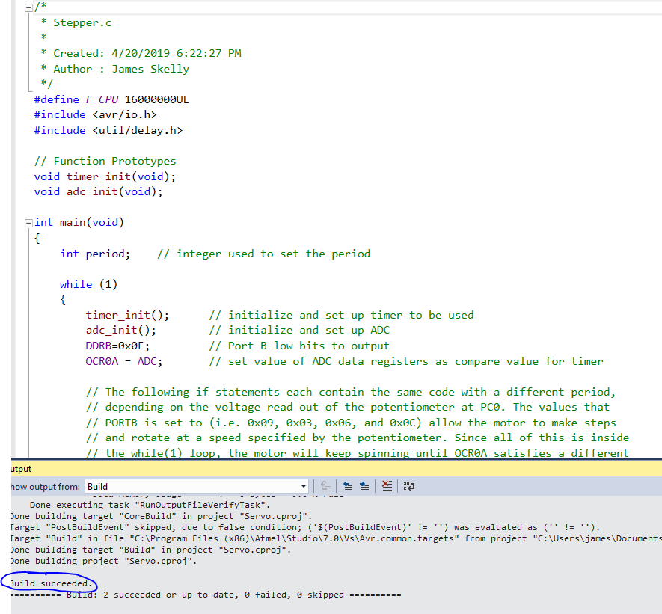

1. **SCREENSHOT OF EACH DEMO (BOARD SETUP)**

**STEPPER SETUP**

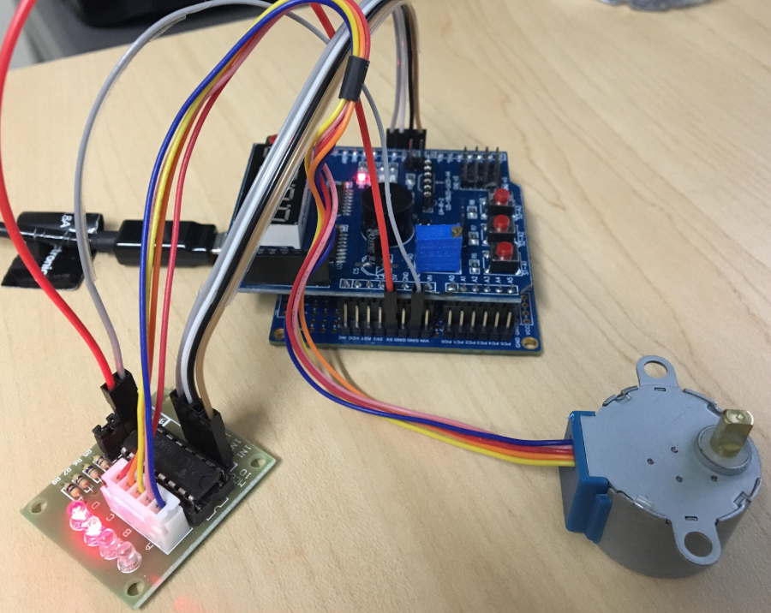

**SERVO SETUP**

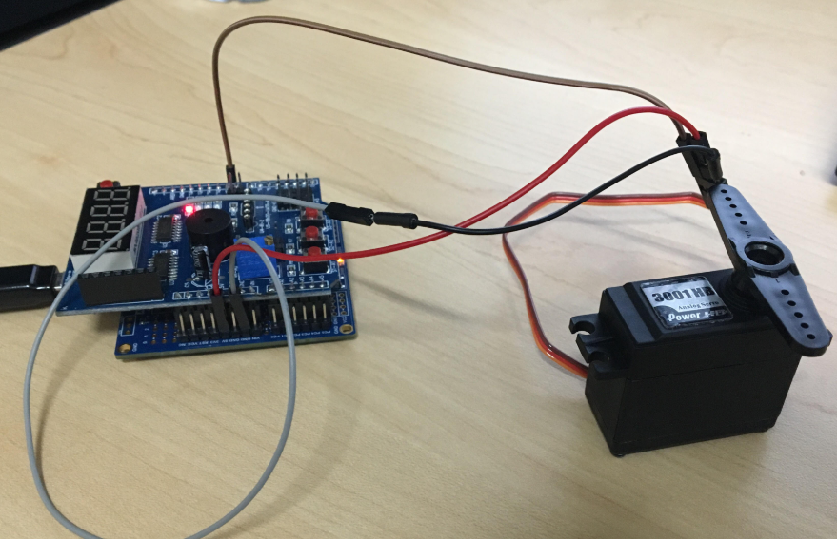

1. **VIDEO LINKS OF EACH DEMO**

**Stepper:** <https://www.youtube.com/watch?v=3mt-dW8fx8I>

**Servo:** <https://www.youtube.com/watch?v=HFwg0y40PsQ>

1. **GITHUB LINK OF THIS DA**

<https://github.com/skellj1/submission_da>

**Student Academic Misconduct Policy**

<http://studentconduct.unlv.edu/misconduct/policy.html>

“This assignment submission is my own, original work”.

James W. Skelly