context 144136 rows
==============================================================================================
-- context definition

CREATE TABLE context (
Id INTEGER PRIMARY KEY,
Data_source TEXT,
Scenario_1 TEXT,
Scenario_2 TEXT,
State TEXT,
Region TEXT,
Technology TEXT
);

==============================================================================================

Id |Data_source |Scenario_1 |Scenario_2 |State|Region|Technology |
---+--------------+---------------------------+--------------+-----+------+-------------+
1|2024 Final ISP|Green Energy Exports - Core|CDP1 |NSW |N10 |Offshore Wind|
2|2024 Final ISP|Green Energy Exports - Core|CDP1 |NSW |N11 |Offshore Wind|
3|2024 Final ISP|Green Energy Exports - Core|CDP2 |NSW |N10 |Offshore Wind|
4|2024 Final ISP|Green Energy Exports - Core|CDP2 |NSW |N11 |Offshore Wind|
5|2024 Final ISP|Green Energy Exports - Core|CDP3 |NSW |N10 |Offshore Wind|
6|2024 Final ISP|Green Energy Exports - Core|CDP3 |NSW |N11 |Offshore Wind|
7|2024 Final ISP|Green Energy Exports - Core|CDP4 |NSW |N10 |Offshore Wind|
8|2024 Final ISP|Green Energy Exports - Core|CDP4 |NSW |N11 |Offshore Wind|
9|2024 Final ISP|Green Energy Exports - Core|CDP5 |NSW |N10 |Offshore Wind|

==============================================================================================
select distinct Data_source from context;

Data_source |
--------------+
2024 Final ISP|
2024 Draft ISP|
2022 Draft ISP|
2022 Final ISP|

==============================================================================================

select distinct Scenario_1 from context;

Scenario_1 |
--------------------------------------------------------+
Green Energy Exports - Core |
Green Energy Exports - Extended Eraring |
Progressive Change - Core |
Progressive Change - Extended Eraring |
Step Change - Additional Load |
Step Change - Alternative Worst Sequence |
Step Change - Constrained Supply Chains |
Step Change - Core |
Step Change - Extended Eraring |
Step Change - Low Hydrogen Flexibility |
Step Change - Lower EV Uptake |
Step Change - Reduced CER Coordination |
Green Energy Exports - HD |
Green Energy Exports - LD |
Green Energy Exports |
Progressive Change - HD |
Progressive Change - LD |
Progressive Change - PB |
Progressive Change |
Step Change - CT |
Step Change - EA |
Step Change - HD |
Step Change - LD |
Step Change - PB |
Step Change - RD |
Step Change - REE |
Step Change - Social Licence |
Step Change |
Hydrogen Superpower - 10% discount rate |
Hydrogen Superpower - 7.5% discount rate |
Hydrogen Superpower - Draft ISP Inputs |
Progressive Change - 10% discount rate |
Progressive Change - 7.5% discount rate |
Progressive Change - Draft ISP Inputs |
Progressive Change - low gas prices |
Slow Change - 10% discount rate |
Slow Change - 7.5% discount rate |
Slow Change - Draft ISP Inputs |
Step Change - 10% discount rate |
Step Change - 7.5% discount rate |
Step Change - Draft ISP Inputs |
Step Change - High DER Sensitivity |
Step Change - low gas prices |
Strong Electrification Sensitivity |
Hydrogen Superpower - 2% discount rate |
Hydrogen Superpower - Offshore Wind |
Hydrogen Superpower - Updated Inputs |
Progressive Change - 2% discount rate |
Progressive Change - Offshore Wind |
Progressive Change - Updated Inputs |
Slow Change - 2% discount rate |
Slow Change - Offshore Wind |
Slow Change - Updated Inputs |
Step Change - 2% discount rate |
Step Change - Borumba Pumped Hydro (With updated inputs)|
Step Change - Low Distributed Storage |
Step Change - Offshore Wind |
Step Change - Updated Inputs |
Strong Electrification Sensitivity - Updated Inputs |

==============================================================================================

select distinct Scenario_2 from context;

Scenario_2 |
--------------+
CDP1 |
CDP2 |
CDP3 |
CDP4 |
CDP5 |
CDP6 |
CDP7 |
CDP8 |
CDP9 |
CDP10 |
CDP11 |
CDP12 |
CDP13 |
CDP14 |
CDP15 |
CDP16 |
CDP17 |
CDP18 |
CDP19 |
CDP20 |
CDP21 |
CDP22 |
CDP23 |
CDP24 |
CDP25 |
Counterfactual|
|
CDP11 (ODP) |
Least-cost DP |

==============================================================================================

select distinct state from context;

State|
-----+
NSW |
VIC |
TAS |
SA |
QLD |

==============================================================================================

select distinct Region from context;

Region|
------+
N10 |
N11 |
V7 |
V8 |
T4 |
T5 |
S10 |
N0 |
N1 |
N2 |
N3 |
N4 |
N5 |
N6 |
N7 |
N8 |
N9 |
N12 |
Q1 |
Q2 |
Q3 |
Q4 |
Q5 |
Q6 |
Q7 |
Q8 |
Q9 |
V0 |
V1 |
V2 |
V3 |
V4 |
V5 |
V6 |
T1 |
T2 |
T3 |
S1 |
S2 |
S3 |
S4 |
S5 |
S6 |
S7 |
S8 |
S9 |
|
Q0 |
T0 |
S0 |
NNSW |
CNSW |
SNW |
SNSW |
NQ |
GG |
CQ |
SQ |
VIC |
CSA |
SESA |
TAS |
O1 |
O2 |
O3 |
O4 |
O5 |
O6 |

==============================================================================================

select distinct Technology from context;

Technology |
----------------------------+
Offshore Wind |
Wind |
Utility-scale Solar |
Black coal |
Mid-merit gas |
Flexible gas with CCS |
Flexible gas |
Hydro |
Utility storage |
Coordinated CER storage |
Passive CER storage |
Offshore wind |
Utility solar |
Distributed PV |
Other renewable fuels |
DSP |
Brown coal |
Utility storage load |
Coordinated CER storage load|
Passive CER storage load |
Snowy 2.0 |
Deep Storage |
Medium Storage |
Shallow Storage |
Coordinated DER Storage |
Distributed Storage |
Black Coal |
Mid-merit Gas |
Mid-merit Gas with CCS |
Flexible Gas |
Hydrogen Turbine |
Biomass |
Utility-scale Storage |
Coordinated CER Storage |
Passive CER Storage |
Solar Thermal |
Brown Coal |
Utility-scale Storage Load |
Coordinated CER Storage Load|
Passive CER Storage Load |
Peaking Gas+Liquids |
Coordinated DER Storage Load|
Distributed Storage Load |

Data: 8182941 rows
==============================================================================================
-- "data" definition

CREATE TABLE data (
Id INTEGER,
Variable TEXT,
Year INTEGER,
Value DOUBLE,
FOREIGN KEY (Id) REFERENCES context(Id)
ON DELETE CASCADE
ON UPDATE CASCADE
);
==============================================================================================

Id|Variable|Year|Value |
--+--------+----+-------------+
1|capacity|2025| 0.0|
2|capacity|2025| 0.0|
3|capacity|2025| 0.0|
4|capacity|2025| 0.0|
5|capacity|2025| 0.0|
6|capacity|2025| 0.0|
7|capacity|2025| 0.0|
8|capacity|2025| 0.0|
...
70|capacity|2046| 780.00000002|
71|capacity|2046|8219.99999257|
72|capacity|2046| 780.00000001|
73|capacity|2046|8219.99998901|
74|capacity|2046| 780.00000001|
75|capacity|2046|8219.99998978|
76|capacity|2046| 780.00000001|
77|capacity|2046|8219.99999057|
78|capacity|2046| 780.00000001|
79|capacity|2046|8219.99999957|

==============================================================================================
select distinct Year from data;

Year |
----------------------+
2025|
2026|
2027|
2028|
2029|
2030|
2031|
2032|
2033|
2034|
2035|
2036|
2037|
2038|
2039|
2040|
2041|
2042|
2043|
2044|
2045|
2046|
2047|
2048|
2049|
2050|
2051|
2052|
2024|
Un33|
Existing and Committed|

Value

select MAX(Value), MIN(Value), AVG(Value) from data where Value != 'x';

MAX(Value) |MIN(Value) |AVG(Value) |
-----------------+-------------------+-----------------+
298715.1675547799|-209146.76984115093|1245.349955131258|

can have the value 'x'

select count(*) from data where value = 'x'

count(*)|
--------+
9|

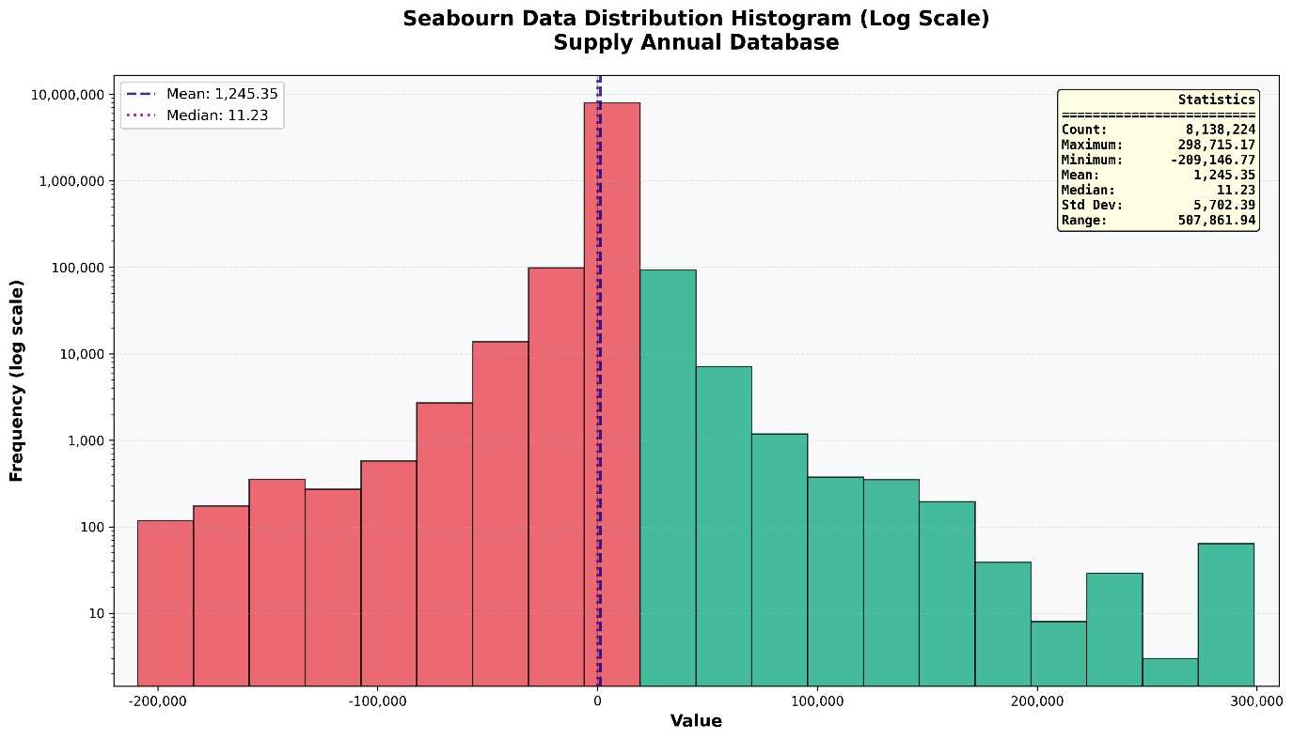

==============================================================================================

select distinct variable from data;

Variable |
----------------+
capacity |
generation |
storage capacity|
storage energy |

==============================================================================================

select distinct(Original_value) from mapping; count = 449

Original_value |
--------------------------------------------------------+
N0 |
N1 |
N2 |
N3 |
N4 |
N5 |
N6 |
N7 |
N8 |
O1 |
O2 |
O3 |
O4 |
Q0 |
Q1 |
Q2 |
Q3 |
Q4 |
Q5 |
Q6 |
Q7 |
Q8 |
Q9 |
S0 |
S1 |
S2 |
S3 |
S4 |
S5 |
S6 |
S7 |
S8 |
S9 |
T0 |
T1 |
T2 |
T3 |
V0 |
V1 |
V2 |
V3 |
V4 |
V5 |
V6 |
Hydrogen Superpower - 10% discount rate |
Hydrogen Superpower - 7.5% discount rate |
Hydrogen Superpower - Draft ISP Inputs |
Progressive Change - 10% discount rate |
Progressive Change - 7.5% discount rate |
Progressive Change - Draft ISP Inputs |
Progressive Change - low gas prices |
Slow Change - 10% discount rate |
Slow Change - 7.5% discount rate |
Slow Change - Draft ISP Inputs |
Step Change - 10% discount rate |
Step Change - 7.5% discount rate |
Step Change - Draft ISP Inputs |
Step Change - High DER Sensitivity |
Step Change - low gas prices |
Strong Electrification Sensitivity |
CDP1 |
CDP10 |
CDP11 |
CDP12 |
CDP13 |
CDP2 |
CDP3 |
CDP4 |
CDP5 |
CDP6 |
CDP7 |
CDP8 |
CDP9 |
Counterfactual |
NSW |
QLD |
SA |
TAS |
VIC |
Black Coal |
Brown Coal |
Coordinated DER Storage |
Coordinated DER Storage Load |
DSP |
Deep Storage |
Distributed PV |
Distributed Storage |
Distributed Storage Load |
Hydro |
Hydrogen Turbine |
Medium Storage |
Mid-merit Gas |
Mid-merit Gas with CCS |
Offshore Wind |
Peaking Gas+Liquids |
Shallow Storage |
Snowy 2.0 |
Solar Thermal |
Utility-scale Solar |
Utility-scale Storage |
Utility-scale Storage Load |
Wind |
O5 |
O6 |
Hydrogen Superpower - 2% discount rate |
Hydrogen Superpower - Offshore Wind |
Hydrogen Superpower - Updated Inputs |
Progressive Change - 2% discount rate |
Progressive Change - Offshore Wind |
Progressive Change - Updated Inputs |
Slow Change - 2% discount rate |
Slow Change - Offshore Wind |
Slow Change - Updated Inputs |
Step Change - 2% discount rate |
Step Change - Borumba Pumped Hydro (With updated inputs)|
Step Change - Low Distributed Storage |
Step Change - Offshore Wind |
Step Change - Updated Inputs |
Strong Electrification Sensitivity - Updated Inputs |
N10 |
N11 |
N12 |
N9 |
S10 |
T4 |
T5 |
V7 |
V8 |
Green Energy Exports |
Green Energy Exports - HD |
Green Energy Exports - LD |
Progressive Change |
Progressive Change - HD |
Progressive Change - LD |
Progressive Change - PB |
Step Change |
Step Change - CT |
Step Change - Constrained Supply Chains |
Step Change - EA |
Step Change - HD |
Step Change - LD |
Step Change - PB |
Step Change - RD |
Step Change - REE |
Step Change - Social Licence |
CDP11 (ODP) |
CDP14 |
CDP15 |
CDP16 |
CDP17 |
Least-cost DP |
Biomass |
Coordinated CER Storage |
Coordinated CER Storage Load |
Flexible Gas |
Passive CER Storage |
Passive CER Storage Load |
CNSW |
CQ |
CSA |
GG |
NNSW |
NQ |
SESA |
SNSW |
SNW |
SQ |
Green Energy Exports - Core |
Green Energy Exports - Extended Eraring |
Progressive Change - Core |
Progressive Change - Extended Eraring |
Step Change - Additional Load |
Step Change - Alternative Worst Sequence |
Step Change - Core |
Step Change - Extended Eraring |
Step Change - Low Hydrogen Flexibility |
Step Change - Lower EV Uptake |
Step Change - Reduced CER Coordination |
CDP18 |
CDP19 |
CDP20 |
CDP21 |
CDP22 |
CDP23 |
CDP24 |
CDP25 |
Black coal |
Brown coal |
Coordinated CER storage |
Coordinated CER storage load |
Flexible gas |
Flexible gas with CCS |
Mid-merit gas |
Offshore wind |
Other renewable fuels |
Passive CER storage |
Passive CER storage load |
Utility solar |
Utility storage |
Utility storage load |

==============================================================================================

select distinct(Standard_value) from mapping;

-- same as Origional_value
select Original_value, Standard_value from mapping where Original_value != Standard_value ;

Original_value|Standard_value|
--------------+--------------+

