Centre for Natural Gas  April 2026 | 

Research Project: Cumulative
social and economic impacts of
CSG development in Chinchilla

[Cover image not found — add cover.jpg to resources/images/towns/chinchilla/]


CREATE CHANGE

DATA REPORT
INDICATORS OF CHANGE IN
CHINCHILLA AND DISTRICT

Statistical data updated in April 2026

Contact:
UQ Centre for Natural Gas
The University of Queensland | Brisbane, QLD, 4072 AUSTRALIA
W: https://natural-gas.centre.uq.edu.au/
E: natural.gas@uq.edu.au

UQ Research Project: Cumulative social and economic impacts of CSG development in Western Downs
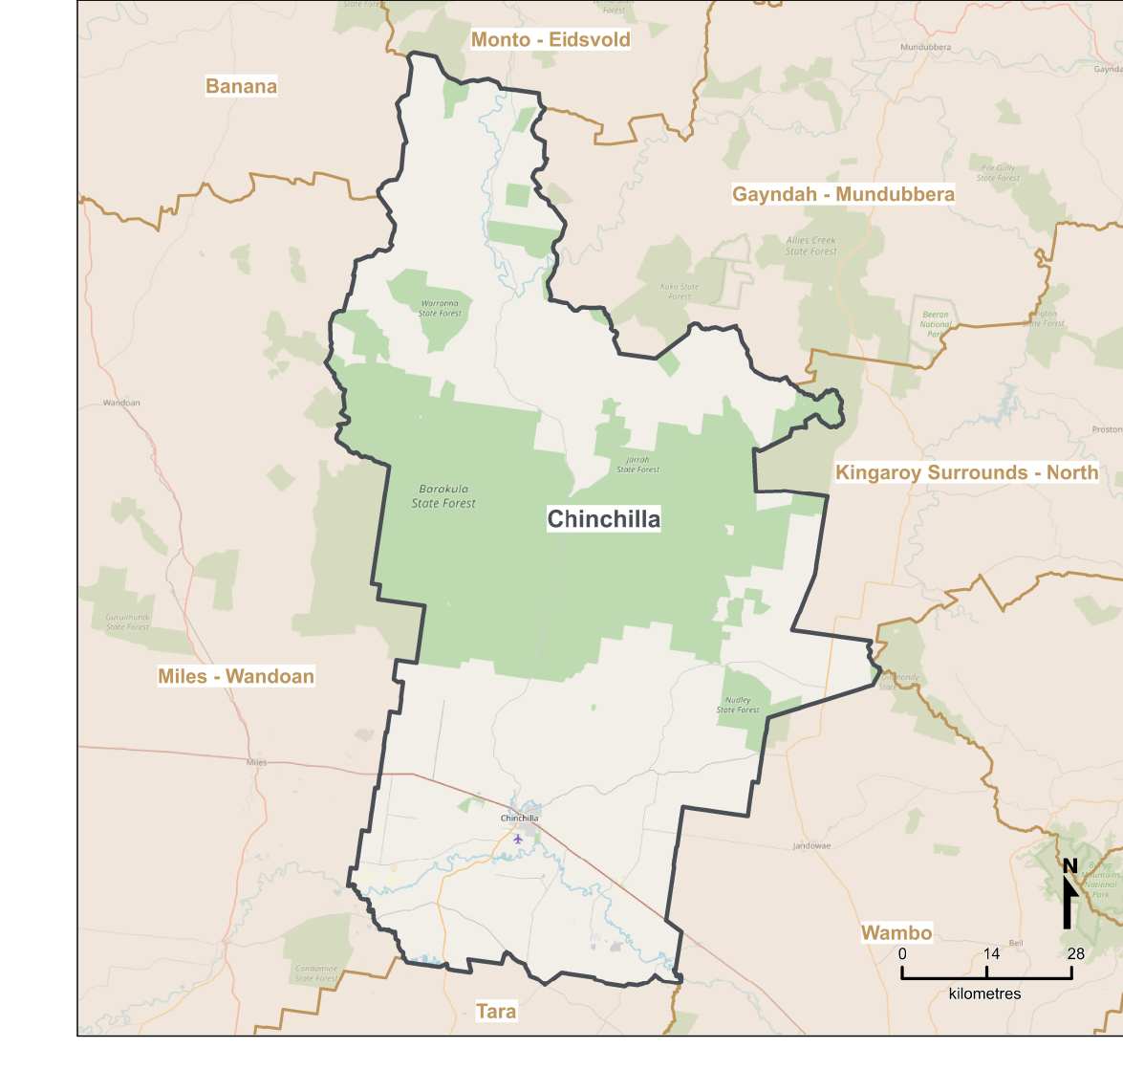
Chinchilla statistical area 2 (SA2) boundary
Source: https://www.qgso.qld.gov.au/issues/10696/qld-sa2-asgs-2021-chinchilla.pdf
This information has been compiled for use in consultation with the Chinchilla community

Population
Estimated resident population — Chinchilla Urban Centre and Locality (UCL)

Year | No. of persons (UCL residents) | Count
2001 |  | 3,545
2002 |  | 3,569
2003 |  | 3,592
2004 |  | 3,642
2005 |  | 3,701
2006 |  | 3,816
2007 |  | 3,984
2008 |  | 4,179
2009 |  | 4,329
2010 |  | 4,570
2011 |  | 4,889
2012 |  | 5,089
2013 |  | 5,318
2014 |  | 5,572
2015 |  | 5,754
2016 |  | 5,986
2017 |  | 6,120
2018 |  | 6,193
2019 |  | 6,305
2020 |  | 6,352
2021 |  | 6,368
2022 |  | 6,385
2023 |  | 6,441
2024 |  | 6,552
2025 |  | 6,565

Source: QGSO Estimated Resident Population by Urban Centre and Locality (UCL), Queensland. Boundary: Urban centre and locality boundary (Chinchilla UCL). Data: Annual ERP at 30 June each year.
This information has been compiled for use in consultation with the Chinchilla community

Unemployment Rate
Annual smoothed unemployment rate — Chinchilla SA2

Year | Unemployment rate (%) | Value
2010 |  | 2.5%
2011 |  | 2.5%
2012 |  | 1.7%
2013 |  | 1.0%
2014 |  | 1.5%
2015 |  | 2.5%
2016 |  | 3.4%
2017 |  | 4.3%
2018 |  | 4.6%
2019 |  | 4.3%
2020 |  | 3.5%
2021 |  | 5.8%
2022 |  | 4.7%
2023 |  | 2.4%
2024 |  | 1.8%
2025 |  | 2.9%

Source: DEWR Small Area Labour Markets (SALM), smoothed SA2 quarterly estimates. Annual value: mean of 4 quarterly estimates. Note: SA2s below statistical threshold are excluded from SALM — data may start from 2010 or later.
This information has been compiled for use in consultation with the Chinchilla community

Housing — Median Sale Price & Volume
Detached dwelling sales — Chinchilla SA2

Median house sale price ($)
Year | Median sale price | Value
2000 |  | $83,625
2001 |  | $80,375
2002 |  | $83,188
2003 |  | $87,375
2004 |  | $107,000
2005 |  | $153,875
2006 |  | $210,188
2007 |  | $228,250
2008 |  | $243,688
2009 |  | $263,500
2010 |  | $310,625
2011 |  | $324,875
2012 |  | $355,838
2013 |  | $394,750
2014 |  | $371,000
2015 |  | $323,875
2016 |  | $274,969
2017 |  | $228,875
2018 |  | $212,250
2019 |  | $203,875
2020 |  | $226,688
2021 |  | $255,000
2022 |  | $277,500
2023 |  | $313,426
2024 |  | $368,547
2025 |  | $435,333

Number of house sales
Year | No. of sales | Value
2000 |  | 71
2001 |  | 95
2002 |  | 110
2003 |  | 172
2004 |  | 234
2005 |  | 210
2006 |  | 221
2007 |  | 131
2008 |  | 161
2009 |  | 143
2010 |  | 149
2011 |  | 199
2012 |  | 194
2013 |  | 156
2014 |  | 71
2015 |  | 75
2016 |  | 77
2017 |  | 111
2018 |  | 108
2019 |  | 133
2020 |  | 146
2021 |  | 233
2022 |  | 244
2023 |  | 251
2024 |  | 226

Source: QGSO Regional Database — Residential land and dwelling sales (DNRM). Boundary: SA2 (Chinchilla, ASGS 2021). Aggregation: Sales count = Dec-quarter rolling 12-month total. Median price = mean of 4 quarterly medians per calendar year.
This information has been compiled for use in consultation with the Chinchilla community

Housing — Median Weekly Rent
3-bedroom house median weekly rent — Chinchilla SA2

Year | Median rent ($/week) | Value
2000 |  | $110
2001 |  | $110
2002 |  | $114
2003 |  | $120
2004 |  | $126
2005 |  | $176
2006 |  | $278
2007 |  | $235
2008 |  | $218
2009 |  | $255
2010 |  | $272
2011 |  | $288
2012 |  | $345
2013 |  | $410
2014 |  | $386
2015 |  | $251
2016 |  | $200
2017 |  | $188
2018 |  | $200
2019 |  | $225
2020 |  | $238
2021 |  | $259
2022 |  | $307
2023 |  | $350
2024 |  | $389
2025 |  | $423

Source: QGSO Regional Database — Median rent (RTA). Boundary: SA2 (Chinchilla, ASGS 2021). Aggregation: Annual figure = mean of 4 quarterly medians.
This information has been compiled for use in consultation with the Chinchilla community

Residential Building Approvals
New private residential dwellings approved — Chinchilla SA2

Year | Residential approvals | Value
2001 |  | 15
2002 |  | 14
2003 |  | 13
2004 |  | 27
2005 |  | 37
2006 |  | 58
2007 |  | 30
2008 |  | 16
2009 |  | 52
2010 |  | 108
2011 |  | 99
2012 |  | 124
2013 |  | 242
2014 |  | 99
2015 |  | 5
2016 |  | 3
2017 |  | 12
2018 |  | 5
2019 |  | 3
2020 |  | 13
2021 |  | 17
2022 |  | 11
2023 |  | 25
2024 |  | 17
2025 |  | 12

Source: QGSO Regional Database — Building Approvals (ABS 8731.0). Boundary: SA2 (Chinchilla, ASGS 2021). Private buildings only. Aggregation: Annual total = sum of 12 monthly values (historical series Jul 2001–Dec 2018 merged with current series Jan 2019–present).
This information has been compiled for use in consultation with the Chinchilla community

Rainfall
Annual total rainfall — Chinchilla (SILO station 42078)

Year | Annual rainfall (mm) | Value
2001 |  | 517 mm
2002 |  | 565 mm
2003 |  | 647 mm
2004 |  | 687 mm
2005 |  | 598 mm
2006 |  | 275 mm
2007 |  | 665 mm
2008 |  | 453 mm
2009 |  | 398 mm
2010 |  | 1010 mm
2011 |  | 879 mm
2012 |  | 608 mm
2013 |  | 578 mm
2014 |  | 446 mm
2015 |  | 593 mm
2016 |  | 712 mm
2017 |  | 519 mm
2018 |  | 567 mm
2019 |  | 162 mm
2020 |  | 524 mm
2021 |  | 789 mm
2022 |  | 843 mm
2023 |  | 477 mm
2024 |  | 678 mm
2025 |  | 637 mm

Historic average (2001–2025): 593 mm/year

Source: SILO Patched Point Dataset (Queensland Government / Bureau of Meteorology). Station: SILO station 42078. Note: SILO interpolates missing daily observations. Years with >10% interpolated days are flagged in the pipeline quality log.
This information has been compiled for use in consultation with the Chinchilla community

Crime
Offences per 1,000 persons per year — Chinchilla QPS Division

All offences (per 1,000 persons)
Year | All offences (per 1,000 persons) | Value
2001 |  | 13.3
2002 |  | 12.7
2003 |  | 13.7
2004 |  | 18.4
2005 |  | 13.1
2006 |  | 15.4
2007 |  | 13.9
2008 |  | 11.6
2009 |  | 12.6
2010 |  | 10.9
2011 |  | 11.0
2012 |  | 12.2
2013 |  | 11.6
2014 |  | 13.2
2015 |  | 18.0
2016 |  | 21.5
2017 |  | 20.7
2018 |  | 20.8
2019 |  | 21.6
2020 |  | 24.0
2021 |  | 21.0
2022 |  | 21.3
2023 |  | 21.3
2024 |  | 21.4
2025 |  | 23.1
2026 |  | 21.0

Drug offences
Year | Drug offences | Value
2001 |  | 0.7
2002 |  | 0.9
2003 |  | 0.8
2004 |  | 1.8
2005 |  | 1.0
2006 |  | 1.3
2007 |  | 0.9
2008 |  | 0.8
2009 |  | 0.9
2010 |  | 1.4
2011 |  | 0.8
2012 |  | 0.8
2013 |  | 0.7
2014 |  | 1.5
2015 |  | 2.3
2016 |  | 3.3
2017 |  | 3.2
2018 |  | 3.4
2019 |  | 4.2
2020 |  | 4.9
2021 |  | 2.7
2022 |  | 2.4
2023 |  | 2.2
2024 |  | 2.6
2025 |  | 2.5
2026 |  | 3.2

Good order offences
Year | Good order offences | Value
2001 |  | 1.1
2002 |  | 0.7
2003 |  | 0.8
2004 |  | 1.1
2005 |  | 0.8
2006 |  | 1.4
2007 |  | 1.2
2008 |  | 1.2
2009 |  | 1.0
2010 |  | 0.9
2011 |  | 1.5
2012 |  | 1.7
2013 |  | 1.3
2014 |  | 1.6
2015 |  | 1.8
2016 |  | 1.9
2017 |  | 1.9
2018 |  | 1.8
2019 |  | 1.6
2020 |  | 1.9
2021 |  | 2.3
2022 |  | 1.9
2023 |  | 1.8
2024 |  | 1.4
2025 |  | 2.0
2026 |  | 1.4

Theft offences
Year | Theft offences | Value
2001 |  | 2.5
2002 |  | 2.3
2003 |  | 2.6
2004 |  | 2.5
2005 |  | 1.9
2006 |  | 2.3
2007 |  | 2.3
2008 |  | 1.6
2009 |  | 1.5
2010 |  | 1.2
2011 |  | 1.4
2012 |  | 1.9
2013 |  | 1.8
2014 |  | 1.4
2015 |  | 2.2
2016 |  | 2.2
2017 |  | 2.0
2018 |  | 1.7
2019 |  | 1.9
2020 |  | 1.4
2021 |  | 1.7
2022 |  | 1.9
2023 |  | 2.5
2024 |  | 2.4
2025 |  | 2.6
2026 |  | 2.0

Traffic offences
Year | Traffic offences | Value
2001 |  | 0.9
2002 |  | 0.9
2003 |  | 0.9
2004 |  | 1.2
2005 |  | 1.2
2006 |  | 1.1
2007 |  | 0.9
2008 |  | 0.9
2009 |  | 1.2
2010 |  | 1.0
2011 |  | 1.0
2012 |  | 0.9
2013 |  | 1.0
2014 |  | 0.9
2015 |  | 1.4
2016 |  | 1.9
2017 |  | 1.9
2018 |  | 1.6
2019 |  | 2.3
2020 |  | 1.9
2021 |  | 2.1
2022 |  | 2.4
2023 |  | 2.1
2024 |  | 2.1
2025 |  | 2.0
2026 |  | 1.8

Source: Queensland Police Service (QPS) open crime data. Unit: Rates per 100,000 persons converted to per 1,000 persons. Geography: QPS Division level.
This information has been compiled for use in consultation with the Chinchilla community

