What to Submit | Commit the Coin Purse with strategies in package coinpurse.stategy to Bitbucket. Use same project as your previous labs, including a TAG for each lab (Lab2, Lab3, …).

Introduction to the Strategy Pattern
Context: An object (called the Context) has some behavior that you can implement using several different algorithms, and you'd like to be able to change the algorithm independent of the object that uses the behavior.
Solution: Design an interface for the method(s) that perform the algorithm (the strategy). This is the Strategy. Modify the Context class so that it calls a method of the Strategy to perform the work, instead of doing the work itself. Then write a concrete implementation of the Strategy interface.
In the Context, provide a "setStrategy" method so you can specify the strategy at run-time.
Context
-strategy: Strategy
setStrategy( Strategy )
doWork( )
<<interface>>
Strategy

doWork( Context )

ConcreteStrategy
doWork( Context )
AnotherStrategy
doWork( Context )

Example: The Swing containers (JFrame, JPanel, JWindow) need to layout components in the container. There are many ways (algorithms) to layout components, and we want to be able to change the way we layout a container. We also want to reuse the same layout algorithm in different containers without duplicating the code. If layout code is written as part of the Container class, we cannot change the layout and cannot reuse the code in other containers.
The solution is for containers use the Strategy Pattern. The LayoutManager interface is the Strategy; it defines the methods needed to lay out components in a container. Each Container has a setLayout( ) method and a reference to an instance of a concrete LayoutManager. When a container needs to layout its components it calls layout.layoutContainer( this ).
Container
layout: LayoutManager
setLayout( Layout...)
<<interface>>
LayoutManager
layoutContainer( Container )

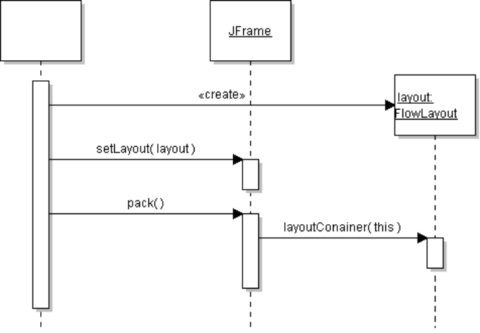
FlowLayout
BorderLayout

Problem 1: Define a Withdraw Strategy for Coin Purse
In the Purse, the most complex method is withdraw. The easiest way to withdraw is the greedy algorithm (as in previous labs) but it doesn't always work. Using recursion would always find a solution (if a solution exists), but recursion takes more time.
Define a WithdrawStrategy to perform withdraw. Then we can change the withdraw algorithm anytime without changing the Purse class.
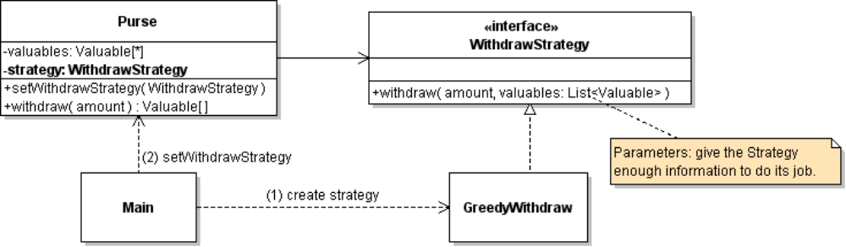
1. Create a new package to hold your strategies, named coinpurse.strategy.
2. Create a WithdrawStrategy interface that has a withdraw method. Notice that the withdraw method has an extra parameter. The Purse will use this to pass information to the Strategy.
3. Write good, complete Javadoc for the withdraw( ) method of WithdrawStrategy. What exactly does it do and what will it return?
Does the WithdrawStrategy actually remove items from the List (Valuables in the Purse) or simply suggest what the purse should withdraw? Your Javadoc should clearly state this.
3. Create a concrete class that implements WithdrawStrategy. For the strategy that we have used before, a good name is GreedyWithdraw (our withdraw uses the greedy algorithm).
4. Move the code from Purse.withdraw(amount) into the concrete GreedyWithdraw class.
5. Modify Purse.withdraw( ) so that it calls the WithdrawStrategy.
There are some things that the Purse can do itself in Purse.withdraw( ) to avoid duplicate code.
For example, Purse.withdraw can verify amount <= balance, and Purse.withdraw is responsible for actually removing items from its Valuables list, and creating an array for the returned value.
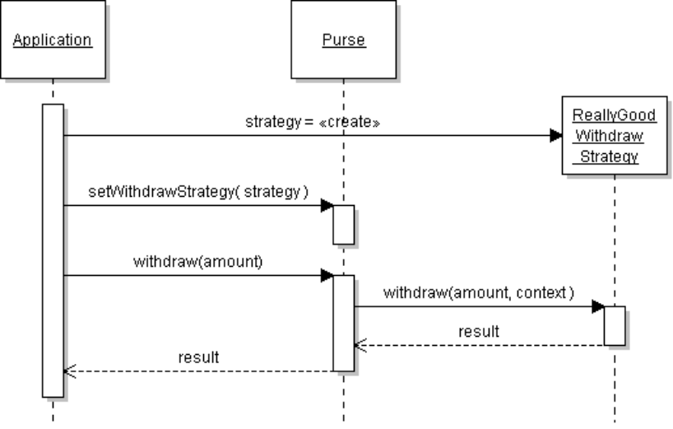
6. Test the new Purse to verify that it withdraws money correctly.

Problem 2: Recursion Practice
Recursion means that a method calls itself. Java (and most languages) allow this, but you have to be careful how you use it. You must ensure that recursion will eventually stop. There are 2 criteria that generally ensure recursion will stop:
    - each time the method calls itself (recursion) the problem is made smaller
    - the recursive method always checks a stopping criterion which must eventually be true

2.1 Sum elements in an array by recursion
To sum elements in an array using a loop (iteration) we would write:
public double sum(double [] x) {
double sum = 0;
for(int k=0; k < x.length; k++ ) sum = sum + x[k];
return sum;
}
To sum by recursion, create a second method, called a helper method, with an extra parameter to make it easier to use recursion. The parameter is the last array index we want to sum:
/**
* Sum all elements of an array up to lastIndex.
* @param x array of elements to sum.
* @param lastIndex is index of the last element to sum.
* The caller must ensure that lastIndex < array.length
*/
private double sumTo( double [] x, int lastIndex)
if (lastIndex < 0) return 0.0; // (1) the stopping criterion
double sum = x[lastIndex]
+ sumTo(x, lastIndex - 1); // (2) recursive step
return sum;
}
In this code:
(2) Recursive Step: the method calls itself, but it makes lastIndex smaller each time, so the problem is getting smaller.
(1) checks a stopping criterion, so the method won't call itself forever. Since lastIndex is decreased by 1 at each step, this test must eventually be true.
private - sumTo is a helper method for use by the public sum( ) method, so we declare it private.
To use the recursive sum, the public sum method calls the helper method:
public double sum(double [] array) {
return sumTo( array, array.length - 1);
}

2.2 Write a Recursive "print" for a List
Create a class named ListUtil and write a static method printList(List<?> list) to print all the elements in a List on one line to System.out, with a comma between elements but no comma after the last element. Use recursion (not a loop). Example using BlueJ Codepad:

> import java.util.Arrays;
> List food = Arrays.asList( "apple", "banana", "grape", "fig" );
> ListUtil.printList( food );
// output appears in console window:
apple, banana, grape, fig

2.3 Write a Recursive "max" for a List of Strings
Write a method that returns the "max" element of a List of String objects, using recursion. For easy testing, make this method static. Design your own helper method.
public class ListUtil {
private static void printList(List<?> list) {
//TODO Problem 2.2
}

/**
* Find the largest element in a List of Strings,
* using the String compareTo method.
* @return the lexically largest element in the List
*/
private static String max( List<String> list) {
//TODO complete this
}

/** Test the max method. */
public static void main(String [] args) {
List<String> list;
// if any command line args, then use them as the list!
if (args.length > 0) list = Arrays.asList( args );
else list = Arrays.asList("bird", "zebra", "cat", "pig");

System.out.print("List contains: ");
printList( list );

String max = max(list);
System.out.println("Lexically greatest element is "+max);
}
}

Problem 3: Implement a Recursive Withdraw Strategy
The greedy withdraw strategy (problem 1) can fail, even when a withdraw is possible. Can you give an example of this?
You can fix this using recursion. Recursion requires more time and memory, but a coin purse doesn't usually have many items and you can quickly eliminate some possibilities (for example, if we need to withdraw 12 Baht, we can skip over items with a value greater than 12).
At each level of recursion you pick one item from the Purse and try two cases:
Case 1: Select this item for withdraw and (by recursion) try to withdraw the remaining amount = amount - value of this item, using only the remaining items.
Case 2: Don't use this item for withdraw. By recursion, try to withdraw the entire amount using only the remaining items.
At each step of the recursion, you don't want to modify the list or create a new list, because that uses more memory and time. Instead, follow the example of Problem 2.1 and write a helper method with a parameter to indicate the last element (or first element) in the list that can be used as candidates for withdraw.
3.1 Write the RecursiveWithdraw strategy in the coinpurse.strategy package.
3.2 In the Purse, add a setWithdrawStrategy method (if you didn't already).
3.3 In the Main class, set the strategy to RecursiveWithdraw. Test your code.
3.4 Construct an example (in the Main class) where GreedyWithdraw fails but RecursiveWithdraw succeeds.

Challenge Problem: Create an Over-withdraw Strategy (not required)
What if lunch costs 15 Baht but your purse only has 20-Baht banknotes? Would you rather go hungry or over-withdraw 20-Baht?
Write an Overwithdraw strategy that withdraws the smallest amount greater than or equal to the requested amount.
One simple way to implement this is as a Composite or Decorator strategy: Overwithdraw is a Withdraw Strategy that calls some other strategy (like RecursiveWithdraw) with increasing amounts, until it finds one that succeeds.

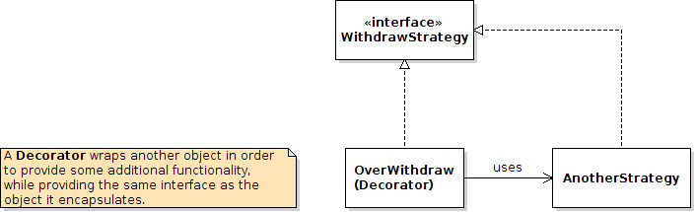

Example:

Here is an example recursive withdraw method that uses a helper method. The example uses a list of integers, for simplicity. Your method should use Valuable, of course.
withdrawFrom( amount, list, lastIndex ) - try to withdraw amount from list of Integer, using only elements 0 through lastIndex. Returns a List of elements to withdraw. Does not modify the list parameter.
Example: Recursive withdraw for list = {2, 2, 2, 5}, amount to withdraw = 6

withdraw( 6, list )

return { 2, 2, 2}

lastIndex = list.size()-1
withdrawFrom( 6, list, 3 )
Consider the element at lastIndex = 3 (5)

withdrawFrom( 6, list, 2 )
case 2: don't use the last element. Try to withdraw 6 using others.
withdrawFrom( 4, list, 1 )
return {2}
case 1: use the last element (5)
null (fail)
return { 2, 2, 2 }

withdrawFrom( 1, list, 2)

case 1: use last element (2) and try to withdraw 4 more from other elements
return { 2, 2 }

case 1: use last element (2) and try to withdraw 2 more

withdrawFrom( 2, list, 0 )

Try to withdraw 2 using only element 0 of the list.
Fortunately, 2 exactly equals the value of list.get(0), so we return that element

Does Recursion Eventually Stop?
In this example, the lastIndex of the helper method is decreased at each step of recursion, so eventually there won't be any candidate elements (lastIndex < 0). And at each step there are only 2 choices: use the last list element or don't use it.

Reference
Big Java chapter 13 covers Recursion.

