Purpose | 1. Use an abstract superclass to implement common behavior and eliminate duplicate code.  2. Practice refactoring in Eclipse.
What to Submit | Commit your code to your "coinpurse" project on Bitbucket.  1. Before committing your work, create an annotated tag named "LAB3" for your Lab3 coin purse.  2. Commit your work to the same project.  3. Add an annotated tag "LAB4" to indicate this revision.
In a previous lab, you wrote an interface for Valuable objects to enable polymorphism, and defined several kinds of valuable objects that can be put in a Purse.
This makes the Purse a lot more flexible, but results in some duplicate code.
For example, getValue() and getCurrency() are the same in most or all the classes implementing Valuable.

1. Create an Abstract Superclass for Valuables
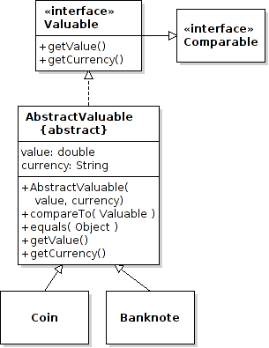
To eliminate duplicate code, create an Abstract class named AbstractValuable. This will be the parent class for Coin and Banknote (and may be used by other kinds of money).
Note: Eclipse can do 1.1 - 1.3 by using Refactoring . See below for how.
1.1 Declare the AbstractValuable class to be abstract.
1.2 Declare that Coin and Banknote, are subclasses of AbstractValuable.
1.3 Move methods that are identical in Coin and Banknote to AbstractValuable. If you are using Eclipse, use Refactoring to extract the methods.
Verify that equals( ) in AbstractValuable works correctly for each subclass. To verify that two objects belong to the same class use:
if (this.getClass() == obj.getClass() ) ...

Note: in the equals and compareTo of AbstractValuable, you should use getValue() to get the value of objects, so that each subclass is free to determine its value any way it wants. Don't try to directly access the value attribute.
Why? A subclass may want to redefine how its value is computed. Using getValue() obeys the principle "Program to an interface, not to an implementation."

2. Modify Valuable to extend Comparable
Every Valuable class should be comparable by value: a 10-Baht coin is worth less than a 50-Baht Banknote. So it makes sense that Valuable itself should be Comparable.
2.1 Modify Valuable to declare it is also Comparable.
2.2 Delete "… implements Valuable" from Coin and BankNote.
2.3 Be careful how you do the comparison. We may have some kinds of Valuable with very small value (0.000001) or very large value (1,000,000,000).

3. What about the value attribute?
What about the value attribute in Coin and Banknote?
Can you move value to the superclass? What should you do with getValue()?

4. Verify Your Code
Check your code:
- Coin and BankNote do not have equals or compareTo, they use the methods from AbstractValuable.
- The Purse and user interface do not depend on AbstractValuable. They depend only on Valuable.

Refactoring in Eclipse
"Refactoring" means to restructure your source code. Eclipse and NetBeans have many refactoring operations to save time & reduce errors. The "Extract Superclass" refactoring creates a superclass and can move methods to the superclass.
We want to create an abstract superclass for Banknote and Coin.  Eclipse can create an AbstractValuable superclass for you. Follow these steps:  1. Open one of the classes in the Eclipse editor.  Double-click on Coin to edit it. |  | 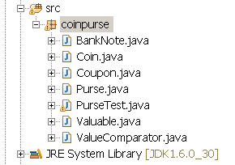
2. From the Refactor menu select Extract Superclass... |  | 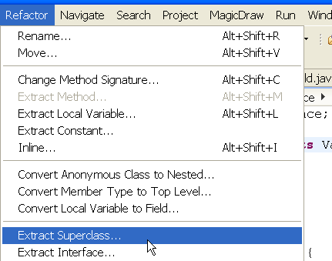
3. In the Extract Superclass dialog, enter AbstractValuable as the Superclass name.  4. Click Add... and add other classes you want to refactor (Banknote).  5. Select equals(Object) as the method to extract to the superclass.  Click the Next> Button. |  | 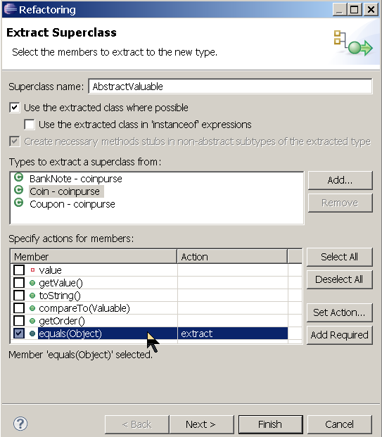
6. This dialog shows which classes will be subclasses and what methods will be extracted to AbstractValuable.  Check equals method for all 3 subclasses.  Click Finish.  You can ignore warning message about problems. You can fix these problems after refactoring. | 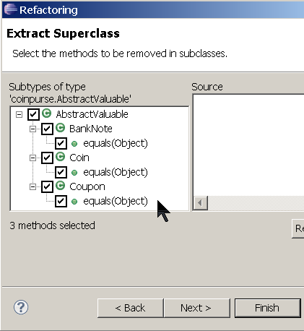

How to Extract More Methods to Superclass
You can move other methods from a subclasses to a superclass . In the Refactor menu choose "Pull Up".

Undo Refactoring
If you make a mistake, you can Undo refactoring (Edit -> Undo or Refactor -> History).

