Programming Assignment: Typing Game
Design and implement a typing game to help students improve typing skill.

Requirements
You can write this in Java using JavaFX, Swing, or Greenfoot. Your game should have these features, but does not need to look like the "java invaders" game below. Use your creativity.
1. Must have significant elements of original design.
2. Require the player to type words not just letters.
3. Provide visual feedback as he types.
4. Game should get harder as the player's skill improves.
5. Provide a scoreboard.
6. Provide on-screen instructions at beginning of the game.
7. Use good Object-oriented style of programming.
8. Should be playable on another person's computer -- create a portable JAR that others can run.

Java Invaders Game: objective is to type the words before they fall on houses and destroy them.
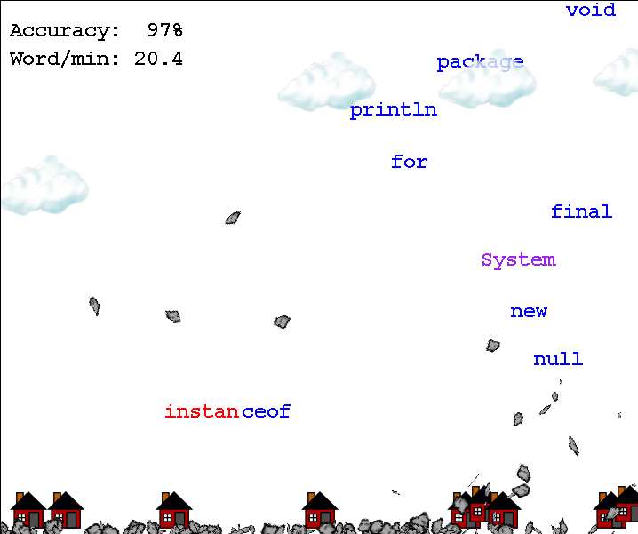
This game gives feedback by changing color of letters typed.
Scoreboard at top shows user's typing speed and accuracy.

