Individual Work | Do this assignment by yourself. You may discuss ideas, but not share code.
What to Submit | Add EchoGame to your Lab 1 code. Add Task to Lab 2 code. Submit to Github.

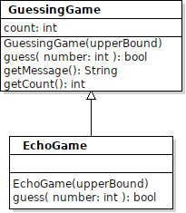
1. Write an EchoGame
Write a subclass of GuessingGame named EchoGame.
The purpose of EchoGame is to print what the user guesses and values returned by guessinggame.guess( value ).
EchoGame needs to override one method (guess) and add its own constructor.
EchoGame(int upperBound) - invokes the GuessingGame(int upperBound) constructor.
boolean guess(int value) - invoke GuessingGame.guess() and also print both the guess and the return value.
Main - modify the main() method so that when GameSolver is used, your code creates an EchoGame to play, instead of GuessingGame.

Do Not Modify GameSolver or GameConsole - the parameter to play() should be GuessingGame! GameSolver or GameConsole do not need to know about EchoGame.

2. Fix And Improve Your Lab1 Code
Implement changes as described in class. A separate file describes some common defects.

3. Apply Inheritance and Polymorphism to Tasks in Lab 2
1. Define a Task class as super-class of all your tasks.
2. Remove duplicate code from the "main" method. Create a new method named:
timeAndPrint(Task task)
this method accepts a Task object (or any subclass object) and does everything that "main" was doing for the tasks. The "main" method just creates the tasks and calls timeAndPrint.
Try to make your code concise yet easy to read, with minimum duplicate code.
See the write-up "Let's Remove Duplicate Code" on class Github site for explanation. That write-up refers to using the Runnable interface to enable polymorphism. For this assignment, use a Task super-class instead.
