How to Add a JAR file to a Project
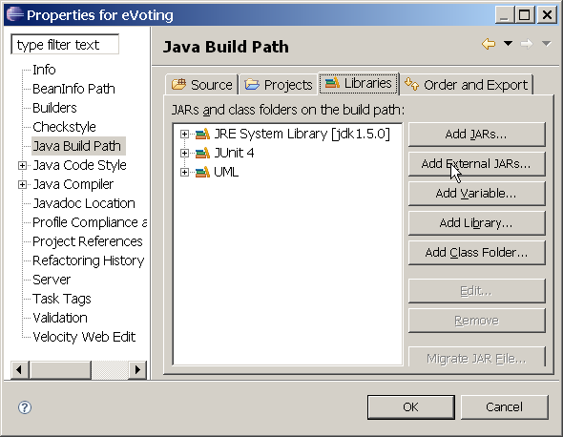
Eclipse
1. Open the Java Project.
2. In the "Project" menu select "Properties".
3. Select "Java Build Path".
4. Click on the "Libraries" tab.
5. Click "Add External JARs".
6. Select the JAR file you want.
7. Click OK.

If you will use this JAR file in several projects it is more convenient to create a User Library for the jar file.
You can also attach a Javadoc location to a JAR file so Eclipse will provide inline help.

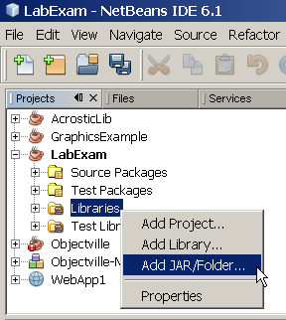
NetBeans
1. Open the Java Project.
2. In the Projects window for your project, right click on Libraries.
3. Select "Add JAR/Folder..."
4. Select the JAR file you want to add.
5. Click OK.
You can specify the Javadoc location for a JAR file after you add it, so NetBeans will provide inline help.
Right-click on the JAR and choose Edit. Click "Browse..." and choose the directory or ZIP file containing the Javadoc.
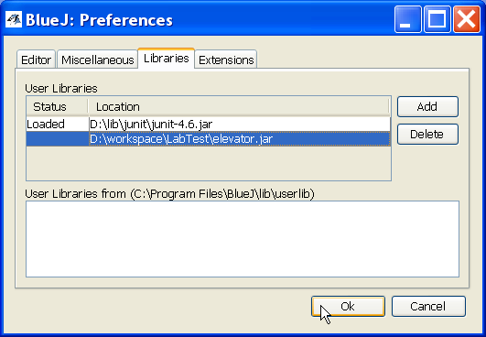
BlueJ
1. Open the Project.
2. In the Tools menu, select Preferences....
3. In Preferences dialog, select the Libraries tab.
4. Click the Add button.
5. Locate the JAR file and click Open.
6. Click OK to close Preferences dialog.
7. Restart the JVM: Tools → Reset JVM.

