1. Identify the type (class) of the components shown in the window below. The component named menu contains all the beverage names in one component.
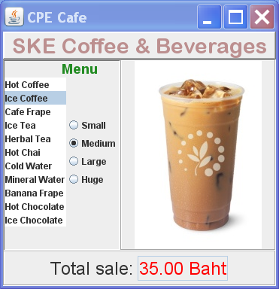
mainTitle
menuTitle
menu
size1
size2
size3
size4
description
totalBox

2. How would you get this layout using layout managers? Draw a diagram of how you'd layout the space using layout managers.

How would you layout this?
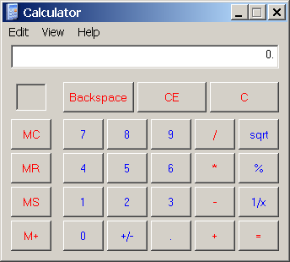

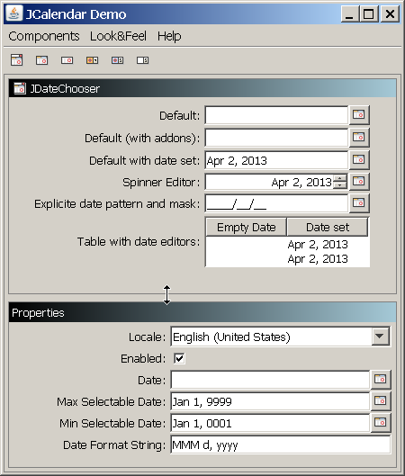
You can resize the top part by dragging the center line.

Useful Graphical Components you can download:
JCalendar - JavaBean for calendar, date, and time choosers
JGoodies - layout managers and components (the above example uses a Form Layout)
JFreeChart - draws many kinds of graphs and charts, can handle multiple data sets.

