Use Dialog Boxes instead of Console Input
This problem will show the benefit of using separate objects for separate responsibilities.
Instead of performing input-output on a console, we can use dialog boxes. But, we won't need to rewrite the application! Just write a new class to replace the GameConsole class. We can reuse the Game class.
In a real project, you might write a simple console input class to test your game logic, then write a graphical interface for really playing the game.
1. Create a new class named GameDialog. Copy the methods from GameConsole to GameDialog.
2. Modify GameDialog to use dialog boxes instead of System.in and System.out.

How to Use Dialog Boxes
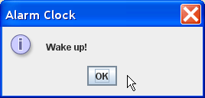
JOptionPane (in package javax.swing) contains many useful dialogs. Here are some examples.
You can run these examples interactively in BlueJ.

Message Dialog
import javax.swing.JOptionPane;
String title = "Alarm Clock";
String message = "Wake Up.";
int type = JOptionPane.INFORMATION_MESSAGE;
JOptionPane.showMessageDialog( null, message, title, type);

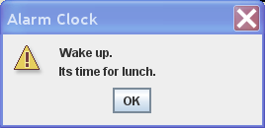
Message Dialog with multi-line message:

message = "Wake up.\nIts time for lunch";
type = JOptionPane.WARNING_MESSAGE;

JOptionPane.showMessageDialog( null, message, title, type);

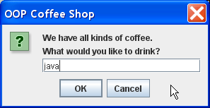
Input Dialog:
Use this to print a hint and ask user to guess a number.

title = "OOP Coffee Shop";
message = "We have all kinds of coffee.\n";
message += "What would you like to drink?";
type = JOptionPane.QUESTION_MESSAGE;
String reply = JOptionPane.showInputDialog(null, message, title,type);
if ( reply == null )
Be careful: if user presses Cancel the dialog returns a null.

/* user pressed Cancel */;
else orderCoffee( reply );

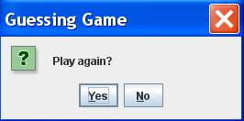
Confirm Dialog:
String title = "Guessing Game";
message = "Play again?";
type = JOptionPane.YES_NO_OPTION;
int opt = JOptionPane.showConfirmDialog(null, message, title, type);
if ( opt == JOptionPane.YES_OPTION ) /* user pressed "Yes" */;

