1. Observer Pattern - draw the relationships between these classes using proper UML notation for inheritance, implements, association, aggregation, or dependency (whichever applies).
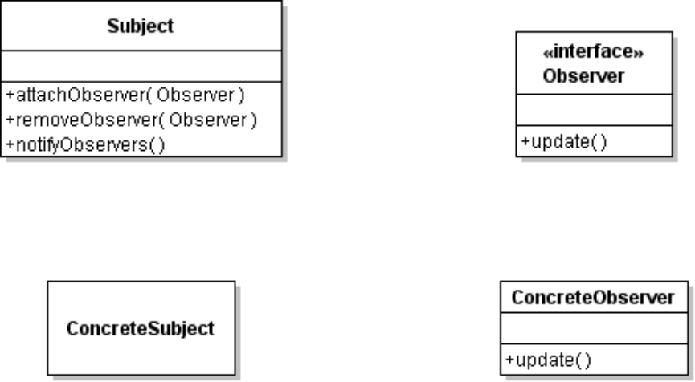

2. Using this code:

JButton okButton = new JButton( "ok" );
okButton.addActionListener( new ButtonHandler() );

public class ButtonHandler implements ActionListener {
public void actionPerformed( ActionEvent evt ) {
System.out.println("You pressed " + evt.getActionCommand() );
}
}

Complete the table describing how the observer pattern is used by the above code:

Name in Pattern | Name in Application
Subject
ConcreteSubject
Observer
ConcreteObserver
attachObserver( )
notifyObservers( )
update( )

2. In the Pizza Shop application, a Pizza has a description and a price. A Pizza Topping (like "mushrooms" or "pineapple") is implemented using a decorator.
A plain pizza would behave like this:
Pizza pizza = new Pizza( Size.LARGE );
System.out.println( pizza.getDescription( ) );
// prints "large pizza"
System.out.println( pizza.getPrice() );
// prints 180 (maybe)
A pizza with pineapple topping would behave like this (using same pizza as above)
pizza = new PineappleTopping( pizza );
System.out.println( pizza.getDescription( ) );
// prints "large pizza with pineapple"
System.out.println( pizza.getPrice() );
// prints 230 (if pineapple costs 50 Baht)
Complete the UML diagram below showing the relation between the PizzaTopping and Pizza. Show all relations between the topping and the pizza. There is more than one possible correct answer, but you must use the decorator pattern.

<<enum>>
Size
SMALL
MEDIUM
LARGE
Pizza
size: Size
description: String

<<constructor>>
Pizza( size: Size )
getPrice( ): int
getDescription( ): String

PineappleTopping

<<constructor>>
PizzaTopping( Pizza )

What methods must a pizza topping have, according to decorator pattern?

Write code for the getDescription( ) method of PineappleTopping. This illustrates how the decorator pattern works.

3. Suppose the Pizza class also has a setSize( ) and getSize( ) method. The decorator doesn't want to change how these methods work. Does PineappleTopping need to override these methods or not?
If "no", explain why.
If "yes", give example code for how they should be overridden.

4. What is the difference between a Decorator and an Adapter?

5.
6. Strategy Pattern
Intent: Define a family of algorithms, encapsulate each one, and make them interchangeable. Strategy lets the algorithm vary independently of the client that uses it.
Give an example of the Strategy Pattern in the Java API. Complete the table below for your example:

Name in Pattern | Name in Your Example
Context
ConcreteContext
Strategy
ConcreteStrategy
setStrategy( Strategy )
doWork( Context )

7. Coupling: Many applications perform Logging. An application uses a logger to record errors, warnings, and other messages to a file, database, or network server.
Here is a BankAccount class that uses a ConsoleLogger to record messages.

public class ConsoleLogger {
/** log level controls which messages are displayed */
private int loglevel = 1;
/** write error messages */
public void error( String msg ) {
if ( loglevel >= 0 )
System.out.println( "Error: " + msg );
}
/** write warning messages */
public void warning( String msg ) {
if ( loglevel >= 1 )
System.out.println( "Warning: " + msg );
}
/** write information messages */
public void info( String msg ) {
if ( loglevel >= 2 )
System.out.println( "Info: " + msg );
}
/** set the logging level */
public void setLoglevel( int level ) { loglevel = level; }
}

Here's part of the BankAccount to illustrate how logging is used:

public class BankAccount {
ConsoleLogger log = new ConsoleLogger( );

public void deposit(double amount ) {
if (amount < 0 )
log.error( "Attempt to deposit negative money" );
else if ( amount == 0 )
log.warning( "Attempt to deposit nothing" );
else {
balance = balance + amount;
log.info("Deposited " + amount );
}
}
}

Which class is coupled to (depends on) which other class?

How could you define and use an interface (let's call it "Logger") to eliminate this coupling?
Draw a UML class diagram showing the methods of your interface, the ConsoleLogger, and BankAccount. Show the relationships between them.

8. After you define the Logger interface, you still have a little problem: how is the BankAccount going to get a Logger object?
If the BankAccount creates the logger itself, like this:
Logger logger = new ConsoleLogger( );

then we still have coupling.

(a) write code for BankAccount to use Dependency Injection to set a logger in BankAccount. (Dependency Injection is how we set a strategy into a context.)

(b) write a LogFactory class with a static method named getLogger( ) that creates and returns a Logger. We only want one logger for the whole application (typically, all the log messages go to the same place), so make getLogger( ) work as follows:
1. the first time getLogger() is called, it creates a new Logger and returns it
2. after that, it always returns the same Logger object.

(c) Write example statement to show how to use LogFactory to get a Logger.

This part is optional and uses material not covered
(c) To really get a feel for how loggers work, have your LogFactory class read a properties file named logger.properties. It gets the name of the Logger class and the loglevel from the properties file. It uses the Logger name (a String to create the logger object).

