1. Classify the design patterns into one of these categories. If a pattern is close to another category, draw it close to the boundary.
Creational  object creation mechanism to deal with a particular situation or design objective | Structural  design of the relationship between objects
Behavioral
pattern of communication between objects; pattern of assigning responsibility to objects

Patterns That Use Inheritance  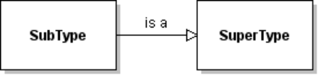 | Patterns That Use Composition  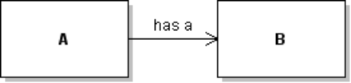
Patterns that Use Polymorphism via an Interface (can also use Inheritance)  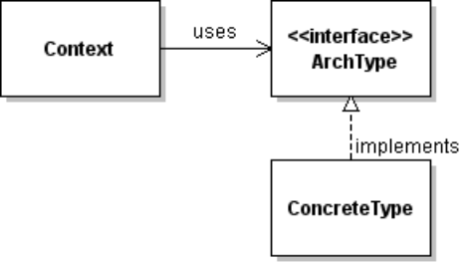 | Patterns that use both "is a" and "has a" to Same Type (Interface or Superclass)  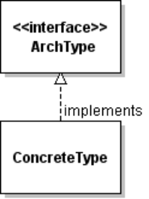  has a

2. Java Layout Managers are an example of the Strategy pattern.
a. Complete the following table:
Name in Pattern | Name in This Example
Context
Strategy
ConcreteStrategy
setStrategy( Strategy )
doStrategy( Context )

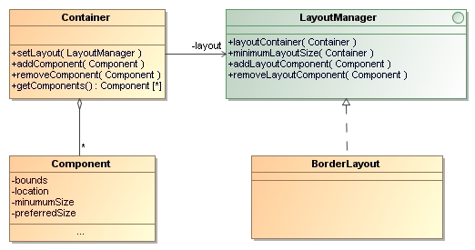
2b. Why does the Strategy (usually) need a reference to the Context?
2c. What is the benefit or advantage(s) of using the Strategy Pattern?
3. What other design pattern has a structure like Strategy?
4. The above diagram also illustrates the Composite Pattern.
4a. What class is the composite?
4b. What UML relation must you add to the above diagram to complete the composite pattern?
5. In Java you add scroll bars to any component using a JScrollPane. Even a Button.
// create a component (anything) with a long label or image
Component component = new JButton("Wow! A scrollable button.");
component.setFont( new Font(Font.DIALOG, Font.PLAIN, 40) ); //big
JScrollPane pane = new JScrollPane( component );
// "as needed" is default for horizontal/vertical scrollbars
pane.setHorizontalScrollBarPolicy(
JScrollPane.HORIZONTAL_SCROLLBAR_AS_NEEDED );
jframe.add( pane );
5.1 What design pattern is used here?
5.2 What is the motivation for using this pattern?
5.3 What is (are) the benefit(s) of this pattern?
5.4 Draw a class diagram of this design and annotate which class is which part of the pattern. Show enough information to illustrate the design pattern.
Name in Pattern | Name in This Example

6. Template Method: Coffee Shop

CPE Coffee Shop has 2 procedures for making brewed beverages:
Make Coffee | Make Tea
1. boil water | 1. boil water
2. put ground coffee in filter and pour hot water through it. | 2. put tea leaves in carafe and add hot water. Seep for 3 minutes.
3. pour into cup | 3. pour into cup
4. (optional) add cream and sugar | 4. (optional) add lemon and sugar

They write an O-O style program to automate this procedure:
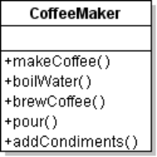 | 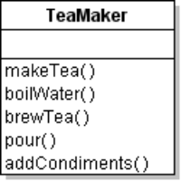
class CoffeeMaker {  void makeCoffee( ) {  boilWater( );  brewCoffee( );  pour( );  addCondiments( );  }  void boilWater( ) {  println("Boiling water");  }  void brewCoffee( ) {  println("add coffee to filter and  pour hot water over it");  }  void pour( ) {  println("Pour into cup");  }  void addCondiments( ) {  println("add cream and sugar");  } | class TeaMaker {  void makeTea( ) {  boilWater( );  brewTea( );  pour( );  addCondiments( );  }  void boilWater( ) {  println("Boiling water");  }  void brewTea( ) {  println("put tea leaves in carafe  and add hot water");  wait( 3*60*1000 ); // 3 minutes  }  void pour( ) {  println("Pour into cup");  }  void addCondiments( ) {  println("add lemon and sugar");  }
6.1 Using O-O design principles, what are two undesirable characteristics of this code?
a.
b.

Classes should be open for extension but closed for modification.
You suggest that they use the Template Method pattern.
For CPE Coffee shop, we name abstract base class "BeverageMaker".
The template method is makeBeverage( ).
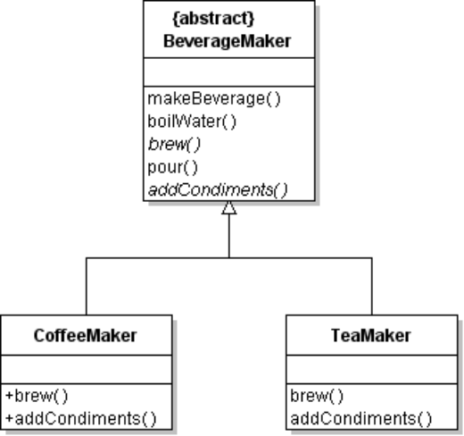
void makeBeverage( ) {
boilWater( );
brew( );
pour( );
addCondiments( );
}
6.2 Implement this class diagram.
Just use System.out.println to display the actions performed.

6.3 Add Hook and Service Methods
1) This algorithm always adds condiments to the beverage. Write a service method to BeverageMaker named wantsCondiment( String name ):
public boolean wantsCondiment( String name ) {
Scanner console = new Scanner( System.in );
System.out.print("do you want "+name+"? [y, n]");
return ( console.nextLine().trim().equalsIgnoreCase("y") );
}
How would you use this method in CoffeeMaker and TeaMaker?
2) Write a hook method named notify to notify the employee when the coffee or tea is ready.
The hook (in base class) does nothing:
public void notify( ) { } // hook method for subclasses to use
void makeBeverage( ) {
boilWater( );
brew( );
pour( );
addCondiments( );
notify( ); // invoke hook method
}
In CoffeeMaker, override the hook to print a message when the coffee is ready.
3) Can you design a better way to let subclasses control condiments?
6.4 In what ways are Template Method and Strategy Patterns similar?
6.5 In what ways are Template Method and Strategy Pattern different?
7. Adapter for Enumeration
The old Java used an Enumeration interface to iterate over elements of a collection. Vector and HashMap use this interface.
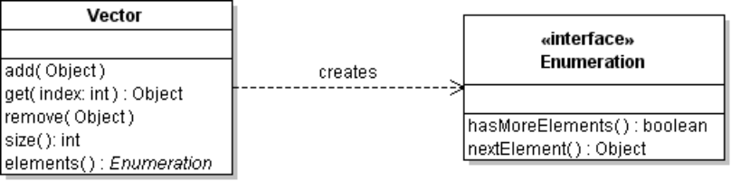
Vector<String> fruit = new Vector<String>( );
fruit.add( "Apple" );
fruit.add( "Banana" );
fruit.add( "Orange" );
Enumeration<String> e = fruit.elements( ); // create enumeration
while ( e.hasMoreElements( ) ) {
System.out.println( e.nextElement( ) );
}
Java now uses Iterator for this.
Write an adapter class to create an Iterator from an Enumeration.
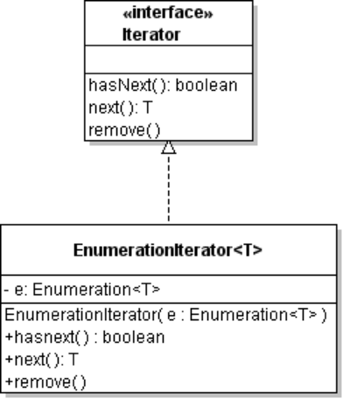 | class EnumerationIterator<T> {  private Enumeration<T> en;  public EnumerationIterator( Enumeration<T> en )  {  this.en = en;  }  // remove does nothing  pubic void remove( ) { /* not implemented */ }
Test your class using the fruit example above.
Iterator<String> iterator =
new EnumerationIterator( fruit.elements() );
while( iterator.hasNext() )
System.out.println( iterator.next() );
8. What patterns would you consider for these situations?
8.1 Your program uses a layered design. You have a UI layer, application layer, domain logic layer, and persistence layer. You want to minimize coupling between layers. What patterns can help do this, and how?
8.2 Your program requires login. Some users have more privilege than other users, so we want to customize the controls on the UI based on logged in user. How to do this without a lot of "if ( user.hasRole(User.ADMIN) ) ... else ..." logic.
8.3 Your program uses a web interface. You want to validate input requests and redirect processing in a way that is invisible to the UI. What pattern can help with this?
8.4 What patterns use the principle "Program to an interface, not an implementation?"

