Assignment | Write a general unit converter that can convert several different types of units. You must have at least 4 kinds of units, including Length, Area, Weight, and at least one other kind of unit.
What to Submit | 1. Create a project named pa3 and commit it to Bitbucket.  2. Create a runnable JAR file of your application with the name  dist/Converter-bxxxxx.jar (your student id) inside your pa3 project.  Please don't create an extra layer of folders when committing to Bitbucket. That is, avoid this: b5710xxxxxxx/pa3/PA3/src, etc.  3. Create a UML class diagram of your application and submit it on paper.
Evaluation | 1. Implements requirements, performs correct conversions, and is usable.  2. Good OO design. Separate UI from application logic; use polymorphism instead of "if". No redundant code.  3. Code quality: follows Java Coding Convention for this course, code is well-documented and easy to read.

Requirements
1. Write a general unit converter that can convert values of different types of units, including Length, Area, and Weight.
2. Provide a menu to select the unit type: Length, Area, or Weight. Include an "Exit" option on the menu. See the Java tutorial for how to create a JMenuBar and JMenu.
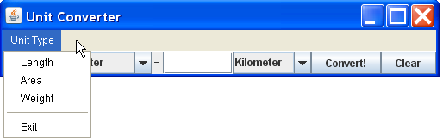
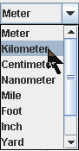
3. When the user selects a type of unit, update the combo boxes to show only that type of unit in the combo-box. Don't mix unit types (e.g. meter and gram).
Button to clear the input fields.
4. For each unit type include at least: 3 metric units (such as meter, cm, micron), 2 English units (such as foot, mile, acre, pound), and at least 1 Thai unit (wa, rai, thang).
5. User should be able to convert in either direction: left-to-right or right-to-left. The converter should be smart enough to determine whether it should convert left-to-right or right-to-left, but give preference to left-to-right.
6. Program should never crash and never print on the console! Catch exceptions and handle them.
7. If user enters an invalid value you should catch it and change text color to RED (don't forget to change the color back the next time enter is pressed). Use try - catch.
8. Avoid "if" and "switch" statements as much as possible! Encapsulate information about units and unit types. See below for suggestions.
9. Create a UML class diagram for your application design.
10. Create a runnable JAR file. A runnable JAR file contains all your project classes in one JAR file and has a designated "main" class. You run a JAR by typing: java -jar myjarfile.jar
You can also run it by double clicking the JAR file's icon (on some operating systems).
In Eclipse, create a JAR file by right-clicking on the project and choose Export... Then choose "Jar" or "Runnable Jar" as export type.
In BlueJ use Project → Create Jar file...

Programming Hints
There are many ways to implement this. Here is one approach, but you can invent your own solution.
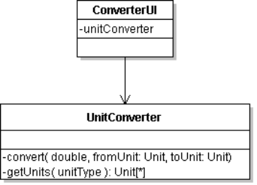
1. Use separate classes for the user interface (view) and the UnitConverter class that performs the conversion. The UI handles events (like button press) and asks the UnitConverter to do the work.
2. So that the UI can accept any kind of unit, you need to enable polymorphism. You need the different kinds of units to "look" alike. Define an interface for Unit that specifies the behavior you require of all units.
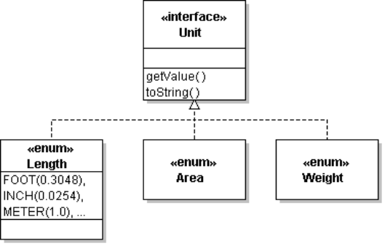
The actual unit types (Length, Area, Weight) implement this interface. An enum can implement an interface, so Length can be an enum. But a unit type is not required to be an enum --
you can use a class instead of an enum. For example, if you want to convert currencies (in real time), you might need a class.

3. You need a way to add different kinds of units to the UnitConverterUI.
The UnitConverterUI should ask another class for the units; preferably it should ask the UnitConverter class.
This was done in Lab 7 where the UnitConverter had a factory method to get length units.
Don't "hardcode" the units into the UI class. The UI should accept any kind of units.
4. You also need a way for the UnitConverterUI to discover what kinds of units are available. Try not to hard-code this into the UI. Two ways to do this are:
(a) a method in the UnitConverter class, such as getUnitTypes().
(b) an enum of UnitTypes, such as:
public enum UnitType {
Length,
Area,
Weight, // this can include mass units, too
AnotherUnit; // your choice
}
5. When the user selects a Unit type using a menu item, the UI asks the UnitConverter for all the units of that type. The UI uses the result to add units to the comboboxes.
UnitType utype = UnitType.Length;
// get all the Length units from the UnitConverter
Unit [] units = converter.getUnits( utype );
// populate the user interface with these units
for( Unit u : units ) comboBox1.add( u );
1 meter = 0.000000000000000105702 light-year
6. The numbers may be very large or very small. So avoid displaying unformatted numbers! For example:
1 light-year = 9.4605284 x 1015 meters
Try the "%g" format, which automatically chooses between fixed point and scientific notation.
Try this in BlueJ: String.format("%.5g", x) with large and small values of x.
7. In Swing, a JFrame contains a JMenuBar. The JMenuBar contains one or more JMenu. Each JMenu contains one or more JMenuItem. You can also add Action objects directly to a JMenu and it will create a menu item for each Action. If you add Action directly to JMenu then you don't need to write an ActionListener, because each Action is its own ActionListener.
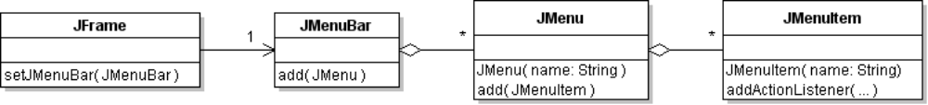

class ExitAction extends AbstractAction {
public ExitAction( ) {
super.setName("Exit");
}
public void actionPerformed(ActionEvent evt) {
//TODO exit the program
}
}
JMenu menu = new JMenu("File");
menu.add( new JMenuItem("...") );
menu.add( new ExitAction() );
JMenuBar menubar = new JMenuBar();
menuBar.add( menu );
frame.setJMenuBar( menubar );
The Java Tutorial has examples of creating a JMenuBar and menus.

Testing
Write and test the UnitConverter class first. Then write the UI.
An effective programming style is to code a little, test, code a little more, test again, etc.

Example Unit Conversion
Suppose the User asks to convert 2 kilometers to feet (plural of "foot").
The UI object calls convert( 2.0, Length.KILOMETER, Length.FOOT )
The convert method computes amount * fromUnit / toUnit:
result = 2.0 * 1000.0 / 0.3048
What about light-years? How many wa equals one light-year?

