Collections

What Kinds of Collections are Available?
Java includes many collections with different semantics. Each kinds of collection has both an Interface and at least one concrete implementation class.
The collections we will study are:
Collection Type | Class | Description
List | ArrayList  LinkedList | Ordered collection where elements can be inserted or removed at any location. Duplicates are allowed.
Set | HashSet  TreeSet | Collection that determines its own ordering of elements. Programmer cannot add element at particular location. No duplicates allowed.
Other types of collections in the Java SE API are Stack, Queue, Deque (double-ended queue), and Tree.

Examples
1. List of Coins
As in the Coin Purse lab, use a List to contain Coins since we may have multiple Coins with same value
List<Coin> money = new ArrayList<Coin>( );
Coin five = new Coin(5);
Coin ten = new Coin(10);
money.add( five );
money.add( ten );
money.add( five ); // duplicate
// can add a new coin at any location
money.add( 0, new Coin(1) );
// Test if list has a "10" coins. Test uses Coin.equals()
Coin testcoin = new Coin(10);
if (money.contains(testcoin) ) money.remove( testcoin );
2. Set of Fruit
Create a set of the fruit we like.
Set<String> fruit = new HashSet<String>( );
fruit.add("Banana"); fruit.add("Apple"); fruit.add("Grape"); fruit.add("Orange");
// if you iterate ove the elements the order will not be same
for( String f: fruit ) System.out.println(f);
// can we add "Apple" again?
fruit.add("Apple"); // returns false -- already has Apple
fruit.contains("Durian"); // false -- I hate durian
fruit.remove("Grape"); // true
fruit.size(); // 3, only Apple, Banana, Orange
3. Map of key-value pairs
Map does not implement the Collection interface, but it is part of Java's collection framework.
A Map is a mapping (association) of keys to values. In Java, the keys and values can be object type.
Use a map to retrieve values by looking up their keys. For example, suppose we have different types of coupons. Red are worth 100Bt, Blue are 50Bt, Green 10Bt:
Map<String,Coupon> map = new HashMap<String,Coupon>( );
map.put("red", new Coupon(100) );
map.put("green", new Coupon(20) );
map.put("blue", new Coupon(50) );
// now you can find coupons by color
if ( map.contains("blue") ) Coupon c = map.get("blue");

Core Collection Interfaces
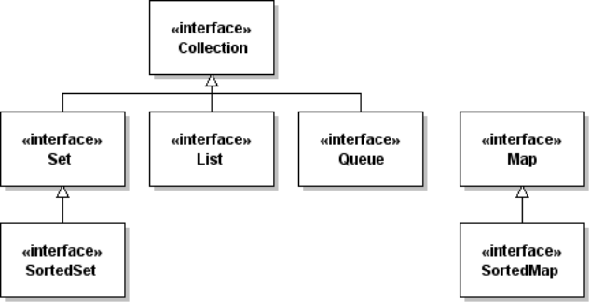
The collections classes all implement a small number of interfaces. If you remember the interface methods, it will be much easier to use the collections.
The Collection interface is the base type for most collections. Collection defines most of the methods in Set, List, and Queue.
<<interface>>
Collection
add( element: E ): boolean
addAll( Collection ): boolean
clear( )
contains( obj: Object )
equals( obj: Object )
isEmpty( ): boolean
iterator( ): Iterator<E>
remove(obj: Object): boolean
removeAll( Collection )
size( ): int
toArray( ): Object[ ]
toArray( E[*] ): E[*]

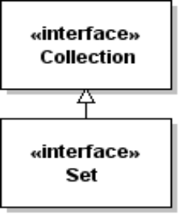

Collection has an iterator method, which means we can iterate over the elements in any collection using a while loop or for-each loop.
In the Set example above, the for(String f: fruit)... statement uses the Iterator to create a for-each loop. We can do the same thing directly using the Iterator:
Iterator<String> iterator = fruit.iterator();
while( iterator.hasNext() )
System.out.println( iterator.next() ); // prints each fruit

Set InterfaceThe Set interface does not add any new methods to Collection, but Set specifies a stronger contract for some of the methods. In particular:
add(element) succeeds only if element isn't in the set already.
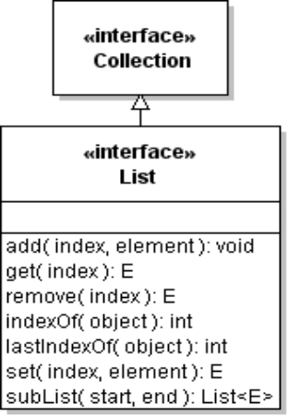
equals( Object )

is true if Object is a Set and both sets contain the same elements, even if the two Sets are instances of different Set classes.List Interface
The List interface adds to Collection the ability to insert and remove elements at a specified position (index) in a List. List also has methods to find the index of an element in the list.
public interface List<E> extends Collection<E> {
// access by index
E get(int index);
// add at index (optional)
void add(int index, E element);
// remove by index (optional)
E remove(int index);
// search for element
int indexOf(Object o);
int lastIndexOf(Object o);
// extra Iterator methods
ListIterator<E> listIterator();
ListIterator<E> listIterator(int index);
// Range-view (not a copy) of this list
List<E> subList(int from, int to);
}
Suppose we have a List of fruit names:
List<String> fruit = new ArrayList<String>( );
fruit.add("Apple"); fruit.add("Orange"); fruit.add("Grape"); fruit.add("Cake");
// Does fruit contain Cake?
int index = fruit.indexOf("Cake");
// Cake is not a fruit, so remove it
if (index >= 0) fruit.remove(index);
if (! fruit.contains("Cake")) System.out.println("no more Cake");
The subList method can be used to perform operations on a section of a List. For example, to remove elements 2 - 4 (assuming list has enough elements):
fruit.subList(2, 5).clear( ); // delete elements from fruit

Map Interface
Map provides an association between keys and values. Unlike other collections, Map has 2 type parameters: one for the key type and one for the value type.
For example, to mapping of Integer to String, you would use: Map<Integer,String>
The most common methods are shown here:
<<interface>>
Map
clear( )
containsKey( key ): boolean
get(key: Object): Value
put(key: Key, value: Value)
keySet( ): Set<Key>
remove( key ): Value
size( ): int
values( ): Collection<Value>

get the value of a given key
insert (key, value) into the map
get all the keys in the map
remove a (key, value) pair from map
number of keys in the map
get all the values in the map

Suppose we want to be able to convert words to integers, so if we see "eleven" in the input we know the value is 11. Use a map whose keys are the strings and whose values are integers:
Map<String,Integer> numbers = new HashMap<String,Integer>( );
numbers.put("one", 1); // autoboxing: 1 --> new Integer(1)
numbers.put("two", 2);
numbers.put("three", 3);
...
numbers.put("twenty", 20);
When we process a word from the input we can look for it in the map and get the value:
// get a word from the input (scanner), test if it is a number
String word = scanner.next();
if ( numbers.contains(word) ) value = numbers.get(word);
else /* not a number */;

Collection Classes
Each Collection interface has at least one concrete class. There are also abstract classes which provide common code and simplify writing new collections.

ArrayList and LinkedList
ArrayList uses an array for storage and is usually faster for sorting and searching. LinkedList is usually faster if you frequently insert and remove element in the List.
If an ArrayList becomes full, it creates a new array and copies all the elements from old array to new array. If you know (approximately) how many elements will be in the ArrayList you can avoid this by reserving an initial capacity. For example, in the Coin Purse constructor, we can create an ArrayList with enough capacity so that the array is never copied:
/** initialize a new Purse with given capacity */
public Purse(int capacity) {
money = new ArrayList<Valuable>( capacity );
this.capacity = capacity;

HashSet and TreeSet
HashSet uses a hash table to store elements and is usually faster than TreeSet. It relies on the hash code of the elements to locate them. Therefore, the hashCode() method of objects in a HashSet should be something that doesn't normally change.

HashMap, Hashtable, and Properties
HashMap is the usual implementation of Map. Hashtable is an older implementation of a map that has extra methods, such as keys() and contains(key). Map has keySet and containsKey() for these.
A java.util.Properties object used to access properties of an application or system properties. Properties has methods to read key-values (as Strings) from a file and save them in a file. Java has a System Properties object that lets you find information about the operating environment.
Here are some examples:
Properties props = System.getProperties();
System.out.println("User is " + props.get("user.name") );
System.out.println("Your OS is " + props.get("os.name") );
To print all the System properties you could use the keySet method:
Properties props = System.getProperties();
Set keys = props.keySet( );
for(Object key: keys)
System.out.printf("%s = %s\n", key, props.get(key) );
The Properties class has a convenience method list(OuputStream) that does the same thing:
Properties props = System.getProperties( );
props.list(System.out);
Applications use Properties to load application configuration data from a file.

Abstract Classes for Collections
Suppose you want to write your own List class. In an IDE you write:
public class MagicList<E> implements List<E> {
The IDE would then inform you that you must implement 23 methods.
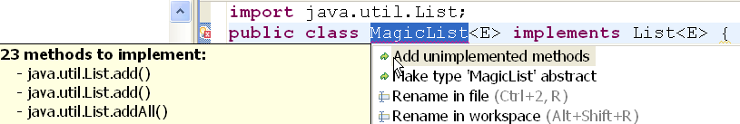
Instead, if you extend AbstractList (which implements List, of course):
public class MagicList<E> extends AbstractList<E> {
then you are only required to implement 2 methods: get( ) and size().
To create a useful list, you'd also want to implement add(element), add(index,element), and a few other methods. Still, you can avoid a lot of coding by inheriting methods from AbstractList.
Java provides abstract collection classes that parallel the collection interfaces:
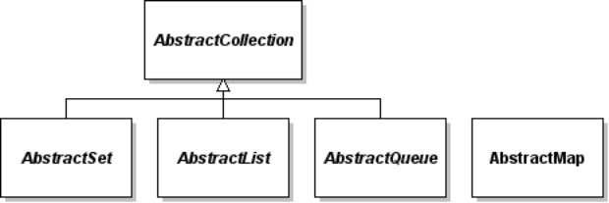

java.util.Collections is not a Collection
The java.util.Collections class (ends with "s") contains static utility methods for collections, such as sorting and searching, and creating an immutable view of a List, Set, or Map. The immutable views are wrappers not copies, and very useful if you want a method to return a collection without breaking encapsulation of the attribute that the collection represents.

Sorting and Sorted Collections
The only collections that the programmer can sort are Lists. To sort a List of objects that implement Comparable use: Collections.sort( list ).
Some collections maintain sorted order automatically. A SortedSet always adds elements in sort order, either using the natural order (the compareTo method of Comparable objects) or using a Comparator object. Since String implements Comparable, we can maintain a sorted set of fruit names:
SortedSet<String> fruit = new TreeSet<String>( );
fruit.add("Orange");
fruit.add("Banana");
fruit.add("Apple");
for( String f: fruit ) System.out.print(f + " ");
// prints "Apple Banana Orange "

