Objectives | 1. Practice creating and using graphical components.  2. Practice adding Event Listeners to handle the events and do something.  3. Learn how to connect a graphical interface to the rest of your application.
What to Submit

Part I: Learn Common Graphics Components

1. Basic Program Structure
To see the basic layout of the code for a GUI app, create a JFrame containing only a single JButton.
import javax.swing.*;
Import classes from AWT and Swing
import java.awt.*;
import java.awt.event.ActionEvent;
Declare attributes for components your application needs to access. Some components can be declared as local vars.
public class ComponentDemo {
private JFrame frame;
// attributes for components
private JButton button;

public ComponentDemo( ) {
Constructor usually does:
(1) initialize attributes
(2) set some properties of the window
(3) call initComponents
frame = new JFrame("Demo");
frame.setDefaultCloseOperation(
JFrame.EXIT_ON_CLOSE );
initComponents( );
}

/** initialize components in the window */
private void initComponents() {
// (1) create components for the UI & set properties (color, font ...)
// (2) position components using layout managers and containers
// (3) add event listeners to components (Problem 2)
button = new JButton("Press Me");
frame.add( button );
frame.pack( );
}
/** Display the graphics window. */
public void run() {
frame.setVisible( true );
}

public static void main(String [] args) {
ComponentDemo demo = new ComponentDemo();
demo.run();
System.out.println("Done launching window. Do you see it?");
}

2. Add an Event Listener
When the user does something in a graphical application, the graphics system dispatches an Event. Your program must tell the graphics system what code it should call when an event occurs. This code is called an "event listener" or "event handler" and it must implement a specific interface.
Let's add an event listener to the JButton so we are notified when the button is pressed.
2.1 Define an inner class that implements ActionListener (the interface for button events). The interface has only one method, as shown here.
// this class is inside the ComponentDemo class. Its an "inner class".
class ButtonListener implements ActionListener {
/** this method receives events */
public void actionPerformed( ActionEvent event ) {
System.out.println("Ouch! Don't press so hard");
}
} // end of inner class
2.2 In the initComponents() method, add a ButtonListener to the button component:
/** initialize components in the window */
private void initComponents() {
button = new JButton("Press Me");
ButtonListener listener = new ButtonListener();
button.addActionListener( listener );
...
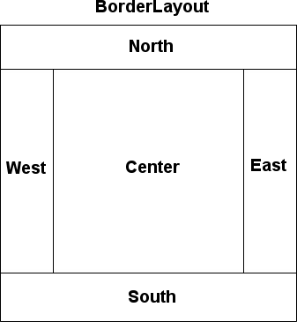

2.3 Run the program and press the button.3. Layout Multiple Components
Java uses a Layout manager to arrange and manage components.
The default layout manager for JFrame is BorderLayout, which divides window into 5 regions North, Center, East, West, and South.
Components are resized to fill the entire region. To see this, add some labels and a Textfield to the ComponentDemo class.
public class ComponentDemo {

//Add a label and textfield
private JLabel counter; // count button clicks
private JTextfield message; // display a message

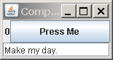
private void initComponents() {
button = new JButton("Press Me");
ButtonListener listener = new ButtonListener();
button.addActionListener( listener );
counter = new JLabel(" 0");
message = new JTextfield("Make my day.");
frame.add(button); // default location in CENTER
frame.add( counter, BorderLayout.WEST );
frame.add( message, BorderLayout.SOUTH );
...

3.1 Count Button Presses
Modify the ButtonListener to do:
a) count how many times the button is pressed and display the value in counter JLabel.
b) print a message in the JTextfield (message) instead of System.out.

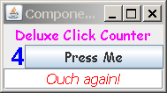
3.2 Add Your Own Components to the EAST and NORTH.

4. Set Component Properties (Make your UI Beautiful)
Most components support these properties:
setForeground( Color ) foreground color (text color)
setBackground( Color ) background color
setEnabled( boolean ) true = enable, false = disable
setBorder( Border ) draw a border around component
setFont( Font ) font for showing text
setToolTipText( "press here" ) shown when mouse is over component
Text fields like JTextField also have these properties:
setEditable( boolean ) false if field is "read only"
setHorizontalAlignment(JTextField.CENTER) LEFT, CENTER, or RIGHT
Visual Graphics Editor for Eclipse
If you are using Eclipse, then use WindowBuilder Editor to do this exercise.
1. Close the editor window for ComponentDemo
2. Right-click on ComponentDemo and choose "Open with... WindowBuilder Editor"
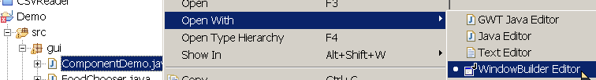
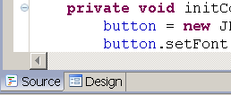
3. At the bottom of the editor window there are 2 tabs: "Source" and "Design".
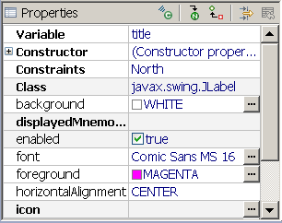
In Source view you can edit the Java source code. In Design view, you use a graphical Window Builder to create the UI and set component properties.
4. In Design view, select (click) a component then edit its properties using the Properties panel as shown here.
5. You can switch to Source view at any time and see the code that Window Builder has generated for you. You should Save changes before switching views.
How to Create Fonts and Colors in Java: to write the code yourself (instead of using Window Builder), see the end of this handout.

5. Fix Ugly Layout: Arrange Components in a JPanel inside the JFrame
The components look ugly.
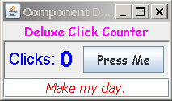
BorderLayout resizes the components to fill all the space available. We can fix this by putting some components in their own container (called a JPanel) and then add the JPanel to the JFrame.
The idea is like this:
1) Create a JPanel in initComponents.
JPanel panel = new JPanel();
2) Put components inside the JPanel (not frame). The default Layout for JPanel is FlowLayout so the components will have their preferred sizes.
panel.add( label );
panel.add( counter );
panel.add( button );
3) Add the panel to the JFrame (actually it gets added to the JFrame's contentPane).
frame.add( panel, BorderLayout.CENTER );
4) (Optional) Add a Border so that the JPanel is visually distinct.
panel.setBorder( new BevelBorder(BevelBorder.LOWERED) );
Swing has many Border types. Other borders are EtchedBorder and TitledBorder.

6. Be a JFrame
In ComponentDemo we created a JFrame as an attribute in the ComponentDemo class.
Another way to create a UI is to extend the JFrame class. Then your UI is a JFrame.
Both ways ("has a JFrame" and "be a JFrame") have advantages, so you should know how to write both. To be a JFrame requires only a small change in the code you already wrote:
public class ComponentDemo extends JFrame {
private JFrame frame;
// attributes for components
private JButton button;

public ComponentDemo( ) {
super("Demo"); // set the title
frame = this; // you don't need the frame variable, but its convenient
initComponents();
Since frame now refers to this object, you can use this in your code. For example:
/** Display the graphics window. */
public void run() {
this.setVisible( true );
}

7. Try Different Layout Managers
The default layout for JFrame is BorderLayout. You can change the layout using the command:
frame.setLayout( someLayoutManager )
Try these layouts and see the difference:
- GridLayout arranges components in a grid and makes them the same size
LayoutManager layout = new GridLayout( rows, columns ); //try: (2,3)
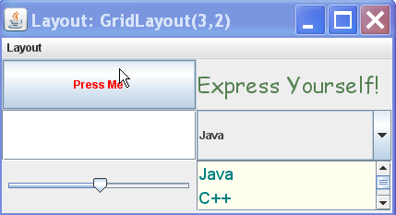
frame.setLayout(layout);
frame.add(button);
frame.add( new JLabel("Express Yourself");
frame.add( new JTextfield(10) );
...
- FlowLayout flows components to use available space and does not resize components. This is the default layout for JPanel.
LayoutManager layout = new FlowLayout( );
// other code same as above
- BoxLayout: Horizontal layout is BoxLayout.X_AXIS, vertical layout is BoxLayout.Y_AXIS.
layout = new BoxLayout( contents, BoxLayout.X_AXIS );
- GridBagLayout: This is one of the best, most flexible layouts and not too hard to use, but you need to study it a little. On your own time, please read the Java Tutorial for GridBagLayout.

Part II: Add a GUI as a User Interface in the GuessingGame
In the Guessing Game you divided the game into 2 classes: Game (the game itself) and GameConsole (user interface). You assigned different responsibilities to separate classes. A benefit of this is that you can change the user interface and still reuse the same Game code.
Apply this design to create a Graphical UI for the Guessing Game.
User Interface or View: the top layer handles interaction with the user, manages the display and receives input events. | 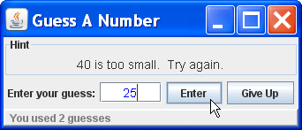
Controller handles processing of user requests. It knows how the application should behave; e.g. stop when the user guesses the secret. It also knows how to translate user input into method calls for the domain layer. | MyActionListener  actionEvent( event )
Domain Layer or Model contains logic used by application, provides "domain objects" and services. | Game  guess( number )  getHint( ): String  getCount( ): int

1. Create a GUI Interface for the GuessingGame
Use what you learned in Part 1 of this lab to create a GUI for playing the guessing game.
The GUI needs a reference to the game, just like the GameConsole interface you wrote before:
GameUI gui = new GameUI( game );

WRONG: The GameUI should not create a Game.
class GameUI extends JFrame {
private Game game;
public GameUI( ) {
// WRONG. Don't write this. UI does not create domain objects.
game = new Game(100);
}

2. Use JPanel to Separate the Input Components
Example:
JPanel panel = new JPanel();
panel.add( label ); // a label
panel.add( inputField );
panel.add( enterButten );
panel.add( quitButton );
contents.add ( panel, BorderLayout.CENTER );

3. Write a Main Class to Connect Components Together
Just like in the original Guessing Game, write a separate Main class to create the objects and connect them together.

Common Graphics Components
JLabel displays text and/or an image:
JLabel label = new JLabel("A nice label");
ImageIcon icon = new ImageIcon("c:/images/1baht.png");
JLabel label = new JLabel(icon);

JButton displays text and/or an image. You can press it.
JButton button = new JButton("Press Me");
ImageIcon coin = new ImageIcon("c:/images/1baht.png");
JButton button2 = new JButton( "One Baht", coin );
JTextField for inputting text:
JTextField textfield = new JTextField( 12 ); // 12 is width
JComboBox to select one item from choices
// you can put any kind of Objects in a combo box
String [] fruit = {"Apple", "Banana", "Orange"};
JComboBox comboBox = new JComboBox( fruit );
JTextArea is a text box with more than one row:
JTextArea textarea = new JTextArea( rows, columns );
textarea.setLineWrap(true);
textarea.setWrapStyleWord(true);
JSlider has a min and max. It can also have labels and tick marks. (See Java Tutorial)
JSlider slider = new JSlider( 0, 100 ); // min 0, max 100
slider.setValue( 50 ); // current value
slider.setMajorTickSpacing( 25 );
slider.setPaintLabels( true );
The Java Tutorial has more component examples:
http://docs.oracle.com/javase//tutorial/ui/features/components.html
How to Create a Color
The Color class has predefined colors: Color.RED, Color.BLUE, Color.GREY, Color.CYAN, etc.
You can create your own colors using:
Color color = new Color( red, green, blue) // red, green, blue are int between 0 and 255
Color darkgreen = new Color( 0, 100, 0); // red = 0, green = 100, blue = 0
Color orange = new Color( 255, 165, 0); // maximum red + some green
Color torquiose = new Color( 0, 245, 255); // green and blue
How to Create a Font
Font font = new Font( name, style, size );
Font arial = new Font("Arial", Font.PLAIN, 24);
name String font name like "Arial", "Angsana New", or an OS-independent font name: Font.DIALOG, Font.DIALOG_INPUT, Font.MONOSPACED, Font.SERIF, or Font.SANS_SERIF
style one of Font.PLAIN, Font.BOLD, Font.ITALIC. (integer constants)
size font size in points. Like in a word processor.

Event Listeners

Use an Event Listener so that your code will be notified when something happens in the graphical interface.
1) create an ActionListener
2) add Listener to a Button
button.addActionListener( me );
me : MyActionListener
actionPerformed( event )

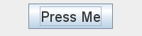

Click!


3) wait for an event

4) Java calls your code
actionPerformed( ActionEvent evt )

Writing an ActionListener
There are 3 common ways to write event listeners:
- create an inner class in the GUI that implements the event listener. The advantage of an inner class is that it can access members its outer class, even private attributes and private methods.
- create an anonymous class and immediately assign it to a variable or component as a listener
- use the GUI class itself as the event listener; e.g. declare the GUI implements ActionListener
Here is how to write an inner class to implement ActionListener. This example displays info about the event on the console so you can see what is passed as the ActionEvent parameter.
class ButtonListener implements ActionListener {
private int count = 0; // count the events
public void actionPerformed( ActionEvent event ) {
// which component caused the event?
Object source = event.getSource(); // e.g. a JButton object
System.out.println(
"Event source: " + source.getClass().getName());
// what event or command occurred?
String cmd = event.getActionCommand();
System.out.println("Action command: " + cmd);
// count the event and show the count
count = count + 1;
label.setText( Integer.toString(count) );
}
You must add the ActionListener to your components. You can use the same listener object as listener for several components.
ActionListener listener = new ButtonListener();
button.addActionListener( listener );
textfield.addActionListener( listener ); // reuse same listener

Other Kinds of Event Listener
Different components require different kinds of event listeners. For example, a JSlider uses a ChangeListener. To write a ChangeListener for a JSlider:
/** a listener for slider */
class SliderListener implements ChangeListener {
public void stateChanged(ChangeEvent e) {
JSlider slider = (JSlider) e.getSource();
int value = slider.getValue();
System.out.println( "slider value is "+ value );
}
In your initComponents() method you would add a change listener to a slider using:
slider.addChangeListener( new SliderListener() );

The Recommended Way to Launch Swing Applications
Swing uses threads. This is why a GUI window keep running even after your main() method has finished. Swing may use several threads, but one thread is special: the Event Dispatcher Thread. This thread performs event handling, which includes responding to all user input.
Java has two rules for using theads in Swing:
1. all UI updates should be performed only in the event dispatcher thread.
2. time consuming or long running tasks should not be performed in the event dispatcher thread.
Rule 1 means we should start our Swing UI in the event dispatcher thread. But how?
The SwingUtility class has method that will insure your code is run in the event dispatcher thread. The typical way of using it is this:
public static void main(String [] args) {
/* Create and display the form */
SwingUtilities.invokeLater( new Runnable() {
public void run() {
new ComponentDemo().setVisible(true);
}
});
}
SwingUtilities.invokeLater() starts the Runnable and returns immediately. As an alternative, you can call SwingUtilities.invokeAndWait() which will wait until the Runnable's run() method exits.
In cases where you need to apply Rule #2 (run a task on another thread and communicate the results to the event dispatcher thread so they show on the UI), use the SwingWorker class.

