Activity 1 Flowchart page 1 of 2
A and C are connectors that join the two pages.
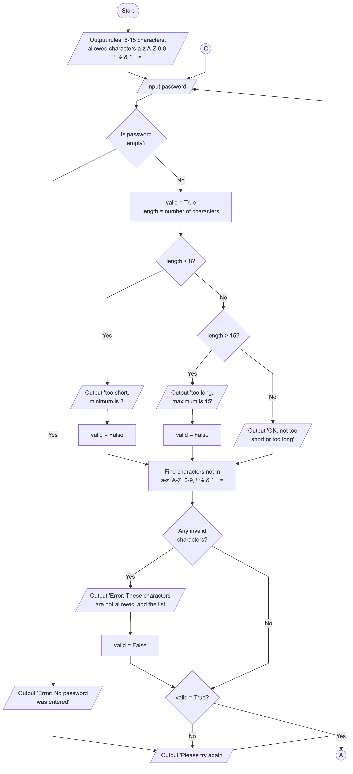

Activity 1 Flowchart page 2 of 2
A and C are connectors that join the two pages.


