Document for Activities 3 and 4
Test Plan (add additional rows as required)
Program language the product is to be produced in (tick box for language used):
☒ Python ☐ C Family
Test Number | Purpose of test | Test Data | Expected Result | Actual Result | Comments
1 | Normal Every type of character | Summer24! | 25 + 5 + 20 + 10 is 60 Medium | 60 Medium | Worked
2 | Normal Lower case only deduction | abcdefgh | 40 take 24 is 16 Very low | 16 Very low | Worked
3 | Normal Numbers only deduction | 12345678 | 80 take 40 is 40 Low | 40 Low | Failed first run, rated Medium. Fixed error 2
4 | Normal All six special characters | Ab1!%&*+= | 5 + 5 + 10 + 60 is 80 High | 80 High | Failed first run, rated Very high. Fixed error 2
5 | Normal Bonus and Very high rating | Hello+World1 | 40 + 10 + 10 + 10 + 20 is 90 Very high | 90 Very high | Worked
6 | Extreme Shortest allowed 8 | Abcdef1! | Accepted 50 Medium | 50 Medium | Worked
7 | Extreme Longest allowed 15 | Aa1!Aa1!Aa1!Aa1 | Accepted 130 Very high | 130 Very high | Worked
8 | Extreme 9 characters no bonus | Abcdefg12 | 30 + 5 + 20 is 55 Medium | 55 Medium | Worked
9 | Extreme 10 characters bonus | Abcdefg123 | 30 + 5 + 30 + 20 is 85 Very high | 85 Very high | Failed first run, 65 with no bonus. Fixed error 1
10 | Abnormal Too short 7 | Abcde1! | Too short, minimum is 8, asked again | Too short, minimum is 8, asked again | Worked
11 | Abnormal Too long 16 | Aa1!Aa1!Aa1!Aa1! | Too long, maximum is 15, asked again | Too long, maximum is 15, asked again | Worked
12 | Abnormal Nothing entered | blank | No password was entered | No password was entered | Worked
13 | Abnormal Characters not allowed | Pass@word#1 | Not allowed @ # | Not allowed @ # | Worked
14 | Abnormal Accented letter | Passwördd1 | Not allowed ö | Not allowed ö | Failed second run, accepted with 75. Fixed error 3
15 | Abnormal Only Y or N accepted | maybe, y, n | Please enter Y or N, y rates another, n ends | As expected | Worked
Test evidence
The program title and rules are shown once in test 1 and cropped off the rest.
Test 1 Summer24!
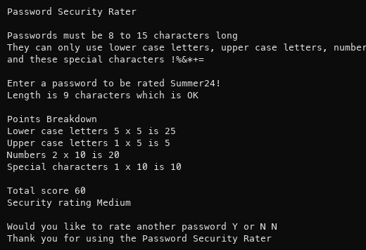
Test 2 abcdefgh
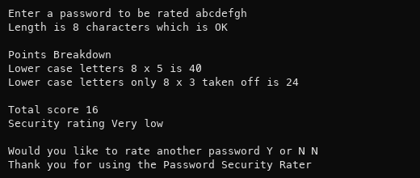
Test 3 12345678
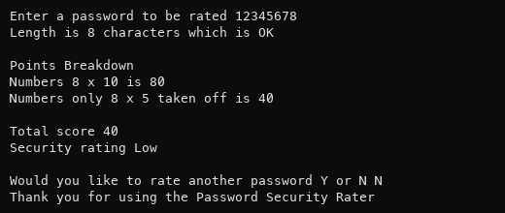
Test 4 Ab1!%&*+=
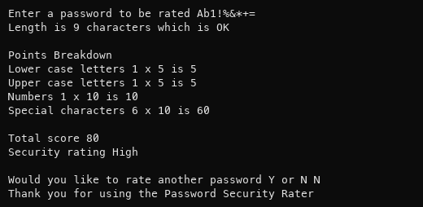
Test 5 Hello+World1
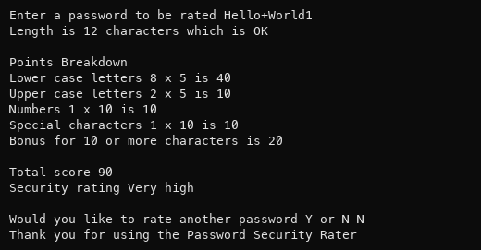
Test 6 Abcdef1!
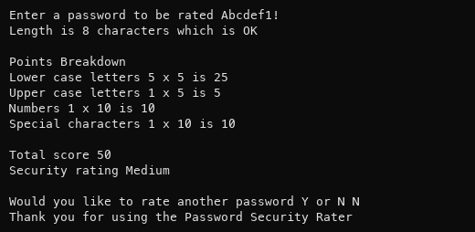
Test 7 Aa1!Aa1!Aa1!Aa1
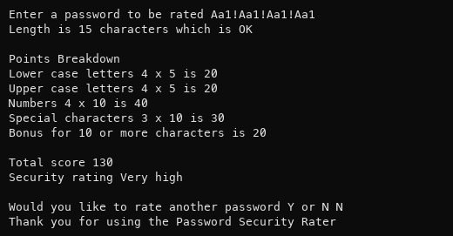
Test 8 Abcdefg12
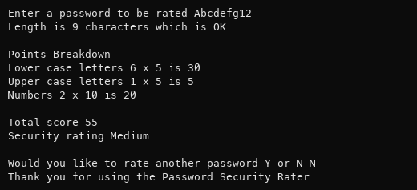
Test 9 Abcdefg123
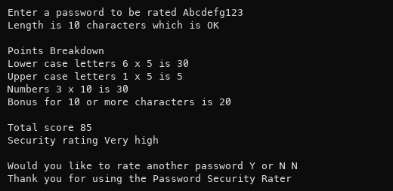
Test 10 Abcde1!
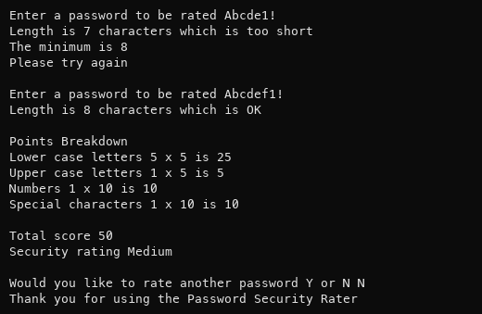
Test 11 Aa1!Aa1!Aa1!Aa1!
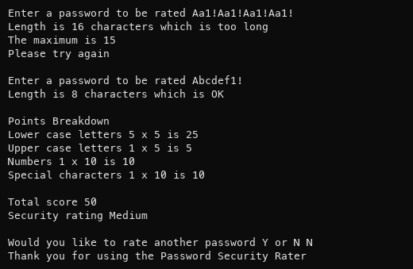
Test 12 blank
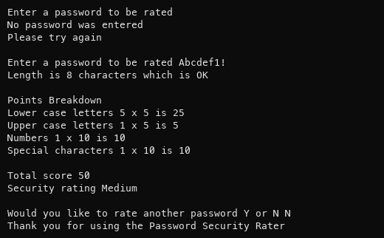
Test 13 Pass@word#1
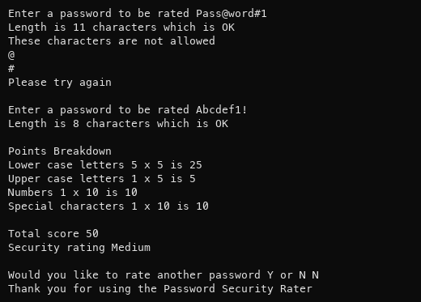
Test 14 Passwördd1
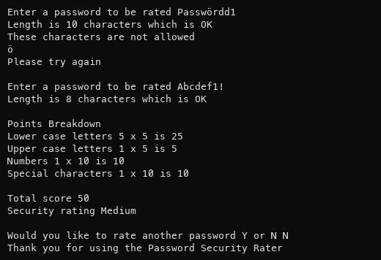
Test 15 maybe then y then n
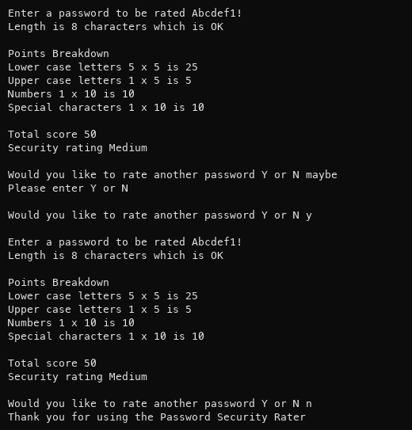
Errors found and fixed
On the first run tests 3, 4 and 9 failed. I fixed errors 1 and 2. On the second run test 14 failed. I fixed error 3. On the third run all tests worked.
Error 1 No bonus at 10 characters in test 9
Abcdefg123 got no bonus and scored 65. The bonus is for 10 or more characters but I used greater than so it only worked from 11.
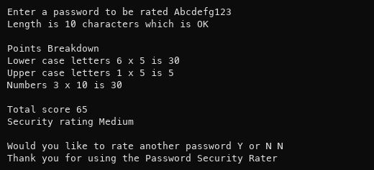
Before if length > BONUS_LENGTH:
After if length >= BONUS_LENGTH:
Retested 85 Very high. Test 8 has 9 characters and still gets no bonus.
Error 2 Top score of a rating went into the next one in test 3
12345678 scored 40 but was rated Medium. Each rating includes its top number but I used less than.
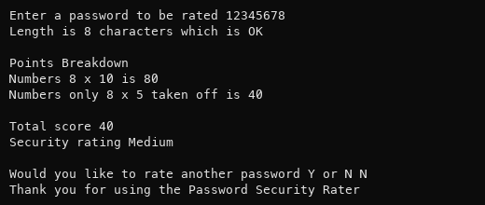
Before elif total < 40:
After elif total <= 40:
Retested test 3 Low, test 4 High. I made the same change for 20, 70 and 80.
Error 3 Accented letters accepted in test 14
Passwördd1 was accepted and scored 75. islower() counts any letter in any language, so ö counted as lower case.
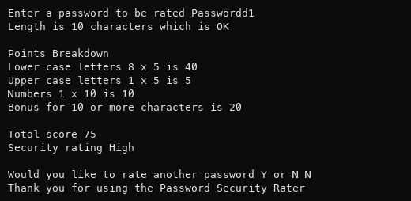
Before return character.islower()
After return character >= "a" and character <= "z"
Did the same for A to Z and 0 to 9. Retested ö is rejected.

