

Safety Plan Lane Assistance

**Document Version: [Version]**

**Template Version 1.0, Released on 2017-06-21**



# Document history

|  |  |  |  |
| --- | --- | --- | --- |
| Date | Version | Editor | Description |
| 01/01/2019 | 1.0 | Chris Sketch | Initial Documentation |
| 01/05/2019 | 2.0 | Chris Sketch | Add table for subsystems |
|  |  |  |  |
|  |  |  |  |
|  |  |  |  |

# Table of Contents

Document history

Table of Contents

Introduction

Purpose of the Safety Plan

Scope of the Project

Deliverables of the Project

Item Definition

Goals and Measures

Goals

Measures

Safety Culture

Safety Lifecycle Tailoring

Roles

Development Interface Agreement

Confirmation Measures

# Introduction

## Purpose of the Safety Plan

The purpose of a safety plan is to outline the steps we will take in order to achieve functional safety. The safety plan will define the parts of the safety lifecycle impacted by new development, the roles and responsiblities of team members, the steps the company takes to promote safety culture, and the confirmation measures that will be used to determine that the plan makes the vehicle safer.

## Scope of the Project

For the lane assistance project, the following safety lifecycle phases are in scope:

Concept phase

Product Development at the System Level

Product Development at the Software Level

following phases are out of scope:

Product Development at the Hardware Level

Production and Operation

## Deliverables of the Project

The deliverables of the project are:

Safety Plan

Hazard Analysis and Risk Assessment

Functional Safety Concept

Technical Safety Concept

Software Safety Requirements and Architecture

# Item Definition

The lane assistance item warns the driver when unintentionally leaving the lane, and assists the driver is staying within the lane.

The first function of the lane assistance item is lane departure warning. Lane departure warning warns the driver when unintentionally leaving the lane by providing haptic feedback by applying an oscillating torque to the steering wheel.

The second function of the lane assistance item is lane keeping assistance. When active, lane keeping assistance will automatically assist the driver in staying in their lane by applying a steering torque in order to stay in the vehicles current lane.

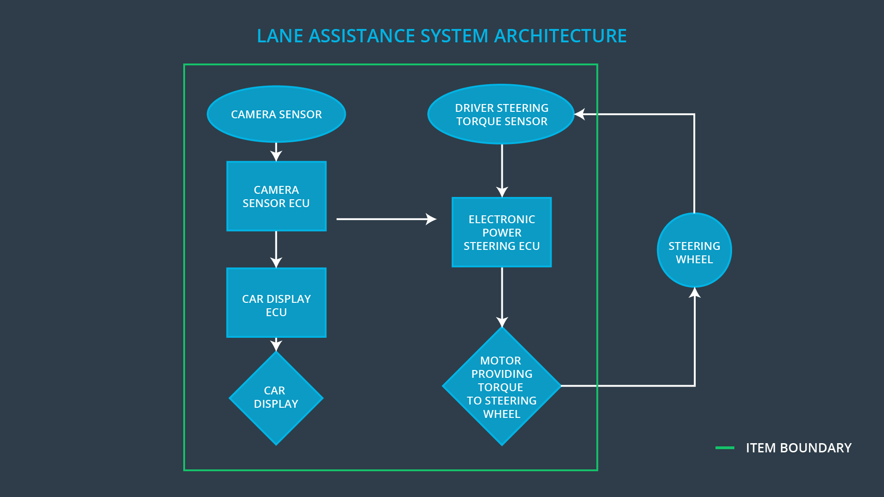  
Figure 1.1: Lane assistance item boundary

The item boundary is drawn in the Figure 1.1.

The lane assistance item contains three subsystems: the camera subsystem, the electronic power steering subsystem, and the car display subsystem. The three subsystems are each involved in lane departure warning and lane keeping assistance.

|  |  |  |  |
| --- | --- | --- | --- |
| Subsystem Name | Purpose | Components | Interface |
| Camera subsystem | responsible for detecting lane lines and determining when the vehicle leaves the lane by mistake | The camera subsystem contains a camera sensor and a camera sensor ECU. | he camera subsystem sends requests to the electronic power steering subsystem and the car display subsystem. |
| Electronic power steering subsystem | Responsible for measuring the torque provided by the driver and then adding an appropriate amount of torque based on a lane assistance system torque request. | The electronic power steering subsystem contains a driver steering torque sensor, an electronic power steering ECU, and a motor providing torque to the steering wheel. | The electronic power steering subsystem receives requests from the camera subsystem. The electronic power steering subsystem receives requests from and sends requests to the steering system. |
| Car display subsystem | Responsible for displaying a warning light indicating the vehicle is departing its current lane when the camera subsystem requests it. | The car display subsystem contains a car display ECU and a car display. | The car display subsystem receives requests from the camera subsystem. |

# Goals and Measures

## Goals

The purpose of this project is to achieve functional safety for the lane keeping item.

## Measures

|  |  |  |
| --- | --- | --- |
| Measures and Activities | Responsibility | Timeline |
| Follow safety processes | All Team Members | Constantly |
| Create and sustain a safety culture | All Team Members | Constantly |
| Coordinate and document the planned safety activities | Safety Manager | Constantly |
| Allocate resources with adequate functional safety competency | Project Manager | Within 2 weeks of start of project |
| Tailor the safety lifecycle | Safety Manager | Within 4 weeks of start of project |
| Plan the safety activities of the safety lifecycle | Safety Manager | Within 4 weeks of start of project |
| Perform regular functional safety audits | Safety Auditor | Once every 2 months |
| Perform functional safety pre-assessment prior to audit by external functional safety assessor | Safety Manager | 3 months prior to main assessment |
| Perform functional safety assessment | Safety Assesor | Conclusion of functional safety activities |

# Safety Culture

Our company’s number one priority is safety. All assessments and audits will be performed by an independent assessor and auditor. All documentation is tied to the person responsible for performing the task using up-to-date safety requirements software. Our company has well defined processes in place in order to assign qualified personnel to the project. Our company will be in close communication in order to detect problems as early as possible and achieve functional safety.

# Safety Lifecycle Tailoring

The safety plan will cover the concept phase, product development at the system level, and product development at the software level. Product development at the hardware level, production, and operation are outside the scope of this safety plan.

# Roles

|  |  |
| --- | --- |
| Role | Org |
| Functional Safety Manager- Item Level | OEM |
| Functional Safety Engineer- Item Level | OEM |
| Project Manager - Item Level | OEM |
| Functional Safety Manager- Component Level | Tier-1 |
| Functional Safety Engineer- Component Level | Tier-1 |
| Functional Safety Auditor | OEM or external |
| Functional Safety Assessor | OEM or external |

# Development Interface Agreement

1. The puuropse of a development interface agreement is to clarify the responsibilities of the different parties involved in a functional safety project, to describe the work products that each company will provide, to help avoid disputes between companies, and to clarify who will be responsible for any safety issues in post-production.
2. The OEM will be responsible for ensuring that the subsystems perform their intended tasks as specified in the safety plan. The tier 1 supplier (us?) will be responsible for modifying the subsystems so that they achieve functional safety. An independent auditor and assesor will be responsible for determining whether the system meets functional safety. After accepting the assessment, the OEM will be responsible for all safety related issues in post-production.

# Confirmation Measures

1. The purpose of confirmation measures are to ensure that a functional safety project conforms to ISO-26262 and that the project makes the vehicle safer
2. A confirmation review is an independent assessment of whether the project complies with ISO-26262.
3. A functional safety audit is a task performed to check whether the actual implementation of the project conforms to its associated safety plan.
4. A functional safety assessment is a task that confirms that the product achieves functional safety