

Functional Safety Concept Lane Assistance

**Document Version: [Version]**

**Template Version 1.0, Released on 2017-06-21**



# Document history

|  |  |  |  |
| --- | --- | --- | --- |
| Date | Version | Editor | Description |
| 01/03/2019 | 1.0 | Chris Sketch | Initial Documentation |
|  |  |  |  |
|  |  |  |  |
|  |  |  |  |
|  |  |  |  |

# Table of Contents

Document history

Table of Contents

Purpose of the Functional Safety Concept

Inputs to the Functional Safety Analysis

Safety goals from the Hazard Analysis and Risk Assessment

Preliminary Architecture

Description of architecture elements

Functional Safety Concept

Functional Safety Analysis

Functional Safety Requirements

Refinement of the System Architecture

Allocation of Functional Safety Requirements to Architecture Elements

Warning and Degradation Concept

# Purpose of the Functional Safety Concept

The purpose of the functional safety concept is to avoid accidents by reducing risk to acceptable levels.

# Inputs to the Functional Safety Concept

## Safety goals from the Hazard Analysis and Risk Assessment

The lane assistance item is composed of two functions: lane departure warning and lane keeping assistance. The lane departure warning function has one goal and the lane keeping function has two goals.

|  |  |
| --- | --- |
| **ID** | **Safety Goal** |
| Safety_Goal_01 | The oscillating steering torque from the lane departure warning function shall be limited. |
| Safety_Goal_02 | The lane keeping assistance function shall be time limited and the additional steering torque shall end after a given time interval so that the driver cannot misuse the system for autonomous driving |
| Safety_Goal_03 | The lane keeping assistance function’s car display subsystem shall reliably display the lane keeping assistance indicator. |

## Preliminary Architecture

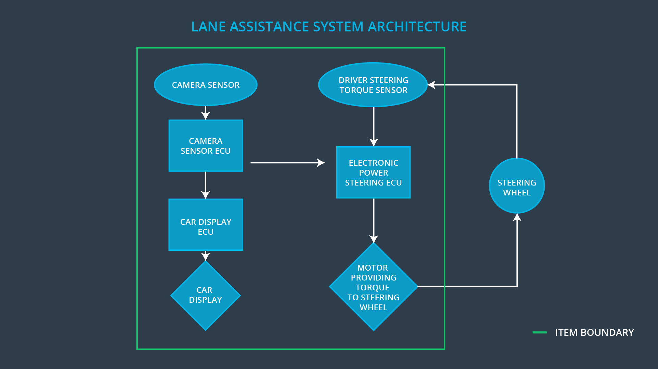

### Description of architecture elements

|  |  |
| --- | --- |
| **Element** | **Description** |
| Camera Sensor | Senses visual information in the environment such as the lane markings and geometry of the road so that the lane assitance item can determine its lane and its position within the lane. |
| Camera Sensor ECU | Processes information received from the camera sensor to determine the current lane and the vehicles position in the lane.  Sends requests to the car display ECU and the electronic power steering ECU. |
| Car Display | Displays an icon to the driver to indicate that the vehicle is departing the lane or the lane keeping function is activated |
| Car Display ECU | Receives request from the camera sensor ECU and turns on the car display. |
| Driver Steering Torque Sensor | Senses the torque that is being applied to the steering wheel. The sensor is necessary to steer and add torque in a controlled manner. |
| Electronic Power Steering ECU | Receives information from the driver steering torque sensor.  Receives lane departure warning requests from the camera sensor ECU when the vehicle is departing the lane.  Receives lane keeping assistance requests from the camera sensor ECU with information about the road geometry and the position of the vehicle on the road.  Processes lane departure warning requests and determines the amount of torque to apply to the steering wheel.  Processes lane keeping assistance requests to determine the amount of torque necessary to steer the vehicle to the center of the lane.  Activates the motor providing torque to the steering wheel in order to oscillate the steering wheel.  Activates the motor providing torque to the steering wheel in order to steer to the center of the lane |
| Motor providing torque to the steering wheel | Provides torque to the steering wheel in order to alert the driver that they are exiting the lane  Provides torque to the steering wheel in order to steer the vehicle to the center of the lane |

# Functional Safety Concept

The functional safety concept consists of:

* Functional safety analysis
* Functional safety requirements
* Functional safety architecture
* Warning and degradation concept

## Functional Safety Analysis

|  |  |  |  |
| --- | --- | --- | --- |
| **Malfunction ID** | **Main Function of the Item Related to Safety Goal Violations** | **Guidewords (NO, WRONG, EARLY, LATE, MORE, LESS)** | **Resulting Malfunction** |
| Malfunction_01 | Lane Departure Warning (LDW) function shall apply an oscillating steering torque to provide the driver a haptic feedback | MORE | The lane departure warning function applies an oscillating torque with very high torque amplitude (above limit) |
| Malfunction_02 | Lane Departure Warning (LDW) function shall apply an oscillating steering torque to provide the driver a haptic feedback | MORE | The lane departure warning function applies an oscillating torque with very high frequency (above limit) |
| Malfunction_03 | Lane Keeping Assistance (LKA) function shall apply the steering torque when active in order to stay in ego lane | NO | The lane keeping assistance function is not limited in time duration which leads to misuse as an autonomous driving function |

## Functional Safety Requirements

Lane Departure Warning (LDW) Requirements:

|  |  |  |  |  |
| --- | --- | --- | --- | --- |
| **ID** | **Functional Safety Requirement** | **ASIL** | **Fault Tolerant Time Interval** | **Safe State** |
| Functional  Safety  Requirement  01-01 | The electronic power steering ECU shall ensure that the lane departure warning oscillating torque amplitude is below Max_Torque_Amplitude | C | 50 ms | Lane departure torque is set to 0. |
| Functional  Safety  Requirement  01-02 | The electronic power steering ECU shall ensure that the lane departure warning oscillating torque frequency is below Max_Torque_Frequency | C | 50 ms | Lane departure torque is set to 0. |

Lane Departure Warning (LDW) Verification and Validation Acceptance Criteria:

|  |  |  |
| --- | --- | --- |
| **ID** | **Validation Acceptance**  **Criteria and Method** | **Verification Acceptance**  **Criteria and Method** |
| Functional  Safety  Requirement  01-01 | Using a representative sample size of drivers, test that the value of Max_Torque_Limit is not too high to be uncontrollable or too low to be unnoticed | Test that after torque has exceeded Max_Torque_Limit that the lane departure warning output torque is set to 0 within the FTTI specified above. |
| Functional  Safety  Requirement  01-02 | Using a representative sample size of drivers, test that the value of Max_Frequency_Limit is not too high to be uncontrollable or uncomfortable and not too low to be unnoticed or cause significant vehicle drift | Test that after torque has exceeded Max_Frequency_Limit that the lane departure warning output torque is set to 0 within the FTTI specified above. |

Lane Keeping Assistance (LKA) Requirements:

|  |  |  |  |  |
| --- | --- | --- | --- | --- |
| **ID** | **Functional Safety Requirement** | **ASIL** | **Fault Tolerant Time Interval** | **Safe State** |
| Functional  Safety  Requirement  02-01 | The electronic power steering ECU shall ensure that the lane keeping assistance torque is applied for only Max_Duration | B | 500 ms | Lane assitance torque is set to 0. |

Lane Keeping Assistance (LKA) Verification and Validation Acceptance Criteria:

|  |  |  |
| --- | --- | --- |
| **ID** | **Validation Acceptance**  **Criteria and Method** | **Verification Acceptance**  **Criteria and Method** |
| Functional  Safety  Requirement  02-01 | Using a representative sample size of drivers, test that the value of Max_Duration discouraged drivers from shifting their attention away from the road | Test that after the lane assistance torque has been applied for Max_Duration, lane assistance torque is set to 0 within the FTTI specified above. |

## Refinement of the System Architecture

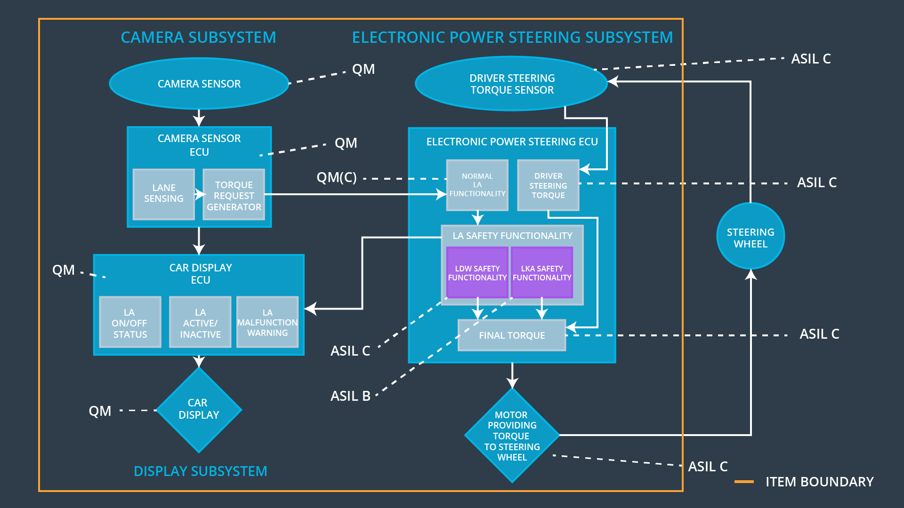

## Allocation of Functional Safety Requirements to Architecture Elements

|  |  |  |  |  |
| --- | --- | --- | --- | --- |
| **ID** | **Functional Safety Requirement** | **Electronic Power Steering ECU** | **Camera ECU** | **Car Display ECU** |
| Functional  Safety  Requirement  01-01 | The electronic power steering ECU shall ensure that the lane departure warning oscillating torque amplitude is below Max_Torque_Amplitude | **X** |  |  |
| Functional  Safety  Requirement  01-02 | The electronic power steering ECU shall ensure that the lane departure warning oscillating torque frequncy is below Max_Torque_Frequency | **X** |  |  |
| Functional  Safety  Requirement  02-01 | The electronic power steering ECU shall ensure that the lane keeping assistance torque is applied for only Max_Duration | **X** |  |  |

## Warning and Degradation Concept

|  |  |  |  |
| --- | --- | --- | --- |
| **ID** | **Degradation Mode** | **Trigger for Degradation Mode** | **Driver Warning** |
| WDC-01 | Lane departure warning function turned off | Oscillating torque amplitude exceeds Max_Torque_Limit or oscillating torque frequency exceeds Max_Torque_Frequency | Car display shows message that lane departure warning is not available |
| WDC-02 | Lane keep assistance function | Lane keeping assistance torque is applied for greater than Max_Duration | Car display shows message that lane keep assistance function is not available |