TO: SHILPA

ATTN: DEEP
8 JUNE 2021
FROM: NAUM FEYNBERG REPEAT ORDEER

ORDER #253/2021 PIERRE CARDIN RUSTIC LEATHER RANGE
MATERIAL | #92 WAXED LEATHER FOR ALL COLOURS WITH DARKENED EDGES, AS PER SAMPLES. PLS CONFIRM.
LINING | PIERRE CARDIN AS PER SAMPLE
HARDWARE | BUFF ANTIQUE AS PER SAMPLE. PLS CONFIRM
ORNAMENT | PIERRE CARDIN EMBOSS ON A PATCH WITH RIVETS, AS PER SAMPLE. PLEASE CONFIRM
INSIDE WOVEN LABEL | - PIERRE CARDIN, GENUINE LEATHER, AS PER SAMPLE  - MADE IN INDIA – IN INNER ZIP POCKET, AS PER SAMPLE.
INSIDE | LEATHER WINDOW FRAME AROUND INNER ZIP POCKET, WITH DIRECT EMBOSS ‘PIERRE CARDIN, GENUINE LEATHER’, AS PER SAMPLES.
PACKAGING | FULLY STUFFED WITH PIERRE CARDIN SWING TICKET, WITH STYLE NUMBER AND COLOUR
LEATHER TAG | PIERRE CARDIN, GENUINE LEATHER TAG, FOR EVERY BAG.  PLS CONFIRM
ZIP PULLER | AS PER SAMPLE.
DELIVERY | 18 JUNE IF POSSIBLE 2021

IMAGE | PIERRE CARDIN  STYLE | FACTORY NO | LEATHER | COLOUR | TOTAL | PRICE IN  $AUS
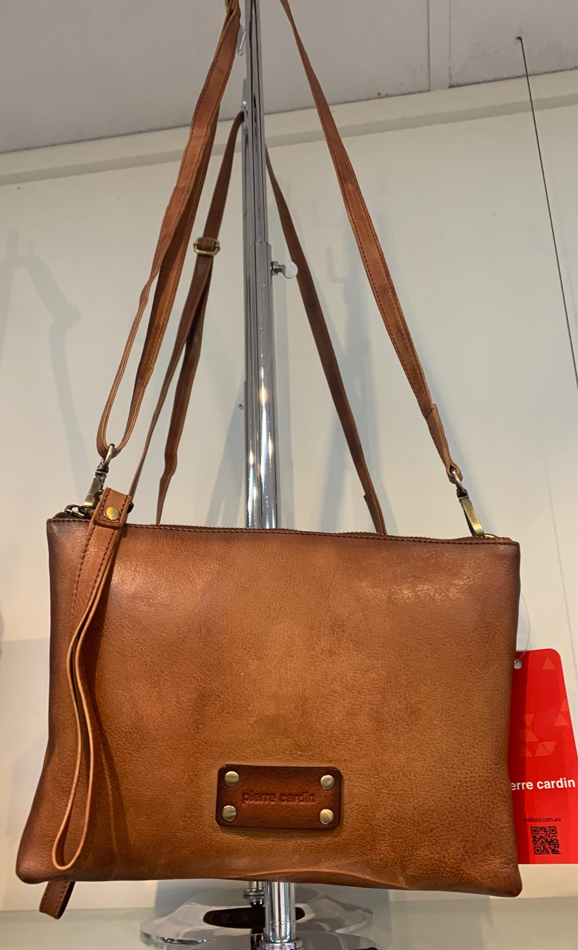 | PC 3329 | GROUP #3, STYLE #6 | #92 WAXED | 60 – COGNAC #92  20 – BLACK #92 | 80 | $21.35
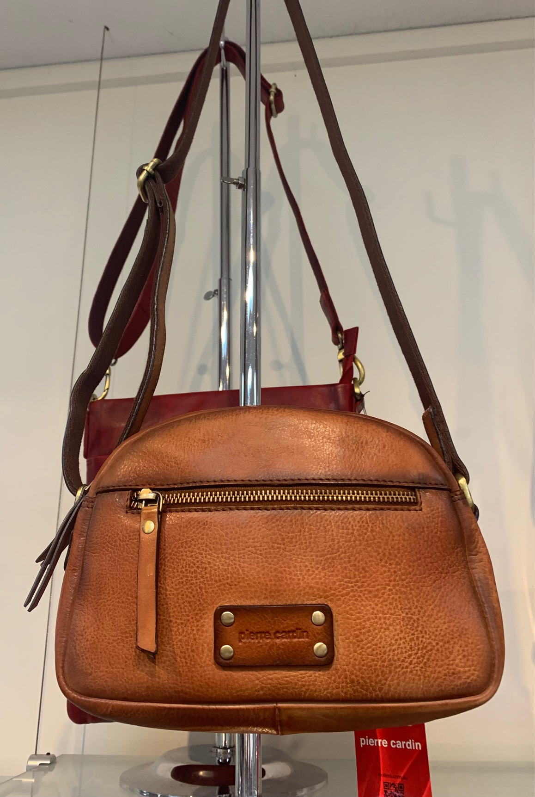 | PC 3330 | GROUP #3,  STYLE #7 | #92 WAXED | 50 – COGNAC #92  20 – BLACK #92 | 70 | $23.55
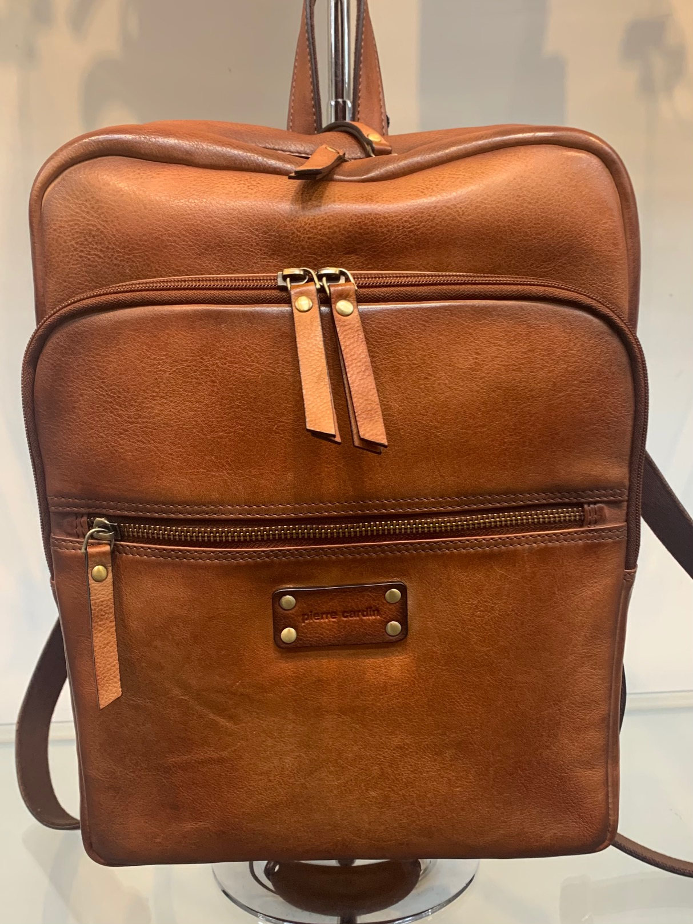 | PC 3332 | GROUP 3,  STYLE #9 | #92 WAXED | 50 – COGNAC#92  20 – BLACK #92 | 70 | $38.00
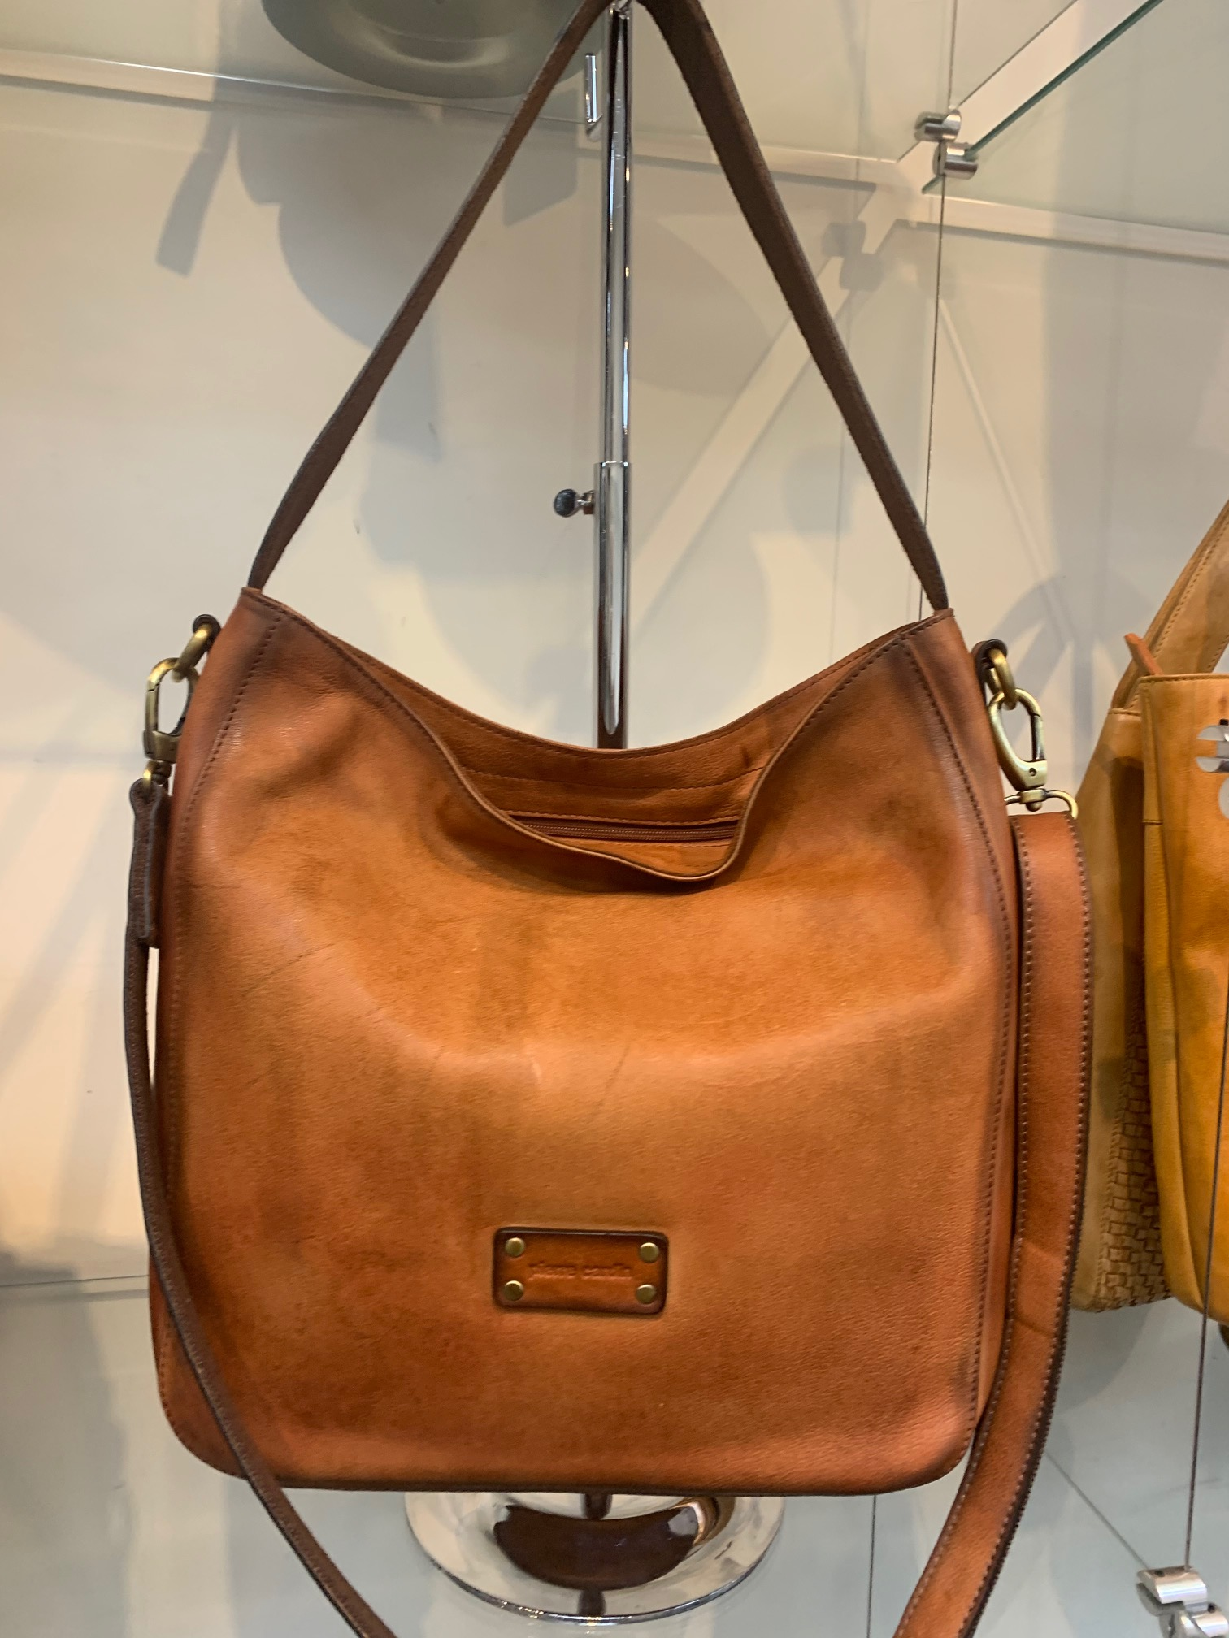 | PC 3334 | GROUP #3,  STYLE #11 | #92 WAXED | 50 – COGNAC #92  20 – BLACK#92 | 70 | $34.80
Total 290 pcs
HI DEEP,

PLS. SEND PROFORMA CONFIRMATION. BEST REGD. NAUM.

