TO: SHILPA

ATTN: DEEP
1 JULY 2021
FROM: NAUM FEYNBERG

ORDER #254/ 2021 MILLENI BRAND FOR TJX EUROPE
MATERIAL | BELLOW
LINING | MILLENI PRINT LINING
HARDWARE | AS PER SAMPLE.
ORNAMENT | MILLENI, DIRECT EMBOSS, PLEASE CONFIRM
INSIDE WOVEN LABEL | - MILLENI, GENUINE LEATHER, AS PER SAMPLE  - MADE IN INDIA – IN INNER ZIP POCKET, AS PER SAMPLE.
INSIDE
PACKAGING | WITH MILLENI CREDIT CARD, PLS PUT CARD IN EACH WINDOW, AND AFTER IN MILLENI GIFT BOX, WITH STYLE NUMBER, COLOUR, AND BARCODE NUMBER.
DIRECT EMBOSS | EACH WALLET IS TO HAVE AN EMBOSS ‘MILLENI, GENUINE LEATHER INSIDE AS PER SAMPLES, PLS CONFIRM
ZIP PULLER | AS PER SAMPLE
DELIVERY | 7 AUGUST 2021 TO TJX FREIGHT FORWARDER IN KOLKATA

IMAGE | PIERRE CARDIN  STYLE | LEATHER AND COLOR | TOTAL | PRICE CIF BY AIR
 | M9130  PC9130 | 300- BLACK #110  200 – NAVY #110  200- ORANGE #21  200- OLIVE#92 WAXED  200- SAGE [MINT #92 WAXED] | 1100 | $9.85  $9.85  $10.50  $10.50  $10.50
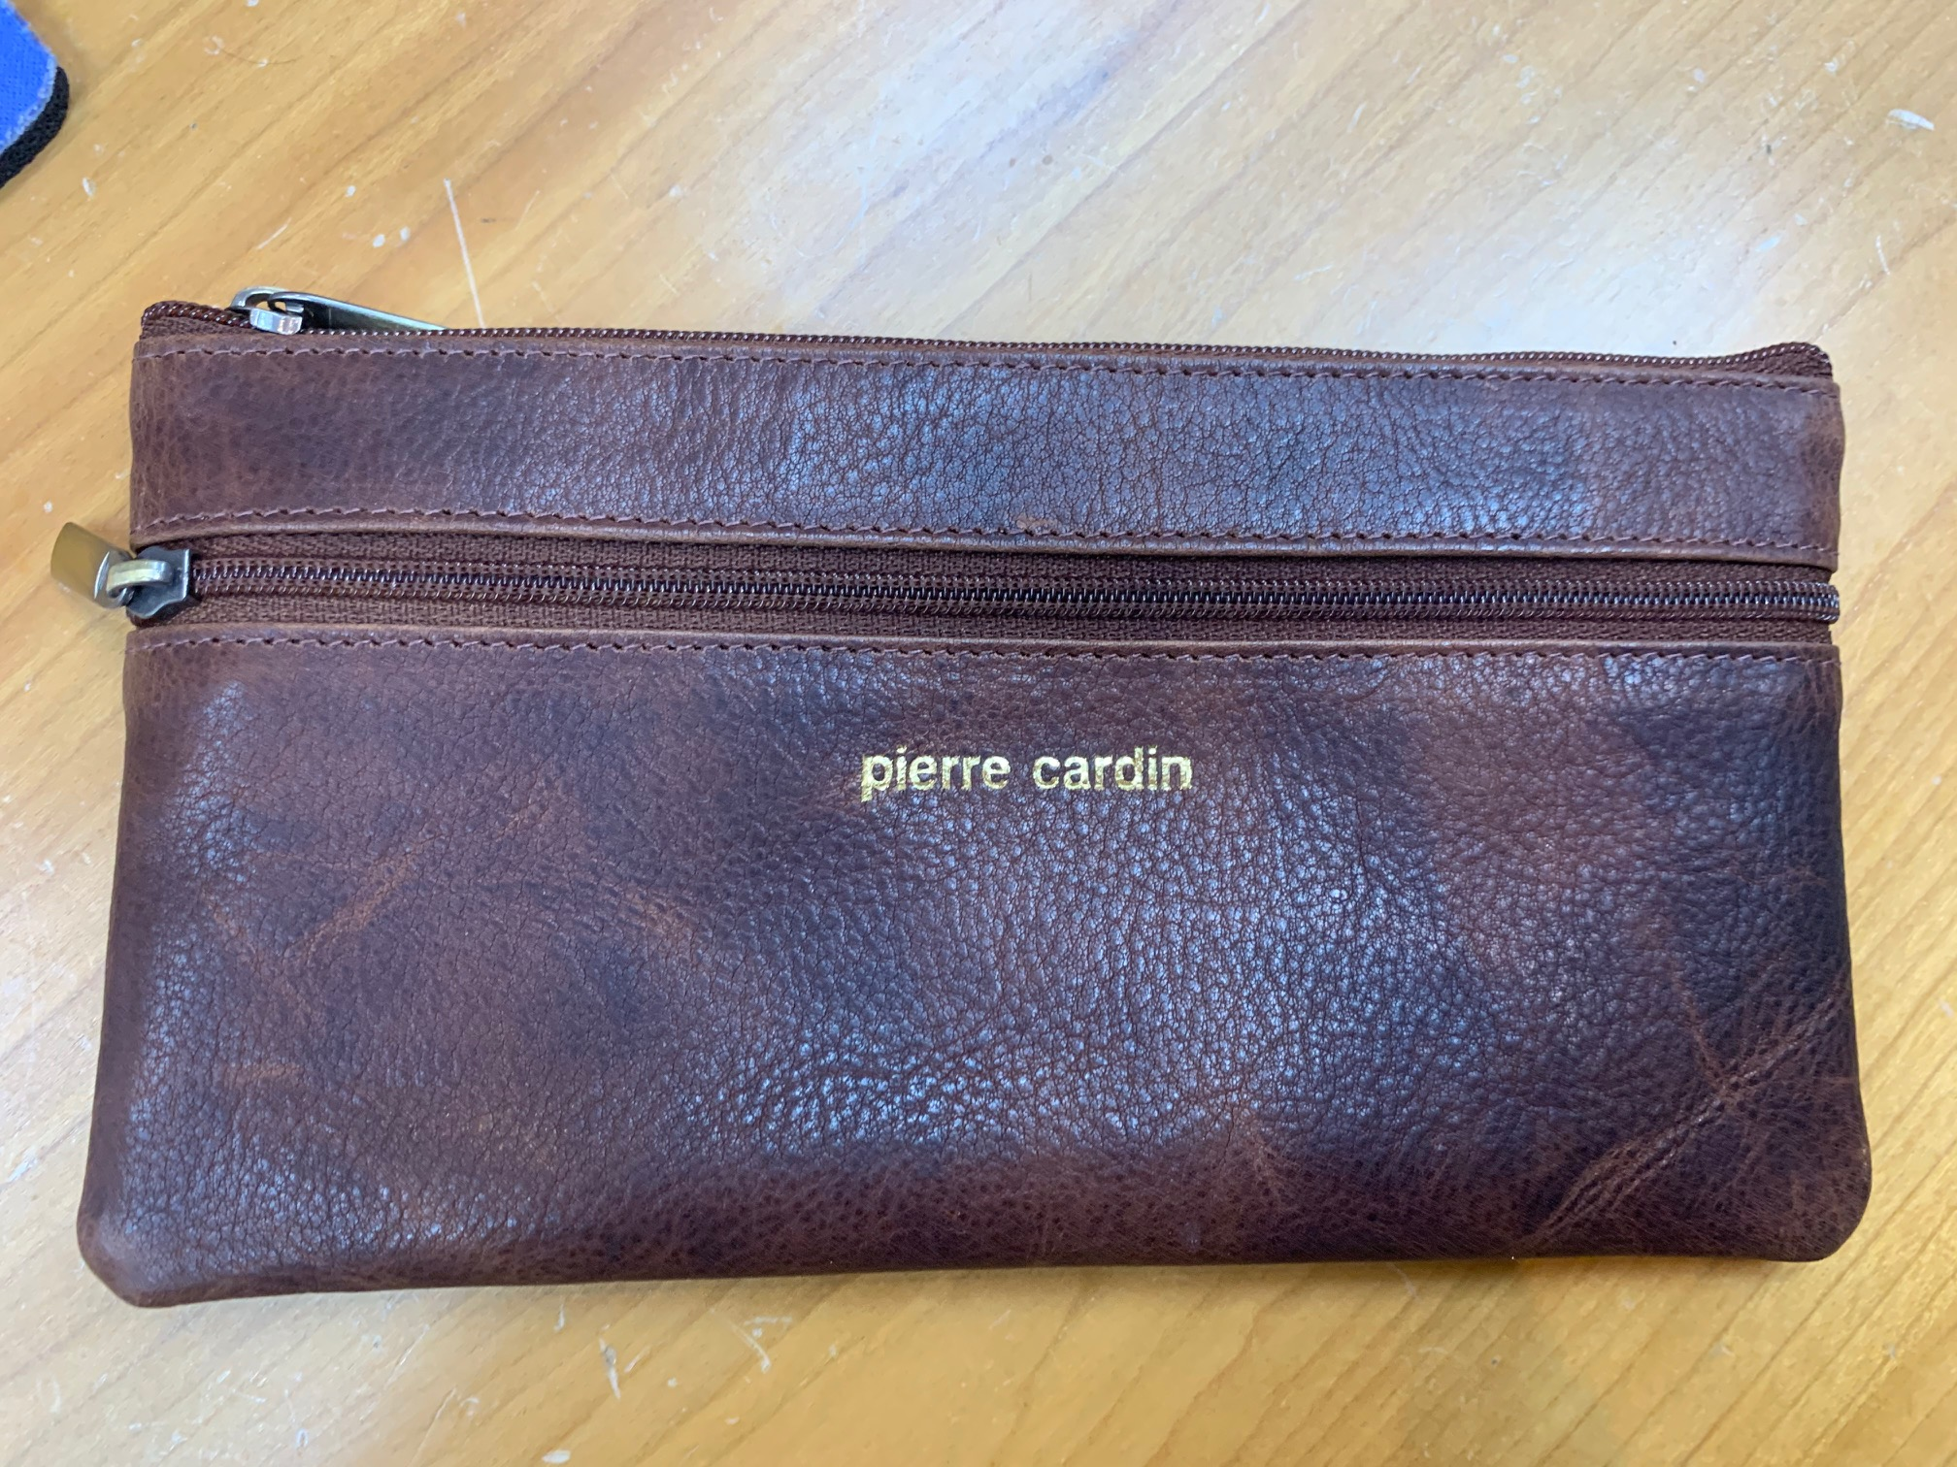 | M1488  PC 1488 | 300- BLACK #110  300 – COGNAC #92 WAXED  200- GREEN [EMERALD #77 ]  200- YELLOW #21 | 1000 | $5.05  $5.40  $5.40  $5.40
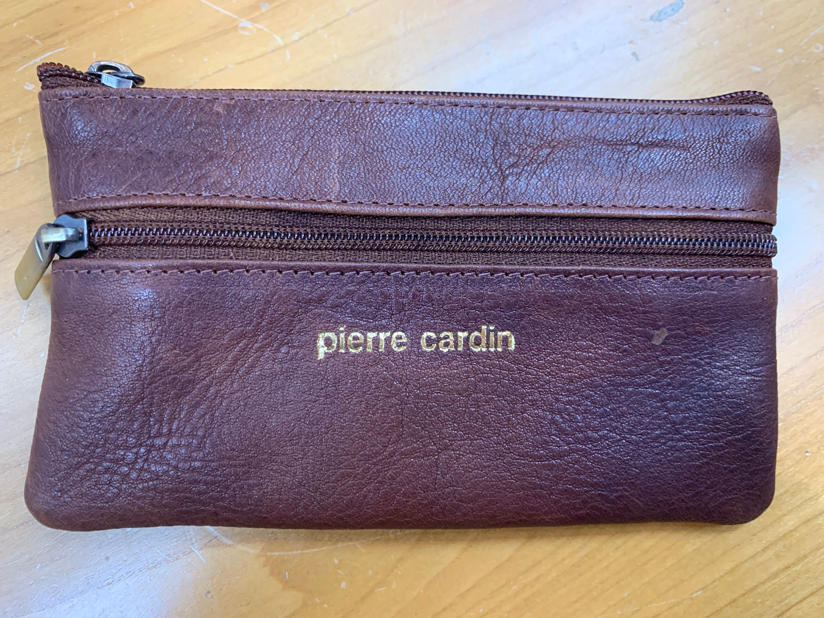 | M1349  PC 1349 | 200 –RED #110  300 – BLACK #110  200- OLIVE #92 WAXED | 700 | $4.35  $4.35  $5.40
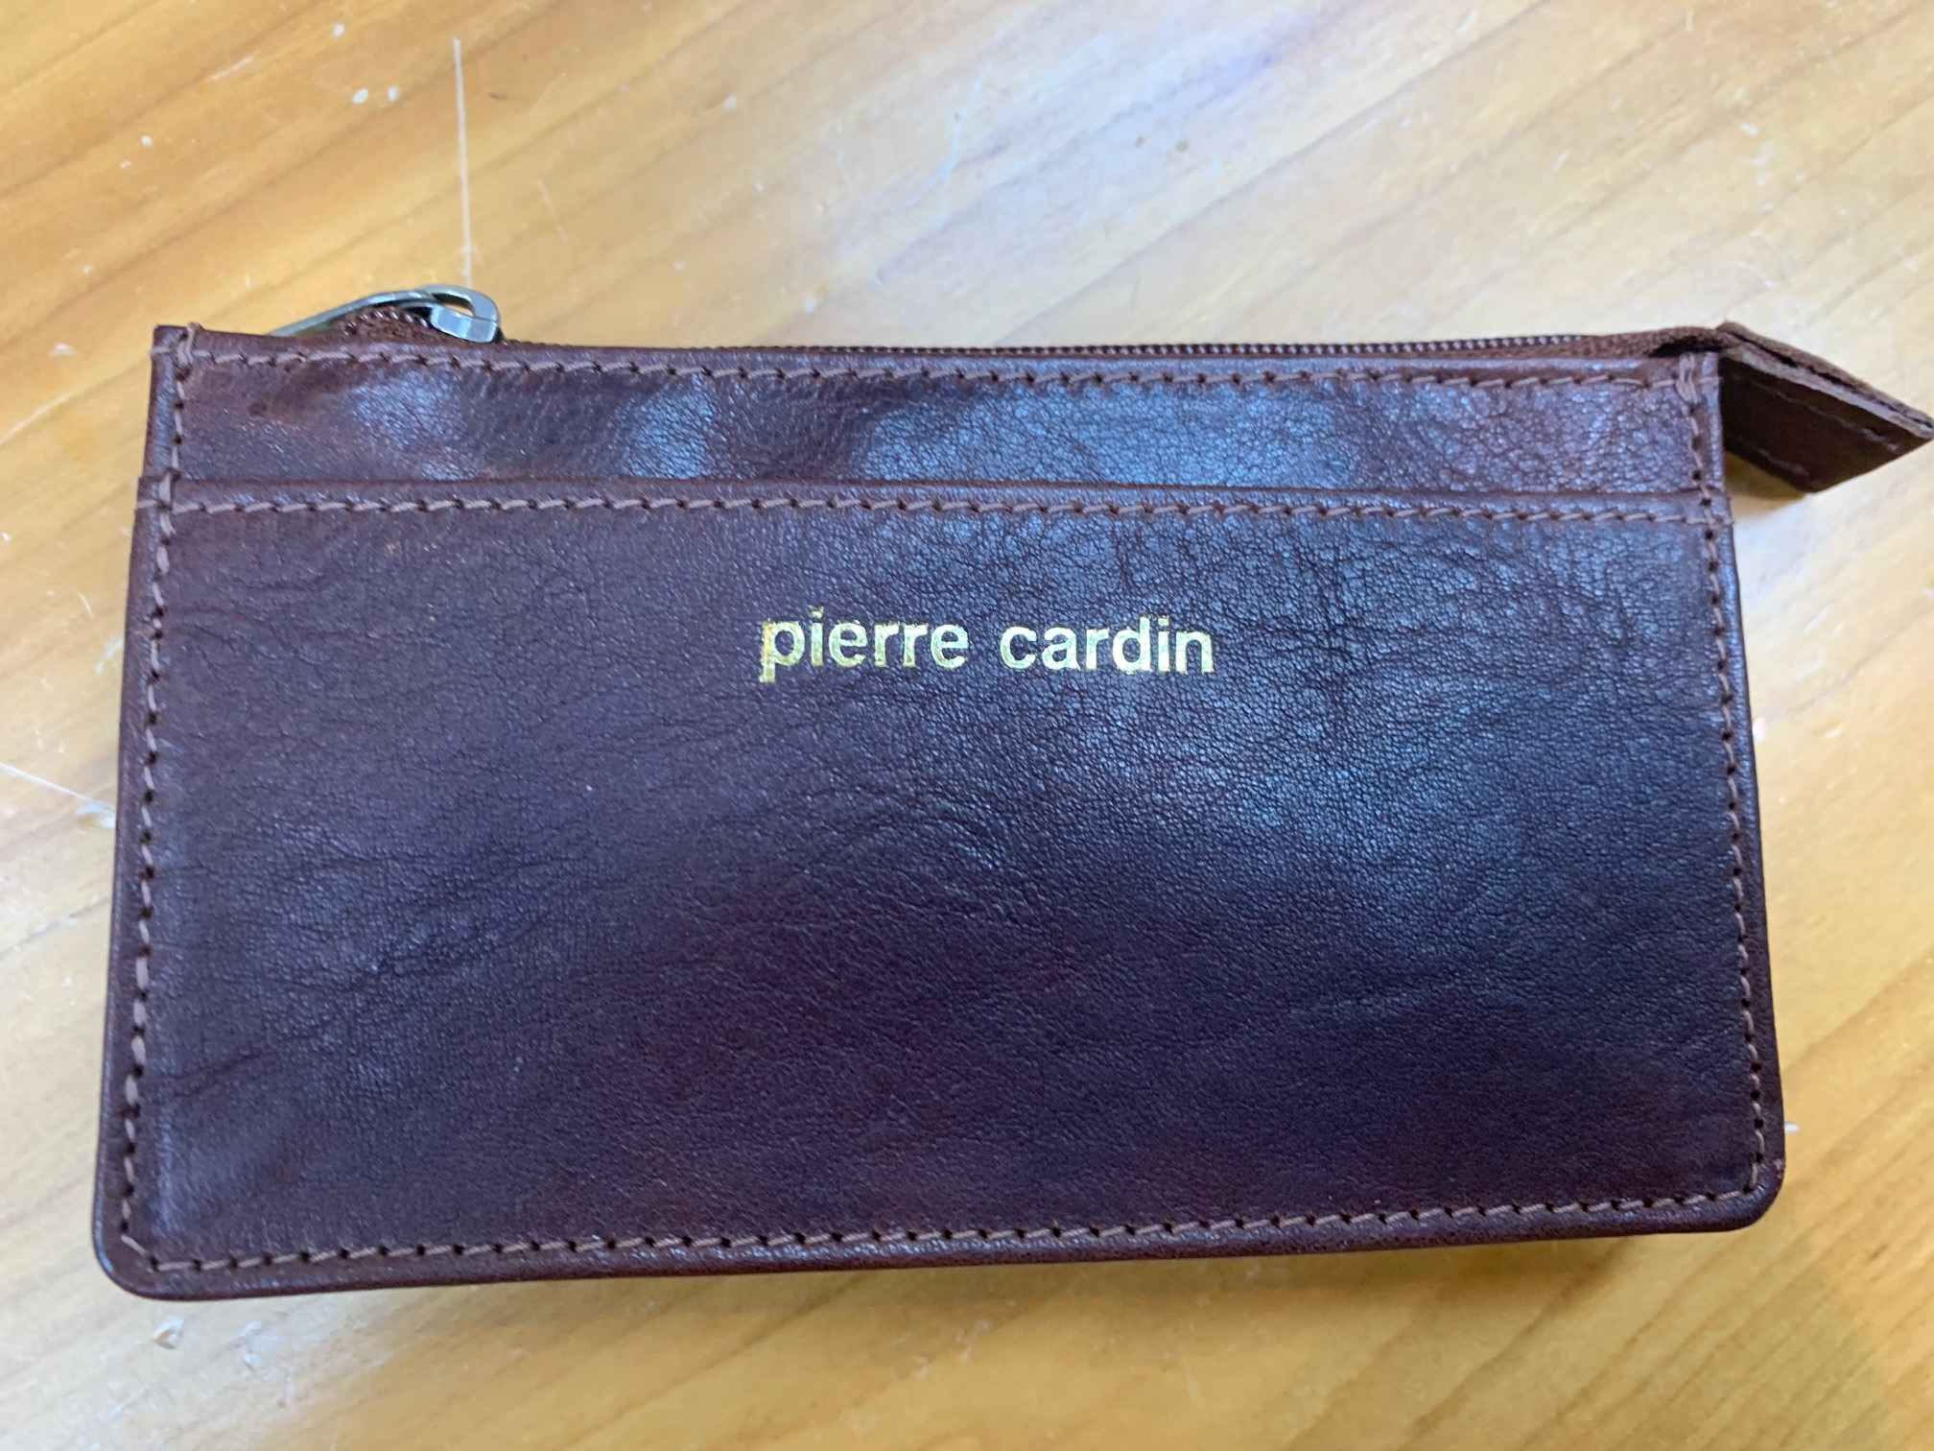 | M2277  PC 2277 | 300- BLACK #110  200- RED #110  200 – NAVY #110  300 – COGNAC#83  200- BLUSH [TEAL #92 ] | 1200 | $4.80  $4.80  $4.80  $5.20  $5.20
Total 4000 pcs
Hi Deep

Please find new order for TJX Europe under Milleni brand
M9130 [ PC9130] wallet in gift packaging with Milleni box as per last order
M1488, M1349, M2277- in polybag as last delivery
This order must be finish by 7 August and make delivery to their freight forwarder
Alla will send invoice and you must send to Alla packing list, because she will provide full set of document to freight forwarder, the same as per Handbag order
Please send proforma invoice and confirm delivery date
Thank you

Regards
Naum.

