Model Architecture
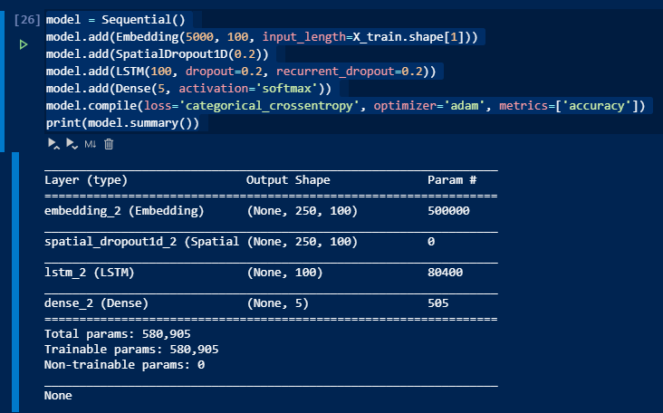
- When train set does not contain test set， test acc is lower.
Code file : lstm(2).ipynb
history=model.fit(X_train,l2_train,epochs=50,batch_size=64,validation_split=0.1,shuffle=True)

output:

Train on 2772 samples, validate on 308 samples
Epoch 1/20
2772/2772 [==============================] - 19s 7ms/step - loss: 0.0749 - acc: 0.9791 - val_loss: 1.7996 - val_acc: 0.6364
Epoch 2/20
2772/2772 [==============================] - 19s 7ms/step - loss: 0.0539 - acc: 0.9841 - val_loss: 1.8619 - val_acc: 0.6461
Epoch 3/20
2772/2772 [==============================] - 19s 7ms/step - loss: 0.0704 - acc: 0.9791 - val_loss: 1.8296 - val_acc: 0.6429
Epoch 4/20
2772/2772 [==============================] - 19s 7ms/step - loss: 0.0693 - acc: 0.9802 - val_loss: 1.7464 - val_acc: 0.6558
Epoch 5/20
2772/2772 [==============================] - 19s 7ms/step - loss: 0.0562 - acc: 0.9856 - val_loss: 1.8579 - val_acc: 0.6461
Epoch 6/20
2772/2772 [==============================] - 19s 7ms/step - loss: 0.1012 - acc: 0.9654 - val_loss: 1.8089 - val_acc: 0.6461
Epoch 7/20
2772/2772 [==============================] - 19s 7ms/step - loss: 0.0559 - acc: 0.9841 - val_loss: 1.8042 - val_acc: 0.6526
Epoch 8/20
2772/2772 [==============================] - 19s 7ms/step - loss: 0.0480 - acc: 0.9867 - val_loss: 1.7695 - val_acc: 0.6623
Epoch 9/20
2772/2772 [==============================] - 19s 7ms/step - loss: 0.0501 - acc: 0.9852 - val_loss: 1.7767 - val_acc: 0.6494
Epoch 10/20
2772/2772 [==============================] - 19s 7ms/step - loss: 0.0476 - acc: 0.9877 - val_loss: 1.8247 - val_acc: 0.6494
Epoch 11/20
2772/2772 [==============================] - 19s 7ms/step - loss: 0.0419 - acc: 0.9870 - val_loss: 1.8952 - val_acc: 0.6688
Epoch 12/20
2772/2772 [==============================] - 19s 7ms/step - loss: 0.0470 - acc: 0.9877 - val_loss: 1.8188 - val_acc: 0.6494
Epoch 13/20
2772/2772 [==============================] - 19s 7ms/step - loss: 0.0451 - acc: 0.9852 - val_loss: 1.8659 - val_acc: 0.6526
Epoch 14/20
2772/2772 [==============================] - 19s 7ms/step - loss: 0.0460 - acc: 0.9859 - val_loss: 1.9198 - val_acc: 0.6526
Epoch 15/20
2772/2772 [==============================] - 19s 7ms/step - loss: 0.0431 - acc: 0.9863 - val_loss: 1.9373 - val_acc: 0.6721
Epoch 16/20
2772/2772 [==============================] - 19s 7ms/step - loss: 0.0340 - acc: 0.9892 - val_loss: 1.9849 - val_acc: 0.6429
Epoch 17/20
2772/2772 [==============================] - 19s 7ms/step - loss: 0.0251 - acc: 0.9942 - val_loss: 1.9744 - val_acc: 0.6526
Epoch 18/20
2772/2772 [==============================] - 19s 7ms/step - loss: 0.0386 - acc: 0.9881 - val_loss: 1.9924 - val_acc: 0.6494
Epoch 19/20
2772/2772 [==============================] - 19s 7ms/step - loss: 0.0602 - acc: 0.9794 - val_loss: 2.0158 - val_acc: 0.6331
Epoch 20/20
2772/2772 [==============================] - 19s 7ms/step - loss: 0.0501 - acc: 0.9820 - val_loss: 2.0474 - val_acc: 0.6364

print("\n 테스트 정확도: %.4f" % (model.evaluate(X_test, l2_test)[1]))

output:
529/529 [==============================] - 2s 5ms/step
테스트 정확도: 0.5047

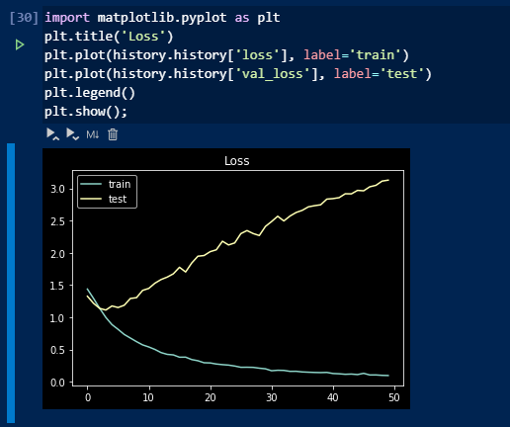

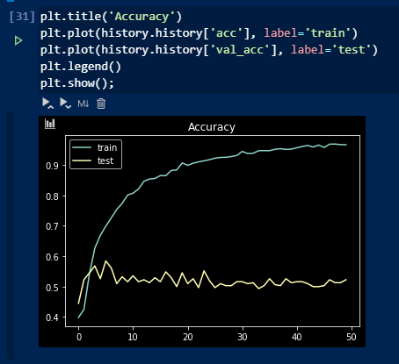

- When train set X_train contains test set， test acc is high.

Code file: lstm_full.ipynb

Updated part compared with A file:
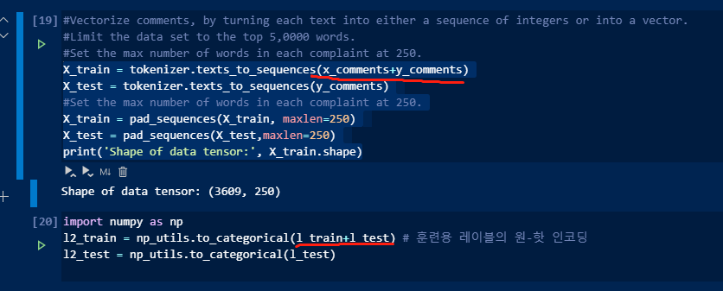

Train on 2772 samples, validate on 308 samples
Epoch 1/20 2772/2772 [==============================] - 19s 7ms/step - loss: 0.0749 - acc: 0.9791 - val_loss: 1.7996 - val_acc: 0.6364 Epoch 2/20 2772/2772 [==============================] - 19s 7ms/step - loss: 0.0539 - acc: 0.9841 - val_loss: 1.8619 - val_acc: 0.6461 Epoch 3/20 2772/2772 [==============================] - 19s 7ms/step - loss: 0.0704 - acc: 0.9791 - val_loss: 1.8296 - val_acc: 0.6429 Epoch 4/20 2772/2772 [==============================] - 19s 7ms/step - loss: 0.0693 - acc: 0.9802 - val_loss: 1.7464 - val_acc: 0.6558 Epoch 5/20 2772/2772 [==============================] - 19s 7ms/step - loss: 0.0562 - acc: 0.9856 - val_loss: 1.8579 - val_acc: 0.6461 Epoch 6/20 2772/2772 [==============================] - 19s 7ms/step - loss: 0.1012 - acc: 0.9654 - val_loss: 1.8089 - val_acc: 0.6461 Epoch 7/20 2772/2772 [==============================] - 19s 7ms/step - loss: 0.0559 - acc: 0.9841 - val_loss: 1.8042 - val_acc: 0.6526 Epoch 8/20 2772/2772 [==============================] - 19s 7ms/step - loss: 0.0480 - acc: 0.9867 - val_loss: 1.7695 - val_acc: 0.6623 Epoch 9/20 2772/2772 [==============================] - 19s 7ms/step - loss: 0.0501 - acc: 0.9852 - val_loss: 1.7767 - val_acc: 0.6494 Epoch 10/20 2772/2772 [==============================] - 19s 7ms/step - loss: 0.0476 - acc: 0.9877 - val_loss: 1.8247 - val_acc: 0.6494 Epoch 11/20 2772/2772 [==============================] - 19s 7ms/step - loss: 0.0419 - acc: 0.9870 - val_loss: 1.8952 - val_acc: 0.6688 Epoch 12/20 2772/2772 [==============================] - 19s 7ms/step - loss: 0.0470 - acc: 0.9877 - val_loss: 1.8188 - val_acc: 0.6494 Epoch 13/20 2772/2772 [==============================] - 19s 7ms/step - loss: 0.0451 - acc: 0.9852 - val_loss: 1.8659 - val_acc: 0.6526 Epoch 14/20 2772/2772 [==============================] - 19s 7ms/step - loss: 0.0460 - acc: 0.9859 - val_loss: 1.9198 - val_acc: 0.6526 Epoch 15/20 2772/2772 [==============================] - 19s 7ms/step - loss: 0.0431 - acc: 0.9863 - val_loss: 1.9373 - val_acc: 0.6721 Epoch 16/20 2772/2772 [==============================] - 19s 7ms/step - loss: 0.0340 - acc: 0.9892 - val_loss: 1.9849 - val_acc: 0.6429 Epoch 17/20 2772/2772 [==============================] - 19s 7ms/step - loss: 0.0251 - acc: 0.9942 - val_loss: 1.9744 - val_acc: 0.6526 Epoch 18/20 2772/2772 [==============================] - 19s 7ms/step - loss: 0.0386 - acc: 0.9881 - val_loss: 1.9924 - val_acc: 0.6494 Epoch 19/20 2772/2772 [==============================] - 19s 7ms/step - loss: 0.0602 - acc: 0.9794 - val_loss: 2.0158 - val_acc: 0.6331 Epoch 20/20 2772/2772 [==============================] - 19s 7ms/step - loss: 0.0501 - acc: 0.9820 - val_loss: 2.0474 - val_acc: 0.6364

Test acc
529/529 [==============================] - 2s 5ms/step

테스트 정확도: 0.920

