Appium Documentation

# Prerequisite

* Install **Java** (JDK)
* Install **Android Studio**
* Install additional Android **SDK tools**
* Install **Appium Desktop Client**
* Install **Eclipse IDE** for Java
* Turn on **USB Debugging** in Android Mobile Phone
* Download **Appium Jar file** for Eclipse
* Create a **new Project** for Appium in Eclipse
* Design test case to test application to **launch the app** on Android Device

### **Install and setup Java**

With Appium, you need to write automation test scripts that can interact with your mobile screen and control fields (such as text boxes, buttons, etc.) in your mobile application, and also can perform actions on them. Java is used to write these automation test scripts. So, download the latest version of JDK and setup the environment variable.

### **Install and setup Android Studio**

This is one of the most time taking step to download and install the Android Studio. It may cause of errors in Appium if not done properly. With downloading the Android Studio, there are many other changes need to be setup. Here, we would recommend you to download the latest version of Android Studio.

[**Download the Android Studio**](http://www.automationtestinghub.com/download-and-install-android/)  
Download the**latest version of Android Studio.** Double click on downloaded **.exe** file to run. To complete the installation process, continue with all default options and finish the installation process. Android studio takes time to install.

**Install additional Android SDK tools**  
After the complete installation of Android Studio, you will see the main panel of Android Studio, as given in the screenshot below. Click on the **Configure** drop-down menu at the bottom right corner and select the **SDK Manager**.

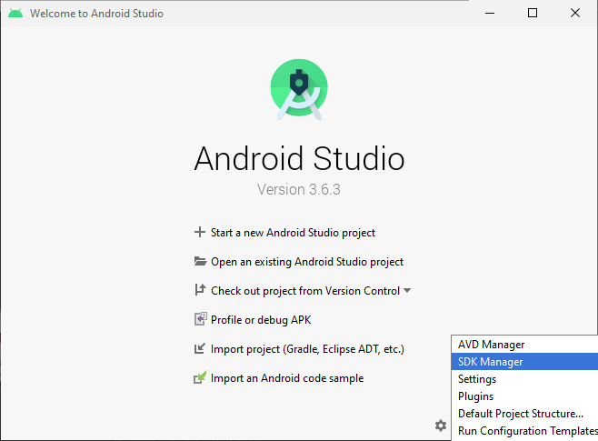

The default screen will open up with Android SDK, where under the SDK Platform, check the latest version of Android is installed. You can also use another android version if you are working with a real android device.

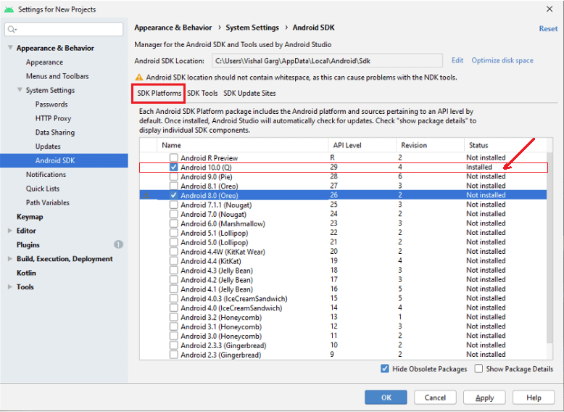

On the same page, switch to **SDK Tools** and check that some of the marked components are installed/updated. If not, mark the checkbox and install them.

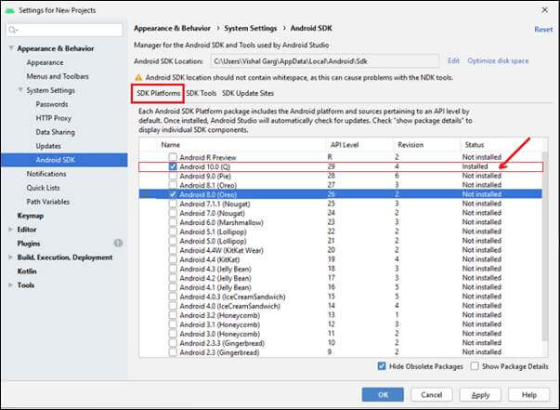

* **Setup Android Environment Variable**

### **Install and setup Appium Desktop Client**

1. Now after installing Java and Android Studio and setting up environment variables for both, download Appium Desktop Client.
2. After downloading the exe file, double click on the downloaded file to run

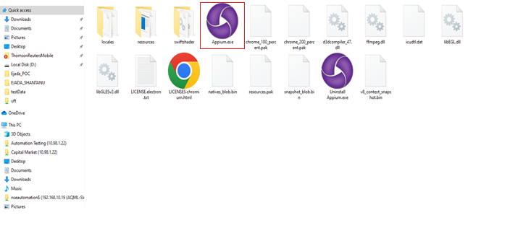

1. Here, you need to choose the installation options. You can select all users, if you have multiple users on your system, otherwise select **only me** for the administrator of the system.

After choosing the installation option, click on the **install** button.

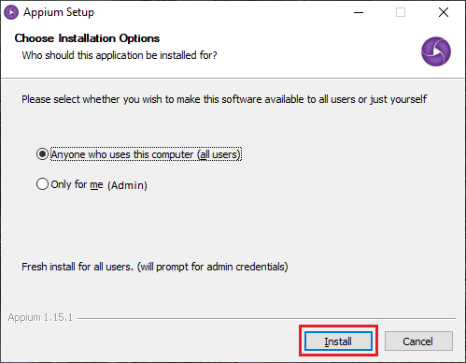

This will start the installation, which may take time to install.

1. Appium has been successfully installed on your system. For completing Appium setup, click on the **Finish** button.
2. Now, Appium Desktop UI will appear on the screen containing the default **Host** and **Port**, which can be changed.

Default Host - 0.0.0.0

Default Port – 4723

# Setting the environment variables

Follow the below steps to add **JAVA_HOME** & **ANDROID_HOME** environment variables.

* Right-click on “My Computer” (or “This PC”) → Properties → Advanced system settings
* Click on “Environment Variables”
* Click on “New” under “User variables for user” or “System variables”
* Input the key as JAVA_HOME and the value as the directory of Java installation.
* Input the key as ANDROID_HOME and the value as the location of the Android SDK installation that we identified above.

## **Appium desktop**

The below images show Edit configurations of the Appium server that we can use in this application:

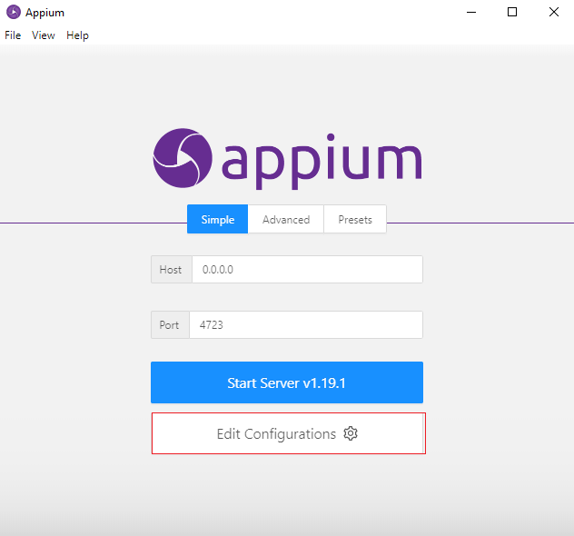

In the environment variables, give the Android sdk path and java sdk path after that save and restart.

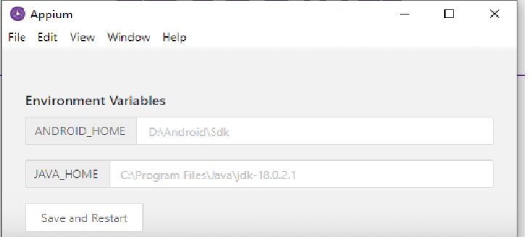

Execution

* 1. Click on the **Start Server** button and start Appium Server.

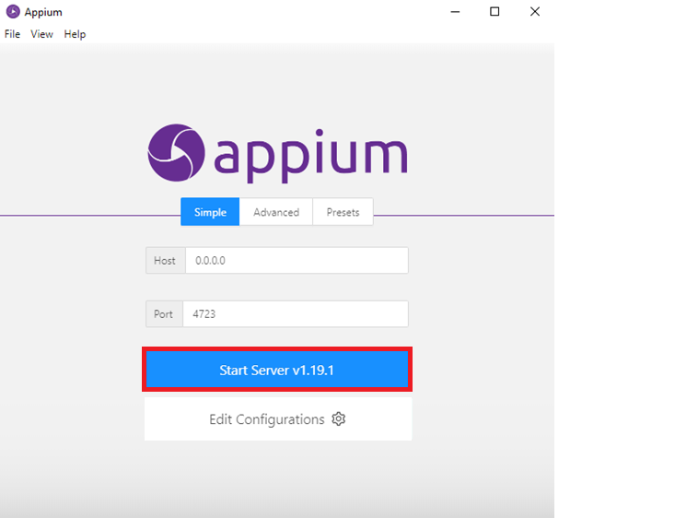

* 1. A new server will launch on the Host and Port specified in previous step. You can see the message on the top of the screen that Server is running.

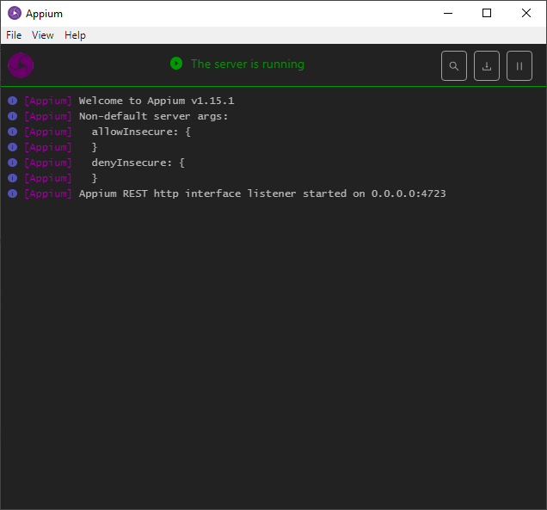

* 1. Click on **start inspector** session

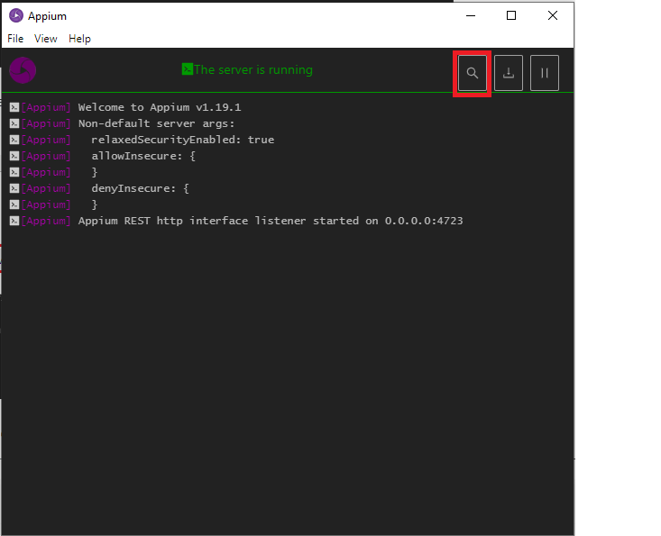

4. Provide all desired capabilities here and Click on the **Start Session** button to start a new session.

