**Project -EJADA_FARHAN**

**About Framework:**

Cucumber based Framework, a testing tool that supports Behaviour Driven Development (BDD). It offers a way to write tests that anybody can understand, regardless of their technical knowledge. It supports,

1. Web Application Testing

2. Mobile Application Testing

3. API Testing

**1.Installation for Web and API testing**

1. JDK 1.8+ (make sure Java class path is set)
2. Maven (make sure .m2 class path is set)
3. Eclipse
4. Eclipse Plugins for
   * Maven
   * Cucumber
5. Browser driver (make sure you have your desired browser driver and class path is set)

**2.Execution**

**2.1 Web Application Execution**

For the Web Application execution do the following setting

2**.1.1. config.properties file settings**

1.Set the URL

2.Set Browser Driver path

3.Set Browser

4.WebDriver=true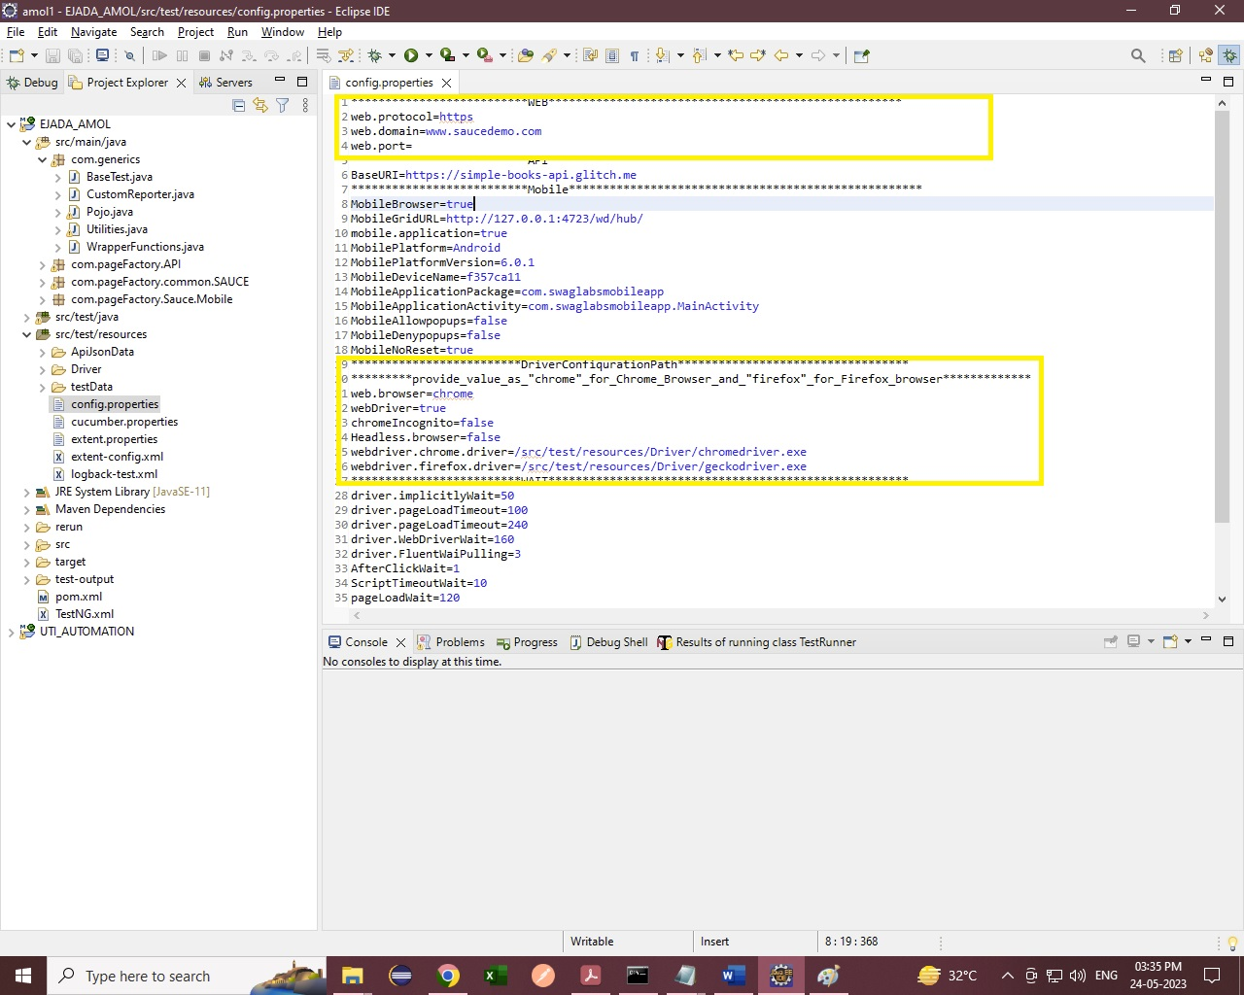

**2.1.2 TestRunner Settings**

1.Set your feature file path

2.Mention Scenario which scenario you want to execute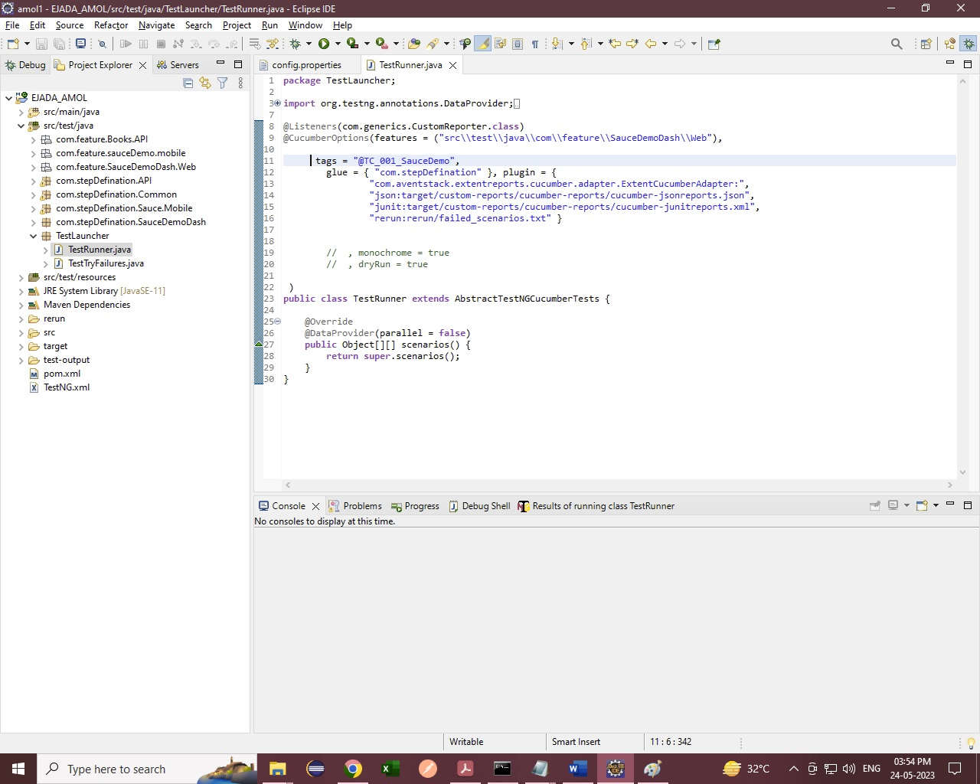

**2.1.3 Run Project**

1.Run your project in following way

Right Click on your project🡪Run As🡪Run Configuration 🡪Do Configuration Settings as per screen shot

Set Goals- clean -Dtest=TestRunner test (It will execute all the listed test cases)

