# Soil logger deployments on Meacham Creek to inform heat exchange portion of hyporheic heat model

# Sunny site surface temperature logger pendant # 10355260, 30cm subsurface logger is in an orange bag, pendant number 10546881, tidbit number 20841221, site is at 45.626277, -118.356008

Shady site, surface temperature logger pendant # 10546877,black bag, pendant number 10546078, tidbit number 20841222, this site is at 45.62563, -118.355665

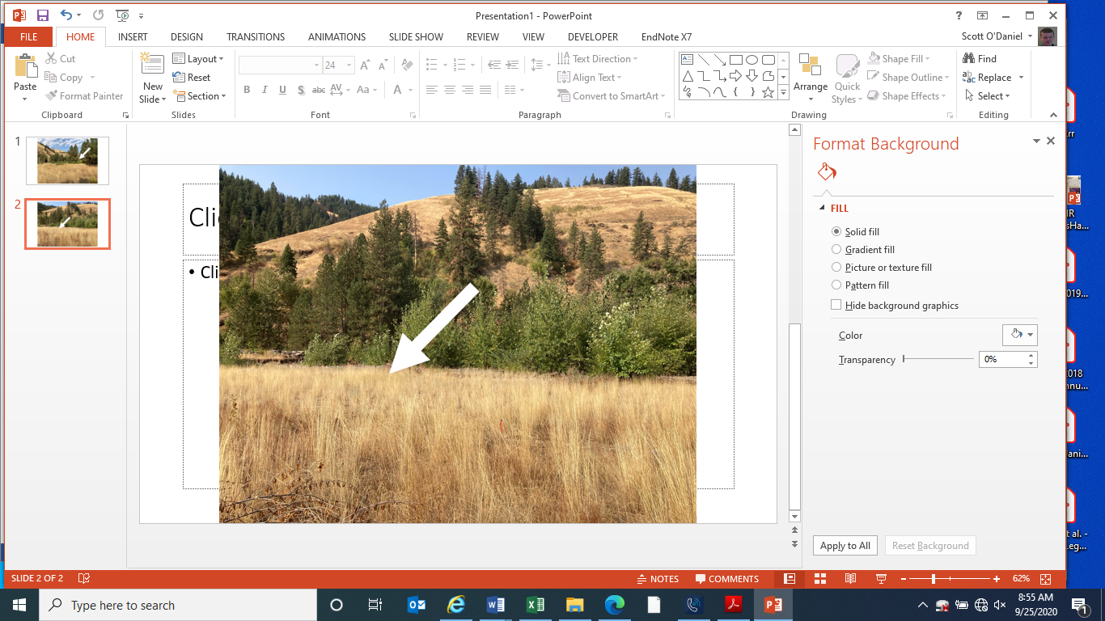

*Figure 1. The image above shows the full sun site on Meacham Creek. Mature grass is about 1m tall and the rebar with the lux and temperature logger is 30 cm above the ground surface.*

# 

*Figure 2. The image above shows the full shade site on Meacham Creek. This lux and temperature logger is 30 cm above the ground surface, zip-tied to the tree trunk.*

# Initial Meacham temperature deployments were made on July 24, 2020

Two temperature and light loggers were installed on the east side of Meacham Creek near the meacham phase 1 “events area” site. The sunlight logger was attached to an existing rebar post with a painted red pink top in full sunlight surrounded by bunch grass (see Figure 1). The shade lighter was placed on the north side of the tree in the patch directly north of the Meacham Creek phase 1 events area. Both loggers were installed at the same height (40cm) and facing the same direction (north).

A pit depth of 30 cm was a challenge to achieve in the floodplain substrate without the Geo-probe. At the full sun sight, we found about 5 centimeters of soil. Below this shallow soil layer, e found gravel and cobbles. We used a pick to remove cobbles at the full sun site. Even at the shade site, which one might think would have more developed soils, we encountered cobbles at a depth of approximately 12 centimeters.

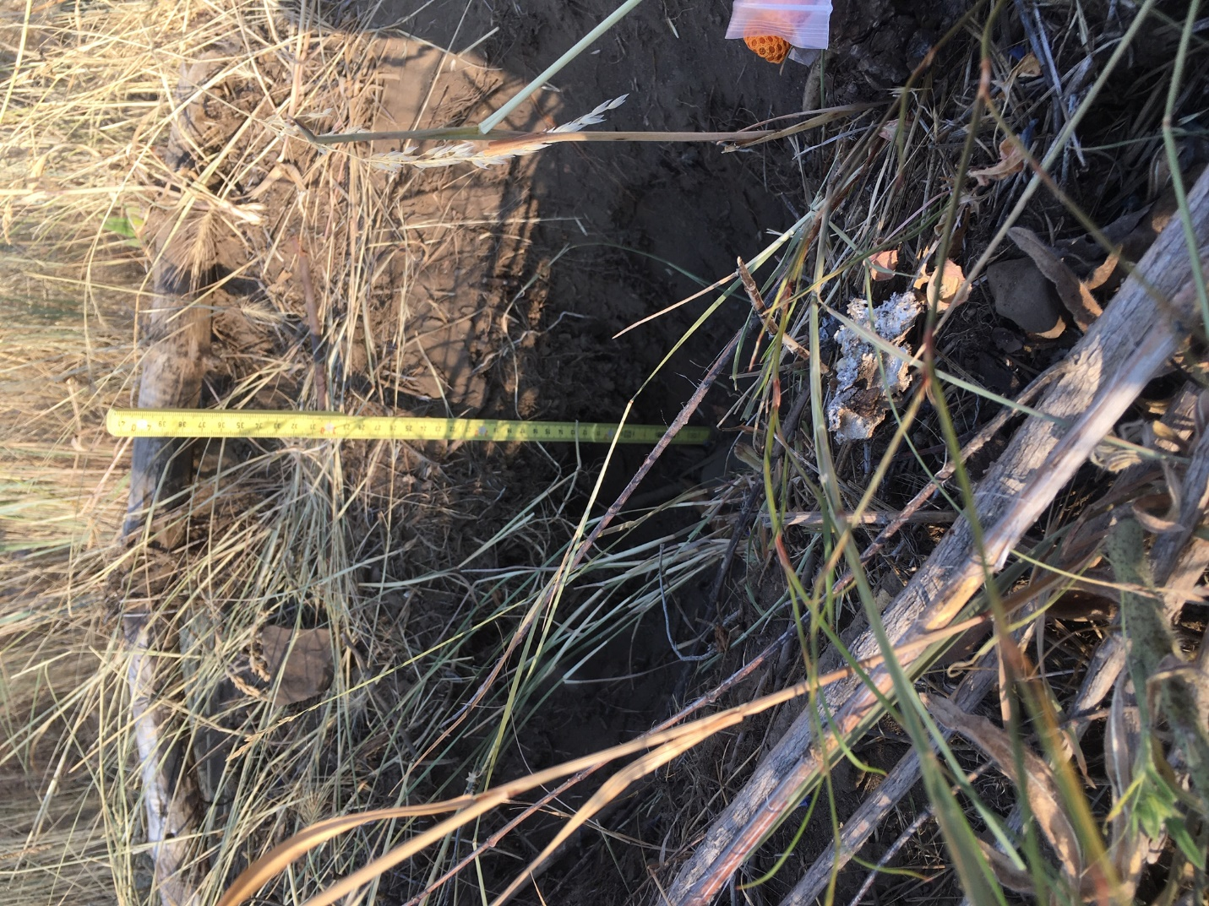

*Figure 3. The full sun site soil pit showing proof of depth (ha!). The bottom of the pit was half soil and half cobble/gravel sized stones.*

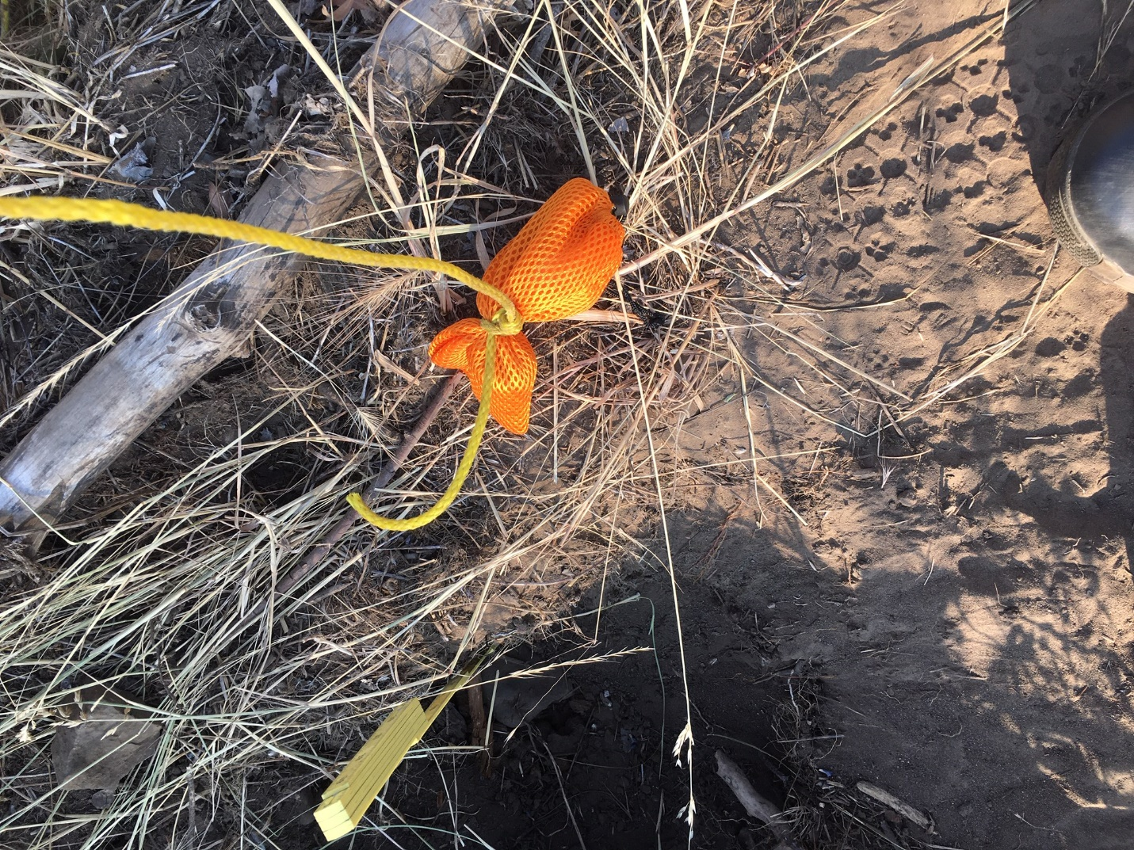

*Figure 4. Sunny site soil pit with the loggers in a nylon mesh bag. The yellow nylon rope is tied to the middle of the bad and threaded up through the replaced soil column to more easily locate the logger (in the orange nylon bag).*