#1. R Program to Compute Sum, Mean, and Product of a Given Vector Elements

# Create a vector

vec <- c(1, 2, 3, 4, 5, 6, 7, 8, 9)

print(vec)

# Compute sum of the vector elements

vec_sum <- sum(vec)

cat("Sum of vector elements:", vec_sum, "\n")

# Compute mean of the vector elements

vec_mean <- mean(vec)

cat("Mean of vector elements:", vec_mean, "\n")

# Compute product of the vector elements

vec_product <- prod(vec)

cat("Product of vector elements:", vec_product, "\n")

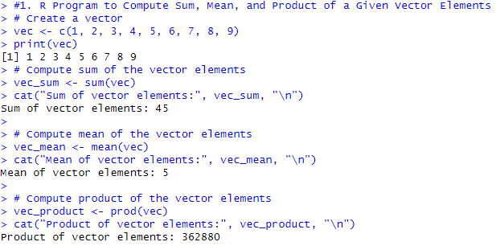

#2. R Program to Call the (Built-in) Dataset airquality

# Load the airquality dataset

data("airquality")

# Display the first few rows of the dataset

head(airquality)

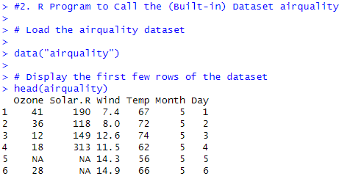

#3. R"iris"#3. R Program to Create a List of Dataframes and Access Each of Those Data Frames from the List

# Create some example dataframes

df1 <- data.frame(A = 1:6, B = c("a", "b", "c","e","d","e"))

df2 <- data.frame(X = 7:9, Y = c("f","g","i"))

# Create a list of dataframes

df_list <- list(df1 = df1, df2 = df2)

# Access each dataframe from the list

cat("Dataframe df1:\n")

print(df_list$df1)

cat("\nDataframe df2:\n")

print(df_list$df2)

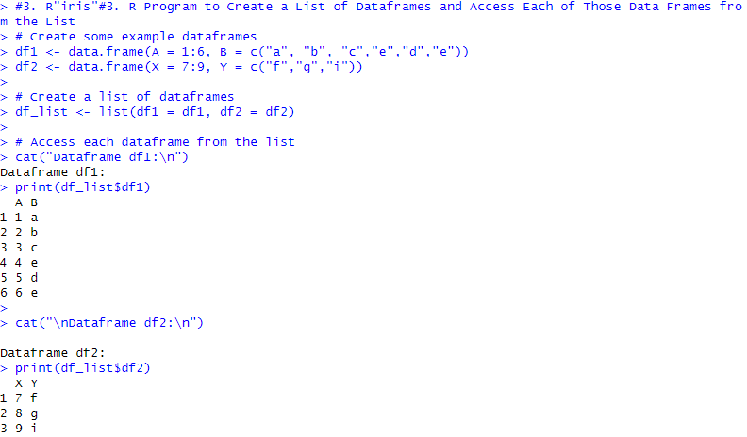

# 4 Install and load the writexl package if not already installed

if (!require("writexl")) install.packages("writexl", dependencies=TRUE)

library(writexl)

# Create a dataframe

df <- data.frame(

Name = c("A", "B", "C", "D"),

Age = c(22, 24, 23, 25),

Score = c(80, 95, 98, 89)

)

# Get the statistical summary of the dataframe

cat("Statistical Summary:\n")

summary(df)

# Get the structure of the dataframe

cat("\nStructure of the dataframe:\n")

str(df)

# Add a new column to the dataframe

df$Grade <- c("C", "A", "A+", "B")

# Sort the dataframe using multiple columns (Age and then Score)

df_sorted <- df[order(df$Age, df$Score),]

cat("\nSorted Dataframe:\n")

print(df_sorted)

# Export the dataframe to an Excel file using writexl package

write_xlsx(df_sorted, "sorted_dataframe.xlsx")

cat("\nDataframe has been exported to 'sorted_dataframe.xlsx'\n")

Output

# 4 Install and load the writexl package if not already installed> if (!require("writexl")) install.packages("writexl", dependencies=TRUE)> library(writexl)> > # Create a dataframe> df <- data.frame(+ Name = c("A", "B", "C", "D"),+ Age = c(22, 24, 23, 25),+ Score = c(80, 95, 98, 89)+ )> > # Get the statistical summary of the dataframe> cat("Statistical Summary:\n")Statistical Summary:> summary(df) Name Age Score

Length:4 Min. :22.00 Min. :80.00

Class :character 1st Qu.:22.75 1st Qu.:86.75

Mode :character Median :23.50 Median :92.00

Mean :23.50 Mean :90.50

3rd Qu.:24.25 3rd Qu.:95.75

Max. :25.00 Max. :98.00 > > # Get the structure of the dataframe> cat("\nStructure of the dataframe:\n")

Structure of the dataframe:> str(df)'data.frame': 4 obs. of 3 variables:

$ Name : chr "A" "B" "C" "D"

$ Age : num 22 24 23 25

$ Score: num 80 95 98 89> > # Add a new column to the dataframe> df$Grade <- c("C", "A", "A+", "B")> > # Sort the dataframe using multiple columns (Age and then Score)> df_sorted <- df[order(df$Age, df$Score),]> > cat("\nSorted Dataframe:\n")

Sorted Dataframe:> print(df_sorted) Name Age Score Grade

1 A 22 80 C

3 C 23 98 A+

2 B 24 95 A

4 D 25 89 B> > # Export the dataframe to an Excel file using writexl package> write_xlsx(df_sorted, "sorted_dataframe.xlsx")> cat("\nDataframe has been exported to 'sorted_dataframe.xlsx'\n")

Dataframe has been exported to 'sorted_dataframe.xlsx'> source("C:/Users/dbda37/Downloads/R_Programming/R_Programming/25020_assignment_1.R")Error in install.packages : Updating loaded packages

[1] 1 2 3 4 5 6 7 8 9

Sum of vector elements: 45

Mean of vector elements: 5

Product of vector elements: 362880

Dataframe df1:

A B

1 1 a

2 2 b

3 3 c

4 4 e

5 5 d

6 6 e

Dataframe df2:

X Y

1 7 f

2 8 g

3 9 i

Statistical Summary:

Structure of the dataframe:

'data.frame': 4 obs. of 3 variables:

$ Name : chr "A" "B" "C" "D"

$ Age : num 22 24 23 25

$ Score: num 80 95 98 89

Sorted Dataframe:

Name Age Score Grade

1 A 22 80 C

3 C 23 98 A+

2 B 24 95 A

4 D 25 89 B

Dataframe has been exported to 'sorted_dataframe.xlsx'