#1. Load and Print XML and JSON Files
# Load necessary libraries
if (!require("xml2")) install.packages("xml2", dependencies=TRUE)
if (!require("jsonlite")) install.packages("jsonlite", dependencies=TRUE)
if (!require("httr")) install.packages("httr", dependencies=TRUE)
if (!require("ggplot2")) install.packages("ggplot2", dependencies=TRUE)

library(xml2)
library(jsonlite)
library(httr)
library(ggplot2)

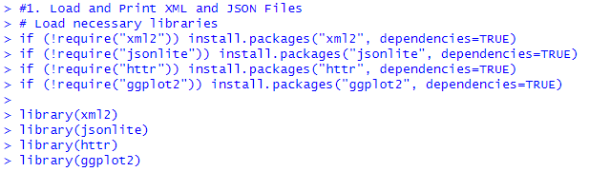

# Load and print XML file
xml_data <- read_xml(xml_file, encoding = "UTF-8")
cat("XML Data:\n")
print(as_list(xml_data))

# Load and print JSON file
json_file <- "data.json"
json_data <- fromJSON(json_file)
cat("\nJSON Data:\n")
print(json_data)

# Get statistical summary of JSON data if it is a data frame
if (is.data.frame(json_data)) {
cat("\nStatistical Summary of JSON Data:\n")
print(summary(json_data))
}

Output:
> # Load and print XML file> xml_data <- read_xml(xml_file, encoding = "UTF-8")> cat("XML Data:\n")XML Data:> print(as_list(xml_data))$library
$library$book
$library$book$title
$library$book$title[[1]]
[1] "The Great Gatsby"

$library$book$author
$library$book$author[[1]]
[1] "F. Scott Fitzgerald"

$library$book$year
$library$book$year[[1]]
[1] "1925"

$library$book
$library$book$title
$library$book$title[[1]]
[1] "To Kill a Mockingbird"

$library$book$author
$library$book$author[[1]]
[1] "Harper Lee"

$library$book$year
$library$book$year[[1]]
[1] "1960"

$library$book
$library$book$title
$library$book$title[[1]]
[1] "1984"

$library$book$author
$library$book$author[[1]]
[1] "George Orwell"

$library$book$year
$library$book$year[[1]]
[1] "1949"

> > # Load and print JSON file> json_file <- "data.json"> json_data <- fromJSON(json_file)> cat("\nJSON Data:\n")
JSON Data:> print(json_data) name age city
1 John 28 New York
2 Alice 30 Los Angeles
3 Bob 25 Chicago> > # Get statistical summary of JSON data if it is a data frame> if (is.data.frame(json_data)) {+ cat("\nStatistical Summary of JSON Data:\n")+ print(summary(json_data))+ }
Statistical Summary of JSON Data:
name age
Length:3 Min. :25.00
Class :character 1st Qu.:26.50
Mode :character Median :28.00
Mean :27.67
3rd Qu.:29.00
Max. :30.00
city
Length:3
Class :character
Mode :character

>
#2 Extract Data from a Website

if (!require("rvest")) install.packages("rvest", dependencies=TRUE)
library(rvest)

# Example: Extract data from Wikipedia page
url <- "https://en.wikipedia.org/wiki/List_of_countries_by_population_(United_Nations)"
webpage <- read_html(url)

# Extract table data
tables <- html_nodes(webpage, "table")
population_table <- html_table(tables[[2]], fill = TRUE)

# Print the first few rows of the table
cat("\nExtracted Data from Website:\n")
print(head(population_table))

Output:
> #2 Extract Data from a Website> > if (!require("rvest")) install.packages("rvest", dependencies=TRUE)> library(rvest)> > # Example: Extract data from Wikipedia page> url <- "https://en.wikipedia.org/wiki/List_of_countries_by_population_(United_Nations)"> webpage <- read_html(url)> > # Extract table data> tables <- html_nodes(webpage, "table")> population_table <- html_table(tables[[2]], fill = TRUE)> > # Print the first few rows of the table> cat("\nExtracted Data from Website:\n")
Extracted Data from Website:> print(head(population_table))# A tibble: 6 × 2
.mw-parser-output .n…¹ .mw-parser-output .n…²
<chr> <chr> 1 Global "Current population\n…2 Continents/subregions "Africa\nAntarctica\n…3 Intercontinental "Americas\nArab world…4 Cities/urban areas "World cities\nNation…5 Past and future "Past and future popu…6 Population density "Current density\nPas…# ℹ abbreviated names:# ¹​`.mw-parser-output .navbar{display:inline;font-size:88%;font-weight:normal}.mw-parser-output .navbar-collapse{float:left;text-align:left}.mw-parser-output .navbar-boxtext{word-spacing:0}.mw-parser-output .navbar ul{display:inline-block;white-space:nowrap;line-height:inherit}.mw-parser-output .navbar-brackets::before{margin-right:-0.125em;content:"[ "}.mw-parser-output .navbar-brackets::after{margin-left:-0.125em;content:" ]"}.mw-parser-output .navbar li{word-spacing:-0.125em}.mw-parser-output .navbar a>span,.mw-parser-output .navbar a>abbr{text-decoration:inherit}.mw-parser-output .navbar-mini abbr{font-variant:small-caps;border-bottom:none;text-decoration:none;cursor:inherit}.mw-parser-output .navbar-ct-full{font-size:114%;margin:0 7em}.mw-parser-output .navbar-ct-mini{font-size:114%;margin:0 4em}html.skin-theme-clientpref-night .mw-parser-output .navbar li a abbr{color:var(--color-base)!important}@media(prefers-color-scheme:dark){html.skin-theme-clientpref-os .mw-parser-output .navbar li a abbr{color:var(--color-base)!important}}@media print{.mw-parser-output .navbar{display:none!important}}vteLists of countries by population statistics`,# ²​`.mw-parser-output .navbar{display:inline;font-size:88%;font-weight:normal}.mw-parser-output .navbar-collapse{float:left;text-align:left}.mw-parser-output .navbar-boxtext{word-spacing:0}.mw-parser-output .navbar ul{display:inline-block;white-space:nowrap;line-height:inherit}.mw-parser-output .navbar-brackets::before{margin-right:-0.125em;content:"[ "}.mw-parser-output .navbar-brackets::after{margin-left:-0.125em;content:" ]"}.mw-parser-output .navbar li{word-spacing:-0.125em}.mw-parser-output .navbar a>span,.mw-parser-output .navbar a>abbr{text-decoration:inherit}.mw-parser-output .navbar-mini abbr{font-variant:small-caps;border-bottom:none;text-decoration:none;cursor:inherit}.mw-parser-output .navbar-ct-full{font-size:114%;margin:0 7em}.mw-parser-output .navbar-ct-mini{font-size:114%;margin:0 4em}html.skin-theme-clientpref-night .mw-parser-output .navbar li a abbr{color:var(--color-base)!important}@media(prefers-color-scheme:dark){html.skin-theme-clientpref-os .mw-parser-output .navbar li a abbr{color:var(--color-base)!important}}@media print{.mw-parser-output .navbar{display:none!important}}vteLists of countries by population statistics`>

#3
# Load the diamonds dataset
data("diamonds")

# Pie chart of cut proportions
cut_counts <- table(diamonds$cut)
pie(cut_counts, main="Pie Chart of Diamond Cuts", col=rainbow(length(cut_counts)))

# Bar graph of cut counts
barplot(cut_counts, main="Bar Graph of Diamond Cuts", col=rainbow(length(cut_counts)))
Output:

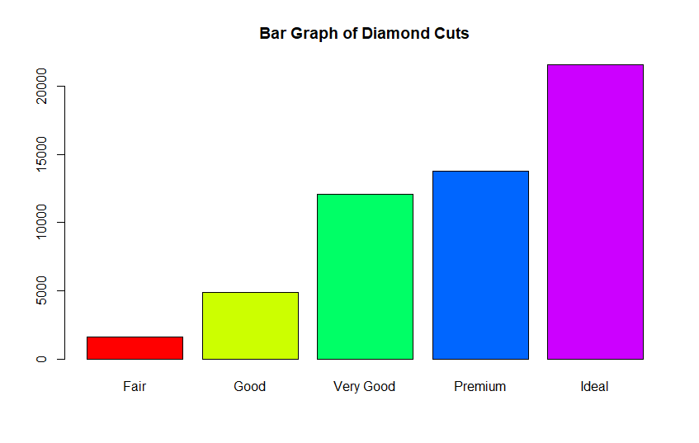
#4

# Load the ChickWeight dataset
data("ChickWeight")

# Construct a plot of weight against time for chick number 34
chick_34 <- subset(ChickWeight, Chick == 34)
plot(chick_34$Time, chick_34$weight, type="b", col="blue", main="Weight vs Time for Chick 34", xlab="Time", ylab="Weight")

# Box plots for each time point for chicks in diet group 4
diet_4 <- subset(ChickWeight, Diet == 4)
boxplot(weight ~ Time, data = diet_4, main="Box Plots for Diet Group 4", xlab="Time", ylab="Weight")

# Compute mean weight for chicks in group 4 for each time point and plot
mean_weight_group_4 <- aggregate(weight ~ Time, data = diet_4, FUN = mean)
plot(mean_weight_group_4$Time, mean_weight_group_4$weight, type="b", col="red", ylim=c(min(mean_weight_group_4$weight), max(mean_weight_group_4$weight)), main="Mean Weight vs Time", xlab="Time", ylab="Mean Weight")

# Compute mean weight for chicks in group 2 for each time point and add to the plot
diet_2 <- subset(ChickWeight, Diet == 2)
mean_weight_group_2 <- aggregate(weight ~ Time, data = diet_2, FUN = mean)
lines(mean_weight_group_2$Time, mean_weight_group_2$weight, type="b", col="blue")

# Add legend and title
legend("topright", legend=c("Diet Group 4", "Diet Group 2"), col=c("red", "blue"), lty=1, cex=0.8)
title("Mean Weight vs Time for Diet Groups 4 and 2")

# Copy and paste the graph into Word (manually)
# You can use RStudio's "Export" button to save the plot and then insert it into Word.
Output:
