Comparison of the algorithms associated with the Force Augmenting Devices

Antonio Concha1, Efrain Ramírez Velazco2, Francisco Emmanuel González Sánchez3, Martín Sánchez3, Suresh Kumar Gadi3,*

1 Facultad de Ingeniería Mecánica y Eléctrica, Universidad de Colima, Coquimatlán, Colima, México

2Departamento de Eléctrica-Electrónica, Instituto Tecnológico de Aguascalientes, Aguascalientes, Mexico.

3Facultad de Ingeniería Mecánica y Eléctrica, Universidad Autónoma de Coahuila, Torreón, Mexico.

Corresponding author

S. K. Gadi, Facultad de Ingeniería Mecánica y Eléctrica, Universidad Autónoma de Coahuila, Torreón, Mexico, 27276; Tel & Fax: +52 1 871 7570239; Email: research@SKGadi.com

Abstract:

This article presents a pictorial representation of a generalized model of a human interacting an exoskeleton or a force augmenting device. This model is used to study four different control schemes. This short review identifies the hardware and software requirements for the presented control algorithms.  
  
Keywords:

Force Augmenting Device; Exoskeletons; Human-Robot Interaction; Control;

**1. Introduction**

There is a growing interest in the area of human-robot interaction. These interactions are of two types: 1) The mechanical forces are not exchanged between the human and the robot arms. Example: Teleoperation 2) The robot arm and the human arm produces reaction forces on each other. This article focuses on the interaction where human and robot are in contact all the times. The human-exoskeleton interaction constitutes these interactions, where anthropomorphic robot arm moves along with the human arm. These force augmenting devices can be used in various applications ranging from active prosthetics, material handling, military, space research, etc. [1]–[5].

Since these force augmenting devices (FAD) are always in contact with the human, stability is of extreme importance. This article presents four control schemes whose stability is rigorously studied. In this document, the words exoskeletons and robot replaces the word force augmenting device.

The next section presents a generalized human-FAD interaction model. Four control schemes proposed in [6]–[9] are applied to this interaction model, and their differences are studied in Section 5.

**2. A general representation of a Human-Robot interaction**

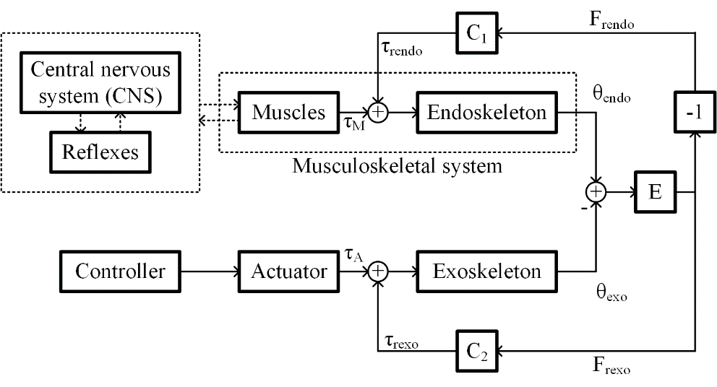

Figure 1: Block diagram showing a general scheme of Human-Robot interaction

Figure 1 shows a block diagram depicting human-robot interaction. In this interaction two controllers work in parallel:

* Human operator: Human operator generates the desired trajectory and exerts torques to follow the desired trajectories closely.
* Electronics: Electronics in the exoskeleton measures the human intention with sensors and provides low mechanical impedance in the human’s desired trajectory with the help of actuators [10].

The blocks Central nervous system (CNS), Reflexes, Muscles and Endoskeleton represent the dynamics associated with the human arm movement. The CNS performs the Coordinate transformation, the Trajectory planning and the Motor command generation [11]–[13]. Hence the CNS generates desired trajectory and passes the information to the spinal cord. A closed loop feedback control loop is executed by the reflexes in the spinal cord to move the arms such that their trajectory mimics the desired human arm trajectory as closely as possible [14], [15].

The difference in human arm position, , and exoskeleton arm position, , causes a force, which can be written as , where  and are the reaction force generated on the exoskeleton and the human arm respectively,  is a nonlinear function which maps difference in  and  to  and . The reaction torque experienced by the human arm  and exoskeleton arm  can be given as  and , where  and  are positive constants.

In the next section, different control schemes are studied by applying to this model.

**3. Comparison of control schemes**

Table 1 presents a comparison between the four control schemes [6]–[9] under study. The following subsections present individual algorithms.

Table 1: Comparison of the four control algorithms under study

|  |  |  |  |  |
| --- | --- | --- | --- | --- |
|  | Kazerooni's algorithm | BLEEX’s algorithm | Algorithm inspired by fictitious gain | Force control with velocity and position feedback |
| Sensors used | Force sensor | None | Electromyography (EMG) sensor | Force sensor |
| Disadvantages with sensors | Since the exoskeleton may make contact at various points, placing a force sensor is tricky. | None | 1. Placing EMG sensor is difficult.  2. Processing EMG signal is difficult compared to processing a force sensor signal.  3. Calibrating EMG sensor is time-consuming | Since the exoskeleton may make contact at various points, placing a force sensor is tricky. |
| Control algorithm complexity | Easy to implement | Difficult: 1. The model should be accurate.  2. Parameters should be estimated accurately.  3. Controller should implement the inverse dynamics | Difficult to implement: 1. Parameters should be estimated accurately. 2. Controller should implement the inverse dynamics | Easy to implement |
| Limitations of the control scheme | User do not experience part of the load he is handling when the exoskeleton arm is stationary | 1. Stability is not guaranteed.  2. The algorithm may not differentiate the perturbations caused by human and external sources. | There is a limitation on the mass of the exoskeleton structure. | None |

**3.1 Kazerooni's algorithm**

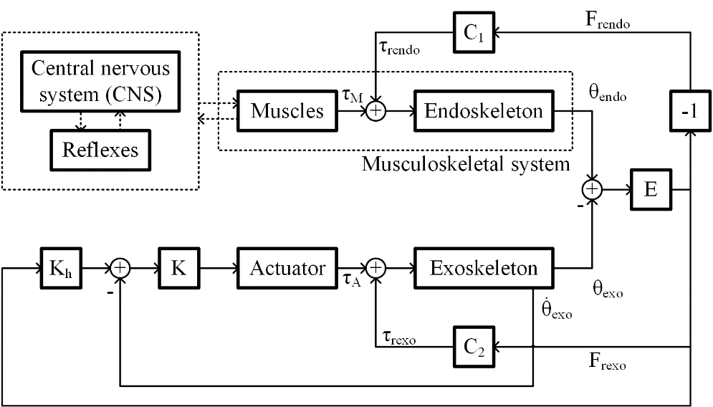

Figure 2: Block diagram showing Kazerooni’s algorithm applied to Human-FAD interaction.

Figure 2 depicts the control scheme presented by Kazerooni in [6]. The author uses linear dynamic models to represent the dynamics of CNS, endoskeleton, and . Author propose and  are linear dynamic systems. This controller controls the velocity of the exoskeleton arm. The difference in the human arm position and the exoskeleton arm position causes a velocity in the exoskeleton arm towards to cancel this difference in position.  is measured using force sensor. We can notice that the exoskeleton arm position stays stationary in case the user is having no interaction with the force sensor.

**3.2 BLEEX (Berkeley Robotics & Human Engineering Laboratory) Algorithm**

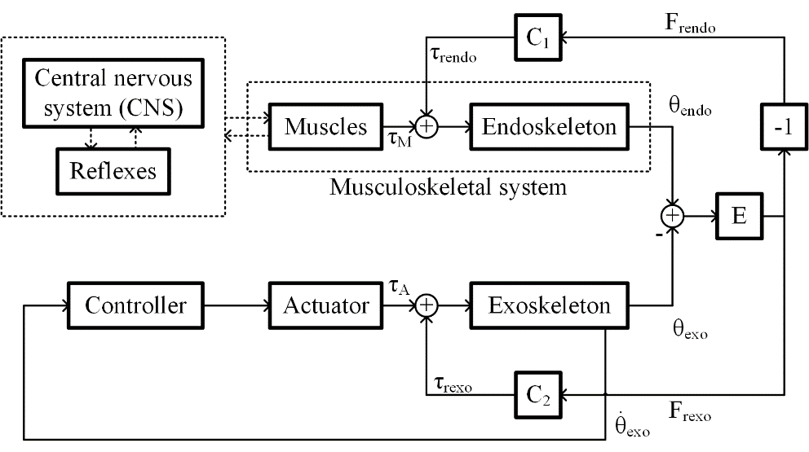

Figure 3: Block diagram showing BLEEX algorithm applied to Human-FAD interaction.

Figure 3 shows BLEEX control scheme proposed in [7], [16]. This control scheme does not use any force sensor. In this control, a positive feedback loop is used to increase the sensitivity to the external disturbances. The controller, , is given by , where  is the exoskeleton dynamics and  is the augmentation factor. The  introduces the external disturbances into the positive feedback system. Due to high sensitivity towards external disturbances, the exoskeleton arm follows the human arm. The controller used in this control scheme needs to implement accurately inverse dynamics of exoskeleton arm and actuator, which needs an accurate model of actuator and exoskeleton arm.

**3.3 Algorithm inspired by fictitious gain**

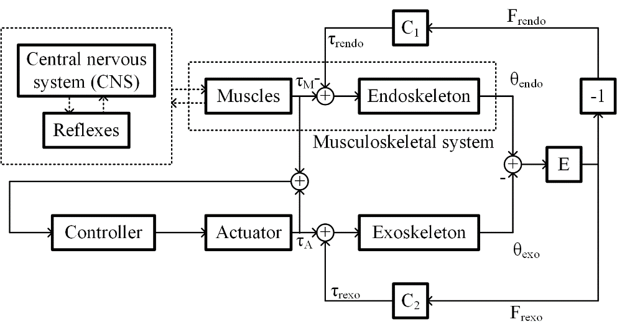

Figure 4: Block diagram showing the algorithm inspired by fictitious gain applied to Human-FAD interaction.

Figure 4 shows a control scheme inspired by fictitious gain presented in [8]. This control scheme needs a positive feedback of the sum of the torques exerted by the muscles and the actuator. Similar to the algorithm mentioned in the previous subsection, the actuator dynamics are canceled by introducing inverse dynamics into the controller. The torque exerted by the muscles can be estimated by an EMG sensor, a muscle hardness sensor, or a muscle fiber expansion sensor. Since this control scheme uses a positive feedback, the closed-loop sensitivity for the torque exerted by the muscles is high. The author of this algorithm also proposes a method to adapt this algorithm to users suffering from tremors.

**3.4 Force control with velocity and position feedback**

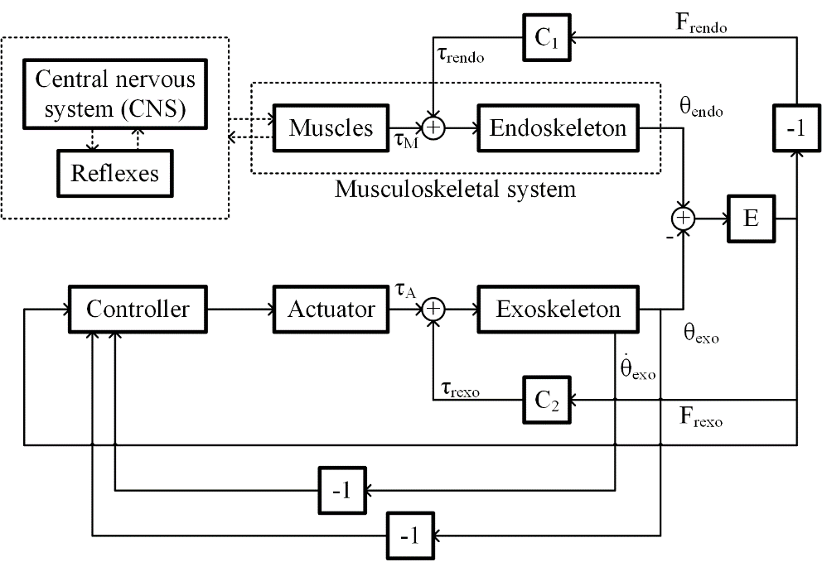

Figure 4: Block diagram showing the force control algorithm with position and velocity feedback applied to Human-FAD interaction.

In this control scheme, authors use a linear model for CNS, spinal cord, muscles and endoskeleton human arm; and  is approximated as a constant. The actuator dynamics are ignored because the by introducing inverse dynamics of the actuator into the controller. The controller provides an amplifying effect of . We can notice that the actuator does not provide any torque while the human arm is released, which will bring the exoskeleton to the equilibrium point. Additionally, the controller provides a velocity and position feedback for obtaining desired performance under no human contact. This control scheme is similar to Kazerooni’s control scheme with a position feedback. The author of [9] present a methodology to calculate the upper-limit of the augmentation factor. It is observed that the human-FAD interaction would be stable for any value of augmentation factor if the delays internal to human reflex action is zero.

**4. Conclusions**

Four control schemes of FAD are studied in this short review. A generalized model of human-robot interaction is presented. Also, the differences in these control algorithms are presented.

It is observed that using the force or the EMG sensor is a good option to get stable interaction. The EMG sensors can be replaced by a muscle hardness sensor or a muscle fiber expansion sensor. Stable operation can be guaranteed to a person suffering from tremor by applying filters in the controller.

References

[1] B. Dellon and Y. Matsuoka, “Prosthetics, exoskeletons, and rehabilitation [Grand Challenges of Robotics],” *IEEE Robot. Autom. Mag.*, vol. 14, no. 1, pp. 30–34, Mar. 2007.

[2] J. B. Makinson, D. P. Bodine, B. R. Fick, and G. E. C. O. S. N. Y. S. M. H. P. OPERATION., *Machine augmentation of human strength and endurance hardiman I prototype project*. Defense Technical Information Center, 1969.

[3] J. Jansen, B. Richardson, F. Pin, R. Lind, and J. Birdwell, “Exoskeleton for soldier enhancement systems feasibility study,” Oak Ridge, Tennessee 37831, 2000.

[4] A. Schiele and G. Visentin, “Exoskeleton for the human arm, in particular for space applications,” *United States Pat. 7410338B*, 2008.

[5] E. Guizzo and H. Goldstein, “The rise of the body bots [robotic exoskeletons],” *IEEE Spectr.*, vol. 42, no. 10, pp. 50–56, 2005.

[6] H. Kazerooni, “Human Machine Interaction via the Transfer of Power and Information Signals,” *ASME Winter Annu. Meet.*, Dec. 1988.

[7] H. Kazerooni, J. L. Racine, L. Huang, and R. Steger, “On the control of the berkeley lower extremity exoskeleton (BLEEX),” in *Proceedings of the 2005 IEEE International Conference on Robotics and Automation, 2005. ICRA 2005.*, 2005, pp. 4353–4360.

[8] K. Kong and M. Tomizuka, “Control of exoskeletons inspired by fictitious gain in human model,” *IEEE/ASME Trans. Mechatronics*, vol. 14, no. 6, pp. 689–698, 2009.

[9] S. K. Gadi, A. Osorio-Cordero, R. Lozano-Leal, and R. A. Garrido, “Stability Analysis of a Human Arm Interacting with a Force Augmenting Device,” *J. Intell. Robot. Syst. Theory Appl.*, vol. 86, no. 2, pp. 215–224, 2017.

[10] S. Lee and Y. Sankai, “Power assist control for leg with hal-3 based on virtual torque and impedance adjustment,” in *Systems, Man and Cybernetics, 2002 IEEE International Conference on*, 2002, vol. 4.

[11] N. Schweighofer, M. A. Arbib, and M. Kawato, “Role of the cerebellum in reaching movements in humans. I. Distributed inverse dynamics control,” *Eur. J. Neurosci.*, vol. 10, no. 1, pp. 86–94, 1998.

[12] A. G. Shaikh, H. Meng, and D. E. Angelaki, “Multiple reference frames for motion in the primate cerebellum,” *J. Neurosci.*, vol. 24, no. 19, pp. 4491–4497, 2004.

[13] A. J. Bastian, T. A. Martin, J. G. Keating, and W. T. Thach, “Cerebellar ataxia: abnormal control of interaction torques across multiple joints,” *J. Neurophysiol.*, vol. 76, no. 1, pp. 492–509, 1996.

[14] J. McIntyre and E. Bizzi, “Servo hypotheses for the biological control of movement,” *J. Mot. Behav.*, vol. 25, no. 3, pp. 193–202, 1993.

[15] J. Randall F and D. Ostry, “Trajectories of human multi-joint arm movements: evidence of joint level planning,” in *Experimental Robotics I*, 1990, pp. 594–613.

[16] H. Kazerooni and R. Steger, “The Berkeley lower extremity exoskeleton,” *J. Dyn. Syst. Meas. Control*, vol. 128, no. 1, pp. 14–25, 2006.