Comparison of control algorithms for Force Augmenting Devices

Antonio Conchaª, Francisco Emmanuel González Sánchez^{b}, Efrain Ramírez Velazco^{c}, Martín Sánchez^{b}, Suresh Kumar Gadi^{b,*}
ªFacultad de Ingeniería Mecánica y Eléctrica, Universidad de Colima, Colima
^{b}Facultad de Ingeniería Mecánica y Eléctrica, Universidad Autónoma de Coahuila, Torreón
^{c}Departamento de Eléctrica-Electrónica, Instituto Tecnológico de Aguascalientes

Abstract

The control algorithm presentation style of exoskeletons varies with the authors. This give difficulty in understanding the difference between various algorithms. This article presents a pictorial representation of a generalized model for a human interacting with an exoskeleton or a force-augmenting device. This way of representing model pictorially is useful in comparing various control algorithms. Also this allows the reader to identify the sensor and actuator requirements for a selected control algorithm. This model is used for comparing four different control schemes, which are: 1) Kazerooni's algorithm, 2) BLEEX’s algorithm, 3) technique inspired by fictitious gain, and 4) Force control with velocity and position feedback. The hardware and software requirements for the presented control algorithms are also discussed.

Keywords: Force Augmenting Device, Exoskeletons, Human-Robot Interaction, Closed-loop control.

1. Introduction
There is a growing interest in the area of human-robot interactions, which are of two types: 1) Teleoperation where mechanical forces are not exchanged between humans and robot arms; and 2) Human-exoskeleton interaction where the robot and the human arms produce reaction forces on each other. This article is focused on the second kind of interaction, where the human and exoskeleton are in contact all the time. The exoskeletons, also called in this document as force augmenting devices (FAD), can be used in various applications ranging from active prosthetics, material handling, military, space research, etc. [1]–[5]. Since the FAD are always in contact with the human, the analysis of the control algorithms of these are of extreme importance.
In the process of building an exoskeleton one may have to compare various existing algorithms. The implementation of algorithms also requires to identify the compatible actuators and sensors. This article presents a pictorial way of representing any FAD. This method of representation allows the author to identify the required sensors and the actuators properties. This model is used to represent four control schemes whose hardware and software requirements are also identified. These four control methodologies are the following: 1) Kazerooni's algorithm [6], 2) BLEEX’s algorithm [7], 3) technique inspired by fictitious gain [8], and 4) Force control with velocity and position feedback [9]. The stability of the control algorithms are not presented in this document. The next section presents a generalized human-FAD interaction model, and the four control schemes applied to it are studied and compared in Section 5.

2. General representation of a Human-Robot interaction
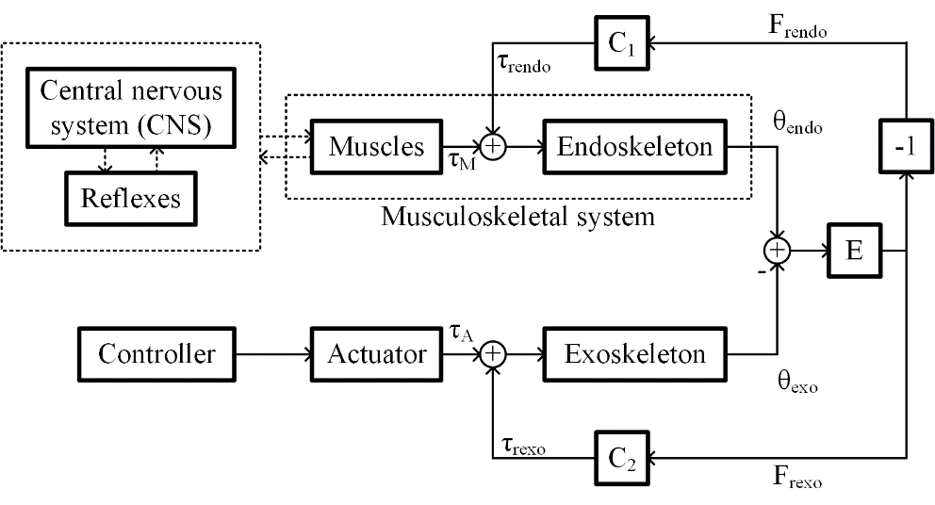
Figure 1: Block diagram showing a general scheme of Human-Robot interaction
Figure 1 shows a block diagram depicting the human-robot interaction, where two controllers work in parallel. The human operator generates the desired trajectory and exerts torques to follow the desired trajectories closely. The electronics in the exoskeleton measures the human interaction with sensors and provides low mechanical impedance in the human’s desired trajectory with the help of actuators [6].
The blocks: Central nervous system (CNS), Reflexes, Muscles and Endoskeleton represent the dynamics associated with the human arm movement. The CNS performs the Coordinate transformation, the Trajectory planning, and the Motor command generation [7]–[9]. Hence the CNS generates desired trajectory and passes the information to the spinal cord. A closed-loop feedback control is executed by the reflexes in the spinal cord in order to move the arms, whose trajectory mimics the desired human arm trajectory as closely as possible [10], [11].
The difference between the human arm position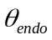and exoskeleton arm position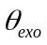 causes a force, which is written as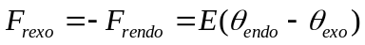, where 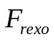 and 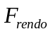are the reaction force generated on the exoskeleton and the human arm respectively. The term 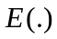 is a nonlinear function, which maps the difference between and to and . The reaction torque experienced by the human arm 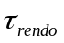 and exoskeleton arm 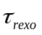 is given by 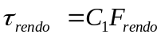 and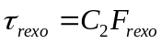, respectively, where 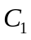 and 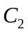 are positive constants. 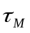 is the torque exerted by the muscles, 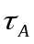 is the torque produced by the exoskeleton’s actuators. The general model shown in Figure 1 doesn’t show any control algorithm’s implementation. Usually the objective of the control algorithms is to generate proportional to . The proportionality constant is termed as an amplification factor 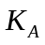. In other words, it can be said that the FAD amplifies the muscle power by a factor of . If a value of 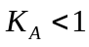 is selected the FAD attenuates the torque produced by human muscle by producing an opposite torque. These are used in rehabilitation robots [12].
In the next section we add various control algorithms to the model presented in Figure 1. The difference between the control algorithms can be identified and also it lets to identify the hardware requirements.

3. Control schemes
3.1 Kazerooni's algorithm
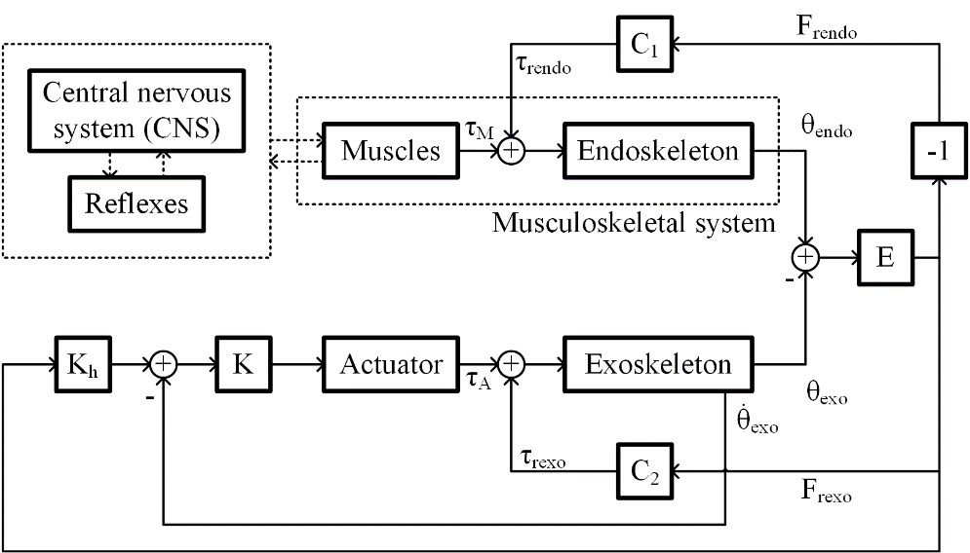
Figure 2: Block diagram showing Kazerooni’s algorithm applied to Human-FAD interaction.

Figure 2 depicts the control scheme presented by Kazerooni in [13]. The author uses linear dynamic models to represent the dynamics of the CNS, endoskeleton, and function . Author assumes that 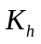 and  are linear dynamic systems. This algorithm controls the velocity of the exoskeleton arm. The difference between the human arm position and the exoskeleton one causes a velocity in the exoskeleton arm that allows cancelling this difference in position. is measured by means a force sensor. It is worth mentioning that the exoskeleton arm position remains stationary in the case that the user is having no interaction with the force sensor.
In Figure 2 it can be observed that the controller requires two inputs, one from the HA-FAD interaction force and another is velocity of the exoskeleton arm. Hence a force sensor and an encoder or a tachogenerator is required.

3.2 BLEEX (Berkeley Robotics & Human Engineering Laboratory) Algorithm
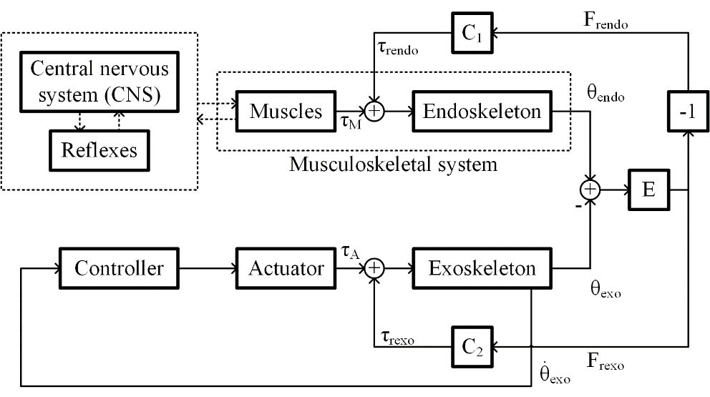
Figure 3: Block diagram showing BLEEX algorithm applied to Human-FAD interaction.
Figure 3 shows the BLEEX control scheme proposed in [14], [15]. This control scheme does not use any force sensor. A positive feedback loop is used to increase the sensitivity of the external disturbances. The controller 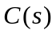 is given by 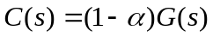, where 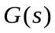 is the exoskeleton dynamics and is the augmentation factor. Signal introduces external disturbances into the positive feedback system. Due to high sensitivity towards external disturbances, the exoskeleton arm follows the human arm. The design of the controller needs the knowledge of an accurate model of the actuator and the inverse model of the exoskeleton arm.
From Figure 3 it can be observed that the controller uses only one feedback. In a way the controller estimates the torque exerted by the HA-FAD interaction the actuator velocity. This helps us to identify that the actuator used

3.3 Algorithm inspired by fictitious gain
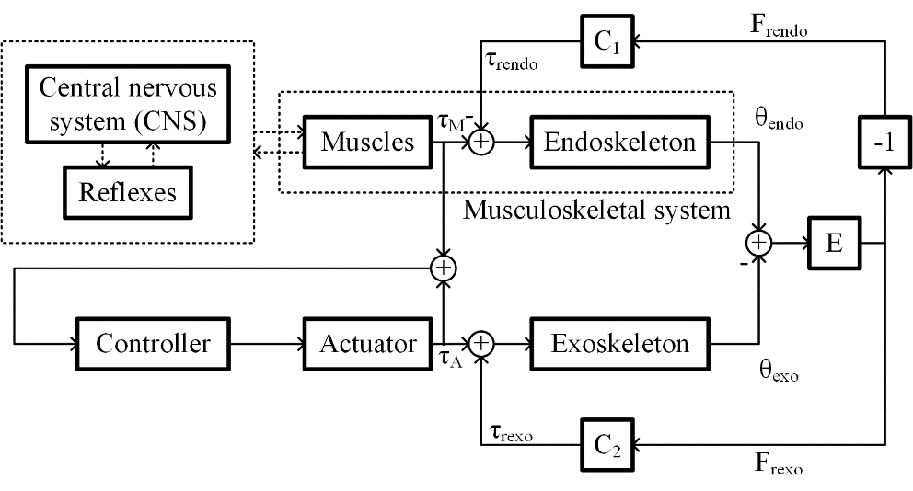
Figure 4: Block diagram showing the algorithm inspired by fictitious gain applied to Human-FAD interaction.
Figure 4 shows a control scheme inspired by fictitious gain presented in [16]. This control scheme needs a positive feedback, that consist in the sum of the torques exerted by the muscles and the actuator. As the algorithm mentioned in the previous subsection, the actuator inverse dynamics is employed by the controller. The torque exerted by the muscles can be estimated by an EMG sensor, a muscle hardness sensor, or a muscle fiber expansion sensor. Since this control scheme uses a positive feedback, the closed-loop sensitivity of the torque exerted by the muscles, is high. The author of this algorithm also proposes a methodology for adapting this algorithm to users that suffer tremors.
3.4 Force control with velocity and position feedback
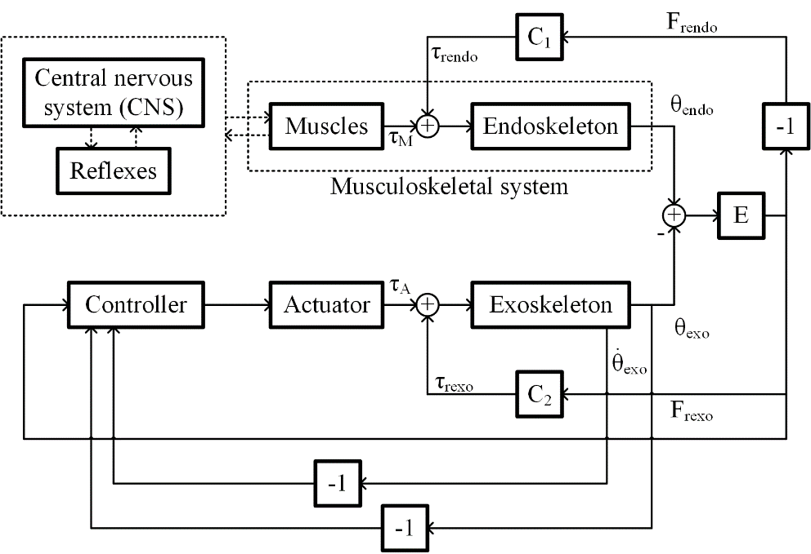
Figure 4: Block diagram showing the force control algorithm with position and velocity feedback applied to Human-FAD interaction.

In this control scheme, authors use a linear model for the CNS, spinal cord, muscles and endoskeleton human arm; and is approximated as a constant. The actuator dynamics is ignored by introducing its inverse dynamics into the controller, which provides an amplifying effect of . The actuator does not provide any torque while the human arm is released, which will bring the exoskeleton to the equilibrium point. Additionally, the controller provides a velocity and position feedback for obtaining the desired performance under no human contact. This control scheme is similar to the Kazerooni’s control scheme with a position feedback. It is worth mentioning that the authors of [17] present a methodology to calculate the upper-limit of the augmentation factor. It is observed that the human-FAD interaction would be stable for any value of the augmentation factor if the internal delay of the human reflex action is zero.

3.4 Comparison between the controllers

Table 1 presents a comparison between the four control schemes aforementioned.

Table 1: Comparison of the four control algorithms under study
 | Kazerooni's algorithm | BLEEX’s algorithm | Algorithm inspired by fictitious gain | Force control with velocity and position feedback
Sensors used | Force sensor | None | Electromyography (EMG) sensor | Force sensor
Disadvantages with sensors | Since the exoskeleton may make contact at various points, placing a force sensor is tricky. | None | 1. Placing EMG sensor is difficult.  2. Processing EMG signal is difficult compared to processing a force sensor signal.  3. Calibrating EMG sensor is time-consuming | Since the exoskeleton may make contact at various points, placing a force sensor is tricky.
Control algorithm complexity | Easy to implement | Difficult:  1. The model should be accurate.  2. Parameters should be estimated accurately.  3. Controller should implement the inverse dynamics | Difficult to implement:  1. Parameters should be estimated accurately.  2. Controller should implement the inverse dynamics | Easy to implement
Limitations of the control scheme | User do not experience part of the load he is handling when the exoskeleton arm is stationary | 1. Stability is not guaranteed.  2. The algorithm may not differentiate the perturbations caused by human and external sources. | There is a limitation on the mass of the exoskeleton structure. | None

4. Conclusions
Four control schemes of FAD are studied in this short review. A generalized model of human-robot interaction is presented. Also, the differences in these control algorithms are presented. It is observed that using the force or the EMG sensor is a good option to get stable interaction. The EMG sensors can be replaced by a muscle hardness sensor or a muscle fiber expansion sensor. Stable operation for a person suffering from tremor can be guaranteed by applying filters to the controller.

References
[1] B. Dellon and Y. Matsuoka, “Prosthetics, exoskeletons, and rehabilitation [Grand Challenges of Robotics],” IEEE Robot. Autom. Mag., vol. 14, no. 1, pp. 30–34, Mar. 2007.
[2] J. B. Makinson, D. P. Bodine, B. R. Fick, and G. E. C. O. S. N. Y. S. M. H. P. OPERATION., Machine augmentation of human strength and endurance hardiman I prototype project. Defense Technical Information Center, 1969.
[3] J. Jansen, B. Richardson, F. Pin, R. Lind, and J. Birdwell, “Exoskeleton for soldier enhancement systems feasibility study,” Oak Ridge, Tennessee 37831, 2000.
[4] A. Schiele and G. Visentin, “Exoskeleton for the human arm, in particular for space applications,” United States Pat. 7410338B, 2008.
[5] E. Guizzo and H. Goldstein, “The rise of the body bots [robotic exoskeletons],” IEEE Spectr., vol. 42, no. 10, pp. 50–56, 2005.
[6] S. Lee and Y. Sankai, “Power assist control for leg with hal-3 based on virtual torque and impedance adjustment,” in Systems, Man and Cybernetics, 2002 IEEE International Conference on, 2002, vol. 4.
[7] N. Schweighofer, M. A. Arbib, and M. Kawato, “Role of the cerebellum in reaching movements in humans. I. Distributed inverse dynamics control,” Eur. J. Neurosci., vol. 10, no. 1, pp. 86–94, 1998.
[8] A. G. Shaikh, H. Meng, and D. E. Angelaki, “Multiple reference frames for motion in the primate cerebellum,” J. Neurosci., vol. 24, no. 19, pp. 4491–4497, 2004.
[9] A. J. Bastian, T. A. Martin, J. G. Keating, and W. T. Thach, “Cerebellar ataxia: abnormal control of interaction torques across multiple joints,” J. Neurophysiol., vol. 76, no. 1, pp. 492–509, 1996.
[10] J. McIntyre and E. Bizzi, “Servo hypotheses for the biological control of movement,” J. Mot. Behav., vol. 25, no. 3, pp. 193–202, 1993.
[11] J. Randall F and D. Ostry, “Trajectories of human multi-joint arm movements: evidence of joint level planning,” in Experimental Robotics I, 1990, pp. 594–613.
[12] W. He et al., “Neural Network Control of a Rehabilitation Robot by State and Output Feedback,” J Intell Robot Syst, vol. 80, pp. 15–31, 2015.
[13] H. Kazerooni, “Human Machine Interaction via the Transfer of Power and Information Signals,” ASME Winter Annu. Meet., Dec. 1988.
[14] H. Kazerooni, J. L. Racine, L. Huang, and R. Steger, “On the control of the berkeley lower extremity exoskeleton (BLEEX),” in Proceedings of the 2005 IEEE International Conference on Robotics and Automation, 2005. ICRA 2005., 2005, pp. 4353–4360.
[15] H. Kazerooni and R. Steger, “The Berkeley lower extremity exoskeleton,” J. Dyn. Syst. Meas. Control, vol. 128, no. 1, pp. 14–25, 2006.
[16] K. Kong and M. Tomizuka, “Control of exoskeletons inspired by fictitious gain in human model,” IEEE/ASME Trans. Mechatronics, vol. 14, no. 6, pp. 689–698, 2009.
[17] S. K. Gadi, A. Osorio-Cordero, R. Lozano-Leal, and R. A. Garrido, “Stability Analysis of a Human Arm Interacting with a Force Augmenting Device,” J. Intell. Robot. Syst. Theory Appl., vol. 86, no. 2, pp. 215–224, 2017.

