

INSTITUTE FOR ADVANCED COMPUTING
AND
SOFTWARE DEVELOPMENT
AKURDI, PUNE

SRS ON

“ONLINE SHOPPING PORTAL FOR HANDICRAFTS”
DAC-Feb-2017

Submitted By :
Group No:42
Rishabh Raj(1190)
Shobhit Kumar Gupta(1200)

Mr. Prashant Karhale Mr. Milind Arjun Course Coordinator Project Guide

Table of Contents

Table of Contents 1
List of Figures 3
1.0. Introduction 1
1.1. Purpose 4
1.2. Scope of Project 4
1.3. Glossary 4
1.4. References 5
1.5. Overview of Document 5
2.0.Overall Description 7
2.1 System Environment 7
2.2 Functional Requirements Specification 7
2.2.1 Reader Use Case
Use case: Search Article 7
2.2.2 Author Use Case
Use case: Submit Article
2.2.3 Reviewer Use Case
Use case: Submit Review 8
2.2.4 Editor Use Cases 9
Use case: Update Author 9
Use case: Update Reviewer 10
Use case: Update Article 10
Use case: Receive Article 11
Use case: Assign Reviewer 11
Use case: Receive Review 12
Use case: Check Status 13
Use case: Send Response 13
Use case: Send Copyright 14
Use case: Remove Article
Use case: Publish Article
2.3 User Characteristics 14
2.4 Non-Functional Requirements 15
3.0. Requirements Specification 16
3.1 External Interface Requirements 16
3.2 Functional Requirements
3.2.1 Search Article
3.2.2 Communicate
3.2.3 Add Author
3.2.4 Add Reviewer
3.2.5 Update Person
3.2.6 Update Article Status
3.2.7 Enter Communication
3.2.8 Assign Reviewer
3.2.9 Check Status
3.2.10 Send Communication
3.2.11 Publish Article
3.2.12 Remove Article
3.3 Detailed Non-Functional Requirements 16
3.3.1 Logical Structure of the Data 16
3.3.2 Security 21
Index

List of Figures

Figure 1 – Use case 7
Figure 2 - DFD 23
Figure 3 - ERD 25

Introduction

1.1. Purpose
The BelieveIT.com (OSS) web application is intended to provide complete solutions for vendors as well as customers through a single get way using the internet as the sole medium. It will enable vendors to setup online shops, customer to browse through the shop and purchase them online without having to visit the shop physically. The administration module will enable a system administrator to approve and reject requests for new shops and maintain various lists of shop category
This document is meant to delineate the features of OSS, so as to serve as a guide to the developers on one hand and a software validation document for the prospective client on the other.

1.2. Scope of Project

Initial functional requirements will be: -

Secure registration and profile management facilities for Customers
Creating a Shopping cart so that customers can shop ‘n’ no. of items and checkout finally with the entire shopping carts
Adequate payment mechanism and gateway for all popular credit cards, cheques and other relevant payment options, as available from time to time.
Browsing through the e-Mall to see the items that are there in each category of products like Apparel, Kitchen accessories, Bath accessories, Food items etc.
Adequate searching mechanisms for easy and quick access to particular products and services.

Feedback mechanism, so that customers can give feedback for the product or service which they have purchased. Also facility rating of individual products by relevant customers. Also feedback can be given on the performance of particular vendors and the entire mall as well.
This software system will be a website for a shopping mall. This system will be designed to maximize the one’s productivity by providing tools to assist in automating the product review and issuing process.
Any visitor can become a member (for free) and then can influence or be influenced by others. By writing reviews, sharing photos and diaries, members create buzz about brands and products.

BelieveIT.com helps consumers make informed shopping decisions. A potential shopper can find reviews on every business or brand right from large corporations to small local businesses, all written by an average consumer like him. This translates to millions of reviews on hundreds of thousands of products.

Initial non functional requirements will be: -
Secure access of confidential data (user’s details). SSL can be used.
24 X 7 availability.
Better component design to get better performance at peak time
Advertisement space where it will effectively catch the customer’s attention and as a source of revenue.
In addition to the above mentioned points, due to the highly evolving nature of the project, the following are planned to be delivered if deemed necessary:
More payment gateways.
Dynamic price model by which prices can be changed based on demand and supply
Dynamic Storefront: Each customer will have a web page personalized based on his or her recent purchases. This is the equivalent of having a unique storefront for each customer in hopes of drawing in as many return customers as possible.

Term | Definition
Active Products | The products that is tracked by the system; it is a narrative that is planned to be upload to the public website.
Administrator | Database Management, Contact and Giving Permission to Vendors, View all details, Advertising the Site, Review the Site
Database | Collection of all the information monitored by this system.
Field | A cell within a form.
Member | A member of the website listed in the users database.
Reader | Anyone visiting the site to search any Product and view the Reviews
Review | A written recommendation about the appropriateness of an Product for selling and buying ; may include suggestions for improvement.
Reviewer | A person that examines an Product and has the ability to recommend approval Product for buying or to request that changes be made in the Product.
Software Requirements Specification | A document that completely describes all of the functions of a proposed system and the constraints under which it must operate. For example, this document.
User | Reviewer or Adminstrator

1.4. References
IEEE. IEEE Std 830-1998 IEEE Recommended Practice for Software Requirements Specifications. IEEE Computer Society, 1998.

1.5. Overview of Document

Functional Requirements
Customers:-
- Products should be Unique.

- Products Details :-Photos,Description,price,Product photo should be mentioned properly

- Products which is delivered is as same as given description in online portal.

- Customer should able to rate the product.

- Customer should able to rate the Seller or craftmen.

- Delivery location must be mentioned clearly and product availability must be provided at different location.

- Payment option should be flexible.ex:-online banking,credit/Debit card payment or Cash on Delivery.
- The return policy should be clear and easy understoodable by customer.
- There are proper feedback system for the customers where customer can give their feedback and suggestions and share their experience of shopping via email or message.

- Customer can avail discount from time to time at different occasion like christmans,Diwali etc.
- Customer can also talk to craftsmen or artician and can also know about the Product and can give their feedback to them via message or email.
- There is customer resolution service to solve customer isuues via telephonic ,email ,message.

Functional Requirement :- Product
1)Products are made by localized handicrafts,craftsmen and handi made.

2)There are wide range of products which is available in our site,they are divided into different categories subcategories.ex:-home decoration-wall decoration,room decoeation etc.

3)In Product packet ,there is descriptionof the product is provided ie;about the product history and why this product is famous.
4)Product which reflects our India,s Country heritage and Indian art works

5)Different Categories of the Products are like
* Painting *Toys
*Sculpture *pottery
*Clothing(Traditional) *Home Decoration
*Handmade Fashion Products.
*Jewllery
name
Phone no
id
HAS
email
Category Id
SEGMENT

address
CUSTOMER
name
id

Category name
CATEGORY
BELOGS
password
DOES

Payment id
ONLINE HANDICRAFT PORTAL
Has

price
type
PAYMENT

BUYS
PRODUCT

Payment
amount
name
Payment type
id

Done for
Cart id
Added to
CART

Total Amount
Items

The next chapter, the Overall Description section, of this document gives an overview of the functionality of the product. It describes the informal requirements and is used to establish a context for the technical requirements specification in the next chapter.

The third chapter, Requirements Specification section, of this document is written primarily for the developers and describes in technical terms the details of the functionality of the product.

Both sections of the document describe the same software product in its entirety, but are intended for different audiences and thus use different language.

2.0. Overall Description

2.1 System Environment

Figure 1 - System Environment

The BelieveIT.com has four active actors and one cooperating system.

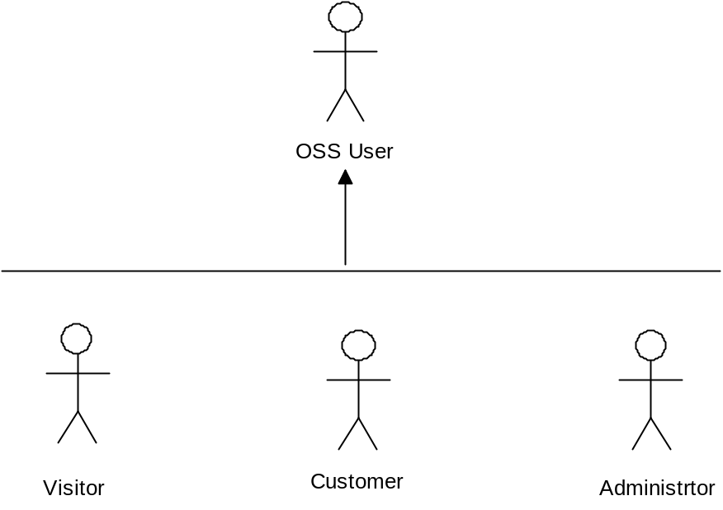

2.2 Functional Requirements Specification
This section outlines the use cases for each of the active Customers separately. The User, and the reviewer have only one use case apiece while the admin is main actor in this system.

Use case: Search Article
Diagram:
User
Search Products

Brief Description
The Useer accesses the Online Shopping Website, searches for an Products and Buy it, Sell it and review for it.

Initial Step-By-Step Description
Before this use case can be initiated, the User has already accessed the Online Shopping Website.

- The User chooses to search by Product name, category, or keyword.
- The system displays the choices to the User.
- The User selects the Product desired.
- The system presents the abstract of the Product to the User.
- The User chooses to buy, sell or writ review for the product.
- The system provides the requested product.

Rewrite
Review
Active Product
Submit
Publish

Use case: Submit Review
Diagram:
Customer
Submit Product

Brief Description
The reviewer submits a review of an product.

Initial Step-By-Step Description
Before this use case can be initiated, the Reviewer has already connected to the Online Website.

- The Reviewer chooses the Review Button.
- The System uses the send to HTML tag to bring up the user’s review system.
- The Reviewer fills in the Subject line gives appropriate rating and after submitting it will stored in our underlined database.

2.2.4 Editor Use Cases
The Editor has the following sets of use cases:

Figure 2 - Editor Use Cases
Update Info
Editor
Handle Art
Status
Send Rec
Publish Art

Update Information use cases

Use case: Update Author
Editor
Update Author
Diagram:

Brief Description
The Editor enters a new Author or updates information about a current Author.

Initial Step-By-Step Description
Before this use case can be initiated, the Editor has already accessed the main page of the Article Manager.

- The Editor selects to Add/Update Author.
- The system presents a choice of adding or updating.
- The Editor chooses to add or to update.
- If the Editor is updating an Author, the system presents a list of authors to choose from and presents a grid filling in with the information; else the system presents a blank grid.
- The Editor fills in the information and submits the form.
- The system verifies the information and returns the Editor to the Article Manager main page.

Use case: Update Reviewer
Diagram:
Editor
Update Reviewer
MANAGER
Brief Description
The Editor enters a new Reviewer or updates information about a current Reviewer.

Initial Step-By-Step Description
Before this use case can be initiated, the Editor has already accessed the main page of the Article Manager.

- The Editor selects to Add/Update Reviewer.
- The system presents a choice of adding or updating.
- The Editor chooses to add or to update.
- The system links to the Historical Society Database.
- If the Editor is updating a Reviewer, the system and presents a grid with the information about the Reviewer; else the system presents list of members for the editor to select a Reviewer and presents a grid for the person selected.
- The Editor fills in the information and submits the form.
- The system verifies the information and returns the Editor to the Article Manager main page.

Use case: Update Article
Diagram:
Editor
Update Article
Brief Description
The Editor enters information about an existing article.

Initial Step-By-Step Description
Before this use case can be initiated, the Editor has already accessed the main page of the Article Manager.

- The Editor selects to Update Article.
- The system presents s list of active articles.
- The system presents the information about the chosen article.
- The Editor updates and submits the form.
- The system verifies the information and returns the Editor to the Article Manager main page.

Handle Article use cases

Use case: Receive Article
Editor
Receive Article
Diagram:

Brief Description
The Editor enters a new or revised article into the system.

Initial Step-By-Step Description
Before this use case can be initiated, the Editor has already accessed the main page of the Article Manager and has a file containing the article available.

- The Editor selects to Receive Article.
- The system presents a choice of entering a new article or updating an existing article.
- The Editor chooses to add or to update.
- If the Editor is updating an article, the system presents a list of articles to choose from and presents a grid for filling with the information; else the system presents a blank grid.
- The Editor fills in the information and submits the form.
- The system verifies the information and returns the Editor to the Article Manager main page.

Use case: Assign Reviewer
This use case extends the Update Article use case.
Diagram:
CUSTOMER
Assign Reviewer
MANAGER
Brief Description
The Editor assigns one or more reviewers to an article.

Initial Step-By-Step Description
Before this use case can be initiated, the Editor has already accessed the article using the Update Article use case.

- The Editor selects to Assign Reviewer.
- The system presents a list of Reviewers with their status (see data description is section 3.3 below).
- The Editor selects a Reviewer.
- The system verifies that the person is still an active member using the Historical Society Database.
- The Editor repeats steps 3 and 4 until sufficient reviewers are assigned.
- The system emails the Reviewers, attaching the article and requesting that they do the review.
- The system returns the Editor to the Update Article use case.

Use case: Receive Review
MANAGER
Receive Review
This use case extends the Update Article use case.
Diagram:

Brief Description
The Editor enters a review into the system.

Initial Step-By-Step Description
Before this use case can be initiated, the Editor has already accessed the article using the Update Article use case.

- The Editor selects to Receive Review.
- The system presents a grid for filling with the information.
- The Editor fills in the information and submits the form.
- The system verifies the information and returns the Editor to the Article Manager main page.

Check Status use case:

Use case: Check Status
Diagram:
CUSTOMER

Check Status

Brief Description
The Customer checks the list of all products.

Initial Step-By-Step Description
Before this use case can be initiated, the Customer has already accessed the main page of the Category.

- The Customers selects to Category.
- The system returns a scrollable list of all available products with their lists of products .
- The system returns the list of product of selected Category.

Add to cart use cases:

Use case: Add to Cart
This use case extends the use case.

Diagram:
CUSTOMER
Add to Cart

Brief Description
It adds the selected products into shopping cart.

Initial Step-By-Step Description
Before confirmation system will ask to user for Continue shopping or Buy Now.
- If customers select to continue shopping then control goes to Home page and carry’s the process of shopping.
- If Customers select Buy Now, if customer registered already then system ask to give the user name and password or if not registered then system will allow to create a new account.
- Customers have to provide his card number for payment the bill.
- After successfully buying system will gives the confirmation of transaction.

Use case: Selling old products
This use case extends the Selling old products use case.

Diagram:
Customer
Selling old products
Brief Description
Only Registered customers can sell his old products through our websites.

Initial Step-By-Step Description
Before this use case customers must have to already buy the product from our websites.

- System will ask to Customers to details such as Product Id, Product Name, Product Description.
- .To proceed further system will ask to give Card Number to accept the request for Customers selling order.
- The system returns the Customers to the Home page.
- After that the old product will added into the Category of Sell old Products.

2.3 User Characteristics
The User is expected to be Internet literate and be able to use a search engine. The main screen of the Online Shopping Website will have the search function and a link to “Administrator/Reviewer Information.”
The Administrator and Reviewer are expected to be Internet literate and to be able to use internet transaction.
The Administrator is expected to be Windows literate and to be able to use button, pull-down menus, and similar tools.
The detailed look of these pages is discussed in section 3.2 below.

2.4 Non-Functional Requirements
The Online Shopping will be on a server with high speed Internet capability. The software developed here assumes the use of a tool such as Tomcat for connection between the Web pages and the database. The speed of the User’s connection will depend on the hardware used rather than characteristics of this system.
The Online Shopping will run on the editor’s PC and will contain an Oracle database. Oracle is already installed on this computer and is a Windows operating system.

3.0. Requirements Specification

3.1 External Interface Requirements
The only link to an external system is the link to the Online Shopping Database to verify the membership of a Reviewer. The Administrator believes that a site member is much more likely to be an effective reviewer and has imposed a membership requirement for a Reviewer. The Database fields of interest to the Web Publishing Systems are member’s name, membership (ID) number, and email address (an optional field for the Database).
The Assign Reviewer use case sends the Reviewer ID to the Database and a Boolean is returned denoting membership status. The Update Reviewer use case requests a list of member names, membership numbers and (optional) email addresses when adding a new Reviewer. It returns a Boolean for membership status when updating a Reviewer.

3.2 Detailed Non-Functional Requirements

3.2.1 Logical Structure of the Data

The logical structure of the data to be stored in the internal Article Manager database is given below.

3.2.2 .Functional Requirement:
Customers will be able to create accounts to store their customer profiles, configure contact information, view their purchase history, and confirm orders. Customers will be able to register, log in, and log out of their accounts. Furthermore, Customer profiles will also include payment information, such as the ability to store credit card information .and address information.

Products will be stored in multi-tiered categories; a category can contain sub categories or products. The inventory management will allow for administrators to update the categories, the products placed in categories, and the specific product details.

Customers will also be able to add products into the shopping cart. The shopping cart will clearly display the number of items in the cart, along with the total cost. The customer will also be able to add to or remove products from the shopping cart prior to checkout and order confirmation.

Customers will be able to confirm the order after checkout. If the order is incorrect, the customer will be able to revise and update their order. The customer will then receive a confirmation email with the specific order details.

3.2.3 Hardware Requirement:

HARDWARE REQUIREMENT

- PROCESSOR : Pentium IV & Above.

- RAM : 1 GB & Above.

- HARD DISC SPACE : 40 GB & above.

- PRINTER : Dot Matrix / Ink Jet

- MONITOR : Color

SOFTWARE REQUIRMENT:

OPERATING SYSTEM : 2000 / XP/Vista. And all above (but Must be
MicrosoftOs Eclipse- 2008

Software Life Cycle Model:

In order to make this Project we are going to use Classic LIFE CYCLE MODEL .Classic life cycle model is also known as WATER FALL MODEL. The life cycle model demands a Systematic sequential approach to software development that begins at the system level and progress through analysis design coding, testing and maintenance.

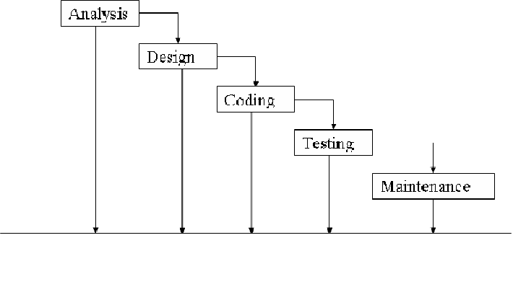
The Classic Life Cycle Model
The waterfall model is sequential software development process, in which progress is seen as flowing steadily downwards (like a waterfall) through the phases of conception initiation, Analysis, Design (validation), construction. Testing and maintained.

1) System Engineering and Analysis:-
Because software is always a part of larger system work. Begins by establishing requirement for all system elements and Then allocating some subset of these requirement to the software system Engineering and analysis encompasses the requirement gathering at the system level with a small amount of top level design and analysis.

2) Software requirement Analysis: =
The requirement gathering process is intensified and focused specifically on the software .Requirement for the both system and software are discussed and reviewed with the customer. The customer specifies the entire requirement or the software and the function to be performed by the software.

3) Design:
Software design is actually a multi-step process that focuses on distinct attributes of the program data structure, software architecture, procedural detail and interface of the software that can be assessed or quality before coding begins .Like requirement the design is documented and becomes part of the software.

4) Coding:
The design must be translated into a machine readable form. The coding step performs this task. If design is programmed in a detailed manner, coding can be accomplished mechanically.

5) Testing:
Once code has been generated programmed testing begins. The testing process focuses on the internals of the software ensuring that all statement have been tested and on the functional externals hat is conducting tests to uncover the errors and ensure that defined input will produce the results that agree with the required results.

Unit testing:-
In computer programming, Unit testing is software Verification and validation method where the programmer gains confidence that individual units of source code are fit to use A unit is the smallest testable part of an application. In procedural programming a unit may be an individual programmed, function, procedure, etc. while in object-oriented programming, the smallest Unit is a class, which may belong to a base/super class abstract class or derived/child class.

Benefits:
The goal of unit testing is to isolate each part of the program and show that the individual parts are correct. A unit test provides a strict written contract that the piece of code must satisfy.

Documentation:-
Unit testing provides a sort of living documentation of the system. Developers looking to learn what functionality is provided by a unit and how to use it can look at the tests to gain a basic understanding of the unit API.

Limitation of unit testing:
Testing cannot be expected to catch error in the program –It is impossible to evaluate all execution paths for all but the most trivial programs. The same is true for unit testing. Additionally, by unit testing only types the functionality if the units themselves.

6) Maintenance:
Software will undoubtedly undergo change after it is Delivered to the customer .Change will occur because errors have been encountered because the software must be able adopted to accommodate changes in its external environment because the customer requires functional or performance enhancement enhancements. The classic life cycle is the oldest and most widely used paradigm or software engineering

Conclusion:

- Using this project “Online Shopping and Selling”, it reduces the manual work of submitting the infrastructure related complains.

- Now, it can be done using this software and hence, it makes the Customers Shopping easier and comfortable. he Logical Structure of the data to be stored in the Online Journal database on the server is as follows:

Published Article Entity

3.3.2 Security

The server on which the Online Journal resides will have its own security to prevent unauthorized write/delete access. There is no restriction on read access. The use of email by an Author or Reviewer is on the client systems and thus is external to the system.
The PC on which the Article Manager resides will have its own security. Only the Editor will have physical access to the machine and the program on it. There is no special protection built into this system other than to provide the editor with write access to the Online Journal to publish an article

Use Case:-
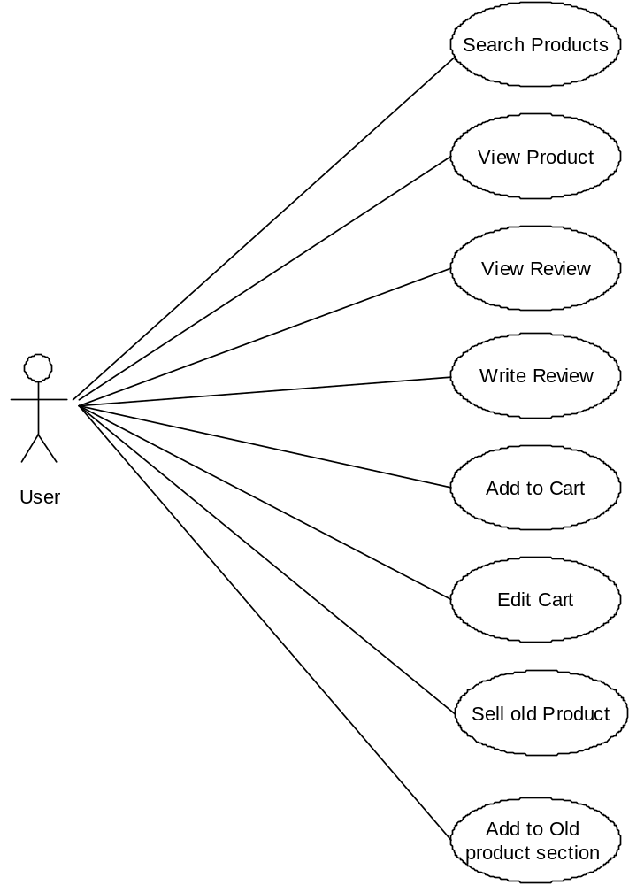

ER Diagram:

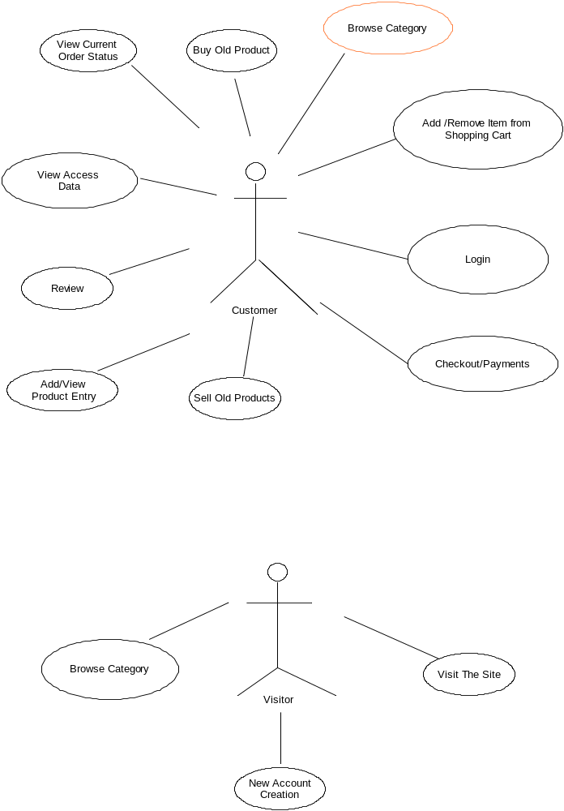
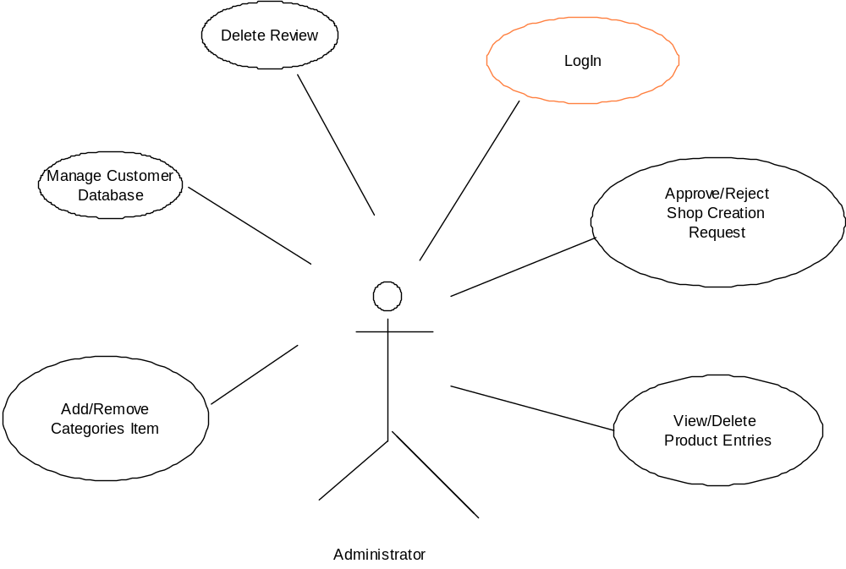

DFD :

LEVEL 0 DFD

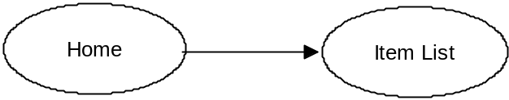

LEVEL 1 DFD

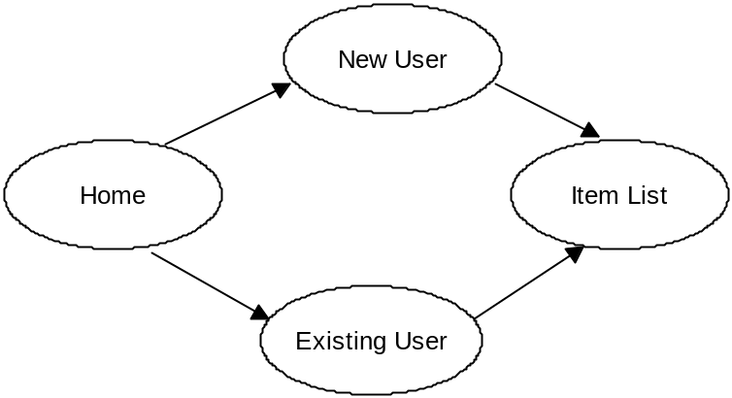

LEVEL 2 DFD

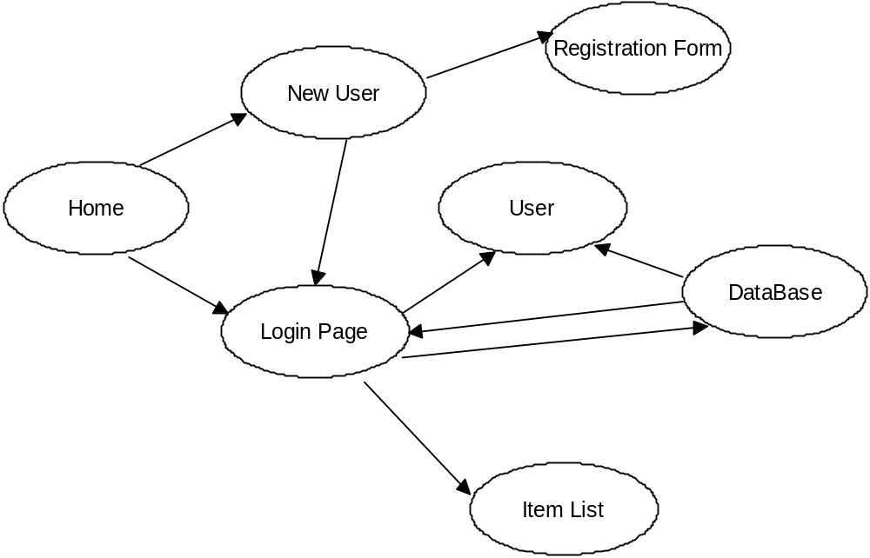

LEVEL 3 DFD

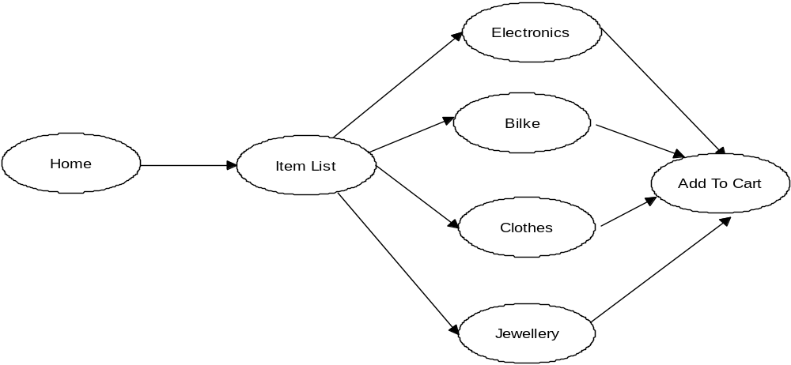
LEVEL 4 DFD

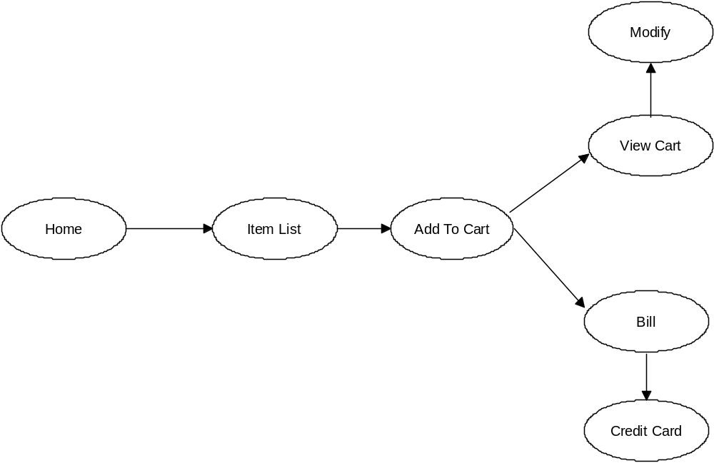

LEVEL 5 DFD

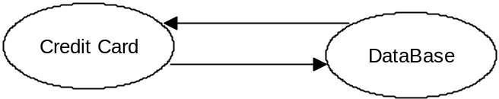

LEVEL 6 DFD

