**Name: Jishnuvardhan Karpuram**

**Class: CS-383**

**INTRODUCTION:**

When it comes to 2D Unity video game production, creating engaging title cards and menus is essential for drawing players into the game's world and improving their overall experience. Developers can navigate players through a variety of game modes, settings, and narratives with ease while keeping a consistent visual identity by concentrating on menu and title management. This crucial component of game design sets the mood and atmosphere while also promoting easy navigation and player interaction, keeping players captivated from the first minute they pick up the game.

A careful balancing act between utility and aesthetics is required when implementing title cards and menus in Unity. Developers may create visually attractive title screens that capture the essence of the game and incorporate menu structures that are easy to navigate by utilizing Unity's powerful user interface framework. Every component, from dynamic transitions to compelling animations, adds to the overall character of the game and strengthens the player's bond with the virtual environment. In addition, good menu and title management goes beyond appearance; it includes elements like save/load capabilities, user-customizable settings, and smooth gameplay integration, all of which are coordinated to provide gamers a smooth and engaging gaming experience.

**CASE DIAGRAM AND SCENARIOS:**

**CASE DIAGRAM:**

**SCENARIOS:**

**Name:** Game Main Menu

**Summary**: This scenario describes the process of the player starting the game from the title screen.

**Actors:** Player

**Preconditions:** The game application is launched, and the title screen is displayed.

**Basic sequence:**

Player sees the title screen.

Player presses a key to enter the main menu.

Player selects "Start Game" from the main menu.

Game begins.

**Exceptions:**

Step 1: If the player does not press any key, the game remains on the title screen.

Step 2: If the player selects a different option instead of starting the game, a different scenario is triggered (e.g., accessing settings or help menu).

**Post conditions:** The game starts and progresses to the gameplay phase.

**Priority:** 1

**ID:** CD1

**Name:** Help Menu

**Summary**: This scenario describes how the player accesses the help menu during gameplay.

**Actors:** Player

**Preconditions:** The game is in progress.

**Basic sequence:**

Player presses the "Help" button during gameplay.

A help menu is displayed.

**Exceptions:**

Step 1: If the player does not press the help button, the game continues without displaying the help menu.

**Post conditions:** The help menu is displayed, helping the player.

**Priority:** 3

**ID:** CD2

**Name:** Pause Menu

**Summary**: This scenario describes how the player pauses the game during gameplay.

**Actors:** Player

**Preconditions:** The game is in progress.

**Basic sequence:**

Player presses the "Pause" button during gameplay.

Pause menu is displayed.

**Exceptions:**

Step 1: If the player does not press the pause button, the game continues without pausing.

**Post conditions:** The game is paused, allowing the player to access options such as resume, help, or quit.

**Priority:** 2

**ID:** CD3

**Name:** Game End Menu

**Summary**: This scenario describes how the player quits the game from the pause menu.

**Actors:** Player

**Preconditions:** The game is paused.

**Basic sequence:**

Step 1: Player selects the "Quit Game" option from the pause menu.

Step 2: Confirmation dialog is displayed.

Step 3: Player confirms quitting the game.

Step 4: Game application closes.

**Exceptions:**

Step 1: If the player selects a different option instead of quitting the game, the corresponding action is executed (e.g., resuming the game).

Step 2: If the player cancels the quit operation, the game remains paused.

**Post conditions:** The game application is closed, returning the player to the system environment.

**Priority:** 1

**ID:** CD4

**Name:** Title Screen

**Summary**: This scenario outlines the process of navigating from the title screen to various menu options.

**Actors:** Player

**Preconditions:** The game application is launched, and the title screen is displayed.

**Basic sequence:**

Step 1: Player views the title screen upon launching the game.

Step 2: Player interacts by pressing a key to access the main menu.

Step 3: Player is presented with options such as starting the game, accessing help, or quitting the game.

**Exceptions:**

Step 1: If the player does not interact within a certain timeframe, the game may automatically transition to the main menu.

**Post conditions:** The player gains access to the main menu options.

**Priority:** 3

**ID:** CD5

**Name:** Game

**Summary**: This case scenario outlines the typical progression of gameplay from the title screen to various game states and options.

**Actors:** Player

**Preconditions:** The game application is launched, and the player is presented with the title screen.

**Basic sequence:**

The player views the title screen upon launching the game.

The player interacts with the title screen by pressing a key to enter the main menu.

In the main menu, the player selects the "Start Game" option to begin gameplay.

The game enters the active gameplay phase.

During gameplay, the player may access the pause menu by pressing a designated button.

From the pause menu, the player has the option to resume the game, access the help menu, or quit the game.

If the player chooses to quit the game, a confirmation dialog is displayed.

Upon confirmation, the game application is closed, returning the player to the system environment.

**Exceptions:**

If the player does not press any key on the title screen, the game remains idle on the title screen.

If the player selects an option other than "Start Game" from the main menu, the corresponding action is executed (e.g., accessing settings or help menu).

If the player cancels the quit operation from the confirmation dialog, the game remains paused.

If the player does not access the pause menu during gameplay, the game continues without interruption.

**Post conditions:** The player progresses through various game states, from title screen to gameplay, with the ability to pause and quit the game as desired.

**Priority:** 1

**ID:** CD6

**Data Flow Diagram:**

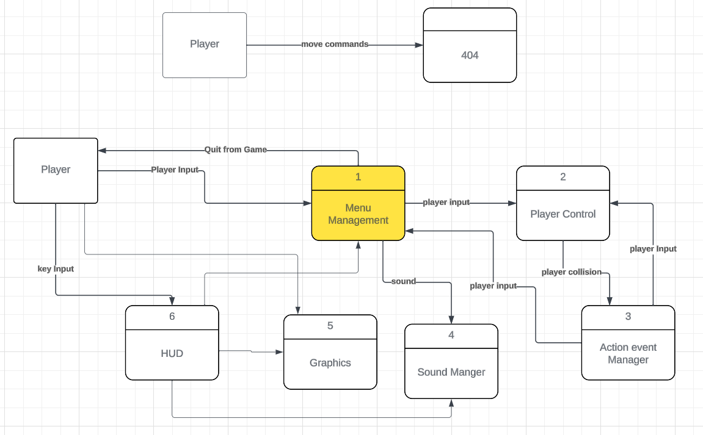

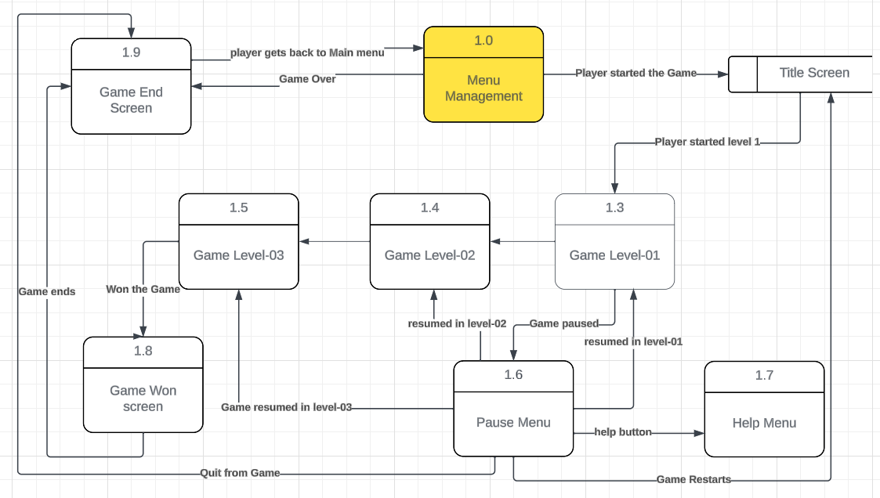

**Process descriptions:**

Management of Menus:

The Title Screen, which is controlled by the Menu Management process, is what the player sees when they first launch the game.

Player-to-Player Communications:

Level 1 is initiated by the player from the Title Screen.

The Pause Menu procedure is initiated when the player pauses the game while it is being played.

If the player so desires, they can get help by going to the Help Menu.

Progression of the game:

The player advances via several stages: Level 1 and if the player gets through the first level, then the player enters Level 2, and then Level 3.

The Game Won Screen:

Appears to the player when they have finished Level 3.

Management of Game States:

The Game Won Screen appears if the player wins the game.

The Game End Screen appears whenever the player ends the game at any time.

The player is brought back to the Main Menu if they lose the game.

Resuming the game:

The player is taken back to the level they were playing (e.g., Level 1, Level 2, or Level 3) if they pause the game and then pick it up again.

Assistance and Further Conversations:

The player can get further help or information via the Help Menu at any point throughout the game.

**Acceptance Tests:**

Test of Title Screen Display:

Start the game as an input. A title screen with choices to launch the game or see the settings and assistance will be shown.

Test for Level Selection:

Enter the game and choose a level by navigating. Levels 1, 2, and 3 should be presented as expected. Make sure each level can be accessed and chosen.

Test of the Gameplay:

Enter: Begin Level 1 and check if player wins then goes to next level.

Anticipated Results: The user may steer the avatar, engage with the surroundings, and advance the level. Make sure that movements, jumps, and collisions all function as they should.

Stop and Pick Up Again Examine:

When playing the game, pause it and then pick it back up. The Pause Menu appears and the game pauses. The game picks off exactly where it left off when it resumes, so there's no loss of progress.

Help Menu Examination:

While playing, go to the Help Menu.A Help Menu including pertinent details on the controls, goals, and gameplay elements will be shown.

Game Completion Test: Finish Level 3. A screen thanking the player on winning the game would appear. Make sure the Main Menu is accessed by the player after that.

Test for Game Over:

Can't finish any level. Depending on how it is implemented, the player will be sent to either the Main Menu or the Game Over screen. Make sure no advancement is lost.

Test of the Quit Game: From any screen, select the option to end the game.

The game will end with a screen offering the choice to go back to the main menu or to end the game altogether.

Cases of Boundaries:

First Boundary Case: Level Finish: Finish Level 3 by taking the fewest possible steps. The game's won screen appears, guaranteeing that it will be activated even with insignificant inputs.

Case 2 of the Boundary: Level Failure. Unable to finish Level 1 in the allotted number of tries. The player is led to the screen indicating that the game is over, even after making the most tries.

Case 3: Access to the Help Menu: Try to open the Help Menu while you're in a tight spot in the game. Help menu that is available without interfering with gaming or important tasks.

**Timeline:**

**Work Items:**

|  |  |  |
| --- | --- | --- |
| **Tasks** | **Duration (hr)** | **Predecessor Task (s)** |
| 1.Sketching & Conceptualization | 3 | - |
| 2.UI design & Layout | 2 | 1 |
| 3.UI Implementation | 3 | 2 |
| 4.Title card Animation | 4 | 2, 3 |
| 5.Menu Transitions | 3 | 4 |
| 6.Scripting | 6 | 5 |
| 7. Main Implementations | 3 | 4, 6 |
| 8.Main menu design | 2 | 5, 7 |
| 9.Help Menu | 3 | 8 |
| 10. Pause Menu | 4 | 9, 6 |
| 11.Title Screen | 3 | 7 |
| 12.Interaction with Game | 1 | 6, 11 |
| 13.Player Interaction Test | 3 | 12 |
| 14.Testing & Iteration | 3 | 13 |
| 15.Documentation | 2 | 6, 14 |
| 16.Final Review & Installation | 3 | 7, 15 |

**Pert diagram:**

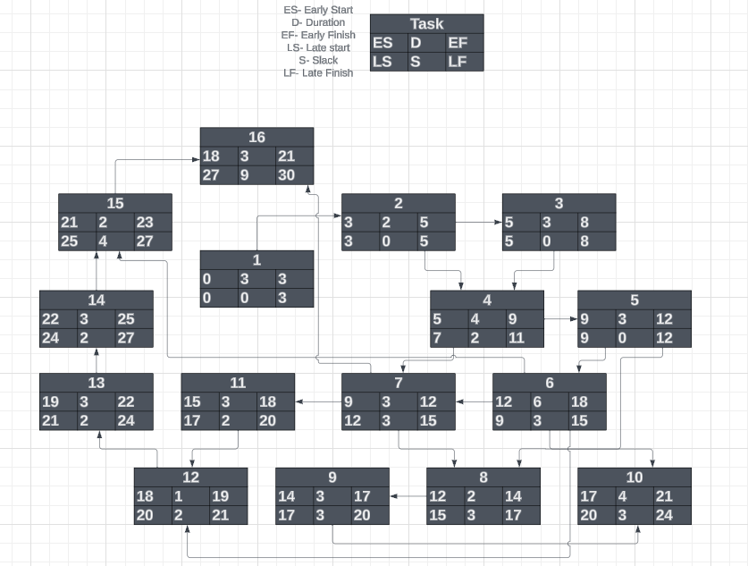

**Gantt timeline:**

|  |  |  |  |  |  |  |  |  |  |  |
| --- | --- | --- | --- | --- | --- | --- | --- | --- | --- | --- |
| Week(s) | 1 | 2 | 3 | 4 | 5 | 6 | 7 | 8 | 9 | 10 |
| T1 |  |  |  |  |  |  |  |  |  |  |
| T2 |  | 1 |  |  |  |  |  |  |  |  |
| T3 |  | 2 |  |  |  |  |  |  |  |  |
| T4 |  |  | 2, 3 |  |  |  |  |  |  |  |
| T5 |  |  |  | 4 |  |  |  |  |  |  |
| T6 |  | 5 |  |  |  |  |  |  |  |  |
| T7 |  |  |  | 4, 6 |  |  |  |  |  |  |
| T8 |  |  |  | 5, 7 |  |  |  |  |  |  |
| T9 |  |  |  | 8 |  |  |  |  |  |  |
| T10 |  |  |  | 9, 6 |  |  |  |  |  |  |
| T11 |  | 7 |  |  |  |  |  |  |  |  |
| T12 | 6,11 |  |  |  |  |  |  |  |  |  |
| T13 |  |  |  |  | 12 |  |  |  |  |  |
| T14 |  | 13 |  |  |  |  |  |  |  |  |
| T15 | 6,14 |  |  |  |  |  |  |  |  |  |
| T16 |  |  |  |  |  |  |  |  | 7,15 |  |