Debug Asignment

import java.io.BufferedReader;
import java.io.IOException;
import java.io.InputStreamReader;
import java.util.ArrayList;

public class UserList {

public static void main(String[] args) throws Exception
{
String str1, str2 = "username";
int index;
int initialCapacity = 10;
BufferedReader dataIn = new BufferedReader(new InputStreamReader(System.in));
ArrayList<String> users = new ArrayList<String>();

System.out.print("Enter a user name: ");
str1 = dataIn.readLine();

while(str1.length() > 0)
{
if(str1.equals(str2))
System.out.println("That user name is NOT allowed!");
else
{
if(users.size() == initialCapacity)
{
System.out.println("List is full!");
System.out.println("Last entry is "+users.get(initialCapacity-1));
}
else
if(!users.contains(str1))
{
users.add(str1);
System.out.println("User \""+str1+"\" added to user list.");
}
else
System.out.println("User \""+str1+"\" already in user list.");
}
System.out.print("\nEnter a user name: ");
str1 = dataIn.readLine();
}

System.out.println("Program complete.");
}
}

Steps involved:--

- putting .equals() method.

2.initialCapacity should be changed to initialCapacity-1 or error will be shown as below.

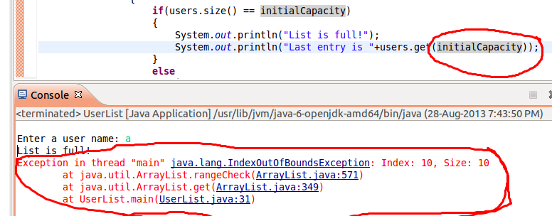

3.putting break points

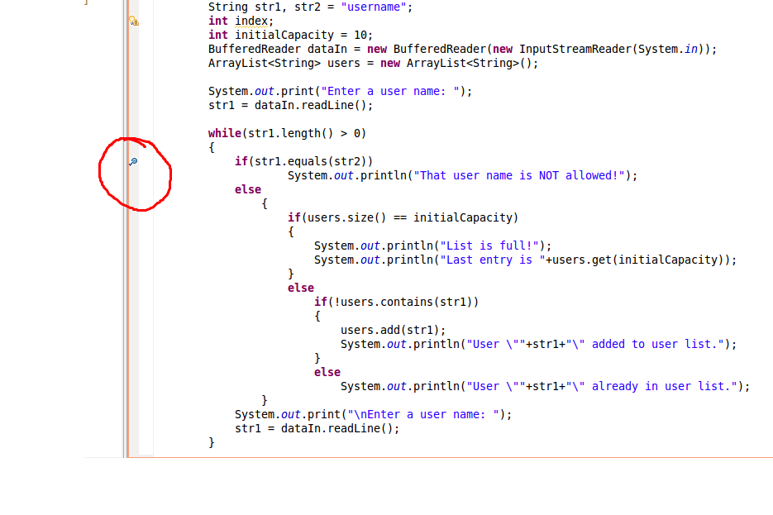

4.Values added to the array

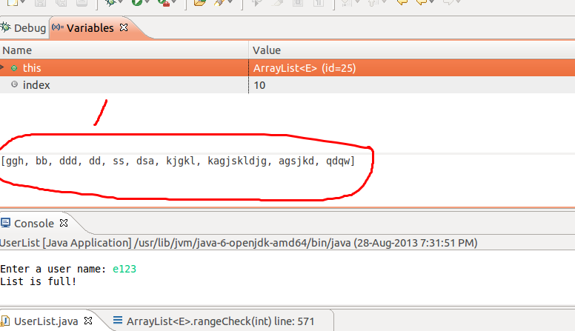

submitted by:-
Sandeep Kumar Gupta

