NODE.JS AUTHENTICATION WEB APPLICATION

Project Title: Node.js Web Application with Authentication

Course: Web Programming (Seminar Homework)

Student Name: ___________________________

Matric Number: ___________________________

Lecturer Name: ___________________________

Department: ___________________________

Institution: ___________________________

Submission Date: ___________________________

PROJECT DESCRIPTION

This seminar project focuses on creating a Node.js web application

with authentication features such as Register, Login, and Dashboard.

The application was built using Express.js, EJS templates, MySQL

database (hosted on Railway), bcrypt for password hashing, and

deployment on Render cloud hosting.

The aim of this project is to demonstrate practical knowledge of:

✔ Server-side programming with Node.js

✔ Secure authentication using bcrypt

✔ Database integration using MySQL

✔ Cloud deployment using Render

✔ Responsive UI using Tailwind CSS

All steps of development are documented with explanations and screenshots across the following sections

This project is a practical implementation of a Node.js web application with user authentication features (Register, Login, Logout, and Dashboard). The main purpose of this work is to understand how server-side web development works using Express.js, EJS templating, MySQL cloud database (Railway), and deployment via Render.com.

In this documentation, I explain all the steps from installation of Node.js, creating a project folder, installing necessary packages, connecting to a cloud database, building authentication (with bcrypt for password hashing), and deploying the final application online. All screenshots are included to show the real implementation on a live server.

The aim of this task is to demonstrate:

- How to create a Node.js server using Express.js

- How to design dynamic frontend pages using EJS

- How to connect Node.js with MySQL database on Railway

- How to implement secure authentication using bcrypt

- How to deploy and host a live web application using Render.com

This project is useful for learning full-stack web development, cloud deployment, and backend programming with JavaScript. It also shows how to solve real-world problems such as database connection errors, deployment challenges, authentication logic, and responsive UI design.

Deployment to render screenshot
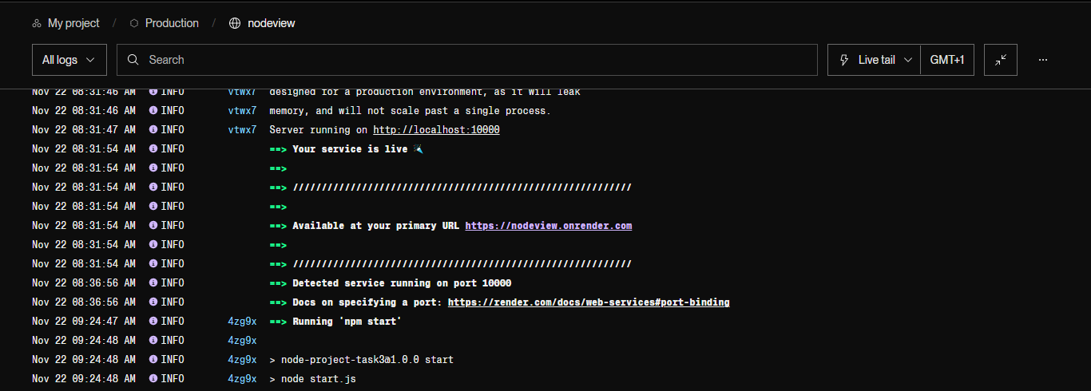

File structure
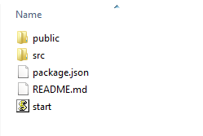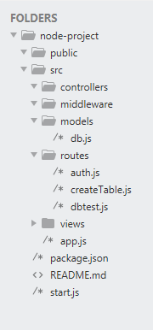

Home screen
This is the home screen where user is going to land at the first app visit
If you take a look at the navigation header there were Register/Login buttons
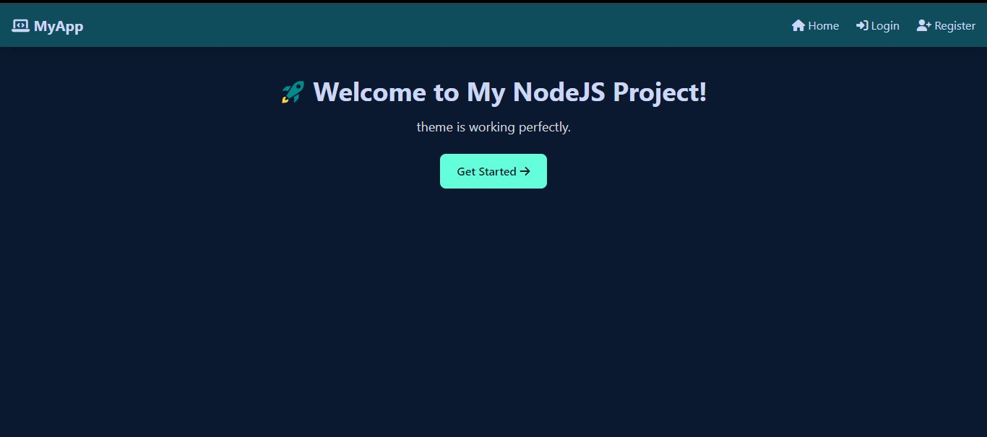

Register Page
User can register via app/register route using responsive form in register.ejs then after registration he will redirected to login page after saving login information in the database , and also the user password was securely encrypted using bcrypt
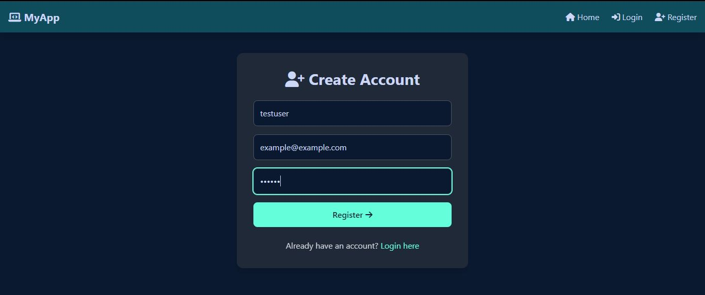

Database table (for storing user details)
I used Railway MySQL as my database for storing datas from my app , as you can see here are some test datas so far,
I.e when ever user input his details from registeration page , the backend was processing it and encrypting the password to hash value and save the data to the database as you can see here.
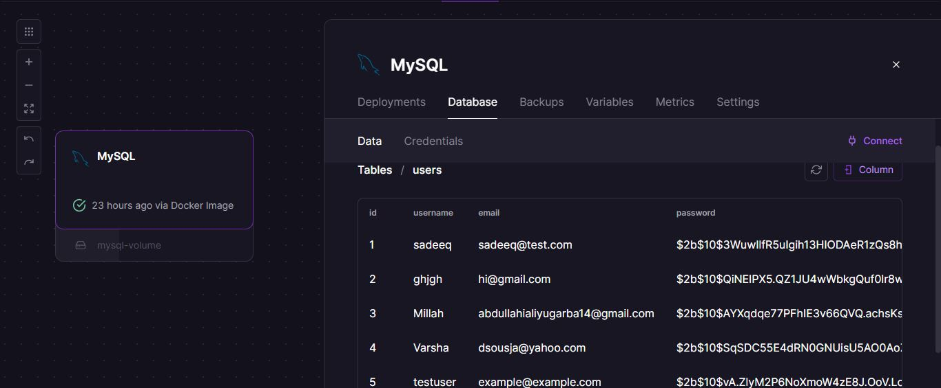

Login page
After user created an account and backend handled the form submission to database , the user was redirected to the login page as you can see here
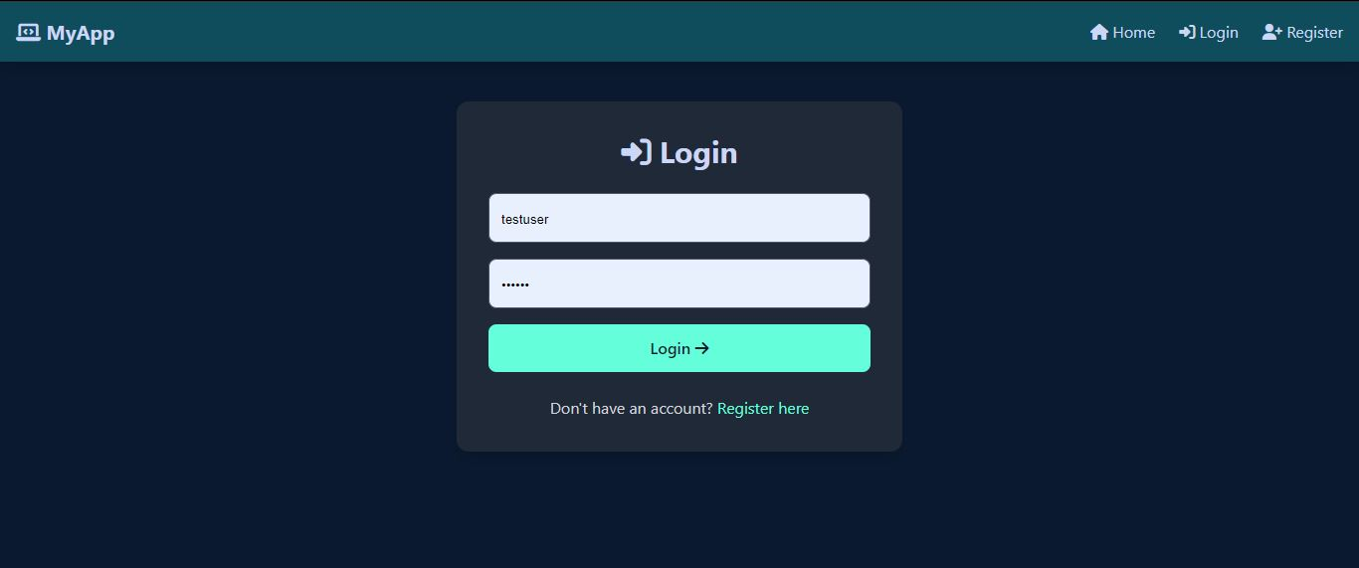

Dashboard screen
After successful Login the user is going to redirect to his dashboard after checking the database and the user is valid this logic I handle by authentication which carried out from auth,js File
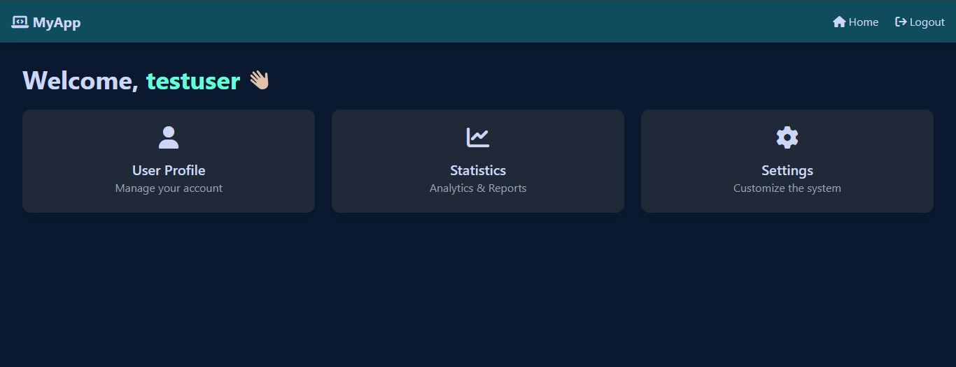

3. Project Structure

To begin the development of this Node.js authentication web application, I created a dedicated project folder on my computer (or on GitHub Codespace). Inside this folder, I initialized the Node.js project using the command:
npm init –y
This generated the `package.json` file which stores project information and dependencies. Next, I installed the required dependencies such as Express.js, EJS, MySQL2, bcrypt, and dotenv. I also organized the project into a clear folder structure including:
- `src/app.js` (main server file)
- `src/routes/` (all route files)
- `src/views/` (EJS pages)
- `src/models/` (database connection)

- `public/` (static CSS, JS, and assets)

After creating the basic structure, I set up Express.js and configured EJS as the template engine. Additionally, I created an `.env` file to store database credentials securely for Railway (MySQL) and Render deployment. This made the project well organized, easy to understand, and ready for further development.

Project Folder Structure Example:

project-folder/

│── src/

│ │── app.js

│ │── routes/

│ │── views/

│ │── models/

│── public/

│── package.json

│── .env

│── README.md

4. Installation of Node.js

To run a Node.js application, Node.js must be installed on the system. In my case, I installed Node.js (version 18+) from the official website: https://nodejs.org

After installation, I opened the terminal (or Git Bash / CMD) and confirmed the installation using the following commands:
node -v
npm -v

These commands are used to verify the version of Node.js and npm (Node Package Manager). Once both versions were displayed, it confirmed that Node.js was successfully installed.

If Node.js is not installed, it can be downloaded manually from the official website or installed using commands such as:

Windows Installer:
Download the .msi installer and follow the setup steps.
For Linux (Ubuntu):
sudo apt update
sudo apt install nodejs
sudo apt install npm

For Mac:
brew install node
After installation, Node.js allows us to run JavaScript on the server, install packages, and manage our authentication web application. This step is very important because without Node.js, the project will not work.

5. Installing Dependencies
After creating the project folder and initializing Node.js using `npm init -y`, the next step was to install all necessary dependencies required for authentication, database connection, and rendering views.

I used the following command to install the dependencies:

npm install express ejs mysql2 dotenv bcrypt express-session

Explanation of each package:

• express – Main web framework for handling routes and requests.
• ejs – Template engine used to display dynamic content on web pages.
• mysql2 – Used to connect Node.js with MySQL database on Railway.
• dotenv – Helps manage secret environment variables securely (.env file).
• bcrypt – Used to hash passwords securely before saving them to the database.
• express-session – Used to manage user login sessions.

These dependencies create the foundation for authentication (register + login), database connection, and secure routing. They are required for building a full Node.js web application with login system.

Additional useful dependencies (optional):
npm install nodemon --save-dev

nodemon helps restart the server automatically while coding. This is useful during development but not required in production.

After installation, all installed packages were automatically added inside the package.json file under the dependencies section.

