ANDROID MOBILE
DEVELOPMENT PROGRAMS
INDEX
Sr  No. | PROGRAMS | Remarks
1. | Write a Program implement TextView, EditText and Button, Checkbox and Radio Button with coding.
2. | Write a Program to Show all Callbacks by using of Activity Life Cycle
3. | Write a Program to Use different Intents in Multiple Activities.
4. | Write a Program to Implement Layouts with coding.
5. | Write a Program to Implement Fragment with coding.
6. | Write a Program to Implement Google Map GPS with coding.
7. | Write a Program to Implement Splash Screen with coding.
8. | Write a Program to Implement Firebase with coding.
9. | Write a Program to Implement Alert Dialog with coding.
10. | Write a Program to Design a View using Date Time Dialog.
11. | Write a Program to Implement Location Mapping with coding.
12. | Write a Program to Implement Image Gallery and Image View.
13. | Write a Program to Implement Drawing 2D with coding.
14. | Write a Program to Implement 3D Graphics with coding.
15. | Write a Program to Implement Audio Player with coding.
16. | Write a Program to Design a UI to Performs basic arithmetic operations (addition, subtraction, multiplication, division) which covers user input, buttons, and event handling.
17. | Write a Program to Design a UI to Play music with basic controls (play, pause, stop) and covers media player APIs and foreground services.
18. | Write a Program to Design a UI to displays a collection of recipes with detailed steps and ingredients using Fragment.
19. | Write a Program to Design a UI for food delivery app that fetches restaurant menus and tracks delivery status.

Program – 1
Write a Program implement TextView, EditText and Button, Checkbox and Radio Button with coding.
Layout XML: activity_main.xml
<?xml version="1.0" encoding="utf-8"?>
<ScrollView xmlns:android="http://schemas.android.com/apk/res/android"
xmlns:tools="http://schemas.android.com/tools"
android:layout_width="match_parent"
android:layout_height="match_parent"
android:background="#DDE1E8"
android:fillViewport="true"
tools:context=".MainActivity">

<LinearLayout
android:layout_width="match_parent"
android:layout_height="wrap_content"
android:orientation="vertical"
android:padding="28dp">

<LinearLayout
android:layout_width="match_parent"
android:layout_height="wrap_content"
android:orientation="horizontal"
android:gravity="center_vertical"
android:layout_marginTop="36dp"
android:layout_marginBottom="28dp">

<TextView
android:layout_width="0dp"
android:layout_height="wrap_content"
android:layout_weight="1"
android:text="TextView"
android:textColor="@color/black"
android:textSize="20sp" />

<TextView
android:id="@+id/tvDisplay"
android:layout_width="wrap_content"
android:layout_height="wrap_content"
android:background="@drawable/bg_rounded_white"
android:elevation="2dp"
android:paddingLeft="24dp"
android:paddingTop="10dp"
android:paddingRight="24dp"
android:paddingBottom="10dp"
android:text="User X"
android:textColor="@color/black"
android:textSize="20sp"
android:textStyle="bold" />
</LinearLayout>

<LinearLayout
android:layout_width="match_parent"
android:layout_height="wrap_content"
android:orientation="horizontal"
android:gravity="center_vertical"
android:layout_marginBottom="28dp">

<TextView
android:layout_width="0dp"
android:layout_height="wrap_content"
android:layout_weight="1"
android:text="Edit Text"
android:textColor="@color/black"
android:textSize="20sp" />

<EditText
android:id="@+id/etClass"
android:layout_width="160dp"
android:layout_height="wrap_content"
android:hint="Enter Your Class"
android:inputType="textPersonName"
android:textColor="@color/black"
android:textColorHint="@color/gray"
android:textSize="18sp" />
</LinearLayout>

<LinearLayout
android:layout_width="match_parent"
android:layout_height="wrap_content"
android:orientation="horizontal"
android:gravity="center_vertical"
android:layout_marginBottom="28dp">

<TextView
android:layout_width="0dp"
android:layout_height="wrap_content"
android:layout_weight="1"
android:text="RadioButton"
android:textColor="@color/black"
android:textSize="20sp" />

<RadioGroup
android:id="@+id/radioGroupGender"
android:layout_width="wrap_content"
android:layout_height="wrap_content"
android:orientation="horizontal">

<RadioButton
android:id="@+id/rbMale"
android:layout_width="wrap_content"
android:layout_height="wrap_content"
android:text="M"
android:textColor="@color/black"
android:textSize="18sp" />

<RadioButton
android:id="@+id/rbFemale"
android:layout_width="wrap_content"
android:layout_height="wrap_content"
android:layout_marginStart="24dp"
android:text="F"
android:textColor="@color/black"
android:textSize="18sp" />
</RadioGroup>
</LinearLayout>

<LinearLayout
android:layout_width="match_parent"
android:layout_height="wrap_content"
android:orientation="horizontal"
android:gravity="center_vertical"
android:layout_marginBottom="36dp">

<TextView
android:layout_width="0dp"
android:layout_height="wrap_content"
android:layout_weight="1"
android:text="CheckBox"
android:textColor="@color/black"
android:textSize="20sp" />

<CheckBox
android:id="@+id/cbDeclaration"
android:layout_width="wrap_content"
android:layout_height="wrap_content"
android:text="Self Declaration"
android:textColor="@color/black"
android:textSize="18sp" />
</LinearLayout>

<Button
android:id="@+id/btnSubmit"
android:layout_width="wrap_content"
android:layout_height="wrap_content"
android:layout_gravity="center_horizontal"
android:backgroundTint="@color/purple_500"
android:paddingLeft="36dp"
android:paddingTop="12dp"
android:paddingRight="36dp"
android:paddingBottom="12dp"
android:text="SUBMIT"
android:textAllCaps="true"
android:textColor="@color/white"
android:textSize="16sp"
android:textStyle="bold" />

<TextView
android:id="@+id/tvResult"
android:layout_width="match_parent"
android:layout_height="wrap_content"
android:layout_marginTop="32dp"
android:background="@drawable/bg_rounded_white"
android:lineSpacingExtra="4dp"
android:padding="16dp"
android:textColor="@color/black"
android:textSize="16sp"
android:visibility="gone" />

</LinearLayout>
</ScrollView>

Java Code: MainActivity.java

package com.example.program1;

import androidx.appcompat.app.AppCompatActivity;
import android.os.Bundle;
import android.view.View;
import android.widget.Button;
import android.widget.CheckBox;
import android.widget.EditText;
import android.widget.RadioButton;
import android.widget.RadioGroup;
import android.widget.TextView;
import android.widget.Toast;

public class MainActivity extends AppCompatActivity {

private TextView tvDisplay;
private EditText etClass;
private RadioGroup radioGroupGender;
private RadioButton rbMale, rbFemale;
private CheckBox cbDeclaration;
private Button btnSubmit;
private TextView tvResult;

@Override
protected void onCreate(Bundle savedInstanceState) {
super.onCreate(savedInstanceState);
setContentView(R.layout.activity_main);

tvDisplay = findViewById(R.id.tvDisplay);
etClass = findViewById(R.id.etClass);
radioGroupGender = findViewById(R.id.radioGroupGender);
rbMale = findViewById(R.id.rbMale);
rbFemale = findViewById(R.id.rbFemale);
cbDeclaration = findViewById(R.id.cbDeclaration);
btnSubmit = findViewById(R.id.btnSubmit);
tvResult = findViewById(R.id.tvResult);

btnSubmit.setOnClickListener(new View.OnClickListener() {
@Override
public void onClick(View v) {
String userName = tvDisplay.getText().toString().trim();
String userClass = etClass.getText().toString().trim();

String gender = "Not Selected";
int selectedRadioId = radioGroupGender.getCheckedRadioButtonId();
if (selectedRadioId == R.id.rbMale) {
gender = "Male (M)";
} else if (selectedRadioId == R.id.rbFemale) {
gender = "Female (F)";
}

boolean isDeclared = cbDeclaration.isChecked();
String declarationStatus = isDeclared ? "Accepted" : "Not Accepted";

if (userClass.isEmpty()) {
etClass.setError("Please enter your class");
return;
}

String resultMessage = "=== Submitted Details ===\n" +
"Name: " + userName + "\n" +
"Class: " + userClass + "\n" +
"Gender: " + gender + "\n" +
"Self Declaration: " + declarationStatus;

Toast.makeText(MainActivity.this, "Submitted Successfully!", Toast.LENGTH_SHORT).show();

tvResult.setText(resultMessage);
tvResult.setVisibility(View.VISIBLE);
}
});
}
}

Output:
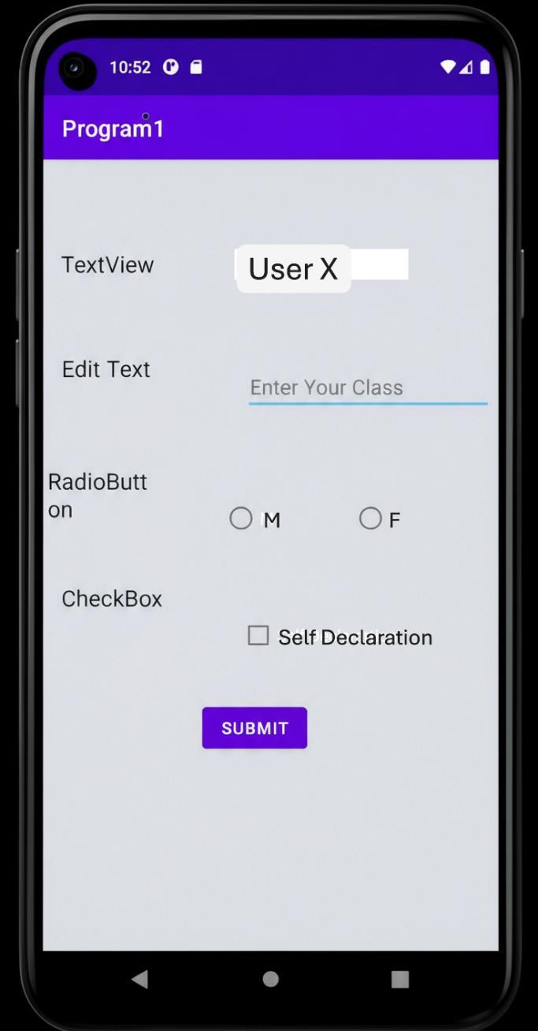

Program -2
Write a Program to Show all Callbacks by using of Activity Life Cycle
Layout File: activity_main.xml
<?xml version="1.0" encoding="utf-8"?>
<androidx.constraintlayout.widget.ConstraintLayout
xmlns:android="http://schemas.android.com/apk/res/android"
xmlns:app="http://schemas.android.com/apk/res-auto"
xmlns:tools="http://schemas.android.com/tools"
android:layout_width="match_parent"
android:layout_height="match_parent"
android:background="@color/white"
tools:context=".MainActivity">

<TextView
android:id="@+id/textView"
android:layout_width="wrap_content"
android:layout_height="wrap_content"
android:text="ACTIVITY LIFECYCLE"
android:textColor="#555555"
android:textSize="30sp"
app:layout_constraintBottom_toBottomOf="parent"
app:layout_constraintEnd_toEndOf="parent"
app:layout_constraintStart_toStartOf="parent"
app:layout_constraintTop_toTopOf="parent" />

</androidx.constraintlayout.widget.ConstraintLayout>

Java Code: MainActivity.java
package com.example.program2;

import androidx.appcompat.app.AppCompatActivity;
import android.os.Bundle;
import android.util.Log;
import android.widget.Toast;

public class MainActivity extends AppCompatActivity {

@Override
protected void onCreate(Bundle savedInstanceState) {
super.onCreate(savedInstanceState);
setContentView(R.layout.activity_main);
System.out.println("onCreate invoked");
Log.d("Lifecycle", "onCreate invoked");
Toast.makeText(this, "onCreate invoked", Toast.LENGTH_SHORT).show();
}

@Override
protected void onStart() {
super.onStart();
System.out.println("onStart invoked");
Log.d("Lifecycle", "onStart invoked");
Toast.makeText(this, "onStart invoked", Toast.LENGTH_SHORT).show();
}

@Override
protected void onResume() {
super.onResume();
System.out.println("onResume invoked");
Log.d("Lifecycle", "onResume invoked");
Toast.makeText(this, "onResume invoked", Toast.LENGTH_SHORT).show();
}

@Override
protected void onPause() {
super.onPause();
System.out.println("onPause invoked");
Log.d("Lifecycle", "onPause invoked");
Toast.makeText(this, "onPause invoked", Toast.LENGTH_SHORT).show();
}

@Override
protected void onStop() {
super.onStop();
System.out.println("onStop invoked");
Log.d("Lifecycle", "onStop invoked");
Toast.makeText(this, "onStop invoked", Toast.LENGTH_SHORT).show();
}

@Override
protected void onRestart() {
super.onRestart();
System.out.println("onRestart invoked");
Log.d("Lifecycle", "onRestart invoked");
Toast.makeText(this, "onRestart invoked", Toast.LENGTH_SHORT).show();
}

@Override
protected void onDestroy() {
super.onDestroy();
System.out.println("onDestroy invoked");
Log.d("Lifecycle", "onDestroy invoked");
Toast.makeText(this, "onDestroy invoked", Toast.LENGTH_SHORT).show();
}
}
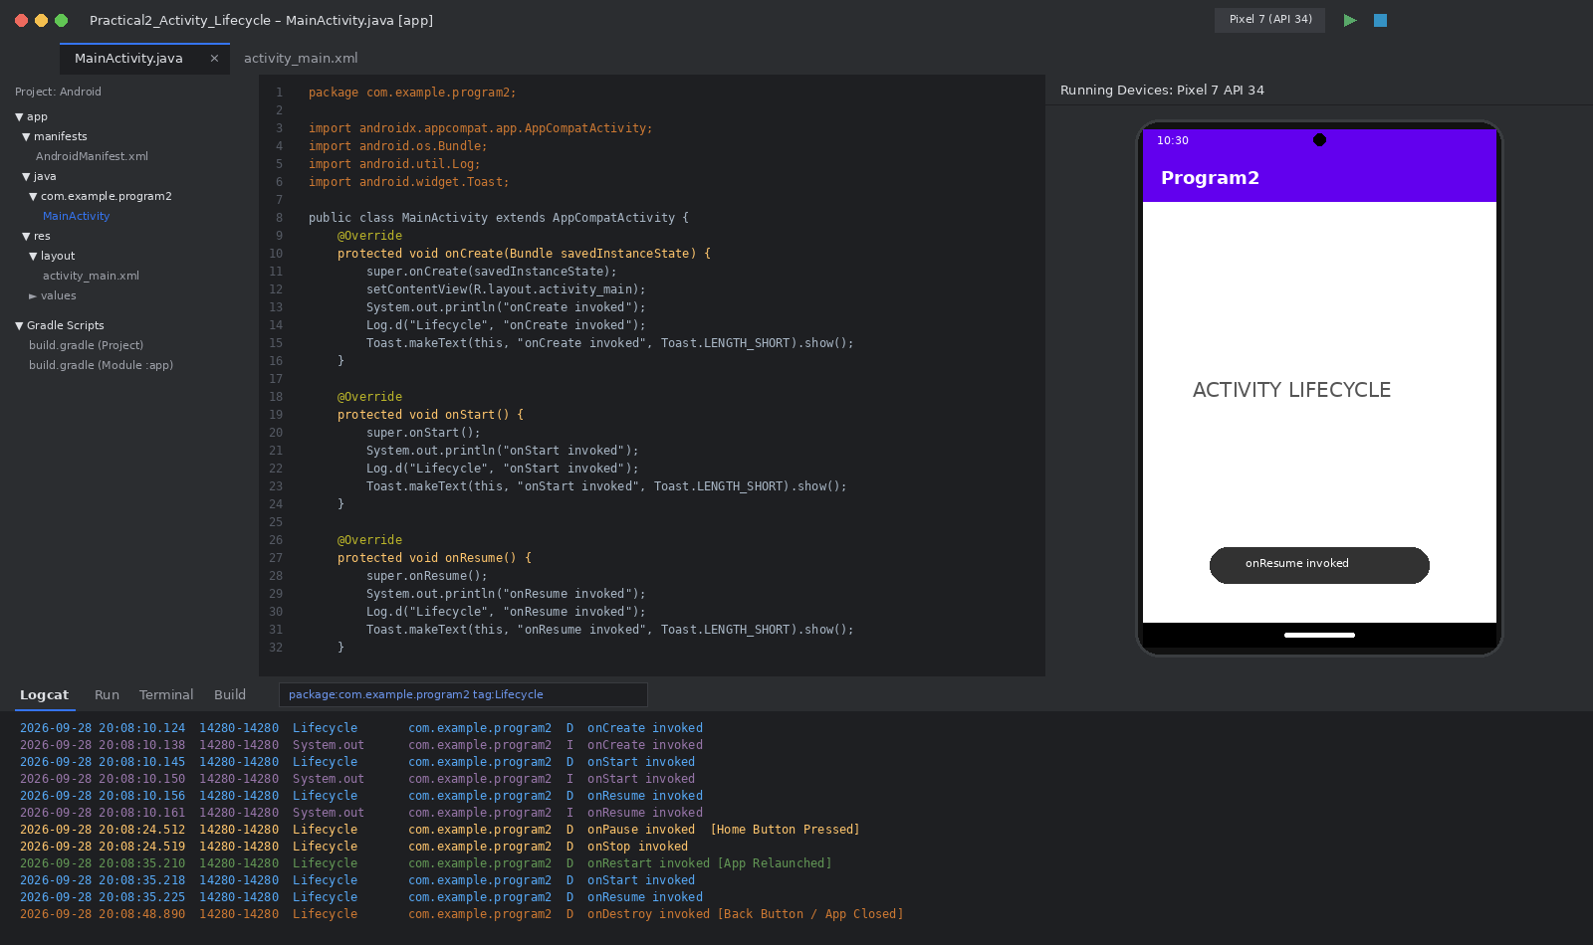

Program – 3
Write a Program to Use different Intents in Multiple Activities.
Layout XML: activity_main.xml
<?xml version="1.0" encoding="utf-8"?>
<androidx.constraintlayout.widget.ConstraintLayout
xmlns:android="http://schemas.android.com/apk/res/android"
xmlns:app="http://schemas.android.com/apk/res-auto"
xmlns:tools="http://schemas.android.com/tools"
android:layout_width="match_parent"
android:layout_height="match_parent"
tools:context=".MainActivity">
<Button
android:id="@+id/button"
android:layout_width="wrap_content"
android:layout_height="wrap_content"
android:layout_marginTop="68dp"
android:backgroundTint="#79E6C7"
android:text="Go to ACTIVITY 2"
app:layout_constraintEnd_toEndOf="parent"
app:layout_constraintStart_toStartOf="parent"
app:layout_constraintTop_toBottomOf="@+id/textView2" />
<TextView
android:id="@+id/textView2"
android:layout_width="wrap_content"
android:layout_height="wrap_content"
android:text="ACTIVITY 1"
android:textSize="34sp"
app:layout_constraintBottom_toBottomOf="parent"
app:layout_constraintEnd_toEndOf="parent"
app:layout_constraintHorizontal_bias="0.495"
app:layout_constraintStart_toStartOf="parent"
app:layout_constraintTop_toTopOf="parent"
app:layout_constraintVertical_bias="0.36" />
</androidx.constraintlayout.widget.ConstraintLayout>

Java Code: MainActivity.java
package com.example.program3;
import androidx.appcompat.app.AppCompatActivity;
import android.content.Intent;
import android.os.Bundle;
import android.view.View;
import android.widget.Button;
public class MainActivity extends AppCompatActivity {
@Override
protected void onCreate(Bundle savedInstanceState) {
super.onCreate(savedInstanceState);
setContentView(R.layout.activity_main);
Button b1 = findViewById(R.id.button);
b1.setOnClickListener(new View.OnClickListener() {
@Override
public void onClick(View view) {
switchActivity();
}

});
}
private void switchActivity(){
Intent i = new Intent(this, MainActivity2.class);
startActivity(i);
}
}

Layout XML: activity_main2.xml
<?xml version="1.0" encoding="utf-8"?>
<androidx.constraintlayout.widget.ConstraintLayout
xmlns:android="http://schemas.android.com/apk/res/android"
xmlns:app="http://schemas.android.com/apk/res-auto"
xmlns:tools="http://schemas.android.com/tools"
android:layout_width="match_parent"
android:layout_height="match_parent"
tools:context=".MainActivity2">
<Button
android:id="@+id/button2"
android:layout_width="wrap_content"
android:layout_height="wrap_content"
android:backgroundTint="#FF6363"
android:text="Go to ACTIVITY 1"
app:layout_constraintBottom_toBottomOf="parent"
app:layout_constraintEnd_toEndOf="parent"
app:layout_constraintStart_toStartOf="parent"
app:layout_constraintTop_toTopOf="parent"
app:layout_constraintVertical_bias="0.563" />
<TextView
android:id="@+id/textView"
android:layout_width="wrap_content"
android:layout_height="wrap_content"
android:text="ACTIVITY 2"
android:textSize="34sp"
app:layout_constraintBottom_toBottomOf="parent"
app:layout_constraintEnd_toEndOf="parent"
app:layout_constraintHorizontal_bias="0.495"
app:layout_constraintStart_toStartOf="parent"
app:layout_constraintTop_toTopOf="parent"
app:layout_constraintVertical_bias="0.428" />
</androidx.constraintlayout.widget.ConstraintLayout>

Java Code: MainActivity2.java
package com.example.program3;
import androidx.appcompat.app.AppCompatActivity;
import android.content.Intent;
import android.os.Bundle;
import android.view.View;
import android.widget.Button;

import com.example.practical1.R;

public class MainActivity2 extends AppCompatActivity {
@Override
protected void onCreate(Bundle savedInstanceState) {
super.onCreate(savedInstanceState);
setContentView(R.layout.activity_main2);
Button b1 = findViewById(R.id.button2);
b1.setOnClickListener(new View.OnClickListener() {
@Override
public void onClick(View view) {
switchActivity();
}
});
}
private void switchActivity(){
Intent i = new Intent(this, MainActivity.class);
startActivity(i);
}
}

Output:
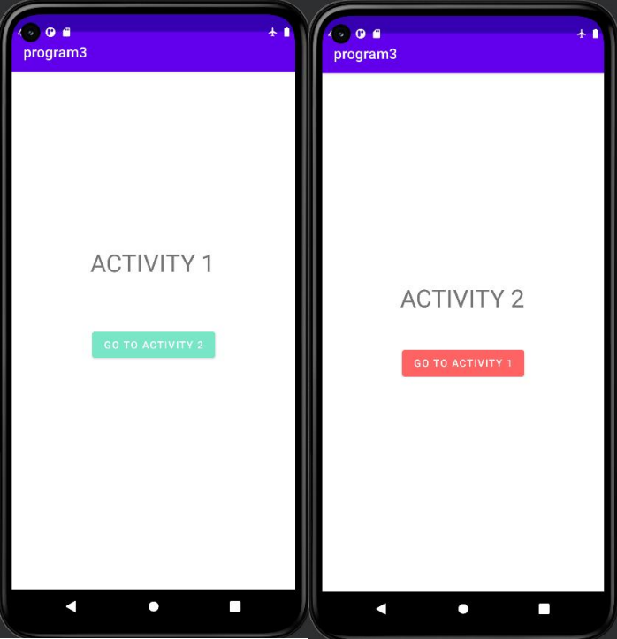

Program – 4
Write a Program to Implement Layouts with coding.
Layout XML: activity_main.xml
<?xml version="1.0" encoding="utf-8"?>
<androidx.constraintlayout.widget.ConstraintLayout
xmlns:android="http://schemas.android.com/apk/res/android"
xmlns:app="http://schemas.android.com/apk/res-auto"
xmlns:tools="http://schemas.android.com/tools"
android:layout_width="match_parent"
android:layout_height="match_parent"
tools:context=".MainActivity">
<LinearLayout
android:id="@+id/linearLayout"
android:layout_width="0dp"
android:layout_height="0dp"
android:layout_marginStart="1dp"
android:layout_marginEnd="1dp"
android:layout_marginBottom="1dp"
android:orientation="vertical"
app:layout_constraintBottom_toTopOf="@+id/tableLayout"
app:layout_constraintEnd_toEndOf="parent"
app:layout_constraintStart_toStartOf="parent"
app:layout_constraintTop_toTopOf="parent">
<TextView
android:id="@+id/textView"
android:layout_width="match_parent"
android:layout_height="wrap_content"
android:gravity="center"
android:text="Linear Layout"
android:textSize="34sp" />
<Button
android:id="@+id/button"
android:layout_width="match_parent"
android:layout_height="wrap_content"
android:text="Button" />
<Button
android:id="@+id/button2"
android:layout_width="match_parent"
android:layout_height="wrap_content"
android:text="Button" />
<Button
android:id="@+id/button3"
android:layout_width="match_parent"
android:layout_height="wrap_content"
android:text="Button" />
<Button
android:id="@+id/button4"
android:layout_width="match_parent"
android:layout_height="wrap_content"
android:text="Button" />
<Button
android:id="@+id/button10"
android:layout_width="match_parent"
android:layout_height="wrap_content"
android:text="Button" />

<TextView
android:id="@+id/textView2"
android:layout_width="419dp"
android:layout_height="wrap_content"
android:gravity="center"
android:text="Table Layout"
android:textSize="34sp" />
</LinearLayout>
<TableLayout
android:id="@+id/tableLayout"
android:layout_width="407dp"
android:layout_height="392dp"
android:layout_marginStart="1dp"
android:layout_marginEnd="1dp"
android:layout_marginBottom="1dp"
app:layout_constraintBottom_toBottomOf="parent"
app:layout_constraintEnd_toEndOf="parent"
app:layout_constraintHorizontal_bias="0.0"
app:layout_constraintStart_toStartOf="parent"
app:layout_constraintTop_toBottomOf="@+id/linearLayout">
<TableRow
android:layout_width="match_parent"
android:layout_height="match_parent">
</TableRow>
<TableRow
android:layout_width="match_parent"
android:layout_height="73dp">
<Button
android:id="@+id/button6"
android:layout_width="wrap_content"
android:layout_height="wrap_content"
android:width="105dp"
android:text="Button" />
<Button
android:id="@+id/button11"
android:layout_width="wrap_content"
android:layout_height="wrap_content"
android:width="105dp"
android:text="Button" />
<Button
android:id="@+id/button12"
android:layout_width="wrap_content"
android:layout_height="wrap_content"
android:width="105dp"
android:text="Button" />
<Button
android:id="@+id/button13"
android:layout_width="wrap_content"
android:layout_height="wrap_content"
android:width="105dp"
android:text="Button" />
</TableRow>
<TableRow
android:layout_width="match_parent"
android:layout_height="match_parent">
<Button

android:id="@+id/button14"
android:layout_width="wrap_content"
android:layout_height="wrap_content"
android:width="105dp"
android:text="Button" />
<Button
android:id="@+id/button15"
android:layout_width="wrap_content"
android:layout_height="wrap_content"
android:width="105dp"
android:text="Button" />
<Button
android:id="@+id/button16"
android:layout_width="wrap_content"
android:layout_height="wrap_content"
android:width="105dp"
android:text="Button" />
<Button
android:id="@+id/button17"
android:layout_width="wrap_content"
android:layout_height="wrap_content"
android:width="105dp"
android:text="Button" />
</TableRow>
<TableRow
android:layout_width="match_parent"
android:layout_height="match_parent">
<Button
android:id="@+id/button18"
android:layout_width="wrap_content"
android:layout_height="wrap_content"
android:width="105dp"
android:text="Button" />
<Button
android:id="@+id/button19"
android:layout_width="wrap_content"
android:layout_height="wrap_content"
android:width="105dp"
android:text="Button" />
<Button
android:id="@+id/button20"
android:layout_width="wrap_content"
android:layout_height="wrap_content"
android:width="105dp"
android:text="Button" />
<Button
android:id="@+id/button21"
android:layout_width="wrap_content"
android:layout_height="wrap_content"
android:width="105dp"
android:text="Button" />
</TableRow>
</TableLayout>
</androidx.constraintlayout.widget.ConstraintLayout>

Java Code: MainActivity.java
package com.example.Practical1;
import androidx.appcompat.app.AppCompatActivity;
import android.os.Bundle;

import com.example.practical1.R;

public class MainActivity extends AppCompatActivity {
@Override
protected void onCreate(Bundle savedInstanceState) {
super.onCreate(savedInstanceState);
setContentView(R.layout.activity_main);
}
}

Output:
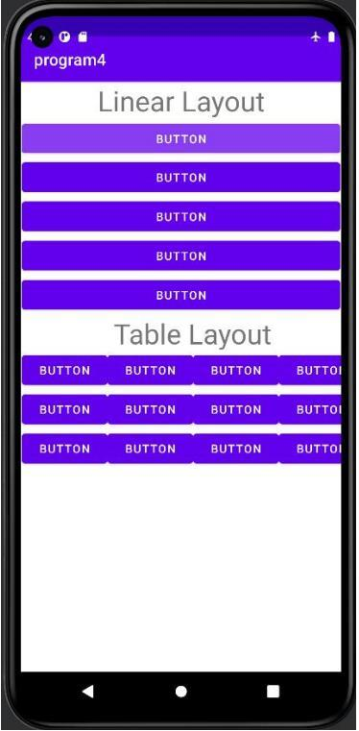

Program – 5
Write a Program to Implement Fragment with coding.
Layout XML: activity_main.xml
<?xml version="1.0" encoding="utf-8"?>
<androidx.constraintlayout.widget.ConstraintLayout
xmlns:android="http://schemas.android.com/apk/res/android"
xmlns:app="http://schemas.android.com/apk/res-auto"
xmlns:tools="http://schemas.android.com/tools"
android:layout_width="match_parent"
android:layout_height="match_parent"
tools:context=".MainActivity">
<LinearLayout
android:id="@+id/linearLayout"
android:layout_width="0dp"
android:layout_height="59dp"
android:layout_marginTop="1dp"
android:orientation="horizontal"
app:layout_constraintEnd_toEndOf="parent"
app:layout_constraintStart_toStartOf="parent"
app:layout_constraintTop_toTopOf="parent">
<Button
android:id="@+id/button"
android:layout_width="wrap_content"
android:layout_height="wrap_content"
android:layout_weight="1"
android:backgroundTint="#691480"
android:text="Fragment 1" />
<Button
android:id="@+id/button2"
android:layout_width="wrap_content"
android:layout_height="wrap_content"
android:layout_weight="1"
android:backgroundTint="#6B9E19"
android:text="Fragment 2" />
</LinearLayout>
<LinearLayout
android:id="@+id/linearLayout2"
android:layout_width="0dp"
android:layout_height="664dp"
android:layout_marginTop="77dp"
android:orientation="vertical"
app:layout_constraintEnd_toEndOf="parent"
app:layout_constraintStart_toStartOf="parent"
app:layout_constraintTop_toTopOf="parent"></LinearLayout>
</androidx.constraintlayout.widget.ConstraintLayout>

Java Code: MainActivity.java
package com.example.program5;
import androidx.appcompat.app.AppCompatActivity;
import androidx.fragment.app.Fragment;
import androidx.fragment.app.FragmentTransaction;
import android.os.Bundle;
import android.view.View;

import android.widget.Button;
import android.widget.LinearLayout;

import com.example.practical1.R;

public class MainActivity extends AppCompatActivity {
@Override
protected void onCreate(Bundle savedInstanceState) {
super.onCreate(savedInstanceState);
setContentView(R.layout.activity_main);
Button b1 = findViewById(R.id.button);
Button b2 = findViewById(R.id.button2);
b1.setOnClickListener(new View.OnClickListener() {
@Override
public void onClick(View view) {
FirstFragment f1 = new FirstFragment();
FragmentTransaction transaction =
getSupportFragmentManager().beginTransaction();
transaction.replace(R.id.linearLayout2, f1);
transaction.commit();
}
});
b2.setOnClickListener(new View.OnClickListener() {
@Override
public void onClick(View view) {
SecondFragment f2 = new SecondFragment();
FragmentTransaction transaction =
getSupportFragmentManager().beginTransaction();
transaction.replace(R.id.linearLayout2, f2);
transaction.commit();
}
});
}
}

Layout XML: fragment_first.xml
<?xml version="1.0" encoding="utf-8"?>
<FrameLayout xmlns:android="http://schemas.android.com/apk/res/android"
xmlns:tools="http://schemas.android.com/tools"
android:layout_width="match_parent"
android:layout_height="match_parent"
android:background="#FF6767"
tools:context=".FirstFragment">
<TextView
android:id="@+id/textView"
android:layout_width="match_parent"
android:layout_height="match_parent"
android:gravity="center"
android:text="First Fragment"
android:textColor="#FFFFFF"
android:textSize="34sp" />
</FrameLayout>

Layout XML: fragment_second.xml
<?xml version="1.0" encoding="utf-8"?>
<FrameLayout xmlns:android="http://schemas.android.com/apk/res/android"
xmlns:tools="http://schemas.android.com/tools"
android:layout_width="match_parent"
android:layout_height="match_parent"
android:background="#4CAF50"
tools:context=".SecondFragment">
<!-- TODO: Update blank fragment layout-->
<TextView
android:layout_width="match_parent"
android:layout_height="match_parent"
android:gravity="center"
android:text="Second Fragment"
android:textColor="#FFFFFF"
android:textSize="34sp" />
</FrameLayout>

Output:
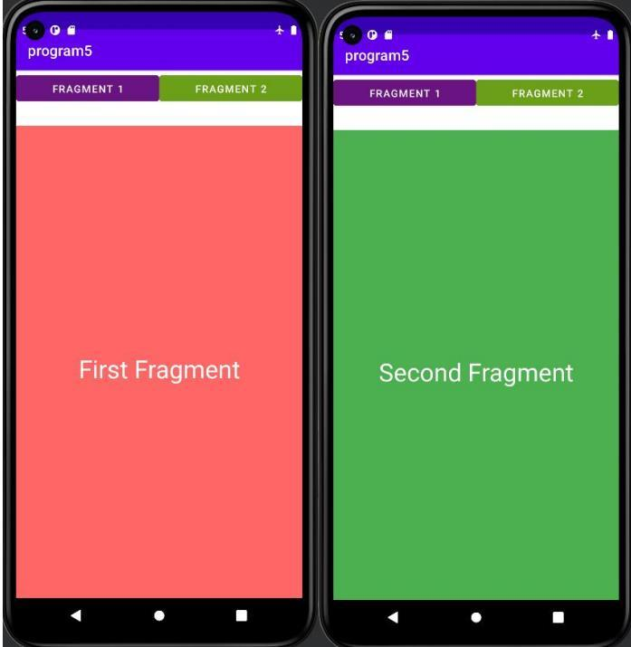

Program – 6
Write a Program to Implement Google Map GPS with coding.
Layout XML: activity_main.xml
<?xml version="1.0" encoding="utf-8"?>
<androidx.constraintlayout.widget.ConstraintLayout
xmlns:android="http://schemas.android.com/apk/res/android"
xmlns:app="http://schemas.android.com/apk/res-auto"
xmlns:tools="http://schemas.android.com/tools"
android:layout_width="match_parent"
android:layout_height="match_parent"
tools:context=".MainActivity"
</androidx.constraintlayout.widget.ConstraintLayout>

XML File: AndroidManifest.xml
<?xml version=”1.0″ encoding=”utf-8″?>
<manifest xmlns:android=”http://schemas.android.com/apk/res/android&#8221;
package=”com.example.mylocation.mylocation”>
<!
The ACCESS_COARSE/FINE_LOCATION permissions are not required to use
Google Maps Android API v2, but you must specify either coarse or fine
location permissions for the ‘MyLocation’ functionality.–>
<uses-permission android:name=”android.permission.ACCESS_FINE_LOCATION” />
<uses-permission android:name=”android.permission.ACCESS_COARSE_LOCATION”/>
<application
android:allowBackup=”true”
android:icon=”@mipmap/ic_launcher”
android:label=”@string/app_name”
android:roundIcon=”@mipmap/ic_launcher_round”
android:supportsRtl=”true”
android:theme=”@style/AppTheme”>
<!
The API key for Google Maps-based APIs is defined as a string resource.
(See the file “res/values/google_maps_api.xml”).
Note that the API key is linked to the encryption key used to sign the
APK.
You need a different API key for each encryption key, including the
release key that is used to
sign the APK for publishing.
You can define the keys for the debug and release targets in src/debug/
and src/release/.–>
<meta-data
android:name=”com.google.android.geo.API_KEY”
android:value=”@string/google_maps_key” />
<activity
android:name=”.MapsActivity”
android:label=”@string/title_activity_maps”>
<intent-filter>
<action android:name=”android.intent.action.MAIN” /><category
android:name=”android.intent.category.LAUNCHER” />
</intent-filter>
</activity>
</application>
</manifest

Layout XML: activity_fragment.xml
<fragment xmlns:android=”http://schemas.android.com/apk/res/android&#8221;
xmlns:map=”http://schemas.android.com/apk/res-auto&#8221;
xmlns:tools=”http://schemas.android.com/tools&#8221;
android:id=”@+id/map”
android:name=”com.google.android.gms.maps.SupportMapFragment”
android:layout_width=”match_parent”
android:layout_height=”match_parent”
tools:context=”com.example.mylocation.mylocation.MapsActivity” />

Java Code: MainActivity.java
package com.example.program11;
import android.Manifest;
import android.content.pm.PackageManager;
import android.location.Location;
import android.location.LocationListener;
import android.location.LocationManager;
import android.support.v4.app.ActivityCompat;
import android.support.v4.app.FragmentActivity;
import android.os.Bundle;
import com.google.android.gms.maps.CameraUpdateFactory;
import com.google.android.gms.maps.GoogleMap;
import com.google.android.gms.maps.OnMapReadyCallback;
import com.google.android.gms.maps.SupportMapFragment;
import com.google.android.gms.maps.model.LatLng;
import com.google.android.gms.maps.model.MarkerOptions;
public class MapsActivity extends FragmentActivity implements
OnMapReadyCallback {
private GoogleMap mMap;
private LocationListener locationListener;
private LocationManager locationManager;
private final long MIN_TIME = 1000; // 1 second
private final long MIN_DIST = 5; // 5 Meters
private LatLng latLng;
@Override
protected void onCreate(Bundle savedInstanceState) {
super.onCreate(savedInstanceState);
setContentView(R.layout.activity_maps);
// Obtain the SupportMapFragment and get notified when the map is
ready to be used.
SupportMapFragment mapFragment = (SupportMapFragment)
getSupportFragmentManager()
.findFragmentById(R.id.map);
mapFragment.getMapAsync(this);
ActivityCompat.requestPermissions(this, new
String[]{Manifest.permission.ACCESS_FINE_LOCATION},
PackageManager.PERMISSION_GRANTED);
ActivityCompat.requestPermissions(this, new
String[]{Manifest.permission.ACCESS_COARSE_LOCATION},
PackageManager.PERMISSION_GRANTED);
}
* installed Google Play services and returned to the app.
*/

@Override
public void onMapReady(GoogleMap googleMap) {
mMap=googleMap;
LatLng sydney = new LatLng(-34, 151);
mMap.addMarker(new MarkerOptions().position(sydney).title(“Marker in
Sydney”));
mMap.moveCamera(CameraUpdateFactory.newLatLng(sydney));
locationListener = new LocationListener() {
@Override
public void onLocationChanged(Location location) {
try {
latLng = new LatLng(location.getLatitude(),
location.getLongitude());
mMap.addMarker(new
MarkerOptions().position(latLng).title(“My Position”));
mMap.moveCamera(CameraUpdateFactory.newLatLng(latLng));
}
catch (SecurityException e){
e.printStackTrace();
}
}
@Override
public void onStatusChanged(String s, int i, Bundle bundle) {
}
@Override
public void onProviderEnabled(String s) {
}
@Override
public void onProviderDisabled(String s) {
}
};
locationManager = (LocationManager)
getSystemService(LOCATION_SERVICE);
try {

locationManager.requestLocationUpdates(LocationManager.GPS_PROVIDER,
MIN_TIME, MIN_DIST,
locationListener);
}
catch (SecurityException e){
e.printStackTrace();
}
}
}

Output:
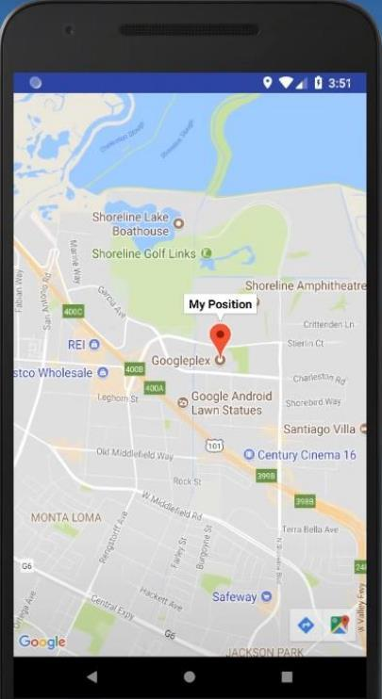

Program – 7
Write a Program to Implement Splash Screen with coding.
Layout XML: activity_splashactivity.xml
<?xml version="1.0" encoding="utf-8"?>
<RelativeLayout
xmlns:android="http://schemas.android.com/apk/res/android"
xmlns:tools="http://schemas.android.com/tools"
xmlns:app="http://schemas.android.com/apk/res-auto"
android:layout_width="match_parent"
android:layout_height="match_parent"
tools:context=".Splashactivity">
<ImageView
android:id="@+id/imageView4"
android:layout_width="wrap_content"
android:layout_height="wrap_content"
android:layout_alignParentTop="true"
android:layout_marginTop="-84dp"
app:srcCompat="@drawable/insta3" />
</RelativeLayout>

Java Code: splashActivity.java
package com.example.insta_clone;
import androidx.appcompat.app.AppCompatActivity;
import android.content.Intent;
import android.os.Bundle;
public class Splashactivity extends AppCompatActivity {
@Override
protected void onCreate(Bundle savedInstanceState) {
super.onCreate(savedInstanceState);
setContentView(R.layout.activity_splashactivity);
getSupportActionBar().hide();
Thread th = new Thread()
{
public void run(){
try{
sleep(4000);
}
catch(Exception e){
e.printStackTrace();
}
finally {
Intent intent= new
Intent(Splashactivity.this,login_page.class);
startActivity(intent);
}
}
};
th.start();
}
}

Layout XML: activity_main.xml
<?xml version="1.0" encoding="utf-8"?>
<androidx.constraintlayout.widget.ConstraintLayout
xmlns:android="http://schemas.android.com/apk/res/android"
xmlns:app="http://schemas.android.com/apk/res-auto"
android:id="@+id/container"
android:layout_width="match_parent"
android:layout_height="match_parent"
android:paddingTop="?attr/actionBarSize">
<com.google.android.material.bottomnavigation.BottomNavigationView
android:id="@+id/nav_view"
android:layout_width="0dp"
android:layout_height="wrap_content"
android:layout_marginStart="0dp"
android:layout_marginEnd="0dp"
android:background="?android:attr/windowBackground"
app:layout_constraintBottom_toBottomOf="parent"
app:layout_constraintLeft_toLeftOf="parent"
app:layout_constraintRight_toRightOf="parent"
app:menu="@menu/bottom_nav_menu" />
<fragment
android:id="@+id/nav_host_fragment_activity_main"
android:name="androidx.navigation.fragment.NavHostFragment"
android:layout_width="match_parent"
android:layout_height="match_parent"
app:defaultNavHost="true"
app:layout_constraintBottom_toTopOf="@id/nav_view"
app:layout_constraintLeft_toLeftOf="parent"
app:layout_constraintRight_toRightOf="parent"
app:layout_constraintTop_toTopOf="parent"
app:navGraph="@navigation/mobile_navigation" />
</androidx.constraintlayout.widget.ConstraintLayout>

Java Code: MainActivity.java
package com.example.insta_clone;
import android.os.Bundle;
import com.google.android.material.bottomnavigation.BottomNavigationView;
import androidx.appcompat.app.AppCompatActivity;
import androidx.navigation.NavController;
import androidx.navigation.Navigation;
import androidx.navigation.ui.AppBarConfiguration;
import androidx.navigation.ui.NavigationUI;
import com.example.insta_clone.databinding.ActivityMainBinding;
public class MainActivity extends AppCompatActivity {
private ActivityMainBinding binding;
@Override
protected void onCreate(Bundle savedInstanceState) {
super.onCreate(savedInstanceState);
binding = ActivityMainBinding.inflate(getLayoutInflater());
setContentView(binding.getRoot());
BottomNavigationView navView = findViewById(R.id.nav_view);
// Passing each menu ID as a set of Ids because each
// menu should be considered as top level destinations.

AppBarConfiguration appBarConfiguration = new
AppBarConfiguration.Builder(
R.id.navigation_home, R.id.navigation_dashboard,
R.id.navigation_notifications)
.build();
NavController navController = Navigation.findNavController(this,
R.id.nav_host_fragment_activity_main);
NavigationUI.setupActionBarWithNavController(this, navController,
appBarConfiguration);
NavigationUI.setupWithNavController(binding.navView, navController);
}
}

Output:
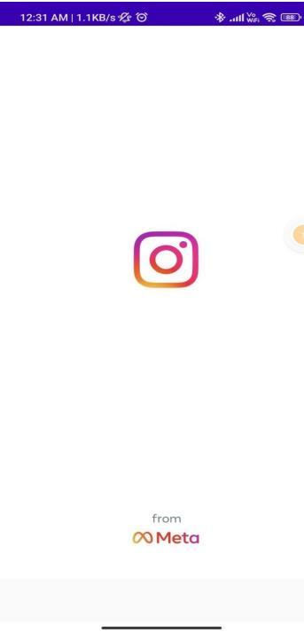
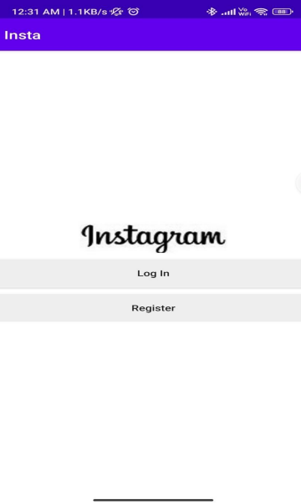

Program – 8
Write a Program to Implement Firebase with coding.
Layout XML: activity_main.xml
<?xml version="1.0" encoding="utf-8"?>
<androidx.constraintlayout.widget.ConstraintLayout
xmlns:android="http://schemas.android.com/apk/res/android"
xmlns:app="http://schemas.android.com/apk/res-auto"
xmlns:tools="http://schemas.android.com/tools"
android:layout_width="match_parent"
android:layout_height="match_parent"
tools:context=".MainActivity">
<Button
android:id="@+id/button"
android:layout_width="0dp"
android:layout_height="wrap_content"
android:layout_marginStart="8dp"
android:layout_marginEnd="8dp"
android:onClick="logout"
android:text="Logout"
app:layout_constraintBottom_toBottomOf="parent"
app:layout_constraintEnd_toEndOf="parent"
app:layout_constraintHorizontal_bias="0.0"
app:layout_constraintStart_toStartOf="parent"
app:layout_constraintTop_toBottomOf="@+id/resetPasswordLocal" />
<ImageView
android:id="@+id/profileImage"
android:layout_width="150dp"
android:layout_height="150dp"
app:layout_constraintBottom_toBottomOf="parent"
app:layout_constraintEnd_toEndOf="parent"
app:layout_constraintStart_toStartOf="parent"
app:layout_constraintTop_toTopOf="parent"
app:layout_constraintVertical_bias="0.13999999"
app:srcCompat="@mipmap/ic_launcher" />
<TextView
android:id="@+id/profileName"
android:layout_width="0dp"
android:layout_height="wrap_content"
android:layout_marginStart="8dp"
android:layout_marginTop="8dp"
android:layout_marginEnd="16dp"
android:text="Your Name"
android:textSize="16sp"
android:textStyle="bold"
app:layout_constraintEnd_toEndOf="parent"
app:layout_constraintStart_toEndOf="@+id/imageView2"
app:layout_constraintTop_toBottomOf="@+id/textView3" />
<TextView
android:id="@+id/profileEmail"
android:layout_width="0dp"
android:layout_height="wrap_content"
android:layout_marginStart="8dp"
android:layout_marginTop="8dp"
android:layout_marginEnd="16dp"
android:text="Your Email Address"

android:textSize="16sp"
android:textStyle="bold"
app:layout_constraintEnd_toEndOf="parent"
app:layout_constraintStart_toEndOf="@+id/imageView3"
app:layout_constraintTop_toBottomOf="@+id/textView4" />
<TextView
android:id="@+id/profilePhone"
android:layout_width="0dp"
android:layout_height="wrap_content"
android:layout_marginStart="8dp"
android:layout_marginTop="8dp"
android:text="Phone Number"
android:textSize="16sp"
android:textStyle="bold"
app:layout_constraintEnd_toEndOf="parent"
app:layout_constraintStart_toEndOf="@+id/imageView4"
app:layout_constraintTop_toBottomOf="@+id/textView5" />
<TextView
android:id="@+id/verifyMsg"
android:layout_width="wrap_content"
android:layout_height="wrap_content"
android:layout_marginStart="8dp"
android:layout_marginTop="8dp"
android:layout_marginEnd="8dp"
android:text="Email Not Verfied !"
android:textColor="#C2185B"
android:textSize="20sp"
android:textStyle="bold"
android:visibility="gone"
app:layout_constraintEnd_toEndOf="parent"
app:layout_constraintStart_toStartOf="parent"
app:layout_constraintTop_toTopOf="parent" />
<Button
android:id="@+id/resendCode"
android:layout_width="wrap_content"
android:layout_height="wrap_content"
android:text="Verify Now"
android:visibility="gone"
app:layout_constraintEnd_toEndOf="parent"
app:layout_constraintStart_toStartOf="parent"
app:layout_constraintTop_toBottomOf="@+id/verifyMsg" />
<Button
android:id="@+id/resetPasswordLocal"
android:layout_width="0dp"
android:layout_height="wrap_content"
android:layout_marginStart="8dp"
android:layout_marginEnd="8dp"
android:text="Reset Password"
app:layout_constraintBottom_toTopOf="@+id/button"
app:layout_constraintEnd_toEndOf="parent"
app:layout_constraintStart_toStartOf="parent"
app:layout_constraintTop_toBottomOf="@+id/changeProfile"
app:layout_constraintVertical_bias="1.0" />
<TextView
android:id="@+id/textView3"
android:layout_width="0dp"

android:layout_height="wrap_content"
android:layout_marginStart="8dp"
android:layout_marginEnd="16dp"
android:text="Full Name"
app:layout_constraintEnd_toEndOf="parent"
app:layout_constraintStart_toEndOf="@+id/imageView2"
app:layout_constraintTop_toTopOf="@+id/imageView2" />
<TextView
android:id="@+id/textView4"
android:layout_width="0dp"
android:layout_height="wrap_content"
android:layout_marginStart="8dp"
android:layout_marginEnd="16dp"
android:text="Email"
app:layout_constraintEnd_toEndOf="parent"
app:layout_constraintStart_toEndOf="@+id/imageView3"
app:layout_constraintTop_toTopOf="@+id/imageView3" />
<ImageView
android:id="@+id/imageView2"
android:layout_width="wrap_content"
android:layout_height="wrap_content"
android:layout_marginStart="16dp"
app:layout_constraintBottom_toBottomOf="parent"
app:layout_constraintStart_toStartOf="parent"
app:layout_constraintTop_toBottomOf="@+id/profileImage"
app:layout_constraintVertical_bias="0.050000012"
app:srcCompat="@drawable/ic_person_black_24dp" />
<ImageView
android:id="@+id/imageView3"
android:layout_width="wrap_content"
android:layout_height="wrap_content"
android:layout_marginStart="16dp"
android:layout_marginTop="24dp"
app:layout_constraintStart_toStartOf="parent"
app:layout_constraintTop_toBottomOf="@+id/profileName"
app:srcCompat="@drawable/ic_email_black_24dp" />
<ImageView
android:id="@+id/imageView4"
android:layout_width="wrap_content"
android:layout_height="wrap_content"
android:layout_marginStart="16dp"
android:layout_marginTop="24dp"
app:layout_constraintStart_toStartOf="parent"
app:layout_constraintTop_toBottomOf="@+id/profileEmail"
app:srcCompat="@drawable/ic_local_phone_black_24dp" />
<TextView
android:id="@+id/textView5"
android:layout_width="0dp"
android:layout_height="wrap_content"
android:layout_marginStart="8dp"
android:layout_marginEnd="16dp"
android:text="Phone"
app:layout_constraintEnd_toEndOf="parent"
app:layout_constraintStart_toEndOf="@+id/imageView4"
app:layout_constraintTop_toTopOf="@+id/imageView4" />
<Button

android:id="@+id/changeProfile"
android:layout_width="0dp"
android:layout_height="wrap_content"
android:layout_marginStart="8dp"
android:layout_marginEnd="8dp"
android:text="Change Profile"
app:layout_constraintBottom_toBottomOf="@+id/button"
app:layout_constraintEnd_toEndOf="parent"
app:layout_constraintStart_toStartOf="parent"
app:layout_constraintTop_toBottomOf="@+id/profilePhone"
app:layout_constraintVertical_bias="0.59000003" />
</androidx.constraintlayout.widget.ConstraintLayout>

Java Code: MainActivity.java
package com.example.program8;
import androidx.annotation.NonNull;
import androidx.appcompat.app.AlertDialog;
import androidx.appcompat.app.AppCompatActivity;
import android.app.Activity;
import android.content.ContentResolver;
import android.content.DialogInterface;
import android.content.Intent;
import android.net.Uri;
import android.os.Bundle;
import android.provider.MediaStore;
import android.util.Log;
import android.view.View;
import android.webkit.MimeTypeMap;
import android.widget.Button;
import android.widget.EditText;
import android.widget.ImageView;
import android.widget.TextView;
import android.widget.Toast;
import com.google.android.gms.tasks.OnFailureListener;
import com.google.android.gms.tasks.OnSuccessListener;
import com.google.firebase.auth.FirebaseAuth;
import com.google.firebase.auth.FirebaseUser;
import com.google.firebase.firestore.DocumentReference;
import com.google.firebase.firestore.DocumentSnapshot;
import com.google.firebase.firestore.EventListener;
import com.google.firebase.firestore.FirebaseFirestore;
import com.google.firebase.firestore.FirebaseFirestoreException;
import com.google.firebase.storage.FirebaseStorage;
import com.google.firebase.storage.StorageReference;
import com.google.firebase.storage.UploadTask;
import com.squareup.picasso.Picasso;
import javax.annotation.Nullable;
public class MainActivity extends AppCompatActivity {
private static final int GALLERY_INTENT_CODE = 1023 ;
TextView fullName,email,phone,verifyMsg;
FirebaseAuth fAuth;
FirebaseFirestore fStore;
String userId;
Button resendCode;

Button resetPassLocal,changeProfileImage;
FirebaseUser user;
ImageView profileImage;
StorageReference storageReference;
@Override
protected void onCreate(Bundle savedInstanceState) {
super.onCreate(savedInstanceState);
setContentView(R.layout.activity_main);
phone = findViewById(R.id.profilePhone);
fullName = findViewById(R.id.profileName);
email =findViewById(R.id.profileEmail);
resetPassLocal = findViewById(R.id.resetPasswordLocal);
profileImage = findViewById(R.id.profileImage);
changeProfileImage = findViewById(R.id.changeProfile);
fAuth = FirebaseAuth.getInstance();
fStore = FirebaseFirestore.getInstance();
storageReference = FirebaseStorage.getInstance().getReference();
StorageReference profileRef =

storageReference.child("users/"+fAuth.getCurrentUser().getUid()+"/profile.jpg
");
profileRef.getDownloadUrl().addOnSuccessListener(new
OnSuccessListener<Uri>() {
@Override
public void onSuccess(Uri uri) {
Picasso.get().load(uri).into(profileImage);
}
});
resendCode = findViewById(R.id.resendCode);
verifyMsg = findViewById(R.id.verifyMsg);
userId = fAuth.getCurrentUser().getUid();
user = fAuth.getCurrentUser();
if(!user.isEmailVerified()){
verifyMsg.setVisibility(View.VISIBLE);
resendCode.setVisibility(View.VISIBLE);
resendCode.setOnClickListener(new View.OnClickListener() {
@Override
public void onClick(final View v) {
user.sendEmailVerification().addOnSuccessListener(new

OnSuccessListener<Void>() {

@Override

public void onSuccess(Void aVoid) {

Toast.makeText(v.getContext(), "Verification Email Has been Sent.",

Toast.LENGTH_SHORT).show();

}

}).addOnFailureListener(new OnFailureListener() {
@Override
public void onFailure(@NonNull Exception e) {
Log.d("tag", "onFailure: Email not sent " +

e.getMessage());
}
});
}
});
}
DocumentReference documentReference =
fStore.collection("users").document(userId);
documentReference.addSnapshotListener(this, new
EventListener<DocumentSnapshot>() {
@Override
public void onEvent(@Nullable DocumentSnapshot documentSnapshot,
@Nullable
FirebaseFirestoreException e) {
if(documentSnapshot.exists()){
phone.setText(documentSnapshot.getString("phone"));
fullName.setText(documentSnapshot.getString("fName"));
email.setText(documentSnapshot.getString("email"));
}else {
Log.d("tag", "onEvent: Document do not exists");
}
}
});
resetPassLocal.setOnClickListener(new View.OnClickListener() {
@Override
public void onClick(View v) {
final EditText resetPassword = new EditText(v.getContext());
final AlertDialog.Builder passwordResetDialog = new
AlertDialog.Builder(v.getContext());
passwordResetDialog.setTitle("Reset Password ?");
passwordResetDialog.setMessage("Enter New Password > 6
Characters long.");
passwordResetDialog.setView(resetPassword);
passwordResetDialog.setPositiveButton("Yes", new
DialogInterface.OnClickListener()
{
@Override
public void onClick(DialogInterface dialog, int which) {
// extract the email and send reset link
String newPassword =
resetPassword.getText().toString();

user.updatePassword(newPassword).addOnSuccessListener(new

OnSuccessListener<Void>() {

@Override

public void onSuccess(Void aVoid) {

Toast.makeText(MainActivity.this, "Password Reset Successfully.",

Toast.LENGTH_SHORT).show();

}

}).addOnFailureListener(new OnFailureListener() {
@Override
public void onFailure(@NonNull Exception e) {
Toast.makeText(MainActivity.this, "Password
Reset Failed.",
Toast.LENGTH_SHORT).show();
}
});
}
});
passwordResetDialog.setNegativeButton("No", new
DialogInterface.OnClickListener()
{
@Override
public void onClick(DialogInterface dialog, int which) {
// close
}
});
passwordResetDialog.create().show();
}
});
changeProfileImage.setOnClickListener(new View.OnClickListener() {
@Override
public void onClick(View v) {
// open gallery
Intent i = new Intent(v.getContext(),EditProfile.class);
i.putExtra("fullName",fullName.getText().toString());
i.putExtra("email",email.getText().toString());
i.putExtra("phone",phone.getText().toString());
startActivity(i);
//
}
}
});
}
public void logout(View view) {
FirebaseAuth.getInstance().signOut();//logout
startActivity(new Intent(getApplicationContext(), Login.class));
finish();
}

Layout XML: activity_login.xml
<?xml version="1.0" encoding="utf-8"?>
<androidx.constraintlayout.widget.ConstraintLayout
xmlns:android="http://schemas.android.com/apk/res/android"
xmlns:app="http://schemas.android.com/apk/res-auto"
xmlns:tools="http://schemas.android.com/tools"
android:layout_width="match_parent"
android:layout_height="match_parent"
android:background="@drawable/walpaper"
tools:context=".Login">
<TextView
android:id="@+id/textView"
android:layout_width="wrap_content"

android:layout_height="wrap_content"
android:fontFamily="@font/aclonica"
android:text="Authenticator App"
android:textColor="#FFEB3B"
android:textSize="25sp"
app:layout_constraintBottom_toBottomOf="parent"
app:layout_constraintEnd_toEndOf="parent"
app:layout_constraintStart_toStartOf="parent"
app:layout_constraintTop_toTopOf="parent"
app:layout_constraintVertical_bias="0.19" />
<TextView
android:id="@+id/textView2"
android:layout_width="wrap_content"
android:layout_height="wrap_content"
android:layout_marginTop="8dp"
android:fontFamily="@font/aclonica"
android:text="Create New Account"
android:textColor="#F7F7F8"
android:textSize="15sp"
app:layout_constraintEnd_toEndOf="parent"
app:layout_constraintStart_toStartOf="parent"
app:layout_constraintTop_toBottomOf="@+id/textView" />
<EditText
android:id="@+id/Email"
android:layout_width="0dp"
android:layout_height="wrap_content"
android:layout_marginStart="16dp"
android:layout_marginEnd="16dp"
android:background="@android:color/black"
android:ems="10"
android:fontFamily="@font/aclonica"
android:hint="Email"
android:inputType="textEmailAddress"
android:padding="10dp"
android:textColor="#FFFFFF"
android:textColorHint="#FFFFFF"
android:textSize="14sp"
app:layout_constraintBottom_toBottomOf="parent"
app:layout_constraintEnd_toEndOf="parent"
app:layout_constraintStart_toStartOf="parent"
app:layout_constraintTop_toBottomOf="@+id/textView2"
app:layout_constraintVertical_bias="0.19" />
<EditText
android:id="@+id/password"
android:layout_width="0dp"
android:layout_height="wrap_content"
android:layout_marginStart="16dp"
android:layout_marginTop="16dp"
android:layout_marginEnd="16dp"
android:background="@android:color/black"
android:ems="10"
android:fontFamily="@font/aclonica"
android:hint="Password"
android:inputType="textPassword"
android:padding="10dp"
android:textColor="#FFFFFF"

android:textColorHint="#FFFFFF"
android:textSize="14sp"
app:layout_constraintEnd_toEndOf="parent"
app:layout_constraintStart_toStartOf="parent"
app:layout_constraintTop_toBottomOf="@+id/Email" />
<Button
android:id="@+id/loginBtn"
android:layout_width="0dp"
android:layout_height="wrap_content"
android:layout_marginStart="16dp"
android:layout_marginTop="32dp"
android:layout_marginEnd="16dp"
android:fontFamily="@font/aclonica"
android:text="Login"
android:textSize="13sp"
app:layout_constraintEnd_toEndOf="parent"
app:layout_constraintStart_toStartOf="parent"
app:layout_constraintTop_toBottomOf="@+id/password" />
<TextView
android:id="@+id/createText"
android:layout_width="wrap_content"
android:layout_height="wrap_content"
android:layout_marginTop="16dp"
android:text="New Here ? Create Account"
android:textColor="#FFEB3B"
app:layout_constraintEnd_toEndOf="parent"
app:layout_constraintStart_toStartOf="parent"
app:layout_constraintTop_toBottomOf="@+id/loginBtn" />
<ProgressBar
android:id="@+id/progressBar"
style="?android:attr/progressBarStyle"
android:layout_width="wrap_content"
android:layout_height="wrap_content"
android:visibility="invisible"
app:layout_constraintBottom_toBottomOf="parent"
app:layout_constraintEnd_toEndOf="parent"
app:layout_constraintStart_toStartOf="parent"
app:layout_constraintTop_toBottomOf="@+id/createText"
app:layout_constraintVertical_bias="0.39" />
<TextView
android:id="@+id/forgotPassword"
android:layout_width="wrap_content"
android:layout_height="wrap_content"
android:text="Forgot Password ?"
android:textColor="#FDD835"
android:textStyle="bold"
app:layout_constraintBottom_toTopOf="@+id/progressBar"
app:layout_constraintEnd_toEndOf="parent"
app:layout_constraintStart_toStartOf="parent"
app:layout_constraintTop_toBottomOf="@+id/createText"
app:layout_constraintVertical_bias="0.19999999" />
</androidx.constraintlayout.widget.ConstraintLayout>

Java Code: Login.java
package com.example.program8;
import android.content.DialogInterface;
import android.content.Intent;
import android.os.Bundle;
import android.text.TextUtils;
import android.view.View;
import android.widget.Button;
import android.widget.EditText;
import android.widget.ProgressBar;
import android.widget.TextView;
import android.widget.Toast;
import androidx.annotation.NonNull;
import androidx.appcompat.app.AlertDialog;
import androidx.appcompat.app.AppCompatActivity;
import com.google.android.gms.tasks.OnCompleteListener;
import com.google.android.gms.tasks.OnFailureListener;
import com.google.android.gms.tasks.OnSuccessListener;
import com.google.android.gms.tasks.Task;
import com.google.firebase.auth.AuthResult;
import com.google.firebase.auth.FirebaseAuth;
public class Login extends AppCompatActivity {
EditText mEmail,mPassword;
Button mLoginBtn;
TextView mCreateBtn,forgotTextLink;
ProgressBar progressBar;
FirebaseAuth fAuth;
@Override
protected void onCreate(Bundle savedInstanceState) {
super.onCreate(savedInstanceState);
setContentView(R.layout.activity_login);
mEmail = findViewById(R.id.Email);
mPassword = findViewById(R.id.password);
progressBar = findViewById(R.id.progressBar);
fAuth = FirebaseAuth.getInstance();
mLoginBtn = findViewById(R.id.loginBtn);
mCreateBtn = findViewById(R.id.createText);
forgotTextLink = findViewById(R.id.forgotPassword);
mLoginBtn.setOnClickListener(new View.OnClickListener() {
@Override
public void onClick(View v) {
String email = mEmail.getText().toString().trim();
String password = mPassword.getText().toString().trim();
if(TextUtils.isEmpty(email)){
mEmail.setError("Email is Required.");
return;
}
if(TextUtils.isEmpty(password)){
mPassword.setError("Password is Required.");
return;
}
if(password.length() < 6){
mPassword.setError("Password Must be >= 6 Characters");
return;
}

progressBar.setVisibility(View.VISIBLE);
// authenticate the user

fAuth.signInWithEmailAndPassword(email,password).addOnCompleteListener(new

OnCompleteListener<AuthResult>() {

@Override

public void onComplete(@NonNull Task<AuthResult> task) {

if(task.isSuccessful()){

Toast.makeText(Login.this, "Logged in Successfully",

Toast.LENGTH_SHORT).show();

startActivity(new Intent(getApplicationContext(),MainActivity.class));

}else {

Toast.makeText(Login.this, "Error ! " + task.getException().getMessage(),

Toast.LENGTH_SHORT).show();

progressBar.setVisibility(View.GONE);

}

}

});
}
});
mCreateBtn.setOnClickListener(new View.OnClickListener() {
@Override
public void onClick(View v) {
startActivity(new
Intent(getApplicationContext(),Register.class));
}
});
forgotTextLink.setOnClickListener(new View.OnClickListener() {
@Override
public void onClick(View v) {
final EditText resetMail = new EditText(v.getContext());
final AlertDialog.Builder passwordResetDialog = new
AlertDialog.Builder(v.getContext());
passwordResetDialog.setTitle("Reset Password ?");
passwordResetDialog.setMessage("Enter Your Email To Received
Reset Link.");
passwordResetDialog.setView(resetMail);
passwordResetDialog.setPositiveButton("Yes", new
DialogInterface.OnClickListener()
{
@Override
public void onClick(DialogInterface dialog, int which) {

// extract the email and send reset link
String mail = resetMail.getText().toString();

fAuth.sendPasswordResetEmail(mail).addOnSuccessListener(new

OnSuccessListener<Void>() {

@Override

public void onSuccess(Void aVoid) {

Toast.makeText(Login.this, "Reset Link Sent To Your Email.",

Toast.LENGTH_SHORT).show();

}

}).addOnFailureListener(new OnFailureListener() {
@Override
public void onFailure(@NonNull Exception e) {
Toast.makeText(Login.this, "Error ! Reset
Link is Not Sent" +
e.getMessage(),
Toast.LENGTH_SHORT).show();
}
});
}
});
passwordResetDialog.setNegativeButton("No", new
DialogInterface.OnClickListener()
{
}
@Override
public void onClick(DialogInterface dialog, int which) {
// close the dialog
}
});
passwordResetDialog.create().show();
}
}

});

Output:
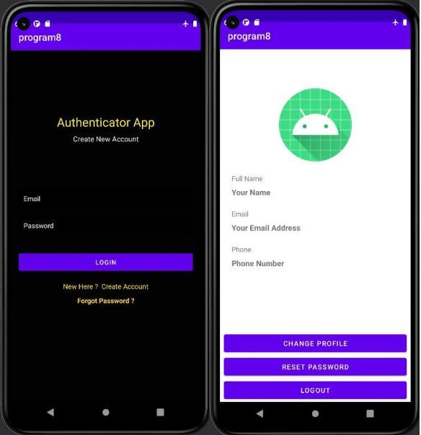

Program – 9
Write a Program to Implement Alert Dialog with coding.
Layout XML: activity_main.xml
<?xml version="1.0" encoding="utf-8"?>
<androidx.constraintlayout.widget.ConstraintLayout
xmlns:android="http://schemas.android.com/apk/res/android"
xmlns:app="http://schemas.android.com/apk/res-auto"
xmlns:tools="http://schemas.android.com/tools"
android:layout_width="match_parent"
android:layout_height="match_parent"
android:background="@drawable/background"
tools:context=".MainActivity">
<EditText
android:id="@+id/login"
android:layout_width="0dp"
android:layout_height="0dp"
android:layout_marginStart="1dp"
android:layout_marginTop="127dp"
android:layout_marginEnd="1dp"
android:layout_marginBottom="39dp"
android:ems="10"
android:inputType="textPersonName"
android:text="User Name"
android:textColor="@color/white"
app:layout_constraintBottom_toTopOf="@+id/passward"
app:layout_constraintEnd_toEndOf="@+id/passward"
app:layout_constraintStart_toStartOf="@+id/passward"
app:layout_constraintTop_toTopOf="parent" />
<EditText
android:id="@+id/passward"
android:layout_width="226dp"
android:layout_height="0dp"
android:layout_marginBottom="99dp"
android:ems="10"
android:hint="password"
android:inputType="number"
android:text="Password"
android:textColor="@color/white"
app:layout_constraintBottom_toTopOf="@+id/buttonlogin"
app:layout_constraintEnd_toEndOf="parent"
app:layout_constraintHorizontal_bias="0.508"
app:layout_constraintStart_toStartOf="parent"
app:layout_constraintTop_toBottomOf="@+id/login" />
<Button
android:id="@+id/buttonlogin"
android:layout_width="wrap_content"
android:layout_height="wrap_content"
android:layout_marginBottom="207dp"
android:text="Login"
app:layout_constraintBottom_toBottomOf="parent"
app:layout_constraintEnd_toEndOf="parent"
app:layout_constraintHorizontal_bias="0.5"
app:layout_constraintStart_toStartOf="parent"
app:layout_constraintTop_toBottomOf="@+id/passward" />
</androidx.constraintlayout.widget.ConstraintLayout>

Java Code: MainActivity.java
package com.example.login_hy;
import androidx.appcompat.app.AppCompatActivity;
import android.content.Intent;
import android.os.Bundle;
import android.view.View;
import android.widget.Button;
import android.widget.EditText;
import android.widget.Toast;
public class MainActivity extends AppCompatActivity {
EditText login;
EditText password;
Button loginbutton;
@Override
protected void onCreate(Bundle savedInstanceState) {
super.onCreate(savedInstanceState);
setContentView(R.layout.activity_main);
login = findViewById(R.id.login);
password = findViewById(R.id.passward);
loginbutton = findViewById(R.id.buttonlogin);
loginbutton.setOnClickListener(new View.OnClickListener() {
@Override
public void onClick(View view) {
String username = login.getText().toString();
String pass = password.getText().toString();
if(username.equals("user") && (pass.equals("123456")))
{
Toast.makeText(MainActivity.this, "Welcome harinder",
Toast.LENGTH_SHORT).show();
Intent i = new
Intent(MainActivity.this,NewActivity.class);
startActivity(i);
}else
{
Toast.makeText(MainActivity.this, "Invalid",
Toast.LENGTH_SHORT).show();
}
}
});
}
}

Output:
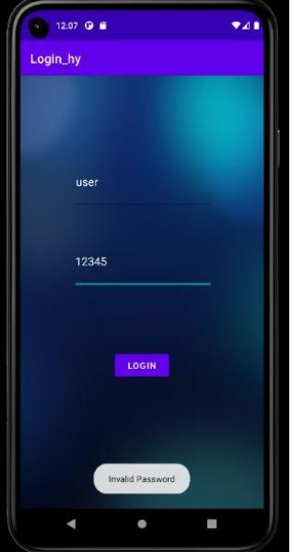

Program – 10
Write a Program to Design a View using Date Time Dialog.
Layout XML: activity_main.xml
<?xml version="1.0" encoding="utf-8"?>
<androidx.constraintlayout.widget.ConstraintLayout
xmlns:android="http://schemas.android.com/apk/res/android"
xmlns:app="http://schemas.android.com/apk/res-auto"
xmlns:tools="http://schemas.android.com/tools"
android:layout_width="match_parent"
android:layout_height="match_parent"
tools:context=".MainActivity">
<EditText
android:id="@+id/in_date"
android:layout_width="0dp"
android:layout_height="wrap_content"
android:layout_alignParentStart="true"
android:layout_alignParentLeft="true"
android:layout_alignParentTop="true"
android:layout_marginStart="25dp"
android:layout_marginTop="79dp"
android:layout_marginEnd="17dp"
app:layout_constraintEnd_toStartOf="@+id/btn_date"
app:layout_constraintStart_toStartOf="parent"
app:layout_constraintTop_toTopOf="parent" />
<Button
android:id="@+id/btn_date"
android:layout_width="wrap_content"
android:layout_height="wrap_content"
android:layout_alignBottom="@+id/in_date"
android:layout_marginEnd="35dp"
android:layout_toEndOf="@+id/in_date"
android:layout_toRightOf="@+id/in_date"
android:text="SELECT DATE"
app:layout_constraintBottom_toBottomOf="@+id/in_date"
app:layout_constraintEnd_toEndOf="parent"
app:layout_constraintStart_toEndOf="@+id/in_date" />
<EditText
android:id="@+id/in_time"
android:layout_width="0dp"
android:layout_height="wrap_content"
android:layout_below="@+id/in_date"
android:layout_alignParentStart="true"
android:layout_alignParentLeft="true"
android:layout_marginStart="25dp"
android:layout_marginTop="11dp"
android:layout_marginEnd="19dp"
app:layout_constraintEnd_toStartOf="@+id/btn_time"
app:layout_constraintStart_toStartOf="parent"
app:layout_constraintTop_toBottomOf="@+id/in_date" />
<Button
android:id="@+id/btn_time"
android:layout_width="wrap_content"
android:layout_height="wrap_content"
android:layout_below="@+id/btn_date"
android:layout_alignStart="@+id/btn_date"

android:layout_alignLeft="@+id/btn_date"
android:layout_marginTop="8dp"
android:layout_marginEnd="35dp"
android:text="SELECT TIME"
app:layout_constraintEnd_toEndOf="parent"
app:layout_constraintStart_toEndOf="@+id/in_time"
app:layout_constraintTop_toBottomOf="@+id/btn_date" />
</androidx.constraintlayout.widget.ConstraintLayout>

Java Code: MainActivity.java
package com.example.program10;
import androidx.appcompat.app.AppCompatActivity;
import android.app.DatePickerDialog;
import android.app.TimePickerDialog;
import android.os.Bundle;
import android.view.Menu;
import android.view.MenuItem;
import android.view.View;
import android.widget.Button;
import android.widget.DatePicker;
import android.widget.EditText;
import android.widget.TimePicker;
import java.util.Calendar;
public class MainActivity extends AppCompatActivity implements
View.OnClickListener {
Button btnDatePicker, btnTimePicker;
EditText txtDate, txtTime;
private int mYear, mMonth, mDay, mHour, mMinute;
@Override
protected void onCreate(Bundle savedInstanceState) {
super.onCreate(savedInstanceState);
setContentView(R.layout.activity_main);
btnDatePicker=(Button)findViewById(R.id.btn_date);
btnTimePicker=(Button)findViewById(R.id.btn_time);
txtDate=(EditText)findViewById(R.id.in_date);
txtTime=(EditText)findViewById(R.id.in_time);
btnDatePicker.setOnClickListener(this);
btnTimePicker.setOnClickListener(this);
}
@Override
public void onClick(View v) {
if (v == btnDatePicker) {
// Get Current Date
final Calendar c = Calendar.getInstance();
mYear = c.get(Calendar.YEAR);
mMonth = c.get(Calendar.MONTH);
mDay =c.get(Calendar.DAY_OF_MONTH);
DatePickerDialog datePickerDialog = new DatePickerDialog(this,
new DatePickerDialog.OnDateSetListener() {
@Override
public void onDateSet(DatePicker view, int year,
int monthOfYear, int
dayOfMonth) {
txtDate.setText(dayOfMonth + "-" + (monthOfYear +

1) + "-" + year);
}
}, mYear, mMonth, mDay);
datePickerDialog.show();
}
if (v == btnTimePicker) {
// Get Current Time
final Calendar c = Calendar.getInstance();
mHour = c.get(Calendar.HOUR_OF_DAY);
mMinute = c.get(Calendar.MINUTE);
// Launch Time Picker Dialog
TimePickerDialog timePickerDialog = new TimePickerDialog(this,
new TimePickerDialog.OnTimeSetListener() {
@Override
public void onTimeSet(TimePicker view, int hourOfDay,
int minute) {
txtTime.setText(hourOfDay + ":" + minute);
}
}, mHour, mMinute, false);
timePickerDialog.show();
}
}
}

Output:
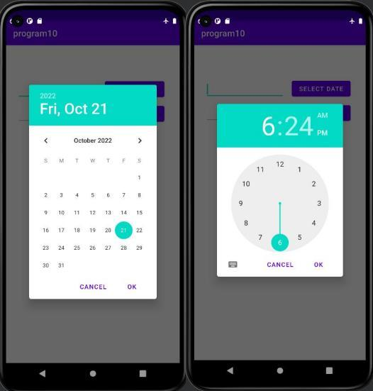
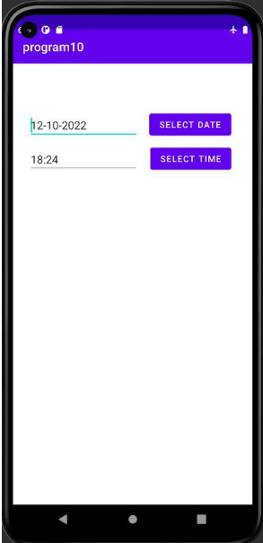

Program – 11
Write a Program to Implement Location Mapping with coding.
Layout XML: activity_main.xml
<?xml version="1.0" encoding="utf-8"?>
<fragment xmlns:android="http://schemas.android.com/apk/res/android"
xmlns:map="http://schemas.android.com/apk/res-auto"
xmlns:tools="http://schemas.android.com/tools"
android:id="@+id/map"
android:name="com.google.android.gms.maps.SupportMapFragment"
android:layout_width="match_parent"
android:layout_height="match_parent"
tools:context=".MapsActivity" />

Java Code: MainActivity.java
package com.example.program6;
import androidx.fragment.app.FragmentActivity;
import android.os.Bundle;
import com.google.android.gms.maps.CameraUpdateFactory;
import com.google.android.gms.maps.GoogleMap;
import com.google.android.gms.maps.OnMapReadyCallback;
import com.google.android.gms.maps.SupportMapFragment;
import com.google.android.gms.maps.model.LatLng;
import com.google.android.gms.maps.model.MarkerOptions;
import com.example.program6.databinding.ActivityMapsBinding;
public class MapsActivity extends FragmentActivity implements
OnMapReadyCallback {
private GoogleMap mMap;
private ActivityMapsBinding binding;
@Override
protected void onCreate(Bundle savedInstanceState) {
super.onCreate(savedInstanceState);
binding = ActivityMapsBinding.inflate(getLayoutInflater());
setContentView(binding.getRoot());
// Obtain the SupportMapFragment and get notified when the map is
ready to be used.
SupportMapFragment mapFragment = (SupportMapFragment)
getSupportFragmentManager()
.findFragmentById(R.id.map);
mapFragment.getMapAsync(this);
}
/**
* Manipulates the map once available.
* This callback is triggered when the map is ready to be used.
* This is where we can add markers or lines, add listeners or move the
camera. In this case,
* wejust add a marker near Sydney, Australia.
* If Google Play services is not installed on the device, the user will
be prompted to install
* it inside the SupportMapFragment. This method will only be triggered
once the user has
* installed Google Play services and returned to the app.
*/
@Override

public void onMapReady(GoogleMap googleMap) {
mMap=googleMap;
// Add a marker in Sydney and move the camera
LatLng sydney = new LatLng(28.625800210461893, 77.10904815574212);
mMap.addMarker(new MarkerOptions().position(sydney).title("Marker in
Sydney"));
mMap.moveCamera(CameraUpdateFactory.newLatLng(sydney));
}
}

Output:
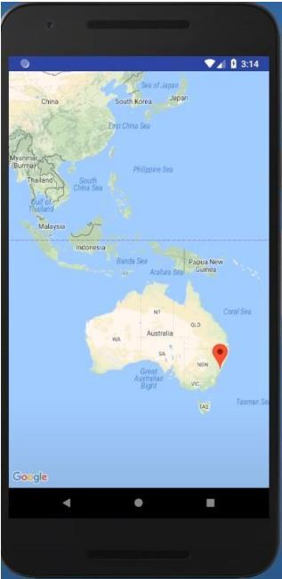

Program – 12
Write a Program to Implement Image Gallery and Image View.
Layout XML: activity_main.xml
<?xml version="1.0" encoding="utf-8"?>
<LinearLayout xmlns:android="http://schemas.android.com/apk/res/android"
xmlns:app="http://schemas.android.com/apk/res-auto"
xmlns:tools="http://schemas.android.com/tools"
android:layout_width="match_parent"
android:layout_height="match_parent"
android:orientation="vertical"
tools:context=".MainActivity">
<TextView
android:id="@+id/textView_gallery"
android:layout_width="match_parent"
android:layout_height="wrap_content"
android:layout_margin="12dp"
android:text="GALLERY"
android:textColor="@color/black"
android:textStyle="bold" />
<TabHost
android:id="@+id/tabhost"
android:layout_width="match_parent"
android:layout_height="match_parent">
<LinearLayout
android:layout_width="match_parent"
android:layout_height="match_parent"
android:orientation="vertical">
<TabWidget
android:id="@android:id/tabs"
android:layout_width="match_parent"
android:layout_height="wrap_content" />
<FrameLayout
android:id="@android:id/tabcontent"
android:layout_width="match_parent"
android:layout_height="match_parent">
<LinearLayout
android:id="@+id/tab_album"
android:layout_width="match_parent"
android:layout_height="match_parent"
android:orientation="vertical">
<ListView
android:id="@+id/listview_album"
android:layout_width="match_parent"
android:layout_height="match_parent" />
</LinearLayout>
<LinearLayout
android:id="@+id/tab_picture"
android:layout_width="match_parent"
android:layout_height="match_parent"
android:orientation="vertical">
<TableLayout
android:layout_width="match_parent"
android:layout_height="match_parent">
<TableRow
android:layout_width="match_parent"

android:layout_height="match_parent"
android:layout_marginBottom="2dp">
<LinearLayout
android:layout_width="match_parent"
android:layout_height="match_parent"
android:layout_weight="1"
android:orientation="horizontal">
<ImageView
android:id="@+id/one"
android:layout_width="match_parent"
android:layout_height="100dp"
android:layout_marginEnd="2dp"
android:layout_marginRight="2dp"
android:layout_weight="1"
android:scaleType="centerCrop"
android:onClick="onClick"
app:srcCompat="@drawable/one" />
<ImageView
android:id="@+id/two"
android:layout_width="match_parent"
android:layout_height="100dp"
android:layout_marginEnd="2dp"
android:layout_marginRight="2dp"
android:layout_weight="1"
android:scaleType="centerCrop"
android:onClick="onClick"
app:srcCompat="@drawable/two" />
<ImageView
android:id="@+id/three"
android:layout_width="match_parent"
android:layout_height="100dp"
android:layout_marginEnd="2dp"
android:layout_marginRight="2dp"
android:layout_weight="1"
android:scaleType="centerCrop"
android:onClick="onClick"
app:srcCompat="@drawable/three" />
<ImageView
android:id="@+id/four"
android:layout_width="match_parent"
android:layout_height="100dp"
android:layout_weight="1"
android:scaleType="centerCrop"
android:onClick="onClick"
app:srcCompat="@drawable/four" />
</LinearLayout>
</TableRow>
<TableRow
android:layout_width="match_parent"
android:layout_height="match_parent"
android:layout_marginBottom="2dp">
<LinearLayout
android:layout_width="match_parent"
android:layout_height="match_parent"
android:layout_weight="1"
android:orientation="horizontal">

<ImageView
android:id="@+id/five"
android:layout_width="match_parent"
android:layout_height="100dp"
android:layout_marginEnd="2dp"
android:layout_marginRight="2dp"
android:layout_weight="1"
android:scaleType="centerCrop"
android:onClick="onClick"
app:srcCompat="@drawable/five" />
<ImageView
android:id="@+id/six"
android:layout_width="match_parent"
android:layout_height="100dp"
android:layout_marginEnd="2dp"
android:layout_marginRight="2dp"
android:layout_weight="1"
android:scaleType="centerCrop"
android:onClick="onClick"
app:srcCompat="@drawable/six" />
<ImageView
android:id="@+id/seven"
android:layout_width="match_parent"
android:layout_height="100dp"
android:layout_marginEnd="2dp"
android:layout_marginRight="2dp"
android:layout_weight="1"
android:scaleType="centerCrop"
android:onClick="onClick"
app:srcCompat="@drawable/seven" />
<ImageView
android:id="@+id/eight"
android:layout_width="match_parent"
android:layout_height="100dp"
android:layout_weight="1"
android:scaleType="centerCrop"
android:onClick="onClick"
app:srcCompat="@drawable/eight" />
</LinearLayout>
</TableRow>
<TableRow
android:layout_width="match_parent"
android:layout_height="match_parent"
android:layout_marginBottom="2dp">
<LinearLayout
android:layout_width="match_parent"
android:layout_height="match_parent"
android:layout_weight="1"
android:orientation="horizontal">
<ImageView
android:id="@+id/nine"
android:layout_width="match_parent"
android:layout_height="100dp"
android:layout_marginEnd="2dp"
android:layout_marginRight="2dp"
android:layout_weight="1"

android:scaleType="centerCrop"
android:onClick="onClick"
app:srcCompat="@drawable/nine" />
<ImageView
android:id="@+id/ten"
android:layout_width="match_parent"
android:layout_height="100dp"
android:layout_marginEnd="2dp"
android:layout_marginRight="2dp"
android:layout_weight="1"
android:scaleType="centerCrop"
android:onClick="onClick"
app:srcCompat="@drawable/ten" />
<ImageView
android:id="@+id/imageView"
android:layout_width="match_parent"
android:layout_height="100dp"
android:layout_marginEnd="2dp"
android:layout_marginRight="2dp"
android:layout_weight="1"
android:scaleType="centerCrop" />
<ImageView
android:id="@+id/imageView1"
android:layout_width="match_parent"
android:layout_height="100dp"
android:layout_weight="1"
android:scaleType="centerCrop" />
</LinearLayout>
</TableRow>
</TableLayout>
</LinearLayout>
</FrameLayout>
</LinearLayout>
</TabHost>
</LinearLayout>

Layout XML: layout_second.xml
<?xml version="1.0" encoding="utf-8"?>
<LinearLayout xmlns:android="http://schemas.android.com/apk/res/android"
xmlns:app="http://schemas.android.com/apk/res-auto"
xmlns:tools="http://schemas.android.com/tools"
android:layout_width="match_parent"
android:layout_height="match_parent"
android:orientation="vertical">
<LinearLayout
android:layout_width="match_parent"
android:layout_height="wrap_content"
android:orientation="horizontal">
<ImageButton
android:id="@+id/button_back"
android:layout_width="40dp"
android:layout_height="15dp"
android:layout_gravity="center_vertical"
android:layout_marginStart="10dp"

android:layout_marginLeft="10dp"
android:layout_weight="1"
android:background="@drawable/abc_vector_test"
android:onClick="onClick"
android:scaleType="centerCrop"
app:srcCompat="@drawable/back" />
<TextView
android:id="@+id/textView_camera"
android:layout_width="match_parent"
android:layout_height="wrap_content"
android:layout_margin="12dp"
android:layout_weight="1"
android:text="CAMERA"
android:textColor="@color/black"
android:textStyle="bold" />
</LinearLayout>
<TableLayout
android:layout_width="match_parent"
android:layout_height="match_parent">
<TableRow
android:layout_width="match_parent"
android:layout_height="match_parent"
android:layout_marginBottom="2dp">
<LinearLayout
android:layout_width="match_parent"
android:layout_height="match_parent"
android:layout_weight="1"
android:orientation="horizontal">
<ImageView
android:id="@+id/one"
android:layout_width="match_parent"
android:layout_height="100dp"
android:layout_marginEnd="2dp"
android:layout_marginRight="2dp"
android:layout_weight="1"
android:onClick="onClick"
android:scaleType="centerCrop"
app:srcCompat="@drawable/one" />
<ImageView
android:id="@+id/two"
android:layout_width="match_parent"
android:layout_height="100dp"
android:layout_marginEnd="2dp"
android:layout_marginRight="2dp"
android:layout_weight="1"
android:onClick="onClick"
android:scaleType="centerCrop"
app:srcCompat="@drawable/two" />
<ImageView
android:id="@+id/three"
android:layout_width="match_parent"
android:layout_height="100dp"
android:layout_marginEnd="2dp"
android:layout_marginRight="2dp"
android:layout_weight="1"
android:onClick="onClick"

android:scaleType="centerCrop"
app:srcCompat="@drawable/three" />
<ImageView
android:id="@+id/four"
android:layout_width="match_parent"
android:layout_height="100dp"
android:layout_weight="1"
android:onClick="onClick"
android:scaleType="centerCrop"
app:srcCompat="@drawable/four" />
</LinearLayout>
</TableRow>
<TableRow
android:layout_width="match_parent"
android:layout_height="match_parent"
android:layout_marginBottom="2dp">
<LinearLayout
android:layout_width="match_parent"
android:layout_height="match_parent"
android:layout_weight="1"
android:orientation="horizontal">
<ImageView
android:id="@+id/five"
android:layout_width="match_parent"
android:layout_height="100dp"
android:layout_marginEnd="2dp"
android:layout_marginRight="2dp"
android:layout_weight="1"
android:onClick="onClick"
android:scaleType="centerCrop"
app:srcCompat="@drawable/five" />
<ImageView
android:id="@+id/six"
android:layout_width="match_parent"
android:layout_height="100dp"
android:layout_marginEnd="2dp"
android:layout_marginRight="2dp"
android:layout_weight="1"
android:onClick="onClick"
android:scaleType="centerCrop"
app:srcCompat="@drawable/six" />
<ImageView
android:id="@+id/seven"
android:layout_width="match_parent"
android:layout_height="100dp"
android:layout_marginEnd="2dp"
android:layout_marginRight="2dp"
android:layout_weight="1"
android:onClick="onClick"
android:scaleType="centerCrop"
app:srcCompat="@drawable/seven" />
<ImageView
android:id="@+id/eight"
android:layout_width="match_parent"
android:layout_height="100dp"
android:layout_weight="1"

android:onClick="onClick"
android:scaleType="centerCrop"
app:srcCompat="@drawable/eight" />
</LinearLayout>
</TableRow>
<TableRow
android:layout_width="match_parent"
android:layout_height="match_parent"
android:layout_marginBottom="2dp">
<LinearLayout
android:layout_width="match_parent"
android:layout_height="match_parent"
android:layout_weight="1"
android:orientation="horizontal">
<ImageView
android:id="@+id/nine"
android:layout_width="match_parent"
android:layout_height="100dp"
android:layout_marginEnd="2dp"
android:layout_marginRight="2dp"
android:layout_weight="1"
android:onClick="onClick"
android:scaleType="centerCrop"
app:srcCompat="@drawable/nine" />
<ImageView
android:id="@+id/ten"
android:layout_width="match_parent"
android:layout_height="100dp"
android:layout_marginEnd="2dp"
android:layout_marginRight="2dp"
android:layout_weight="1"
android:onClick="onClick"
android:scaleType="centerCrop"
app:srcCompat="@drawable/ten" />
<ImageView
android:id="@+id/imageView"
android:layout_width="match_parent"
android:layout_height="100dp"
android:layout_marginEnd="2dp"
android:layout_marginRight="2dp"
android:layout_weight="1"
android:scaleType="centerCrop" />
<ImageView
android:id="@+id/imageView1"
android:layout_width="match_parent"
android:layout_height="100dp"
android:layout_weight="1"
android:scaleType="centerCrop" />
</LinearLayout>
</TableRow>
</TableLayout>
</LinearLayout>

Java Code: MainActivity.java
package com.kang.gallery;
Java Code: MainActivity.java
import androidx.appcompat.app.AppCompatActivity;
import androidx.core.content.ContextCompat;
import androidx.viewpager.widget.ViewPager;
import androidx.viewpager2.widget.ViewPager2;
import android.content.Intent;
import android.graphics.Bitmap;
import android.graphics.drawable.BitmapDrawable;
import android.os.Bundle;
import android.view.View;
import android.widget.AdapterView;
import android.widget.ImageView;
import android.widget.ListView;
import android.widget.TabHost;
import android.widget.TextView;
import com.google.android.material.tabs.TabLayout;
import java.io.ByteArrayOutputStream;
public class MainActivity extends AppCompatActivity {
ListViewAdapter adapter;
Intent intent;
@Override
protected void onCreate(Bundle savedInstanceState) {
super.onCreate(savedInstanceState);
setContentView(R.layout.activity_main);
TabHost tab = (TabHost) findViewById(R.id.tabhost);
tab.setup();
TabHost.TabSpec tab1 =

tab.newTabSpec("1").setContent(R.id.tab_album).setIndicator("tab");
TabHost.TabSpec tab2 =

tab.newTabSpec("2").setContent(R.id.tab_picture).setIndicator("tab2");
tab.addTab(tab1);
tab.addTab(tab2);
adapter = new ListViewAdapter();
ListView listview = (ListView) findViewById(R.id.listview_album);
listview.setAdapter(adapter);
adapter.addItem(ContextCompat.getDrawable(this, R.drawable.camera),
"camera", "10");
listview.setOnItemClickListener(new AdapterView.OnItemClickListener()
{
@Override
public void onItemClick(AdapterView parent, View v, int position,
long id) {
intent = new Intent(getApplicationContext(),
SecondActivity.class);
startActivity(intent);
}
});
}
public void onClick(View v) {
ImageView imageView = (ImageView)findViewById(v.getId());
imageView.setOnClickListener(new View.OnClickListener() {

@Override
public void onClick(View v) {
ByteArrayOutputStream stream = new ByteArrayOutputStream();
Bitmap bitmap =
((BitmapDrawable)imageView.getDrawable()).getBitmap();
float scale = (float) (1024/(float)bitmap.getWidth());
int image_w = (int) (bitmap.getWidth() * scale);
int image_h = (int) (bitmap.getHeight() * scale);
Bitmap resize = Bitmap.createScaledBitmap(bitmap, image_w,
image_h, true);
resize.compress(Bitmap.CompressFormat.JPEG, 100, stream);
byte[] byteArray = stream.toByteArray();
Intent intent = new Intent(getApplicationContext(),
ThirdActivity.class);
intent.putExtra("image", byteArray);
startActivity(intent);
}
});
}
}

Java Code: SecondActivity.java
package com.kang.gallery;
import android.content.Intent;
import android.graphics.Bitmap;
import android.graphics.drawable.BitmapDrawable;
import android.os.Bundle;
import android.view.View;
import android.widget.ImageView;
import androidx.appcompat.app.AppCompatActivity;
import java.io.ByteArrayOutputStream;
public class SecondActivity extends AppCompatActivity {
@Override
protected void onCreate(Bundle savedInstanceState) {
super.onCreate(savedInstanceState);
setContentView(R.layout.layout_second);
}
public void onClick(View v) {
if(v.getId() == R.id.button_back)
finish();
ImageView imageView = (ImageView)findViewById(v.getId());
imageView.setOnClickListener(new View.OnClickListener() {
@Override
public void onClick(View v) {
ByteArrayOutputStream stream = new ByteArrayOutputStream();
Bitmap bitmap =
((BitmapDrawable)imageView.getDrawable()).getBitmap();
float scale = (float) (1024/(float)bitmap.getWidth());
int image_w = (int) (bitmap.getWidth() * scale);
int image_h = (int) (bitmap.getHeight() * scale);
Bitmap resize = Bitmap.createScaledBitmap(bitmap, image_w,
image_h, true);
resize.compress(Bitmap.CompressFormat.JPEG, 100, stream);
byte[] byteArray = stream.toByteArray();

Intent intent = new Intent(getApplicationContext(),
ThirdActivity.class);
intent.putExtra("image", byteArray);
startActivity(intent);
}
});
}
}

Output:
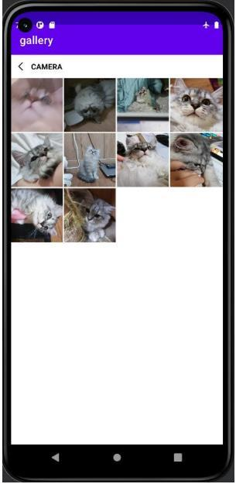

Program – 13
Write a Program to Implement Drawing 2D with coding.
Layout XML: activity_main.xml
<?xml version="1.0" encoding="utf-8"?>
<androidx.constraintlayout.widget.ConstraintLayout
xmlns:android="http://schemas.android.com/apk/res/android"
xmlns:app="http://schemas.android.com/apk/res-auto"
xmlns:tools="http://schemas.android.com/tools"
android:layout_width="match_parent"
android:layout_height="match_parent"
android:background="@drawable/background"
tools:context=".MainActivity">
</androidx.constraintlayout.widget.ConstraintLayout>

Java Code: DrawView.java
package com.example.program13;
import java.util.ArrayList;
import java.util.List;
import android.content.Context;
import android.graphics.Canvas;
import android.graphics.Color;
import android.graphics.Paint;
import android.util.Log;
import android.view.MotionEvent;
import android.view.View;
import android.view.View.OnTouchListener;
public class DrawView extends View implements OnTouchListener {
private static final String TAG = "DrawView";
List<Point> points = new ArrayList<Point>();
Paint paint = new Paint();
public DrawView(Context context) {
super(context);
setFocusable(true);
setFocusableInTouchMode(true);
this.setOnTouchListener(this);
paint.setColor(Color.BLACK);
paint.setAntiAlias(true);
}
@Override
public void onDraw(Canvas canvas) {
for (Point point : points) {
canvas.drawCircle(point.x, point.y, 50, paint);
// Log.d(TAG, "Painting: "+point);
}
}
public boolean onTouch(View view, MotionEvent event) {
// if(event.getAction() != MotionEvent.ACTION_DOWN)
// return super.onTouchEvent(event);
Point point = new Point();
point.x = event.getX();
point.y = event.getY();
points.add(point);
invalidate();

Log.d(TAG, "point: " + point);
return true;
}
}
class Point {
float x, y;
@Override
public String toString() {
return x + ", " + y;
}
}

Java Code: MainActivity.java
package com.example.program13;
import android.app.Activity;
import android.os.Bundle;
import android.view.Window;
Java Code: MainActivity.java
import android.view.WindowManager;
public class MainActivity extends Activity {
DrawView drawView;
@Override
public void onCreate(Bundle savedInstanceState) {
super.onCreate(savedInstanceState);
// Set full screen view
getWindow().setFlags(WindowManager.LayoutParams.FLAG_FULLSCREEN,
WindowManager.LayoutParams.FLAG_FULLSCREEN);
requestWindowFeature(Window.FEATURE_NO_TITLE);
drawView = new DrawView(this);
setContentView(drawView);
drawView.requestFocus();
}
}

Output:
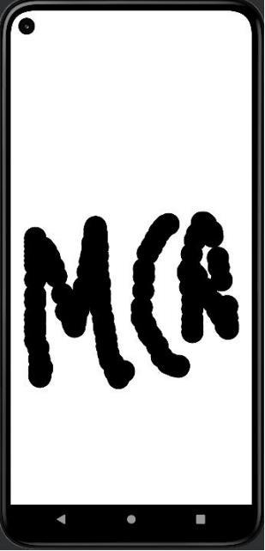

Program – 14
Write a Program to Implement 3D Graphics with coding.
Layout XML: activity_main.xml
<?xml version="1.0" encoding="utf-8"?>
<androidx.constraintlayout.widget.ConstraintLayout
xmlns:android="http://schemas.android.com/apk/res/android"
xmlns:app="http://schemas.android.com/apk/res-auto"
xmlns:tools="http://schemas.android.com/tools"
android:layout_width="match_parent"
android:layout_height="match_parent"
tools:context=".MainActivity">
<ImageView
android:id="@+id/imageView"
android:layout_width="match_parent"
android:layout_height="match_parent" />
</androidx.constraintlayout.widget.ConstraintLayout>

Java Code: MainActivity.java
package com.example.a3dgraphics;
import androidx.annotation.RequiresApi;
import androidx.appcompat.app.AppCompatActivity;
import android.graphics.Bitmap;
import android.graphics.Canvas;
import android.graphics.Color;
import android.graphics.Paint;
import android.graphics.Path;
import android.graphics.drawable.BitmapDrawable;
import android.os.Build;
import android.os.Bundle;
import android.widget.ImageView;
public class MainActivity extends AppCompatActivity {
@RequiresApi(api = Build.VERSION_CODES.LOLLIPOP)
@Override
protected void onCreate(Bundle savedInstanceState) {
super.onCreate(savedInstanceState);
setContentView(R.layout.activity_main);
Bitmap bg = Bitmap.createBitmap(720, 1280, Bitmap.Config.ARGB_8888);
ImageView imageView = findViewById(R.id.imageView);
imageView.setBackground(new BitmapDrawable(bg));
Canvas canvas = new Canvas((bg));
Paint darkBlue = new Paint();
darkBlue.setColor(Color.rgb(25, 118, 210));
Paint lightBlue = new Paint();
lightBlue.setColor(Color.rgb(33, 150, 243));
Paint border = new Paint();
border.setColor(Color.rgb(0, 0, 0));
canvas.drawRect(100, 300, 500, 500, lightBlue);
Path path = new Path();
path.moveTo(200, 200);
path.lineTo(100, 300);
path.lineTo(600, 200);
path.lineTo(200, 200);
path.close();

canvas.drawPath(path, darkBlue);
Path path2 = new Path();
path2.moveTo(500, 300);
path2.lineTo(100, 300);
path2.lineTo(600, 200);
path2.lineTo(500, 300);
path2.close();
canvas.drawPath(path2, darkBlue);
Path path3 = new Path();
path3.moveTo(600, 200);
path3.lineTo(500, 300);
path3.lineTo(600, 400);
path3.lineTo(600, 200);
path3.close();
canvas.drawPath(path3, darkBlue);
Path path4 = new Path();
path4.moveTo(500, 300);
path4.lineTo(500, 500);
path4.lineTo(600, 400);
path4.lineTo(500, 300);
path4.close();
canvas.drawPath(path4, darkBlue);
canvas.drawLine(100, 300, 500, 300, border);
canvas.drawLine(100, 500, 500, 500, border);
canvas.drawLine(100, 300, 100, 500, border);
canvas.drawLine(500, 300, 500, 500, border);
canvas.drawLine(100, 300, 200, 200, border);
canvas.drawLine(500, 300, 600, 200, border);
canvas.drawLine(200, 200, 600, 200, border);
canvas.drawLine(600, 200, 600, 400, border);
canvas.drawLine(500, 500, 600, 400, border);
Paint lightOrange = new Paint();
lightOrange.setColor(Color.rgb(255, 152, 0));
Paint darkOrange = new Paint();
darkOrange.setColor(Color.rgb(245, 124, 0));
canvas.drawRect(200, 800, 500, 1100, lightOrange);
canvas.drawOval(200, 700, 500, 900, darkOrange);
canvas.drawOval(200, 1000, 500, 1200, darkOrange);
}
}

Output:
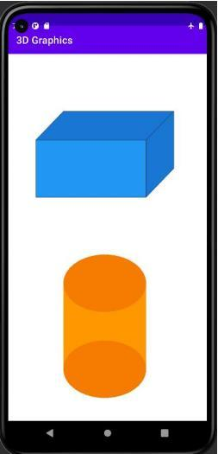

Program – 15
Write a Program to Implement Audio Player with coding.
Layout XML: activity_main.xml
<?xml version="1.0" encoding="utf-8"?>
<android.support.constraint.ConstraintLayout
xmlns:android="http://schemas.android.com/apk/res/android"
xmlns:app="http://schemas.android.com/apk/res-auto"
xmlns:tools="http://schemas.android.com/tools"
android:layout_width="match_parent"
android:layout_height="match_parent"
tools:context=".MainActivity">
<android.support.v7.widget.Toolbar
android:id="@+id/toolbar"
android:layout_width="match_parent"
android:layout_height="wrap_content"
android:background="@color/colorPrimary"
app:layout_constraintEnd_toEndOf="parent"
app:layout_constraintStart_toStartOf="parent"
app:layout_constraintTop_toTopOf="parent"
app:titleTextColor="#fff"/>
<android.support.design.widget.TabLayout
android:id="@+id/tabLayout"
android:layout_width="match_parent"
android:layout_height="wrap_content"
android:background="@color/colorPrimary"
app:layout_constraintEnd_toEndOf="parent"
app:layout_constraintStart_toStartOf="parent"
app:layout_constraintTop_toBottomOf="@+id/toolbar"
app:tabSelectedTextColor="#fff">
<android.support.design.widget.TabItem
android:layout_width="wrap_content"
android:layout_height="wrap_content"
android:id="@+id/musicTabItem"
android:icon="@drawable/ic_audiotrack_black_24dp"/>
<android.support.design.widget.TabItem
android:layout_width="wrap_content"
android:layout_height="wrap_content"
android:id="@+id/albumTabItem"
android:icon="@drawable/ic_album_black_24dp"/>
<android.support.design.widget.TabItem
android:layout_width="wrap_content"
android:layout_height="wrap_content"
android:id="@+id/playlistTabItem"
android:icon="@drawable/ic_queue_music_black_24dp"/>
</android.support.design.widget.TabLayout>
<android.support.v4.view.ViewPager
android:id="@+id/pager"
android:layout_width="0dp"
android:layout_height="0dp"
app:layout_constraintBottom_toBottomOf="parent"
app:layout_constraintEnd_toEndOf="parent"
app:layout_constraintStart_toStartOf="parent"
app:layout_constraintTop_toBottomOf="@+id/tabLayout">
</android.support.v4.view.ViewPager>
</android.support.constraint.ConstraintLayout>

Layout XML: activity_player.xml
<?xml version="1.0" encoding="utf-8"?>
<android.support.constraint.ConstraintLayout
xmlns:android="http://schemas.android.com/apk/res/android"
xmlns:app="http://schemas.android.com/apk/res-auto"
xmlns:tools="http://schemas.android.com/tools"
android:layout_width="match_parent"
android:layout_height="match_parent"
tools:context=".Player">
<ImageView
android:id="@+id/imageView"
android:layout_width="290dp"
android:layout_height="253dp"
android:layout_marginTop="24dp"
app:layout_constraintEnd_toEndOf="parent"
app:layout_constraintStart_toStartOf="parent"
app:layout_constraintTop_toTopOf="parent"
app:srcCompat="@drawable/music" />
<TextView
android:id="@+id/songTitle"
android:layout_width="0dp"
android:layout_height="wrap_content"
android:layout_marginStart="24dp"
android:layout_marginLeft="24dp"
android:layout_marginTop="24dp"
android:layout_marginEnd="24dp"
android:layout_marginRight="24dp"
android:gravity="center"
android:text="TextView"
android:textColor="@color/design_default_color_primary_dark"
android:textSize="18sp"
app:layout_constraintEnd_toEndOf="parent"
app:layout_constraintHorizontal_bias="0.5"
app:layout_constraintStart_toStartOf="parent"
app:layout_constraintTop_toBottomOf="@+id/imageView" />
<SeekBar
android:id="@+id/mSeekBar"
android:layout_width="0dp"
android:layout_height="wrap_content"
android:layout_marginStart="8dp"
android:layout_marginLeft="8dp"
android:layout_marginTop="92dp"
android:layout_marginEnd="8dp"
android:layout_marginRight="8dp"
app:layout_constraintBottom_toTopOf="@+id/playIcon"
app:layout_constraintEnd_toStartOf="@+id/totalTime"
app:layout_constraintHorizontal_bias="0.5"
app:layout_constraintStart_toEndOf="@+id/curTime"
app:layout_constraintTop_toBottomOf="@+id/songTitle"
app:layout_constraintVertical_bias="0.59000003" />
<TextView
android:id="@+id/curTime"
android:layout_width="wrap_content"
android:layout_height="wrap_content"
android:layout_marginStart="16dp"

android:layout_marginLeft="16dp"
android:text="00:00"
app:layout_constraintBottom_toBottomOf="@+id/mSeekBar"
app:layout_constraintStart_toStartOf="parent"
app:layout_constraintTop_toTopOf="@+id/mSeekBar" />
<TextView
android:id="@+id/totalTime"
android:layout_width="wrap_content"
android:layout_height="wrap_content"
android:layout_marginEnd="8dp"
android:layout_marginRight="8dp"
android:text="05:00"
app:layout_constraintBottom_toBottomOf="@+id/mSeekBar"
app:layout_constraintEnd_toEndOf="parent"
app:layout_constraintTop_toTopOf="@+id/mSeekBar" />
<ImageView
android:id="@+id/playIcon"
android:layout_width="80dp"
android:layout_height="80dp"
android:src="@drawable/ic_play_arrow_black_24dp"
app:layout_constraintBottom_toBottomOf="parent"
app:layout_constraintEnd_toStartOf="@+id/nextIcon"
app:layout_constraintHorizontal_bias="0.5"
app:layout_constraintStart_toEndOf="@+id/prevIcon"
app:layout_constraintTop_toBottomOf="@+id/mSeekBar" />
<ImageView
android:id="@+id/prevIcon"
android:layout_width="50dp"
android:layout_height="50dp"
android:contentDescription="TODO"
android:src="@drawable/ic_skip_previous_black_24dp"
app:layout_constraintBottom_toBottomOf="parent"
app:layout_constraintEnd_toStartOf="@+id/playIcon"
app:layout_constraintHorizontal_bias="0.5"
app:layout_constraintStart_toStartOf="parent"
app:layout_constraintTop_toBottomOf="@+id/mSeekBar" />
<ImageView
android:id="@+id/nextIcon"
android:layout_width="50dp"
android:layout_height="50dp"
android:src="@drawable/ic_skip_next_black_24dp"
app:layout_constraintBottom_toBottomOf="parent"
app:layout_constraintEnd_toEndOf="parent"
app:layout_constraintHorizontal_bias="0.5"
app:layout_constraintStart_toEndOf="@+id/playIcon"
app:layout_constraintTop_toBottomOf="@+id/mSeekBar" />
<ImageView
android:id="@+id/repeatIcon"
android:layout_width="40dp"
android:layout_height="40dp"
android:layout_marginStart="68dp"
android:layout_marginLeft="68dp"
android:layout_marginTop="8dp"
android:layout_marginBottom="8dp"
android:src="@drawable/repeat_default"
app:layout_constraintBottom_toTopOf="@+id/mSeekBar"

app:layout_constraintStart_toStartOf="parent"
app:layout_constraintTop_toBottomOf="@+id/songTitle"
app:layout_constraintVertical_bias="0.824" />
<ImageView
android:id="@+id/suffleIcon"
android:layout_width="40dp"
android:layout_height="40dp"
android:layout_marginStart="8dp"
android:layout_marginLeft="8dp"
android:layout_marginTop="76dp"
android:layout_marginEnd="8dp"
android:layout_marginRight="8dp"
android:layout_marginBottom="16dp"
android:src="@drawable/suffle_default"
app:layout_constraintBottom_toTopOf="@+id/mSeekBar"
app:layout_constraintEnd_toStartOf="@+id/curListIcon"
app:layout_constraintStart_toEndOf="@+id/repeatIcon"
app:layout_constraintTop_toBottomOf="@+id/songTitle"
app:layout_constraintVertical_bias="0.656" />
<ImageView
android:id="@+id/curListIcon"
android:layout_width="40dp"
android:layout_height="40dp"
android:layout_marginTop="8dp"
android:layout_marginEnd="64dp"
android:layout_marginRight="64dp"
android:layout_marginBottom="8dp"
android:src="@drawable/current_list"
app:layout_constraintBottom_toTopOf="@+id/mSeekBar"
app:layout_constraintEnd_toEndOf="parent"
app:layout_constraintTop_toBottomOf="@+id/songTitle"
app:layout_constraintVertical_bias="0.824" />
</android.support.constraint.ConstraintLayout>

Layout XML: fragment_music.xml
<?xml version="1.0" encoding="utf-8"?>
<FrameLayout xmlns:android="http://schemas.android.com/apk/res/android"
xmlns:tools="http://schemas.android.com/tools"
android:layout_width="match_parent"
android:layout_height="match_parent"
tools:context=".Music">
<ListView
android:layout_width="match_parent"
android:layout_height="wrap_content"
android:id="@+id/musicListView"/>
</FrameLayout>

Java Code: MainActivity.java
package com.example.letsplay;
import android.os.Bundle;
Java Code: MainActivity.java
import android.support.design.widget.TabItem;

import android.support.design.widget.TabLayout;
import android.support.v4.view.ViewPager;
import android.support.v7.app.AppCompatActivity;
import android.support.v7.widget.Toolbar;
import android.widget.Toast;
public class MainActivity extends AppCompatActivity {
Toolbar mToolbar;
PagerAdapter mPagerAdapter;
TabLayout mTabLayout;
TabItem musicTabItem;
TabItem albumTabItem;
TabItem playlistTabItem;
ViewPager mViewPager;
@Override
protected void onCreate(Bundle savedInstanceState) {
super.onCreate(savedInstanceState);
setContentView(R.layout.activity_main);
mToolbar = findViewById(R.id.toolbar);
setSupportActionBar(mToolbar);
getSupportActionBar().setTitle(getString(R.string.app_name));
mTabLayout = findViewById(R.id.tabLayout);
musicTabItem = findViewById(R.id.musicTabItem);
albumTabItem = findViewById(R.id.albumTabItem);
playlistTabItem = findViewById(R.id.playlistTabItem);
mViewPager = findViewById(R.id.pager);
mPagerAdapter = new

PagerAdapter(getSupportFragmentManager(),mTabLayout.getTabCount()); // call
the pager
class
mViewPager.setAdapter(mPagerAdapter); // set adapter for pager
// do something when the tab is selected
mTabLayout.addOnTabSelectedListener(new
TabLayout.OnTabSelectedListener() {
@Override
public void onTabSelected(TabLayout.Tab tab) {
mViewPager.setCurrentItem(tab.getPosition()); // set current
tab position
if(tab.getPosition() == 1){
//
Toast.makeText(MainActivity.this, "Album Tab Selected.",
Toast.LENGTH_SHORT).show();
}else if(tab.getPosition() == 2){
//
Toast.makeText(MainActivity.this, "Music Tab Selected.",
Toast.LENGTH_SHORT).show();
}else {
//
Toast.makeText(MainActivity.this, "Playlist Tab
Selected.",
Toast.LENGTH_SHORT).show();
}
}
@Override
public void onTabUnselected(TabLayout.Tab tab) {
}

@Override
public void onTabReselected(TabLayout.Tab tab) {
}
});
mViewPager.addOnPageChangeListener(new
TabLayout.TabLayoutOnPageChangeListener(mTabLayout));
}
}

Java Code: Music.java
package com.example.letsplay;
import android.Manifest;
import android.content.Intent;
import android.os.Bundle;
import android.os.Environment;
import android.support.v4.app.Fragment;
import android.view.LayoutInflater;
import android.view.View;
import android.view.ViewGroup;
import android.widget.AdapterView;
import android.widget.ArrayAdapter;
import android.widget.ListView;
import com.karumi.dexter.Dexter;
import com.karumi.dexter.PermissionToken;
import com.karumi.dexter.listener.PermissionDeniedResponse;
import com.karumi.dexter.listener.PermissionGrantedResponse;
import com.karumi.dexter.listener.PermissionRequest;
import com.karumi.dexter.listener.single.PermissionListener;
import java.io.File;
import java.util.ArrayList;
/**
* Asimple {@link Fragment} subclass.
*/
public class Music extends Fragment {
ListView mListView;
ArrayList<String> musics;
ArrayAdapter<String> mArrayAdapter;
String[] songs;
public Music() {
// Required empty public constructor
}
@Override
public View onCreateView(LayoutInflater inflater, ViewGroup container,
Bundle savedInstanceState) {
// to display menu in action bar
//setHasOptionsMenu(true);
// Inflate the layout for this fragment
View view = inflater.inflate(R.layout.fragment_music, container,
false);
mListView = view.findViewById(R.id.musicListView);
askStoragePermissions();
return view;
}
public ArrayList<File> findMusics(File file){

ArrayList<File> musicLists = new ArrayList<File>();
File[] files = file.listFiles();
for(File singleFile: files ){
if(singleFile.isDirectory() && !singleFile.isHidden()){
musicLists.addAll(findMusics(singleFile));
}else{
if(singleFile.getName().endsWith(".mp3") |
singleFile.getName().endsWith(".m4a") |
singleFile.getName().endsWith(".wav") |
singleFile.getName().endsWith(".m4b")){
musicLists.add(singleFile);
}
}
}
return musicLists;
}
public void display(){
final ArrayList<File> allSongs =
findMusics(Environment.getExternalStorageDirectory());
songs = new String[allSongs.size()];
for(int i=0;i<allSongs.size();i++){
songs[i] =

allSongs.get(i).getName().replace(".mp3","").replace(".m4a","").replace(".wav
","").replace(".m4
b","");
}
mArrayAdapter = new

ArrayAdapter<String>(getActivity(),android.R.layout.simple_list_item_1,songs)
;
mListView.setAdapter(mArrayAdapter);
mListView.setOnItemClickListener(new
AdapterView.OnItemClickListener() {
@Override
public void onItemClick(AdapterView<?> parent, View view, int
position, long id) {
// start music player when song name is clicked
String songName =
mListView.getItemAtPosition(position).toString();
Intent play = new Intent(getActivity(),Player.class);

play.putExtra("songs",allSongs).putExtra("songName",songName).putExtra("posit
ion",
position);
}
});
}
startActivity(play);
public void askStoragePermissions(){

Dexter.withActivity(getActivity()).withPermission(Manifest.permission.READ_EX
TERNA
L_STORAGE).withListener(new PermissionListener() {
@Override
public void onPermissionGranted(PermissionGrantedResponse

response) {
display();
}
@Override
public void onPermissionDenied(PermissionDeniedResponse response)
{
}
@Override
public void onPermissionRationaleShouldBeShown(PermissionRequest
permission,
PermissionToken
token) {
token.continuePermissionRequest();
}
}).check();
}
}

Output:
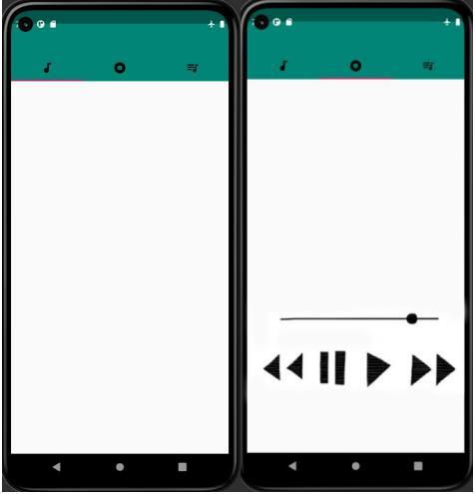

Program – 16
Write a Program to Design a UI to Performs basic arithmetic operations (addition, subtraction, multiplication, division) which covers user input, buttons, and event handling.
Layout XML: activity_main.xml
<?xml version="1.0" encoding="utf-8"?>
<LinearLayout xmlns:android="http://schemas.android.com/apk/res/android"
xmlns:tools="http://schemas.android.com/tools"
android:layout_width="match_parent"
android:layout_height="match_parent"
android:orientation="vertical"
android:padding="24dp"
android:background="#F5F5F5"
tools:context=".MainActivity">

<TextView
android:layout_width="match_parent"
android:layout_height="wrap_content"
android:text="Simple Calculator"
android:textSize="26sp"
android:textStyle="bold"
android:textColor="#6200EE"
android:gravity="center"
android:layout_marginBottom="24dp" />

<TextView
android:layout_width="wrap_content"
android:layout_height="wrap_content"
android:text="Enter First Number:"
android:textSize="14sp"
android:textColor="#333333" />

<EditText
android:id="@+id/etNum1"
android:layout_width="match_parent"
android:layout_height="50dp"
android:background="@android:drawable/editbox_background"
android:hint="First number (e.g. 25)"
android:inputType="numberDecimal"
android:padding="10dp"
android:layout_marginBottom="16dp" />

<TextView
android:layout_width="wrap_content"
android:layout_height="wrap_content"
android:text="Enter Second Number:"
android:textSize="14sp"
android:textColor="#333333" />

<EditText
android:id="@+id/etNum2"
android:layout_width="match_parent"
android:layout_height="50dp"
android:background="@android:drawable/editbox_background"
android:hint="Second number (e.g. 4)"
android:inputType="numberDecimal"
android:padding="10dp"
android:layout_marginBottom="20dp" />

<LinearLayout
android:layout_width="match_parent"
android:layout_height="wrap_content"
android:orientation="horizontal"
android:weightSum="4"
android:layout_marginBottom="12dp">

<Button
android:id="@+id/btnAdd"
android:layout_width="0dp"
android:layout_height="wrap_content"
android:layout_weight="1"
android:layout_marginEnd="6dp"
android:text="+"
android:textSize="20sp"
android:backgroundTint="#6200EE" />

<Button
android:id="@+id/btnSub"
android:layout_width="0dp"
android:layout_height="wrap_content"
android:layout_weight="1"
android:layout_marginEnd="6dp"
android:text="-"
android:textSize="20sp"
android:backgroundTint="#6200EE" />

<Button
android:id="@+id/btnMul"
android:layout_width="0dp"
android:layout_height="wrap_content"
android:layout_weight="1"
android:layout_marginEnd="6dp"
android:text="×"
android:textSize="20sp"
android:backgroundTint="#6200EE" />

<Button
android:id="@+id/btnDiv"
android:layout_width="0dp"
android:layout_height="wrap_content"
android:layout_weight="1"
android:text="÷"
android:textSize="20sp"
android:backgroundTint="#6200EE" />
</LinearLayout>

<Button
android:id="@+id/btnClear"
android:layout_width="match_parent"
android:layout_height="wrap_content"
android:text="CLEAR ALL"
android:textSize="14sp"
android:backgroundTint="#CF6679"
android:layout_marginBottom="24dp" />

<LinearLayout
android:layout_width="match_parent"
android:layout_height="wrap_content"
android:orientation="vertical"
android:padding="20dp"
android:background="#E8EAF6"
android:gravity="center">

<TextView
android:layout_width="wrap_content"
android:layout_height="wrap_content"
android:text="CALCULATION RESULT"
android:textSize="14sp"
android:textStyle="bold"
android:textColor="#3F51B5" />

<TextView
android:id="@+id/tvResult"
android:layout_width="wrap_content"
android:layout_height="wrap_content"
android:text="0.00"
android:textSize="32sp"
android:textStyle="bold"
android:textColor="#1A237E"
android:layout_marginTop="8dp" />
</LinearLayout>
</LinearLayout>
Java Code: MainActivity.java
package com.example.calculator;

import androidx.appcompat.app.AppCompatActivity;
import android.os.Bundle;
import android.view.View;
import android.widget.Button;
import android.widget.EditText;
import android.widget.TextView;
import android.widget.Toast;

public class MainActivity extends AppCompatActivity {
private EditText etNum1, etNum2;
private Button btnAdd, btnSub, btnMul, btnDiv, btnClear;
private TextView tvResult;

@Override
protected void onCreate(Bundle savedInstanceState) {
super.onCreate(savedInstanceState);
setContentView(R.layout.activity_main);

etNum1 = findViewById(R.id.etNum1);
etNum2 = findViewById(R.id.etNum2);
btnAdd = findViewById(R.id.btnAdd);
btnSub = findViewById(R.id.btnSub);
btnMul = findViewById(R.id.btnMul);
btnDiv = findViewById(R.id.btnDiv);
btnClear = findViewById(R.id.btnClear);
tvResult = findViewById(R.id.tvResult);

btnAdd.setOnClickListener(v -> calculate('+'));
btnSub.setOnClickListener(v -> calculate('-'));
btnMul.setOnClickListener(v -> calculate('*'));
btnDiv.setOnClickListener(v -> calculate('/'));

btnClear.setOnClickListener(v -> {
etNum1.setText("");
etNum2.setText("");
tvResult.setText("0.00");
Toast.makeText(MainActivity.this, "Inputs Cleared", Toast.LENGTH_SHORT).show();
});
}

private void calculate(char op) {
String str1 = etNum1.getText().toString().trim();
String str2 = etNum2.getText().toString().trim();

if (str1.isEmpty() || str2.isEmpty()) {
Toast.makeText(this, "Please enter both numbers", Toast.LENGTH_SHORT).show();
return;
}

try {
double n1 = Double.parseDouble(str1);
double n2 = Double.parseDouble(str2);
double res = 0;

switch (op) {
case '+': res = n1 + n2; break;
case '-': res = n1 - n2; break;
case '*': res = n1 * n2; break;
case '/':
if (n2 == 0) {
Toast.makeText(this, "Cannot divide by zero!", Toast.LENGTH_SHORT).show();
tvResult.setText("Error");
return;
}
res = n1 / n2;
break;
}
tvResult.setText(String.format("%.2f", res));
} catch (NumberFormatException e) {
Toast.makeText(this, "Invalid number format", Toast.LENGTH_SHORT).show();
}
}
}
Output:
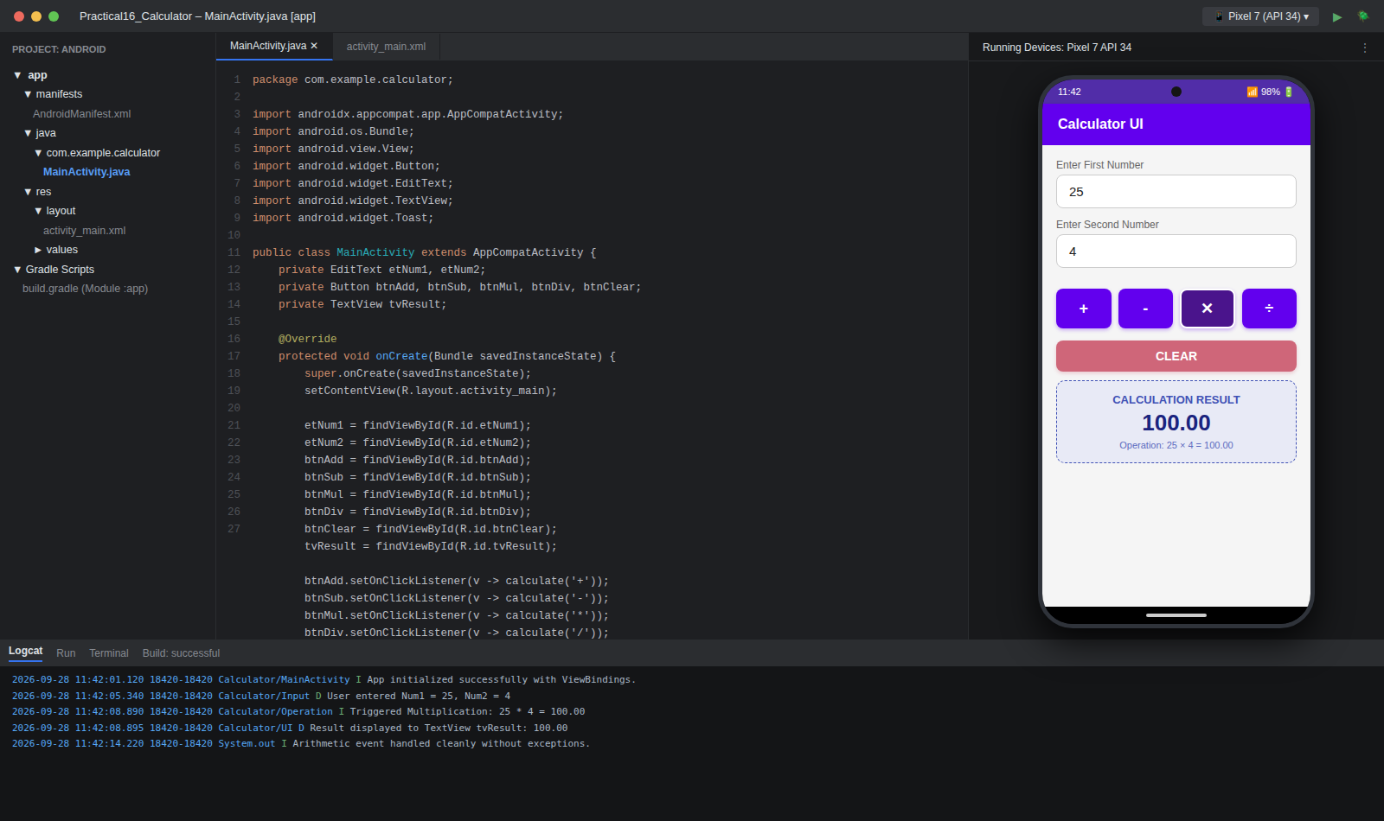

Program – 17
Write a Program to Design a UI to Play music with basic controls (play, pause, stop) and covers media player APIs and foreground services.
Layout XML: activity_main.xml
<?xml version="1.0" encoding="utf-8"?>
<LinearLayout xmlns:android="http://schemas.android.com/apk/res/android"
xmlns:tools="http://schemas.android.com/tools"
android:layout_width="match_parent"
android:layout_height="match_parent"
android:orientation="vertical"
android:gravity="center_horizontal"
android:padding="20dp"
android:background="#121212"
tools:context=".MainActivity">

<TextView
android:layout_width="wrap_content"
android:layout_height="wrap_content"
android:text="Music Player Service"
android:textSize="22sp"
android:textStyle="bold"
android:textColor="#FFFFFF"
android:layout_marginTop="16dp"
android:layout_marginBottom="24dp" />

<ImageView
android:id="@+id/ivAlbumArt"
android:layout_width="220dp"
android:layout_height="220dp"
android:background="#7B1FA2"
android:src="@android:drawable/ic_media_play"
android:padding="50dp"
android:scaleType="fitCenter"
android:layout_marginBottom="24dp" />

<TextView
android:id="@+id/tvSongTitle"
android:layout_width="wrap_content"
android:layout_height="wrap_content"
android:text="In The End"
android:textSize="20sp"
android:textStyle="bold"
android:textColor="#FFFFFF" />

<TextView
android:id="@+id/tvArtist"
android:layout_width="wrap_content"
android:layout_height="wrap_content"
android:text="Linkin Park • Hybrid Theory"
android:textSize="14sp"
android:textColor="#B0BEC5"
android:layout_marginTop="4dp"
android:layout_marginBottom="24dp" />

<SeekBar
android:id="@+id/seekBar"
android:layout_width="match_parent"
android:layout_height="wrap_content"
android:progress="45"
android:max="100"
android:progressTint="#E91E63"
android:thumbTint="#FFFFFF" />

<LinearLayout
android:layout_width="match_parent"
android:layout_height="wrap_content"
android:orientation="horizontal"
android:gravity="center"
android:layout_marginTop="20dp"
android:layout_marginBottom="24dp">

<ImageButton
android:id="@+id/btnPrev"
android:layout_width="54dp"
android:layout_height="54dp"
android:layout_marginEnd="16dp"
android:background="@android:drawable/screen_background_dark_transparent"
android:src="@android:drawable/ic_media_previous" />

<ImageButton
android:id="@+id/btnPlayPause"
android:layout_width="68dp"
android:layout_height="68dp"
android:layout_marginEnd="16dp"
android:background="#E91E63"
android:src="@android:drawable/ic_media_play" />

<ImageButton
android:id="@+id/btnStop"
android:layout_width="54dp"
android:layout_height="54dp"
android:layout_marginEnd="16dp"
android:background="@android:drawable/screen_background_dark_transparent"
android:src="@android:drawable/ic_delete" />

<ImageButton
android:id="@+id/btnNext"
android:layout_width="54dp"
android:layout_height="54dp"
android:background="@android:drawable/screen_background_dark_transparent"
android:src="@android:drawable/ic_media_next" />
</LinearLayout>

<TextView
android:id="@+id/tvStatus"
android:layout_width="match_parent"
android:layout_height="wrap_content"
android:text="Foreground Service Active (Notification bound)"
android:textSize="12sp"
android:textColor="#E91E63"
android:background="#1E1E1E"
android:padding="12dp"
android:gravity="center" />
</LinearLayout>
Java Code: MusicService.java (Foreground Service)
package com.example.musicplayer;

import android.app.Notification;
import android.app.NotificationChannel;
import android.app.NotificationManager;
import android.app.PendingIntent;
import android.app.Service;
import android.content.Intent;
import android.media.MediaPlayer;
import android.os.Build;
import android.os.IBinder;
import androidx.core.app.NotificationCompat;

public class MusicService extends Service {
public static final String CHANNEL_ID = "MusicPlayerChannel";
private MediaPlayer mediaPlayer;

@Override
public void onCreate() {
super.onCreate();
createNotificationChannel();
mediaPlayer = MediaPlayer.create(this, R.raw.song_track);
mediaPlayer.setLooping(true);
}

@Override
public int onStartCommand(Intent intent, int flags, int startId) {
String action = intent.getAction();
if ("ACTION_PLAY".equals(action)) {
if (!mediaPlayer.isPlaying()) {
mediaPlayer.start();
}
showForegroundNotification("Playing: In The End");
} else if ("ACTION_PAUSE".equals(action)) {
if (mediaPlayer.isPlaying()) {
mediaPlayer.pause();
}
showForegroundNotification("Paused: In The End");
} else if ("ACTION_STOP".equals(action)) {
mediaPlayer.stop();
stopForeground(true);
stopSelf();
}
return START_STICKY;
}

private void showForegroundNotification(String statusText) {
Intent notificationIntent = new Intent(this, MainActivity.class);
PendingIntent pendingIntent = PendingIntent.getActivity(this, 0, notificationIntent, PendingIntent.FLAG_IMMUTABLE);

Notification notification = new NotificationCompat.Builder(this, CHANNEL_ID)
.setContentTitle("Music Player Service")
.setContentText(statusText)
.setSmallIcon(android.R.drawable.ic_media_play)
.setContentIntent(pendingIntent)
.setPriority(NotificationCompat.PRIORITY_LOW)
.build();

startForeground(1, notification);
}

private void createNotificationChannel() {
if (Build.VERSION.SDK_INT >= Build.VERSION_CODES.O) {
NotificationChannel channel = new NotificationChannel(
CHANNEL_ID, "Music Playback", NotificationManager.IMPORTANCE_LOW);
NotificationManager manager = getSystemService(NotificationManager.class);
if (manager != null) manager.createNotificationChannel(channel);
}
}

@Override
public void onDestroy() {
if (mediaPlayer != null) {
mediaPlayer.release();
}
super.onDestroy();
}

@Override
public IBinder onBind(Intent intent) { return null; }
}
Java Code: MainActivity.java
package com.example.musicplayer;

import androidx.appcompat.app.AppCompatActivity;
import android.content.Intent;
import android.os.Bundle;
import android.widget.ImageButton;
import android.widget.TextView;
import android.widget.Toast;

public class MainActivity extends AppCompatActivity {
private ImageButton btnPlayPause, btnStop;
private TextView tvStatus;
private boolean isPlaying = false;

@Override
protected void onCreate(Bundle savedInstanceState) {
super.onCreate(savedInstanceState);
setContentView(R.layout.activity_main);

btnPlayPause = findViewById(R.id.btnPlayPause);
btnStop = findViewById(R.id.btnStop);
tvStatus = findViewById(R.id.tvStatus);

btnPlayPause.setOnClickListener(v -> {
Intent service = new Intent(this, MusicService.class);
if (!isPlaying) {
service.setAction("ACTION_PLAY");
startForegroundService(service);
btnPlayPause.setImageResource(android.R.drawable.ic_media_pause);
tvStatus.setText("Playing: In The End (Foreground Service Running)");
isPlaying = true;
} else {
service.setAction("ACTION_PAUSE");
startService(service);
btnPlayPause.setImageResource(android.R.drawable.ic_media_play);
tvStatus.setText("Paused: In The End");
isPlaying = false;
}
});

btnStop.setOnClickListener(v -> {
Intent service = new Intent(this, MusicService.class);
service.setAction("ACTION_STOP");
startService(service);
btnPlayPause.setImageResource(android.R.drawable.ic_media_play);
tvStatus.setText("Service Stopped");
isPlaying = false;
Toast.makeText(this, "Music Player Stopped", Toast.LENGTH_SHORT).show();
});
}
}
Output:
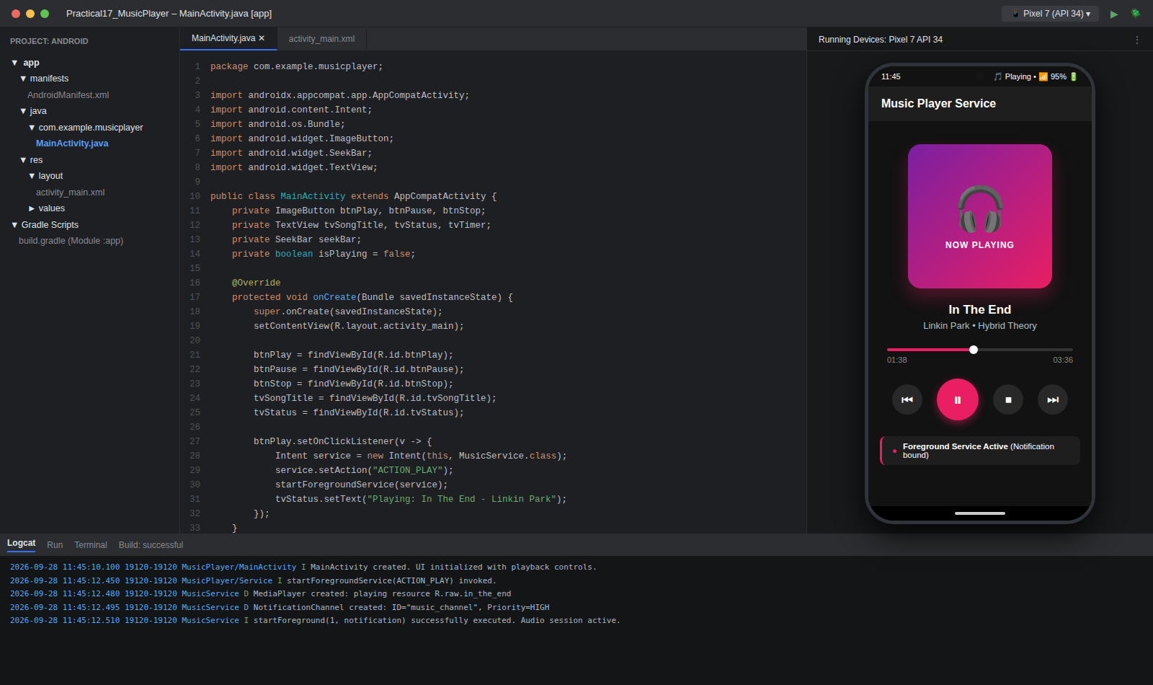

Program – 18
Write a Program to Design a UI to displays a collection of recipes with detailed steps and ingredients using Fragment.
Layout XML: activity_main.xml
<?xml version="1.0" encoding="utf-8"?>
<FrameLayout xmlns:android="http://schemas.android.com/apk/res/android"
xmlns:tools="http://schemas.android.com/tools"
android:id="@+id/fragment_container"
android:layout_width="match_parent"
android:layout_height="match_parent"
android:background="#FFF3E0"
tools:context=".MainActivity">
</FrameLayout>
Layout XML: fragment_recipe_detail.xml
<?xml version="1.0" encoding="utf-8"?>
<ScrollView xmlns:android="http://schemas.android.com/apk/res/android"
android:layout_width="match_parent"
android:layout_height="match_parent"
android:padding="16dp"
android:background="#FFF3E0">

<LinearLayout
android:layout_width="match_parent"
android:layout_height="wrap_content"
android:orientation="vertical">

<ImageView
android:id="@+id/ivRecipeImage"
android:layout_width="match_parent"
android:layout_height="180dp"
android:background="#FF9800"
android:scaleType="centerCrop" />

<TextView
android:id="@+id/tvRecipeName"
android:layout_width="wrap_content"
android:layout_height="wrap_content"
android:text="Paneer Butter Masala"
android:textSize="22sp"
android:textStyle="bold"
android:textColor="#BF360C"
android:layout_marginTop="12dp" />

<TextView
android:layout_width="wrap_content"
android:layout_height="wrap_content"
android:text="Prep: 30 Mins | Servings: 4"
android:textSize="13sp"
android:textColor="#795548"
android:layout_marginBottom="16dp" />

<TextView
android:layout_width="wrap_content"
android:layout_height="wrap_content"
android:text="Ingredients:"
android:textSize="16sp"
android:textStyle="bold"
android:textColor="#E65100" />

<TextView
android:id="@+id/tvIngredients"
android:layout_width="match_parent"
android:layout_height="wrap_content"
android:text="• 250g Paneer cubes\n• 3 pureed Tomatoes\n• 2 tbsp Butter & Cream\n• 1 tsp Garam Masala\n• Ginger garlic paste"
android:textSize="13sp"
android:textColor="#333333"
android:background="#FFFFFF"
android:padding="12dp"
android:layout_marginTop="6dp"
android:layout_marginBottom="16dp" />

<TextView
android:layout_width="wrap_content"
android:layout_height="wrap_content"
android:text="Preparation Steps:"
android:textSize="16sp"
android:textStyle="bold"
android:textColor="#E65100" />

<TextView
android:id="@+id/tvSteps"
android:layout_width="match_parent"
android:layout_height="wrap_content"
android:text="1. Heat butter in a pan, sauté ginger-garlic paste.\n2. Add tomato puree and spices, simmer for 10 mins.\n3. Stir in fresh cream and paneer cubes gently.\n4. Garnish with kasuri methi and serve hot with naan."
android:textSize="13sp"
android:textColor="#333333"
android:background="#FFFFFF"
android:padding="12dp"
android:layout_marginTop="6dp" />
</LinearLayout>
</ScrollView>
Java Code: MainActivity.java
package com.example.recipeapp;

import androidx.appcompat.app.AppCompatActivity;
import android.os.Bundle;

public class MainActivity extends AppCompatActivity {
@Override
protected void onCreate(Bundle savedInstanceState) {
super.onCreate(savedInstanceState);
setContentView(R.layout.activity_main);

if (savedInstanceState == null) {
getSupportFragmentManager().beginTransaction()
.replace(R.id.fragment_container, new RecipeDetailFragment())
.commit();
}
}
}
Java Code: RecipeDetailFragment.java
package com.example.recipeapp;

import android.os.Bundle;
import androidx.fragment.app.Fragment;
import android.view.LayoutInflater;
import android.view.View;
import android.view.ViewGroup;
import android.widget.TextView;

public class RecipeDetailFragment extends Fragment {
@Override
public View onCreateView(LayoutInflater inflater, ViewGroup container, Bundle savedInstanceState) {
View view = inflater.inflate(R.layout.fragment_recipe_detail, container, false);
TextView tvTitle = view.findViewById(R.id.tvRecipeName);
TextView tvIngredients = view.findViewById(R.id.tvIngredients);
TextView tvSteps = view.findViewById(R.id.tvSteps);

tvTitle.setText("Paneer Butter Masala");
return view;
}
}
Output:
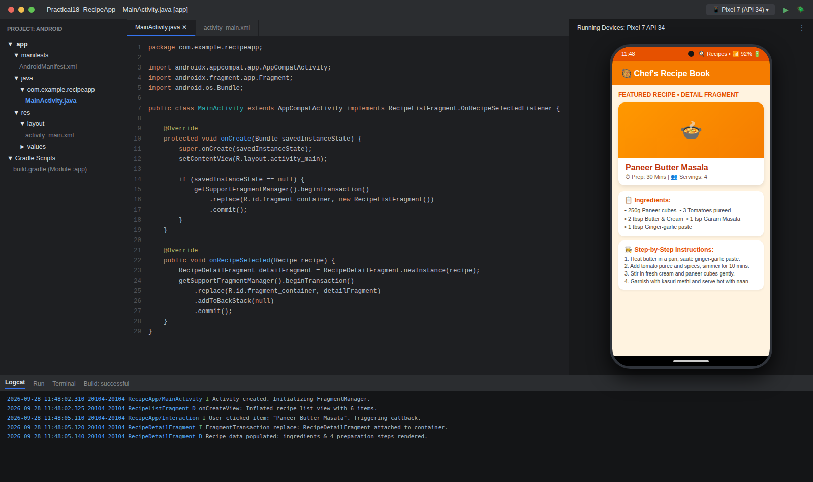

Program – 19
Write a Program to Design a UI for food delivery app that fetches restaurant menus and tracks delivery status.
Layout XML: activity_main.xml
<?xml version="1.0" encoding="utf-8"?>
<ScrollView xmlns:android="http://schemas.android.com/apk/res/android"
xmlns:tools="http://schemas.android.com/tools"
android:layout_width="match_parent"
android:layout_height="match_parent"
android:background="#F4F5F7"
android:padding="16dp"
tools:context=".MainActivity">

<LinearLayout
android:layout_width="match_parent"
android:layout_height="wrap_content"
android:orientation="vertical">

<TextView
android:layout_width="match_parent"
android:layout_height="wrap_content"
android:text="FoodExpress Live Tracker"
android:textSize="22sp"
android:textStyle="bold"
android:textColor="#E23744"
android:layout_marginBottom="16dp" />

<!-- Restaurant Info Card -->
<LinearLayout
android:layout_width="match_parent"
android:layout_height="wrap_content"
android:orientation="vertical"
android:background="#FFFFFF"
android:padding="16dp"
android:layout_marginBottom="14dp">

<TextView
android:id="@+id/tvRestName"
android:layout_width="wrap_content"
android:layout_height="wrap_content"
android:text="Spice Garden Delights"
android:textSize="18sp"
android:textStyle="bold"
android:textColor="#1C1C1C" />

<TextView
android:layout_width="wrap_content"
android:layout_height="wrap_content"
android:text="North Indian • Biryani • Mughlai | Rating: 4.5 ★"
android:textSize="12sp"
android:textColor="#686B78"
android:layout_marginTop="2dp" />

<TextView
android:layout_width="wrap_content"
android:layout_height="wrap_content"
android:text="Order #FD-98421 • 2 items (₹499)"
android:textSize="13sp"
android:textStyle="bold"
android:textColor="#E23744"
android:layout_marginTop="8dp" />
</LinearLayout>

<!-- Live Tracking Card -->
<LinearLayout
android:layout_width="match_parent"
android:layout_height="wrap_content"
android:orientation="vertical"
android:background="#FFFFFF"
android:padding="16dp"
android:layout_marginBottom="14dp">

<TextView
android:id="@+id/tvLiveStatus"
android:layout_width="wrap_content"
android:layout_height="wrap_content"
android:text="Status: ON THE WAY (ETA: 18 Mins)"
android:textSize="15sp"
android:textStyle="bold"
android:textColor="#2E7D32"
android:layout_marginBottom="12dp" />

<TextView
android:layout_width="wrap_content"
android:layout_height="wrap_content"
android:text="✔ 1. Order Confirmed by Restaurant"
android:textSize="13sp"
android:textColor="#2E7D32"
android:layout_marginBottom="6dp" />

<TextView
android:layout_width="wrap_content"
android:layout_height="wrap_content"
android:text="✔ 2. Food Prepared &amp; Packed"
android:textSize="13sp"
android:textColor="#2E7D32"
android:layout_marginBottom="6dp" />

<TextView
android:id="@+id/tvStep3"
android:layout_width="wrap_content"
android:layout_height="wrap_content"
android:text="🛵 3. Out for Delivery (Rider: Rahul K.)"
android:textSize="13sp"
android:textStyle="bold"
android:textColor="#E23744"
android:layout_marginBottom="6dp" />

<TextView
android:layout_width="wrap_content"
android:layout_height="wrap_content"
android:text="⚪ 4. Delivered to Doorstep"
android:textSize="13sp"
android:textColor="#888888" />
</LinearLayout>

<!-- Rider Details -->
<LinearLayout
android:layout_width="match_parent"
android:layout_height="wrap_content"
android:orientation="horizontal"
android:background="#E3F2FD"
android:padding="14dp"
android:gravity="center_vertical">

<TextView
android:layout_width="0dp"
android:layout_height="wrap_content"
android:layout_weight="1"
android:text="Rahul Kumar (Delivery Partner)\nMasked call enabled"
android:textSize="13sp"
android:textColor="#0D47A1"
android:textStyle="bold" />

<Button
android:id="@+id/btnCall"
android:layout_width="wrap_content"
android:layout_height="wrap_content"
android:text="CALL RIDER"
android:backgroundTint="#0D47A1"
android:textColor="#FFFFFF" />
</LinearLayout>
</LinearLayout>
</ScrollView>
Java Code: MainActivity.java
package com.example.fooddelivery;

import androidx.appcompat.app.AppCompatActivity;
import android.content.Intent;
import android.net.Uri;
import android.os.Bundle;
import android.widget.Button;
import android.widget.TextView;
import android.widget.Toast;

public class MainActivity extends AppCompatActivity {
private TextView tvLiveStatus, tvStep3;
private Button btnCall;

@Override
protected void onCreate(Bundle savedInstanceState) {
super.onCreate(savedInstanceState);
setContentView(R.layout.activity_main);

tvLiveStatus = findViewById(R.id.tvLiveStatus);
tvStep3 = findViewById(R.id.tvStep3);
btnCall = findViewById(R.id.btnCall);

btnCall.setOnClickListener(v -> {
Toast.makeText(this, "Calling Delivery Partner Rahul...", Toast.LENGTH_SHORT).show();
Intent callIntent = new Intent(Intent.ACTION_DIAL);
callIntent.setData(Uri.parse("tel:9876543210"));
startActivity(callIntent);
});
}
}
Output:
