In Command Prompt, use utility ‘curl’ to send request to a website

After u enter, ‘-v’ makes it look better to see

# HTTP

5 most important HTTPS request methods in REST APIs:

POST: The POST method submits an entity to the specified resource, often causing a change in state or side effects on the server.

PATCH: The PATCH method applies partial modifications to a resource.

PUT: The PUT method replaces all current representations of the target resource with the request payload.

GET: The GET method requests a representation of the specified resource. Requests using GET should only retrieve data.

DELETE: The DELETE method deletes the specified resource.

Most common:

100 continue – smth further is going to happen – a waiting msg

200 ok – rep ok in dif ways

300 – moved to another location bc out of date and browser will take u – 301 most common

400 – some sort of error on part of client – most common 404 not found

500 – server error. Server unable to respond to it for some reason

Versions of http most commonly found on internet nowadays: 1.1 and 2

What is HTTPS? A secure version of HTTP, providing encryption of msgs.

What is TLS? Transport Layer Security, the current standard for implementing secure internet connections

What does HTTP stand for? Hypertext Transfer Protocol

What is curl? A command-line HTTP client

A HTTP request can contain a body

What are cookies used for? Storing information on the browser for sending to a server

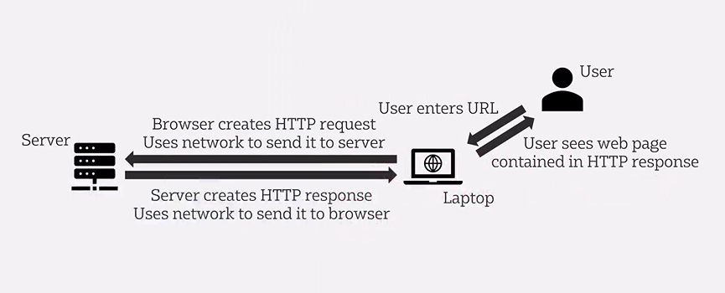

^ way they communicate

One of the foundational technologies for REST APIs. A way in which applications can communicate w each other across the internet e.g. web browser communicating w web server across the internet, or a phone application communicating w service to get data on a server side – it’s a protocol to allow for this communication to take place.

# JSON

JavaScript Object Notation

Which 6 of these types of data can be included in a JSON data structure?

Null, number, array, Boolean, string, json object (see py notes)

A JSON data structure can contain embedded JSON data structures

What is Unicode? A standard for encoding text

Json is a text based data structure. Originates from javascript. Can have 6 dif types of data within json data structure.

# REST Concepts

REST APIs must use specific technologies in their implementation FALSE

HTTP and JSON support are widespread within programming languages

Which technology is widely used to share information about the way in which a REST API can be accessed? Swagger/OpenAPI

A REST API is an API a way for websites to communicate w each other which is based on the REST architectural style. Not a standard, but a set of rules abt how an application shd be built. Important bc so easy to use from javascript & generally bc v widely supported by programming languages so can use for integrating applications in general way. Ways to implement: http, URIs, http methods, json, & possibly swagger or open api.

# REST Implementation

In a REST endpoint, collections are normally names with plural nouns.

What is the name given to the architectural constraint in REST which gives us links in the returned JSON document, allowing further data to be retrieved by following the links? Hyptertext as the engine of application state

The following responses could realistically be cached for 30 minutes – technical details of movie from 2001, details of branch of high street bank. (Only cache things where yk info won’t change so that it is quicker to load)

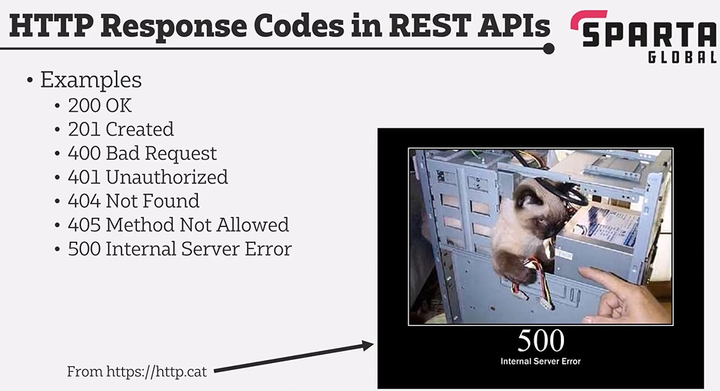

REST APIs often used to implement a kind of crud interface. Key thing: very often they provide crud interface using http as transport and json as way to represent data structures. Correlation btwn crud operations and corresponding http methods that r used. Can test APIs using curl, browser for simple get request, anything remotely complex – postman. Restfox.dev is simple web base to test utilities.