Sana Khan

IST659

Lab 5

User Table

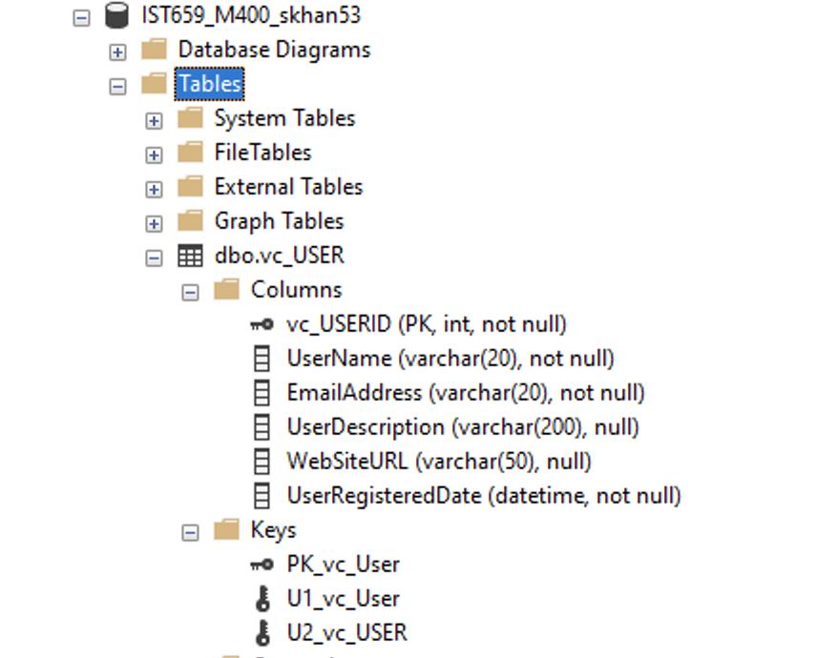

User Login Table

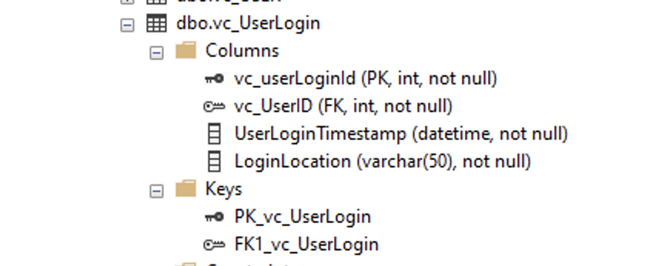

User Records

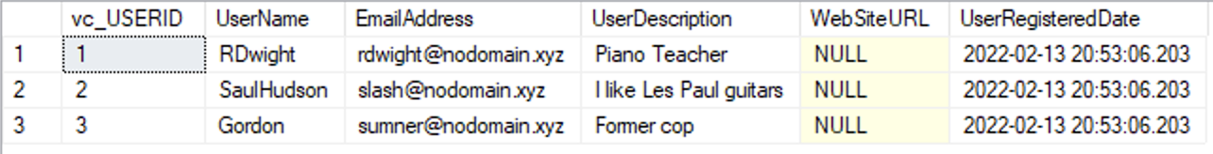

VidCast Tables

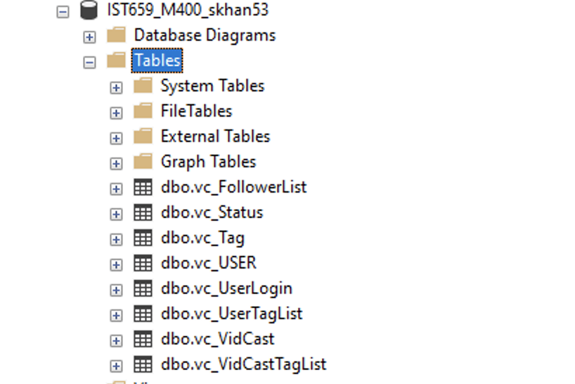

SQL Code:

/*

Author : Sana Khan

Course : IST659 M400

Term : Winter 2022

*/

--Creating the user table --

CREATE TABLE vc_User (

--Cloumns for the user table --

vc_USERID int identity,

UserName varchar(20) not null,

EmailAddress varchar(20) not null,

UserDescription varchar(200),

WebSiteURL varchar(50),

UserRegisteredDate datetime not null default GetDate(),

-- Constaints on the User Table

CONSTRAINT PK_vc_User PRIMARY KEY (vc_UserID),

CONSTRAINT U1_vc_User UNIQUE(UserName),

CONSTRAINT U2_vc_User UNIQUE(EmailAddress)

)

--End Creating user table

--Creating the UserLogin table

CREATE TABLE vc_UserLogin(

--Columns or UserLogin Table

vc_userLoginId int identity,

vc_UserID int not null,

UserLoginTimestamp datetime not null default GetDate(),

LoginLocation varchar(50) not null,

--Constraints on the User Login Table

CONSTRAINT PK_vc_UserLogin PRIMARY KEY (vc_UserLoginID),

CONSTRAINT FK1_vc_UserLogin Foreign Key (vc_UserID) REFERENCES vc_User(vc_UserID)

)

--End creating the User Login Table

-- Adding Data to the User table

INSERT INTO vc_User(UserName, EmailAddress, UserDescription) VALUES

('RDwight', 'rdwight@nodomain.xyz', 'Piano Teacher'), ('SaulHudson', 'slash@nodomain.xyz', 'I like Les Paul guitars'), ('Gordon', 'sumner@nodomain.xyz', 'Former cop')

SELECT * FROM vc_user

--Creating the Follower List table

CREATE TABLE vc_FollowerList (

--Columns for the follower List table

vc_FollowerListID int identity,

FollowerID int not null,

FollowedID int not null,

FollowerSince datetime not null,

-- Constraints on the Follower List table

CONSTRAINT PK_vc_FollowerList PRIMARY KEY (vc_FollowerListID),

CONSTRAINT U1_vc_FollowerList UNIQUE (Followerid, FollowedID),

CONSTRAINT FK1__FollowerList FOREIGN KEY(FollowerID) REFERENCES vc_User(vc_UserID),

CONSTRAINT FK2__FollowerList FOREIGN KEY(FollowerID) REFERENCES vc_User(vc_UserID)

)

-- End creating the Follower List table

--Creating the Tag table

CREATE TABLE vc_Tag(

--Columns for the Tag table

vc_TagID int identity,

TagText varchar(20) not null,

TagDescription varchar(100)

-- Constraints on the tag table

CONSTRAINT PK_vc_Tag PRIMARY KEY (vc_TagID),

CONSTRAINT U1_vc_Tag UNIQUE (TagText)

)

-- End Creating theTtag table

--Creating Status table

CREATE TABLE vc_Status(

--Columns for the Status table

vc_StatusID int identity,

StatusText varchar(20)

-- Constraints on the Status table

CONSTRAINT PK_vc_Staus PRIMARY KEY (vc_StatusID),

CONSTRAINT U1_vc_Status UNIQUE (StatusText)

)

--end

--Creating VidCast table

CREATE TABLE vc_VidCast(

--Columns for the VidCast table

vc_VidCastID int identity,

VidCastTitle varchar(50) not null,

StartDateTime datetime,

EndDateTime datetime,

ScheduledDurationMinutes int,

RecordingURL varchar(50),

vc_UserID int not null,

vc_StatusID int not null,

-- Constraints on the Vidcast table

CONSTRAINT PK_vc_VidCast PRIMARY KEY (vc_VidCastID),

CONSTRAINT FK1_vc_VidCast FOREIGN KEY (vc_UserID) REFERENCES vc_User(vc_UserID),

CONSTRAINT FK2_vc_VidCast FOREIGN KEY (vc_StatusID) REFERENCES vc_Status(vc_StatusID)

)

--Creating VidCastTagList table

CREATE TABLE vc_VidCastTagList (

--Columns for the VidCast Tag List table

vc_VidCastTagListID int identity,

vc_TagID int not null,

vc_VidCastID int not null

-- Constraints on the VidCastTag table

CONSTRAINT PK_vc_VidCastTagList PRIMARY KEY (vc_VidCastTagListID),

CONSTRAINT U1_vc_VidCastTagList UNIQUE (vc_TagID, vc_VidCastID),

CONSTRAINT FK1_vc_VidCastTagList FOREIGN KEY (vc_TagID) REFERENCES vc_Tag(vc_TagID),

CONSTRAINT FK2_vc_VidCastTagList FOREIGN KEY (vc_VidCastID) REFERENCES vc_VidCast(vc_VidCastID)

)

--Creating VidCast User Tag List table

CREATE TABLE vc_UserTagList (

--Columns for the VidCast User Tag List table

vc_UserTagListID int identity,

vc_TagID int not null,

vc_UserID int not null

-- Constraints on the VidCaast User Tag List table

CONSTRAINT PK_vc_UserTagList PRIMARY KEY (vc_UserTagListID),

CONSTRAINT U1_vc_UserTagList UNIQUE (vc_TagID, vc_UserID),

CONSTRAINT FK1_vc_UserTagList FOREIGN KEY (vc_TagID) REFERENCES vc_Tag(vc_TagID),

CONSTRAINT FK2_vc_UserTagList FOREIGN KEY (vc_UserID) REFERENCES vc_User(vc_UserID)

)

--End