Sana Khan

Lab 6

**First VidCast**



**Saul’s First VidCast**



**Update a User**



**No more on time**

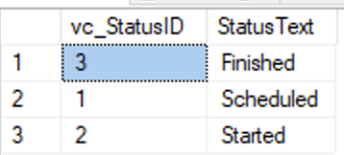

**Tags**

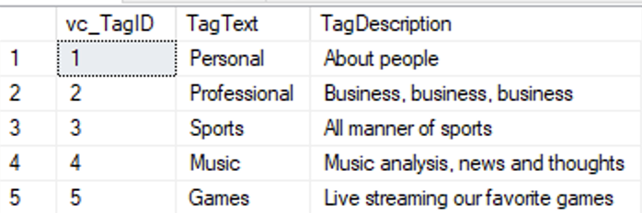

**Users**

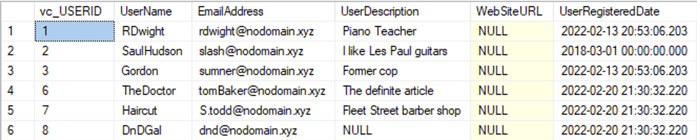

**User Tag List**

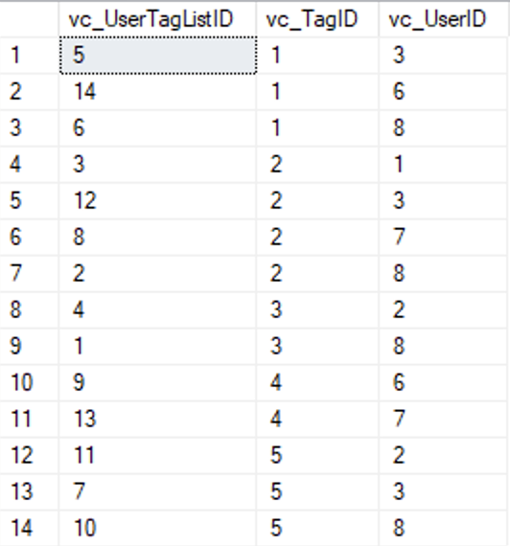

**User Tags Report**

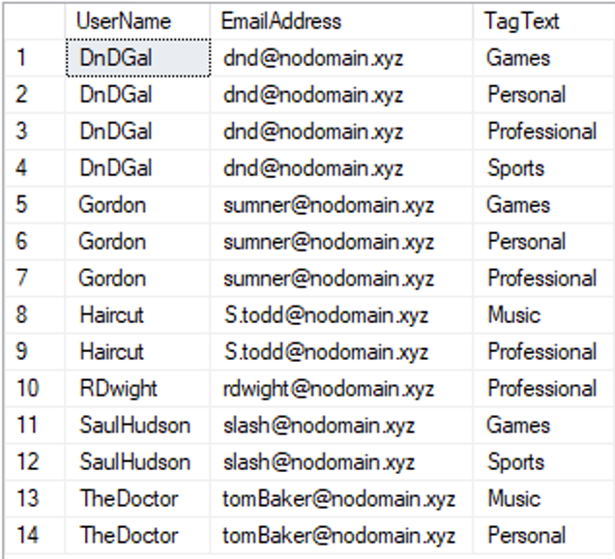

**Code**

--Add a row to the vc_Status Table

INSERT INTO vc_Status (StatusText)

VALUES ('Scheduled')

--Pull all rows from vc_Status table

SELECT * FROM vc_Status

--Adding three more rows to the vc_Status table

INSERT INTO vc_Status (StatusText)

VALUES ('Started'), ('Finished'), ('On time')

--Pull all rows from vc_Status table

SELECT * FROM vc_Status

SELECT * FROM vc_USER WHERE UserName = 'SaulHudson'

SELECT * FROM vc_Status WHERE StatusText = 'Finished'

--Adding a vidcast record to the Vidcast Table

INSERT INTO vc_VidCast

(VidCastTitle, StartDateTime, EndDateTime, ScheduledDurationMinutes, RecordingURL, vc_UserID, vc_StatusId)

VALUES

('December Snow', '3/1/2018 14:00', '3/1/2018 14:30','30', '/XVF1234', 2, 3)

SELECT * FROM vc_VidCast

SELECT vc_User.UserName

,vc_User.EmailAddress

,vc_VidCast.VidCastTitle

,vc_VidCast.StartDateTime

,vc_VidCast.EndDateTime

,vc_VidCast.ScheduledDurationMinutes / 60.0 as ScheduledHours, vc_Status.StatusText

,vc_Status.StatusText

FROM vc_VidCast

JOIN vc_User on vc_VidCast.vc_UserID = vc_User.vc_UserID

JOIN vc_Status on vc_VidCast.vc_StatusID = vc_Status.vc_StatusID WHERE vc_User.UserName = 'SaulHudson'

ORDER BY vc_VidCast.StartDateTime

--Updating Users Data

UPDATE vc_User SET UserRegisteredDate = '3/1/2018' WHERE UserName = 'SaulHudson'

Select * FROM vc_User WHERE UserName = 'SaulHudson'

SELECT * FROM vc_Status

--Delete the On Time status

DELETE vc_Status WHERE StatusText = 'On Time'

SELECT * FROM vc_Status

INSERT INTO vc_Tag

(TagText, TagDescription)

VALUES

('Personal', 'About people')

,('Professional', 'Business, business, business')

,('Sports', 'All manner of sports')

,('Music', 'Music analysis, news and thoughts')

,('Games', 'Live streaming our favorite games')

SELECT * FROM vc_Tag

SELECT * FROM vc_User

ALTER TABLE vc_User

MODIFY COLUMN EmailAddress

varchar(30);

INSERT INTO vc_User

(UserName, EmailAddress, UserDescription)

VALUES

('TheDoctor', 'tomBaker@nodomain.xyz', 'The definite article')

,('Haircut', 'S.todd@nodomain.xyz','Fleet Street barber shop')

,('DnDGal', 'dnd@nodomain.xyz', 'NULL')

SELECT * FROM vc_User

INSERT INTO vc_UserTagList (vc_UserID, vc_TagID) VALUES

((SELECT vc_UserID FROM vc_User WHERE UserName='DnDGal'),

(SELECT vc_TagID FROM vc_Tag WHERE TagText='Sports')),

((SELECT vc_UserID FROM vc_User WHERE UserName='DnDGal'),

(SELECT vc_TagID FROM vc_Tag WHERE TagText='Professional')),

((SELECT vc_UserID FROM vc_User WHERE UserName='RDwight'),

(SELECT vc_TagID FROM vc_Tag WHERE TagText='Professional')),

((SELECT vc_UserID FROM vc_User WHERE UserName='SaulHudson'),

(SELECT vc_TagID FROM vc_Tag WHERE TagText='Sports')),

((SELECT vc_UserID FROM vc_User WHERE UserName='Gordon'),

(SELECT vc_TagID FROM vc_Tag WHERE TagText='Personal')),

((SELECT vc_UserID FROM vc_User WHERE UserName='DnDGal'),

(SELECT vc_TagID FROM vc_Tag WHERE TagText='Personal')),

((SELECT vc_UserID FROM vc_User WHERE UserName='Gordon'),

(SELECT vc_TagID FROM vc_Tag WHERE TagText='Games')),

((SELECT vc_UserID FROM vc_User WHERE UserName='HairCut'),

(SELECT vc_TagID FROM vc_Tag WHERE TagText='Professional')), ((SELECT vc_UserID FROM vc_User WHERE UserName='TheDoctor'),

(SELECT vc_TagID FROM vc_Tag WHERE TagText='Music')),

((SELECT vc_UserID FROM vc_User WHERE UserName='DnDGal'),

(SELECT vc_TagID FROM vc_Tag WHERE TagText='Games')),

((SELECT vc_UserID FROM vc_User WHERE UserName='SaulHudson'),

(SELECT vc_TagID FROM vc_Tag WHERE TagText='Games')),

((SELECT vc_UserID FROM vc_User WHERE UserName='Gordon'),

(SELECT vc_TagID FROM vc_Tag WHERE TagText='Professional')),

((SELECT vc_UserID FROM vc_User WHERE UserName='HairCut'),

(SELECT vc_TagID FROM vc_Tag WHERE TagText='Music')),

((SELECT vc_UserID FROM vc_User WHERE UserName='TheDoctor'),

(SELECT vc_TagID FROM vc_Tag WHERE TagText='Personal'))

SELECT * FROM vc_UserTagList

SELECT vc_User.UserName

,vc_User.EmailAddress

,vc_Tag.TagText

FROM vc_UserTagList

LEFT JOIN vc_User on vc_UserTagList.vc_UserID = vc_User.vc_UserID

LEFT JOIN vc_Tag on vc_UserTagList.vc_TagID = vc_Tag.vc_TagID

ORDER BY vc_User.UserName, vc_Tag.TagText