1. Introduction
For this case study, I selected YouTube because it is a platform I can relate to as a user. I use the example of YouTube to understand how a large digital product organises its information and connects people with videos. YouTube allows people to watch, upload, search for, comment on, and share videos. It also gives creators a place to publish content and build an audience.
The aim of my project is to dissect the main features of YouTube and propose a simplified database schema that could support those features. This is an educational design based on publicly visible functionality; it is not a claim about YouTube’s private internal database.

2. Company and Product Overview
YouTube is an online video platform where viewers can discover and watch content while creators upload videos and manage channels. The platform supports different kinds of content, including long videos, Shorts, live streams, music, tutorials, entertainment, reviews, and educational videos. Users can subscribe to channels, interact through comments and likes, and save videos in playlists.
YouTube’s official help pages describe personalised recommendations on the Home page and in the Up next area. The recommendations can use signals such as watch history, search history, subscriptions, likes, dislikes, and feedback from viewers [1]. This makes YouTube a useful platform for studying relationships between users, videos, channels, and viewing activity.

3. Main Features I Identified
- User accounts and channels: A user can have an account and operate a channel with a name, description, and published videos.
- Video publishing: Creators upload videos with titles, descriptions, visibility settings, upload dates, and other metadata.
- Search and discovery: Viewers search for videos and discover content through recommendations, topic browsing, and channel pages.
- Subscriptions: A viewer can subscribe to a channel to keep up with its new uploads.
- Likes and comments: Viewers can react to videos and leave comments, creating interaction between the audience and creator.
- Playlists and saved videos: Users can group videos into playlists and return to them later. Playlist privacy settings can control who can view them [2].
- Watch history: Viewing activity can help users find previously watched videos and can influence recommendations [1].
- Tags and metadata: Creators can add descriptive information that helps organise and identify content.

4. Real-World Problems YouTube Helps Solve

4.1 Finding useful information quickly
A person may need to learn how to repair a bicycle, understand a difficult topic, cook a recipe, or use new software. Instead of relying only on written instructions, the person can search for a video and watch the steps being demonstrated.

4.2 Helping creators reach an audience
People with knowledge, skills, or creative ideas may not have access to a television channel or a large publishing company. YouTube gives them a way to upload content and potentially reach viewers beyond their local area.

4.3 Discovering relevant content
Because YouTube contains a huge amount of content, finding a suitable video can be difficult. Search, channel subscriptions, and personalised recommendations help viewers narrow down what to watch. YouTube explains that recommendations use different signals, including watch and search history and feedback [1].

4.4 Keeping content organised
Playlists let users collect related videos—for example, exam lessons, workout routines, music, or travel guides—in one place. This reduces the effort of searching for each video again [2].

4.5 Supporting discussion and feedback
Comments and likes let viewers respond to videos. Creators can learn what their audience finds useful or interesting, while viewers can share reactions and questions.

5. Short Case Study: A Student Learning a Topic
To make the analysis practical, I considered a typical situation. Suppose a student is preparing for an exam and does not understand a topic from the classroom notes.
- The student opens YouTube and searches for the topic using relevant words.
- YouTube returns videos whose titles and descriptions match the search.
- The student watches one lesson and checks the explanation against their notes.
- If the lesson is helpful, the student may like it, subscribe to the channel, or save it to a study playlist.
- Later, the student can return to the playlist or watch history instead of searching from the beginning.
- YouTube may also suggest related lessons based on available activity and recommendation signals [1].
In this example, the platform helps with discovery, learning, and organisation. From a schema-design point of view, the activity involves users, videos, channels, subscriptions, playlists, playlist items, likes, and watch-history records.

6. Proposed Database Schema
I designed the schema around the features discussed above. I used primary keys (PK) to uniquely identify records and foreign keys (FK) to connect related records. The table design below is a simplified proposal for a learning project, not YouTube’s actual production schema.
Entity / Table | Main attributes | Purpose
USERS | user_id (PK), username, email, created_at | Stores account-level details.
CHANNELS | channel_id (PK), owner_user_id (FK → USERS.user_id), channel_name, description, created_at | Stores creator/channel information. One user may own a channel in this simplified model.
VIDEOS | video_id (PK), channel_id (FK → CHANNELS.channel_id), title, description, duration_seconds, visibility, uploaded_at | Stores each uploaded video and its metadata.
COMMENTS | comment_id (PK), video_id (FK → VIDEOS.video_id), user_id (FK → USERS.user_id), comment_text, created_at | Connects a comment to the video and the user who wrote it.
VIDEO_LIKES | like_id (PK), video_id (FK → VIDEOS.video_id), user_id (FK → USERS.user_id), created_at | Records which users liked which videos. A unique constraint on (user_id, video_id) can prevent duplicate likes.
SUBSCRIPTIONS | subscription_id (PK), user_id (FK → USERS.user_id), channel_id (FK → CHANNELS.channel_id), subscribed_at | Connects viewers to channels they subscribe to. A unique constraint on (user_id, channel_id) can prevent duplicate subscriptions.
PLAYLISTS | playlist_id (PK), user_id (FK → USERS.user_id), playlist_name, privacy, created_at | Stores playlists created by users.
PLAYLIST_VIDEOS | playlist_video_id (PK), playlist_id (FK → PLAYLISTS.playlist_id), video_id (FK → VIDEOS.video_id), position, added_at | Join table for the many-to-many relationship between playlists and videos.
WATCH_HISTORY | history_id (PK), user_id (FK → USERS.user_id), video_id (FK → VIDEOS.video_id), watched_at, progress_seconds | Stores a user's viewing event and optional progress position.
VIDEO_TAGS | video_tag_id (PK), video_id (FK → VIDEOS.video_id), tag_text | Stores searchable descriptive tags associated with videos.

7. Relationships Between Entities
- USERS → CHANNELS: one user can own a channel in this simplified model; each channel has one owner.
- CHANNELS → VIDEOS: one channel can publish many videos; each video belongs to one channel.
- USERS → COMMENTS and VIDEOS → COMMENTS: a user can write many comments, and a video can receive many comments.
- USERS ↔ VIDEOS through VIDEO_LIKES: users can like many videos, and each video can receive likes from many users.
- USERS ↔ CHANNELS through SUBSCRIPTIONS: many users can subscribe to many channels.
- USERS → PLAYLISTS: one user can create many playlists.
- PLAYLISTS ↔ VIDEOS through PLAYLIST_VIDEOS: a playlist can contain many videos, and a video can appear in many playlists.
- USERS → WATCH_HISTORY and VIDEOS → WATCH_HISTORY: a user can have many viewing-history records, and a video can appear in many users’ histories.
- VIDEOS → VIDEO_TAGS: one video can have multiple tags.

8. Entity-Relationship (ER) Diagram
The diagram below shows the main entities and the links between them. I have kept it simplified so that the relationships are easier to understand in a presentation.
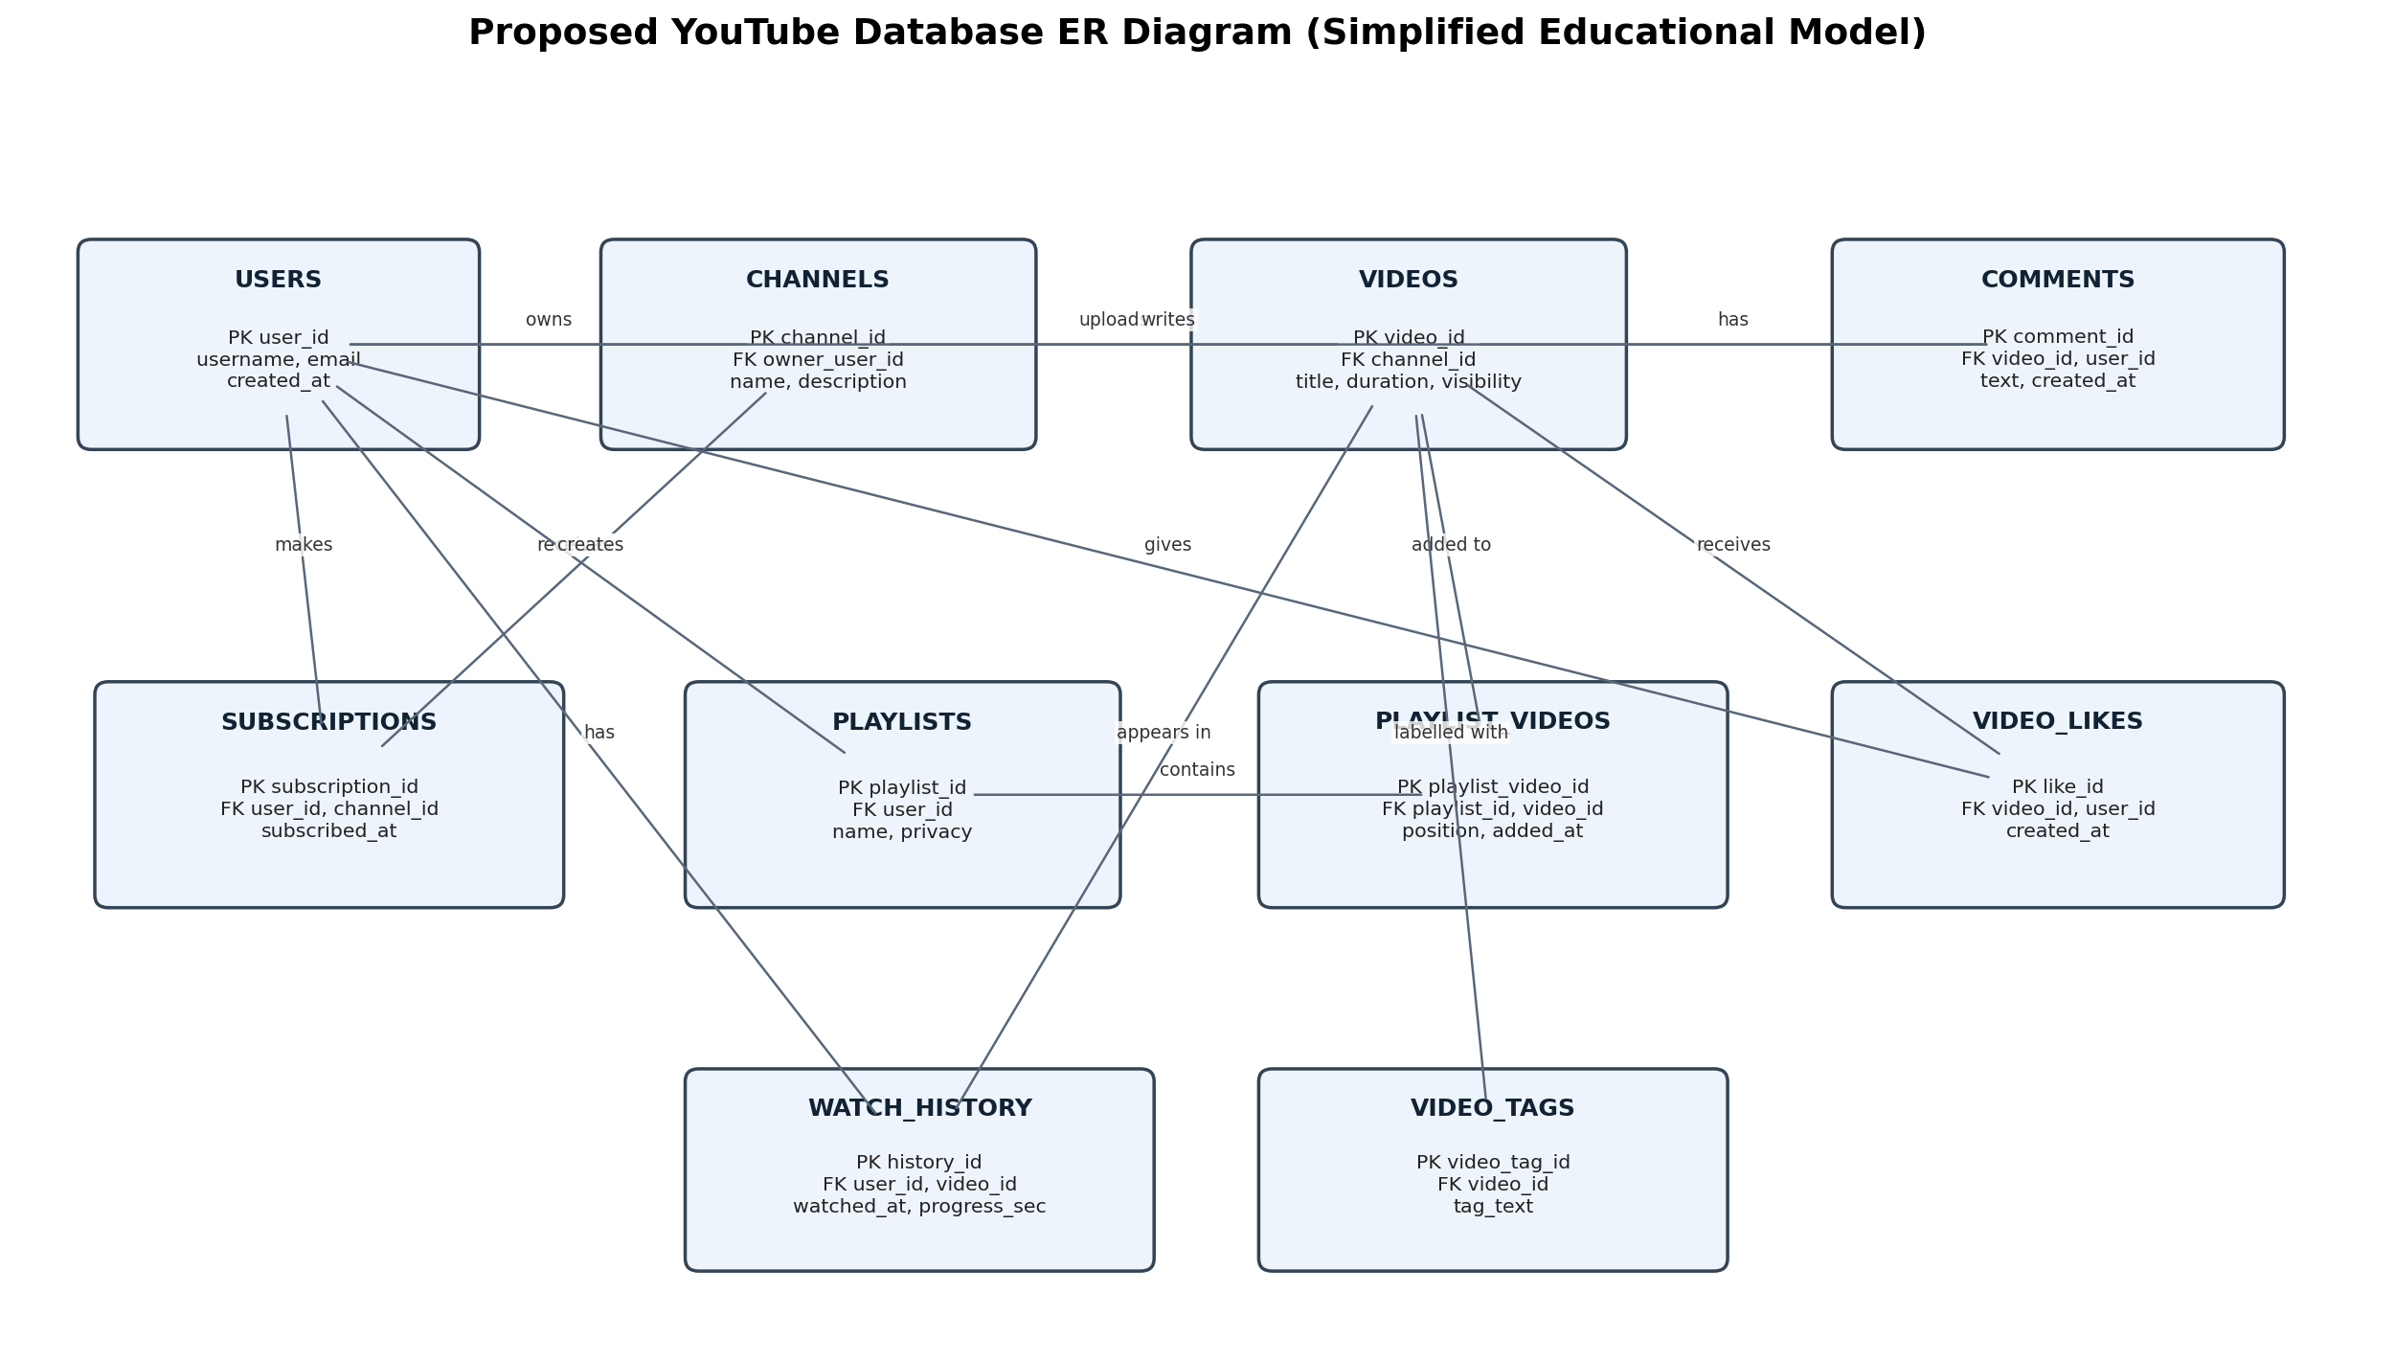
Note: This is my proposed educational ER model. Real systems can use additional tables, services, caches, and specialised storage for scale, safety, analytics, and media delivery.

9. Rationale Behind My Design
- Separate users and channels: an account represents a person or account, while a channel represents the publishing identity and its videos.
- Separate videos from comments and likes: one video can have many comments and likes, so storing these as separate records avoids repeating data in the video table.
- Use join tables for many-to-many relationships: subscriptions connect users to channels, and playlist items connect playlists to videos.
- Keep watch history as individual events: a user may watch the same video more than once, so each viewing event can have its own timestamp and progress position.
- Store tags separately: this allows each video to have multiple tags without placing a list of tags in one database field.
- Use IDs and foreign keys: IDs provide stable identifiers, while foreign keys help maintain consistent relationships between tables.

10. How the Schema Supports the Features
User action | Tables involved
Upload a video | CHANNELS + VIDEOS
Comment on a video | USERS + VIDEOS + COMMENTS
Like a video | USERS + VIDEOS + VIDEO_LIKES
Subscribe to a creator | USERS + CHANNELS + SUBSCRIPTIONS
Create a study playlist | USERS + PLAYLISTS + PLAYLIST_VIDEOS + VIDEOS
Return to a previously watched lesson | USERS + WATCH_HISTORY + VIDEOS
Organise videos by tags | VIDEOS + VIDEO_TAGS

11. Limitations and Possible Improvements
This schema covers selected features, not the complete YouTube platform. A production system would need more detailed models for video processing and storage, captions, live streaming, notifications, reporting, moderation, advertising, creator analytics, permissions, and recommendations. Recommendation systems are especially complex and cannot be represented fully by a few relational tables. I would also consider indexes on video titles, channel IDs, timestamps, and foreign keys to improve common queries.
I would add constraints to prevent duplicate subscriptions and likes, validate visibility values, and consider soft deletion or moderation status fields where appropriate. For privacy, access to account data and watch history would need suitable controls.

12. Conclusion
Through this case study, I learned that a platform that looks simple to use can depend on many connected data entities. YouTube needs to connect users, channels, videos, comments, likes, subscriptions, playlists, and viewing activity. My proposed schema separates these entities and uses primary keys, foreign keys, and join tables to represent their relationships.
The main lesson I took from this project is that good schema design should reflect how people actually use a product. When the relationships are planned carefully, it becomes easier to support features, reduce repeated data, and keep information organised.

13. Video Presentation Script (Approx. 2–3 Minutes)
Hello everyone. In this presentation, I am explaining my product dissection and schema design of YouTube.
I selected YouTube because it is a familiar platform used for education, entertainment, music, tutorials, and many other types of content. Its main features include uploading videos, searching, subscribing to channels, commenting, liking, saving playlists, and receiving recommendations.
One real-world problem YouTube helps solve is finding information in a visual and easy-to-follow format. For example, a student who does not understand a topic can search for a lesson, watch it, and save it in a study playlist for later.
To represent these features, I designed a simplified database schema. The main tables are Users, Channels, Videos, Comments, Video Likes, Subscriptions, Playlists, Playlist Videos, Watch History, and Video Tags.
Users and Channels are connected because users manage publishing identities. Channels can upload many videos. Comments connect a user to a video. Likes connect users and videos, while Subscriptions connect users and channels. Since one playlist can contain many videos and a video can appear in many playlists, I used a separate Playlist Videos table.
I used primary keys to identify records and foreign keys to connect tables. This structure helps avoid unnecessary duplication and makes it easier to represent the main interactions on YouTube.
This is only an educational model, not YouTube’s real internal database. A real platform would need additional systems for video storage, recommendations, safety, analytics, and large-scale performance.
To conclude, this project helped me understand how product features can be translated into entities, attributes, and relationships. Thank you.

14. References
- [1] YouTube Help, “How YouTube recommendations work.” https://support.google.com/youtube/answer/16089387?hl=en-in (accessed 19 October 2026).
- [2] YouTube Help, “Create & manage playlists.” https://help.youtube.com/support/youtube/bin/answer.py?answer=57792 (accessed 19 October 2026).
- [3] YouTube for Developers, “YouTube Data API / YouTube functionality.” https://developers.google.com/youtube/ (accessed 19 October 2026).
Video link: Add your own recorded presentation link here before final submission.

