BISHOP HEBER COLLEGE (AUTONOMOUS)
Tiruchirappalli – 620 017
DEPARTMENT OF COMPUTER APPLICATIONS

MINI PROJECT REPORT

BUS RESERVATION SYSTEM

Submitted in partial fulfilment of the requirements
for the award of the degree of Bachelor of Computer Applications

Submitted by
HARISRI
245113227
III BCA – SECTION B

Mentor
Dr. ADLIN SUJI

OCTOBER 2026

1. ABSTRACT
The Bus Reservation System is a web-based application developed to simplify and automate the process of searching for buses, entering passenger details, selecting seats, and making payments for bus tickets. In a traditional bus booking system, passengers visit the booking counter or contact agents to reserve a seat, and operators maintain records manually. This process may lead to long queues, booking errors, and difficulty in tracking seat availability.
The proposed system provides a centralized platform where passengers can register, log in, search for buses by source, destination, and journey date, enter passenger details, choose a seat, and complete the payment online using different payment methods such as UPI, Credit Card, Debit Card, and Net Banking.
The application is designed using ASP.NET Web Forms with C# and Microsoft SQL Server. The system aims to improve efficiency, reduce waiting time, avoid manual errors, and provide a simple and user-friendly environment for booking bus tickets.
Keywords: Bus Reservation, ASP.NET, C#, SQL Server, Web Application.

2. INTRODUCTION
The Bus Reservation System is designed to manage the bus ticket booking process. It provides a digital platform for passengers to search buses, reserve seats, and pay for tickets without visiting a booking counter.
The system helps passengers search buses between two locations on a selected date, provide their details, select a seat, and make the payment online. User account details are stored in a database for secure login and easy retrieval.

3. OBJECTIVES
- To develop a web-based Bus Reservation System.
- To allow passengers to register and log in online.
- To enable passengers to search buses by source, destination, and journey date.
- To allow passengers to enter details and select a seat for the journey.
- To provide online payment options and booking confirmation.
- To reduce manual work and improve efficiency of ticket booking.

4. EXISTING SYSTEM
- Passengers book tickets physically at counters or through agents.
- Booking records are maintained manually.
- Booking takes more time and requires long queues.
- Checking seat availability and booking history is difficult.
- Errors such as double booking may occur during record maintenance.

5. PROPOSED SYSTEM
The proposed Bus Reservation System automates the ticket booking and payment process.
- User registration
- User login
- Bus search
- Passenger details entry
- Seat selection
- Online payment
- Booking confirmation

6. MODULES
6.1 Login and Registration Module
Allows new users to create an account and registered users to log in securely using email and password.
6.2 Search Bus Module
Passengers enter the From location, To location, and journey date to search for available buses.
6.3 Passenger and Seat Selection Module
Passengers enter name, phone number, and email, and then choose one seat from the seat layout.
6.4 Payment and Booking Module
Displays the selected seat and amount, accepts the payment method (UPI, Credit Card, Debit Card, Net Banking), and shows the booking confirmation.

7. SOFTWARE REQUIREMENTS
Component | Requirement
Front End | HTML, CSS, ASP.NET Web Forms
Programming Language | C#
Database | Microsoft SQL Server
IDE | Visual Studio
Operating System | Windows

8. DATABASE DESIGN
Users Table
Field | Data Type
UserID | int
FullName | varchar
Email | varchar
Password | varchar
Booking Table
Field | Data Type
BookingID | int
UserID | int
PassengerName | varchar
Phone | varchar
FromCity | varchar
ToCity | varchar
JourneyDate | date
SeatNumber | int
Amount | decimal
PaymentMethod | varchar

9. SYSTEM FLOWCHART

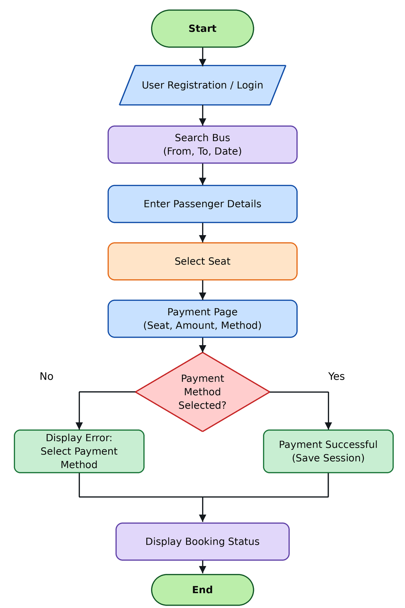

10. SCREENSHOTS
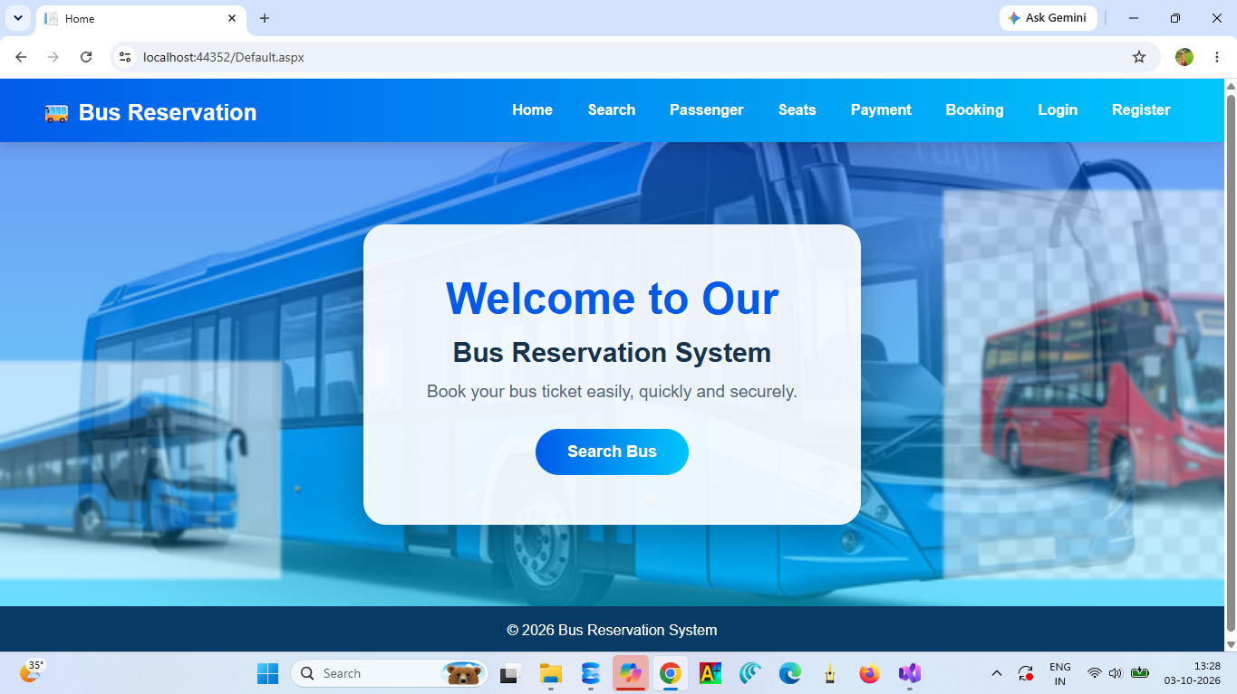
Screenshot 1 – Home Page: Welcome page with navigation menu and Search Bus button.
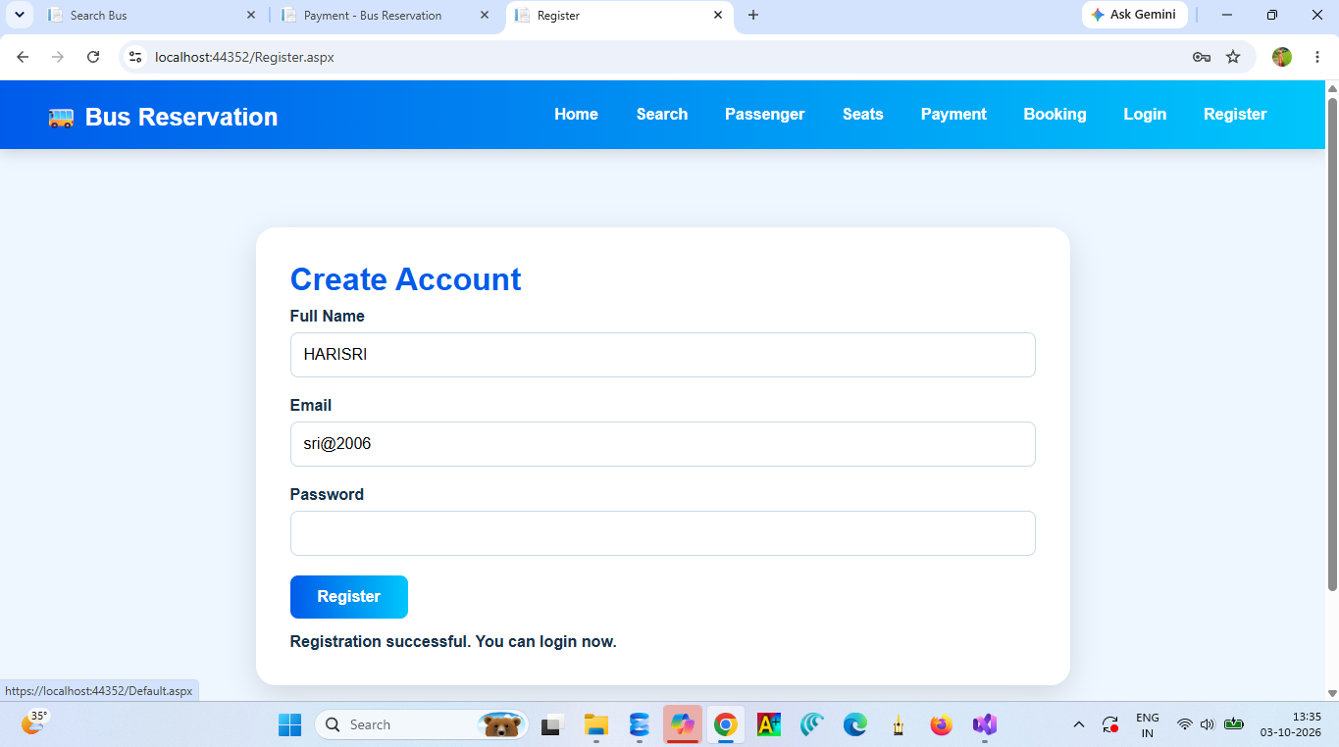
Screenshot 2 – Register Page: Full name, email, and password fields with registration success message.
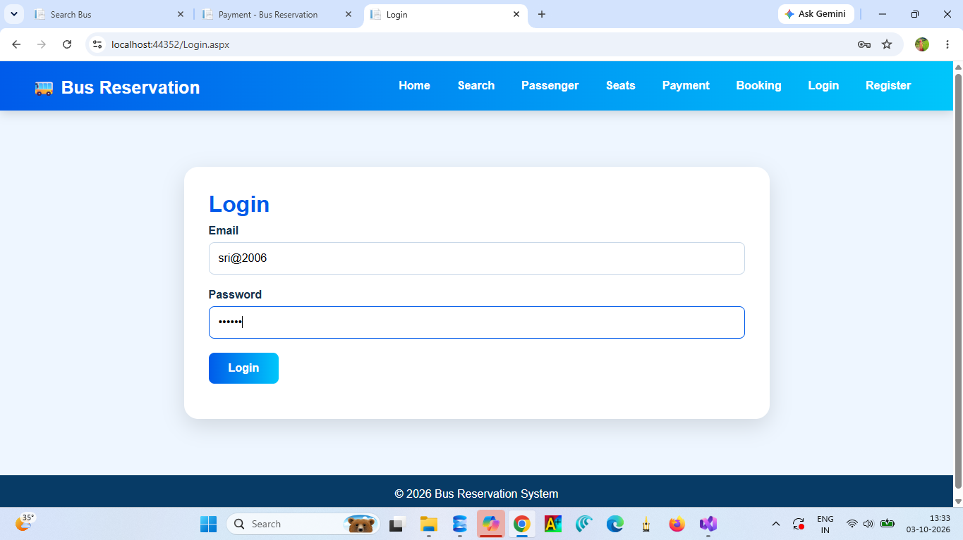
Screenshot 3 – Login Page: Email and password fields with Login button.
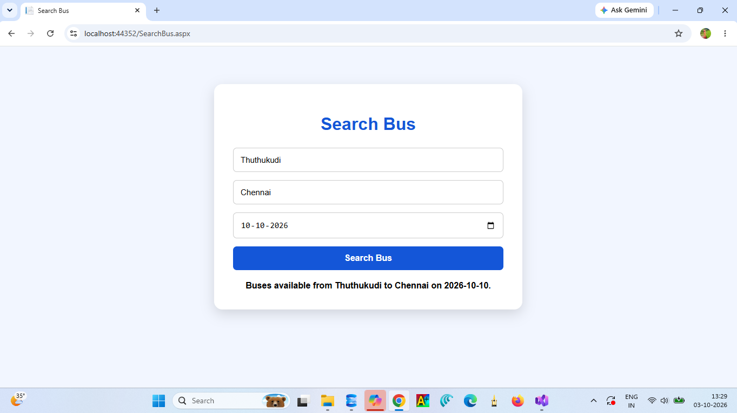
Screenshot 4 – Search Bus: From, To, and journey date with available buses message.
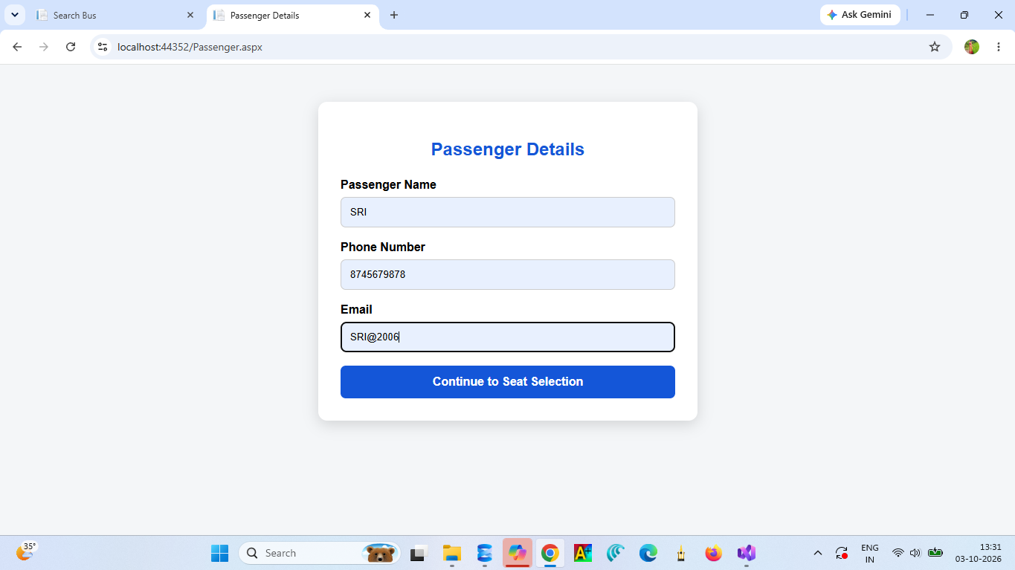
Screenshot 5 – Passenger Details: Passenger name, phone number, and email.
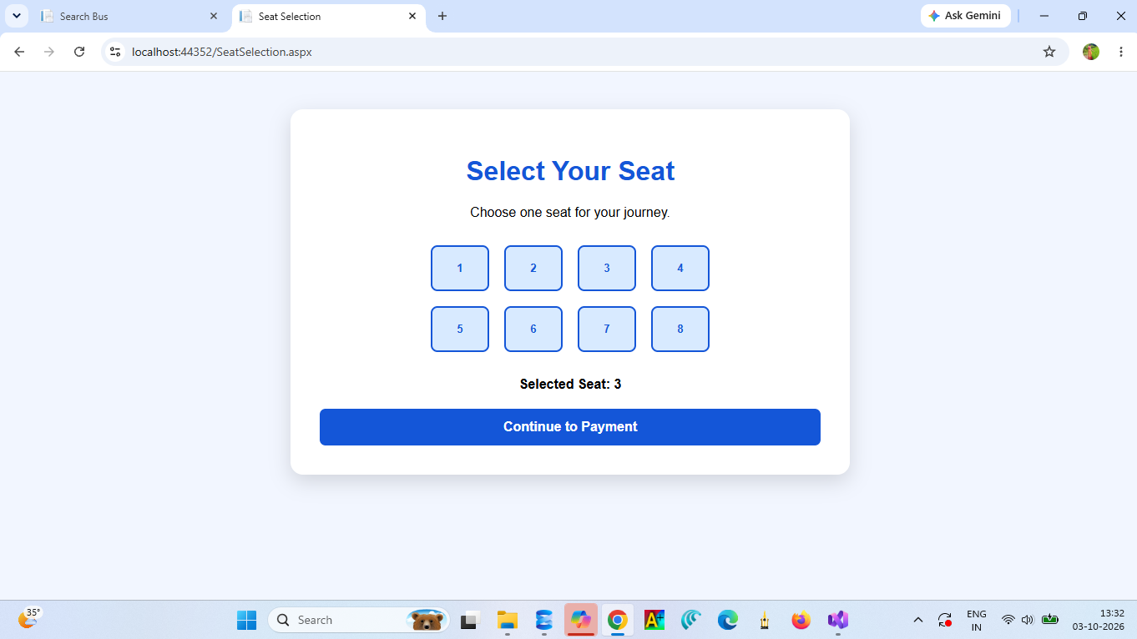
Screenshot 6 – Seat Selection: Seat layout with the selected seat displayed.
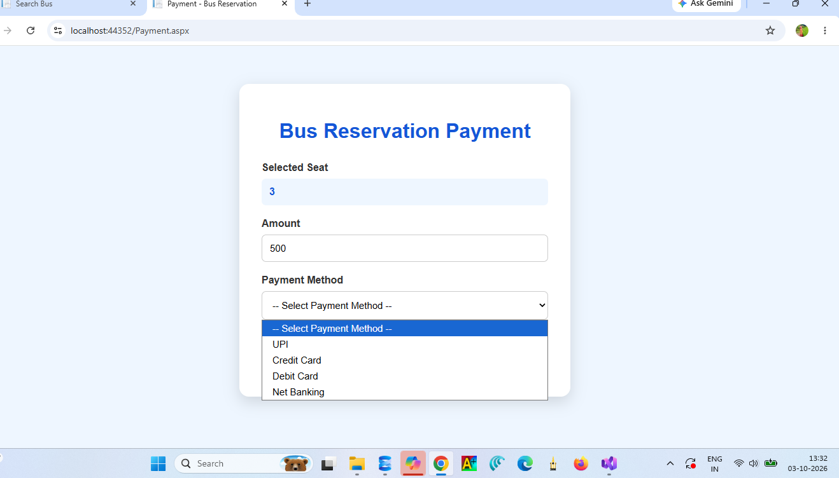
Screenshot 7 – Payment Page: Selected seat, amount, and payment method options.
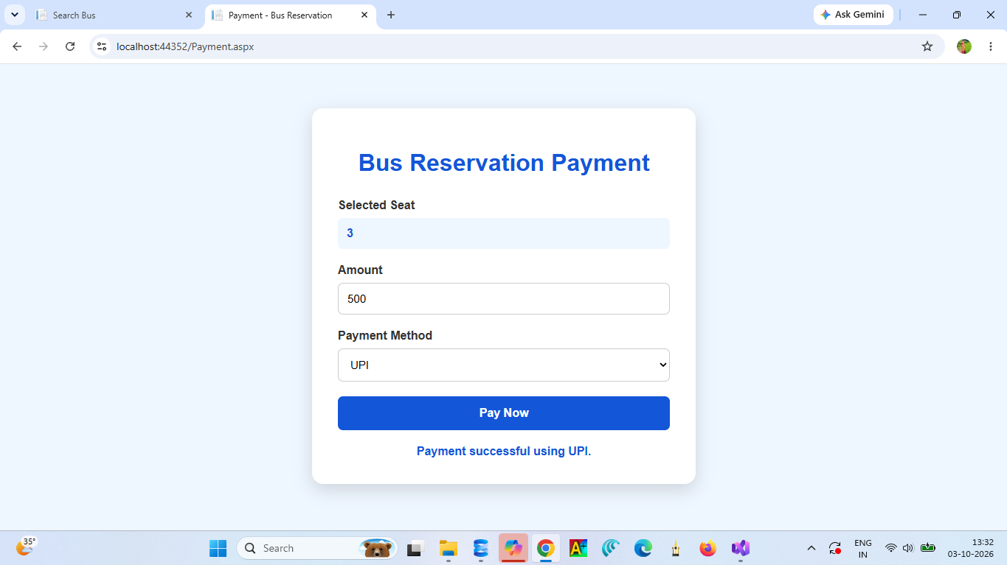
Screenshot 8 – Payment Success: Payment successful message using UPI.

11. TESTING
Test Case | Expected Result
Valid login | Login Successful message displayed
Invalid login | Invalid Email or Password message displayed
Search bus with empty fields | Error message displayed
Search bus with valid details | Available buses message displayed
Submit passenger details | Seat selection page displayed
Continue without selecting a seat | Please select a seat first message displayed
Pay without payment method | Please select a payment method message displayed
Pay with valid method | Payment successful message displayed

12. CONCLUSION
The Bus Reservation System provides an efficient method for booking bus tickets online. It reduces manual work, improves booking accuracy, and simplifies the process of searching buses, selecting seats, and making payments. The project demonstrates the use of web development technologies, database connectivity, form validation, and session management.

13. REFERENCES
- Matthew MacDonald, Beginning ASP.NET in C#.
- Microsoft ASP.NET Documentation.
- Microsoft SQL Server Documentation.
- C# Programming Reference Materials.

14. LMS SUBMISSION CHECKLIST
- Mini Project Report – PDF
- Source Code – ZIP/RAR
- Project Presentation – PPT/PPTX
- Working Project Screenshots
- Student name and register number verified
- Correct allotted project title verified
- All files opened and checked
- Submit button clicked in LMS

