**Build 32 UI Implementation Feedback**

Stride Labs | 06/22/15

Yellow highlight indicates top priority items as they enhance usability/ legibility

**Global Changes:**

0) Nav

1. Background

• “Settings” / selected button:

Hex Val: #2b2333

• “Team, Me, Favorites” / other buttons:

Hex Val: #494c54

b. Icons

• Height: 30 px

c. Text

• Type: Helvetica Regular

• Size: 18px

d. Padding

• Y distance, Top Icon to Top Grey Box: 17px

• Y distance, Bottom Icon to Nav Text: 13 px

• Y distance, Bottom Nav Text to Bottom Screen: 14px

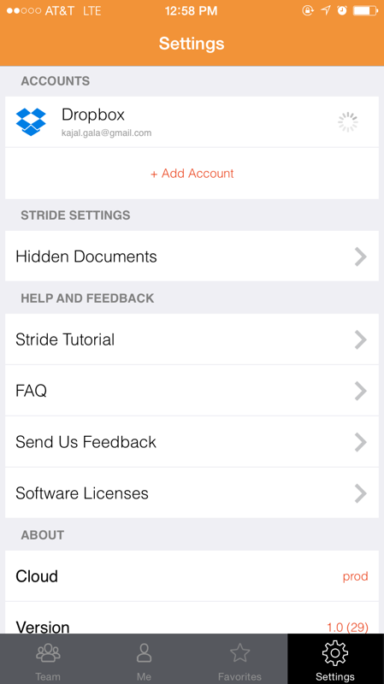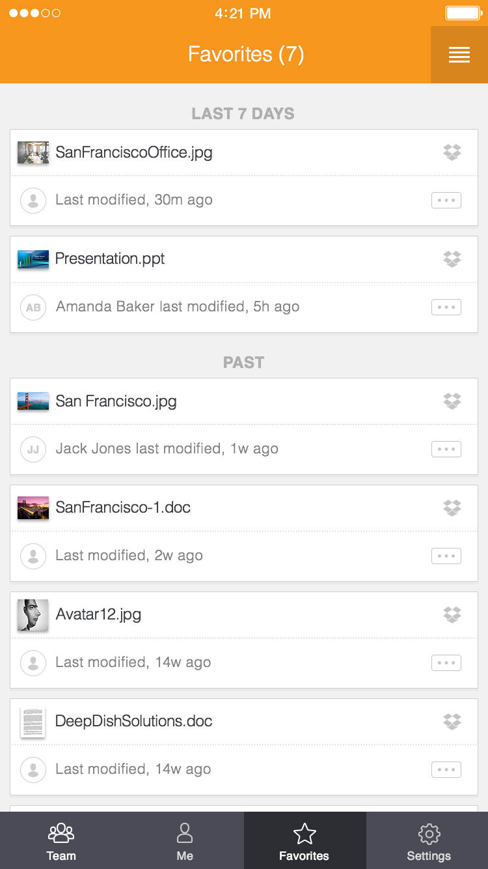

Live Visual Mock Up

All Pages:

1) Background

Hex val: #f1f1f1

2)Top Header (orange)

* 1. Hex Val: #f7961d

3) Padding

X distance, white card to left side screen: 15 px

X distance, white card to right side screen: 15 px

All White Box Units have 30 px LEFT and RIGHT padding from content

4) Misc.

Put a stroke/ outline around all white cards.

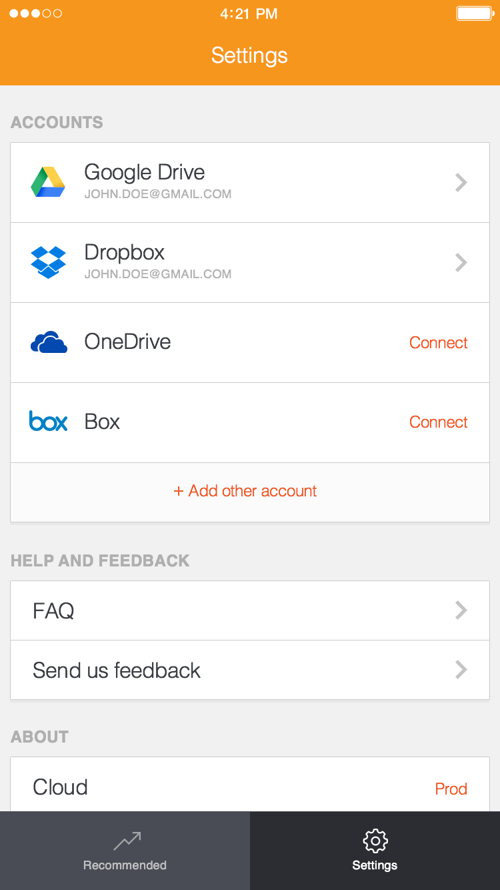

Live Visual Mock Up

Settings

**Local Changes**

1. **Text:**

*NOTE: “CLOUD” and “Version” should not be different font sizes*

1.“Settings” in Top Header Bar:

**Font:** Helvetica Light

**Font Size:** 32 pt

2. “ACCOUNTS/ STRIDE SETTINGS/ HELP/ ABOUT”

**Font:** Helvetica Bold

**Font Size:** 24pt

**Hex Val:** #adadad

3. “Add Account/ Connect/ prod”

**Font:** Helvetica Regular

**Font Size:** 24pt

**Hex Val:** #f15922

**B. Alignment:**

1. Align “Accounts,” “Stride Settings,” “Help and Feedback,” and White Units LEFT

**C. Padding**

1. Vertical between “Accounts” and header: 50 px
2. Vertical between “Accounts” and White Color Block: 20 px
3. Repeat steps 2-6 for “Stride Settings”,
4. Repeat (6) for “Help and Feedback”

**D. Other**

Capitalize “prod” → “Prod”

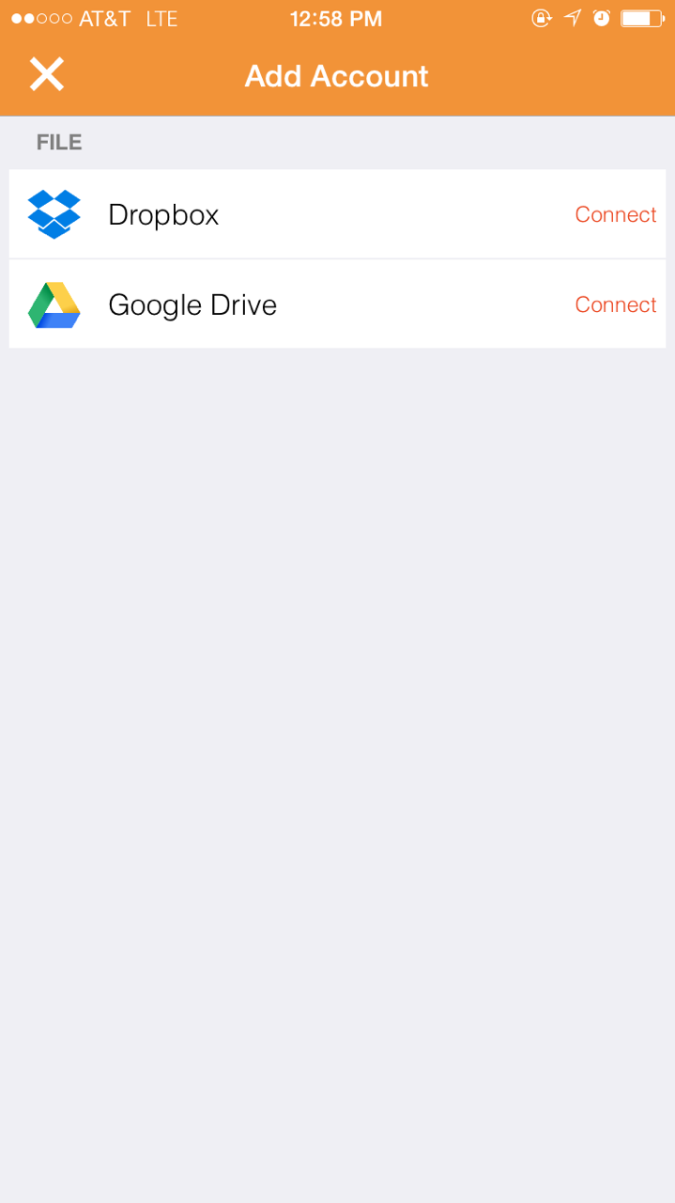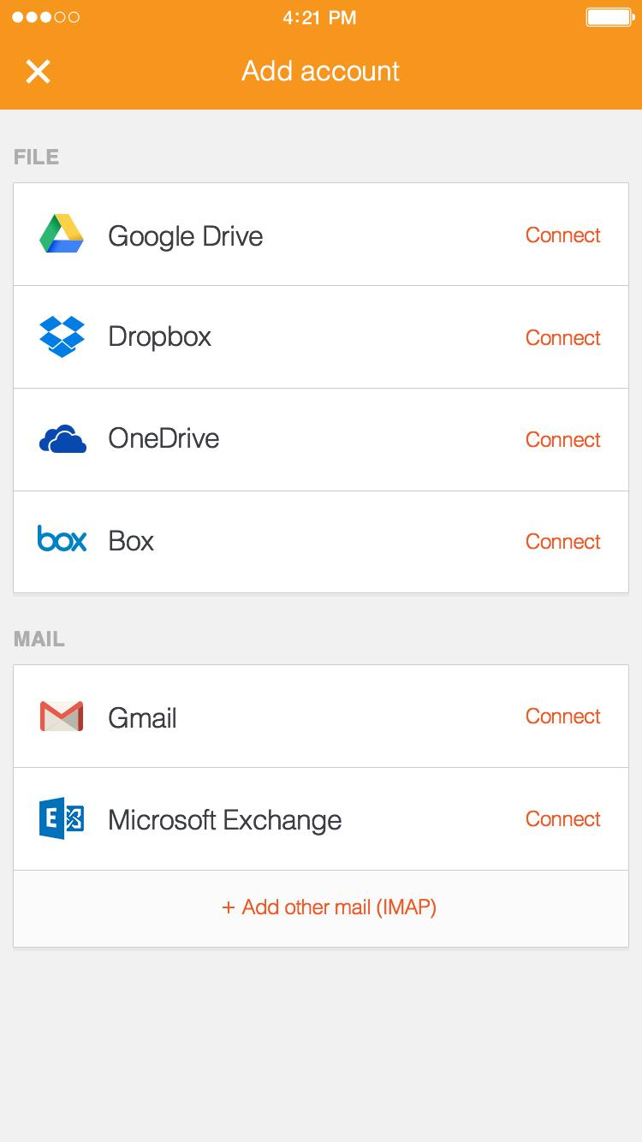

Live Visual Mock Up

Add Account

**A.Text:**

1. “Add Account”:

**Font:** Helvetica Light

**Font Size:** 32 pt

2. “FILE”

**Font:** Helvetica Bold

**Font Size:** 24pt

**Hex Val:** #adadad

3. “Connect”

**Font:** Helvetica Regular

**Font Size:** 24pt

**Hex Val:** #f15922

**B. Alignment:**

1. Align “File,” “Mail,” and white color units LEFT

**C. Padding**

1. Horizontal between “Connect” and right of box: 30 px
2. Vertical between “Connect” and top of box: 50 px
3. Vertical between “Connect and bottom of box: 50 px
4. Vertical between “File” and header Block: 50 px
5. Vertical between “File” and White Color Block: 20 px
6. Repeat steps 2-6 for “Mail”

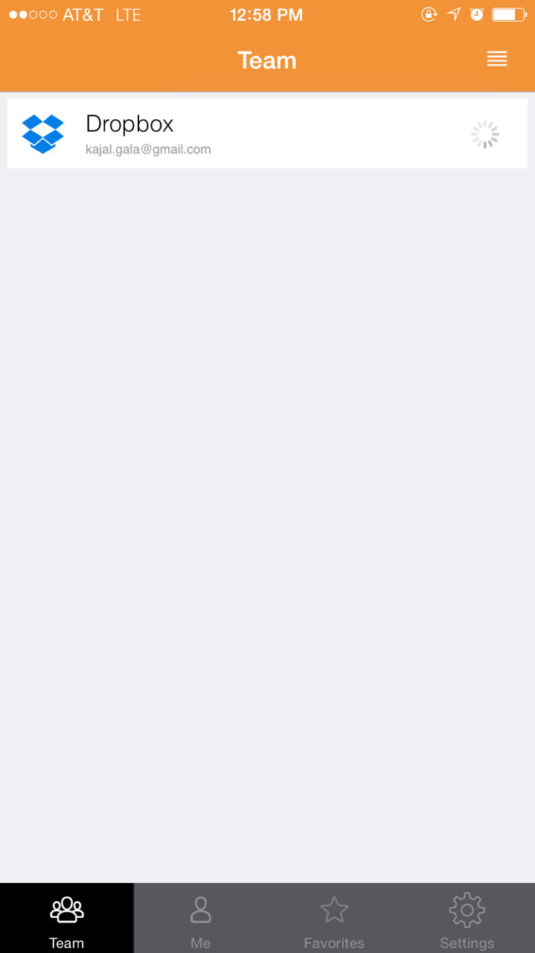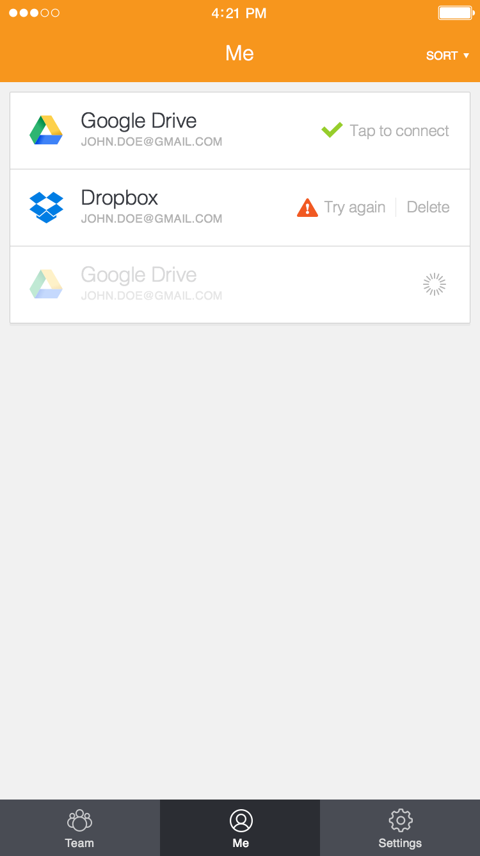

Live Visual Mock Up

Syncing

**A.Text:**

1.“Team” in Top Header Bar:

**Font:** Helvetica Light

**Font Size:** 32 pt

**B. Padding**

1. Horizontal between White Color Block and Left Screen Edge: 15 px
2. Repeat (1) for Right Screen Edge
3. Vertical between White Color Block and Top Header Bar: 15px

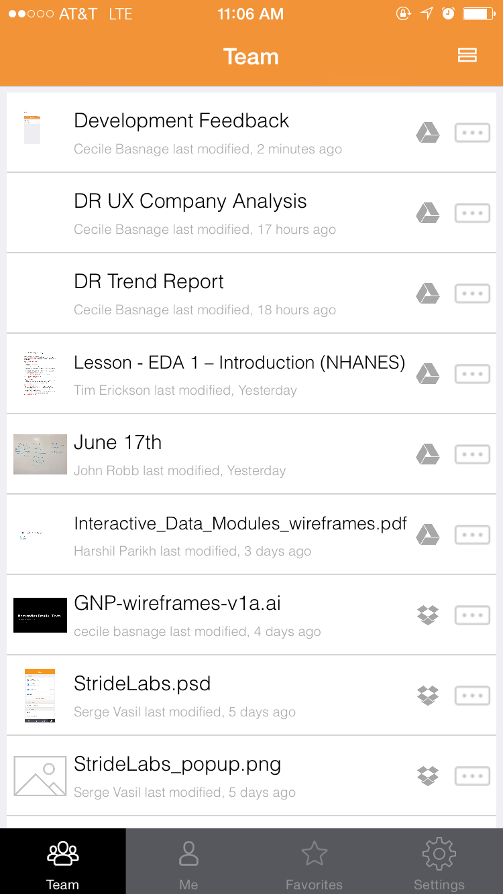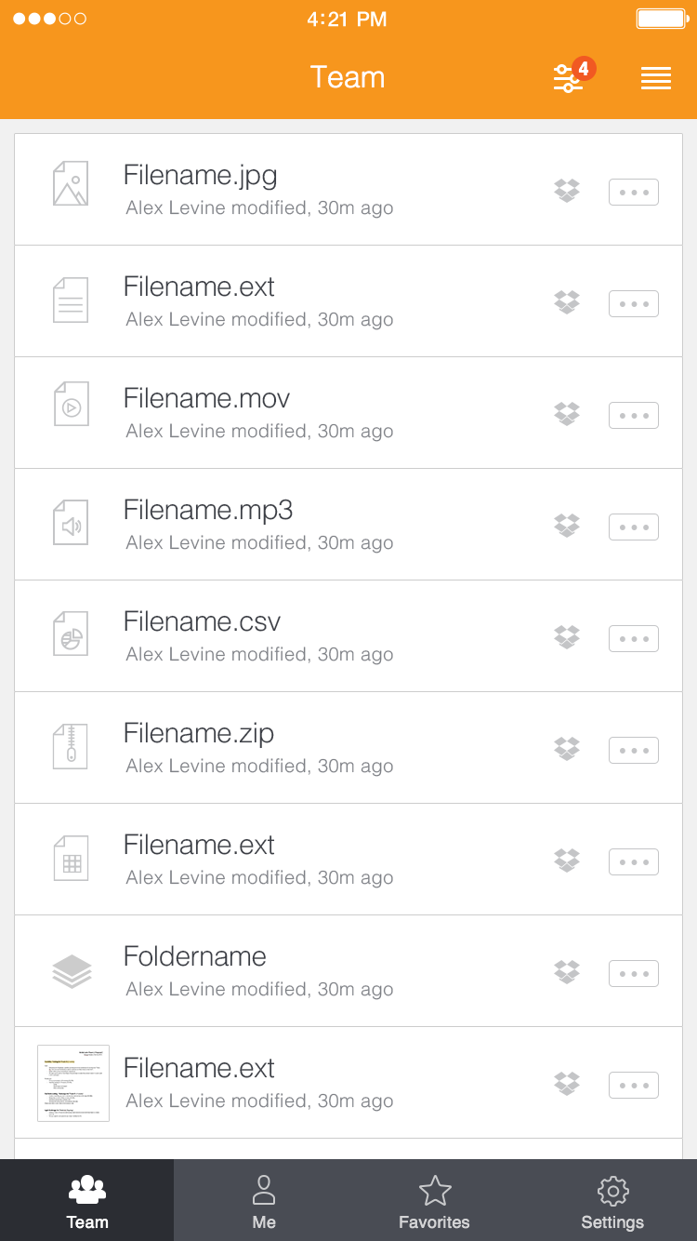

Live Visual Mock Up

Compact View

**A.Text:**

1.“Team” in Top Header Bar:

**Font:** Helvetica Light

**Font Size:** 32 px

2. “Development Feedback..” / All File Titles

**Font:** Helvetica Light

**Font Size:** 30px

**Hex Val:** #3b3e45

3. “Person X last modified...” / File Editors

**Font:** Helvetica Light

**Font Size:** 20px

**Hex Val:** #777d8b

**B. Padding**

Y distance

White block to Top Header Bar: 15 px

Between FileName and File Editor: 15px

**C. Grey Assets (Box, Dropbox icons)**

* 1. Hex Val: #c4c5c7
  2. Height: 25px

**D. Other**

• Divider line between White Blocks

Hex Val: #cccccc

Height: 1 px

• Add 1 px grey stroke around all document icons

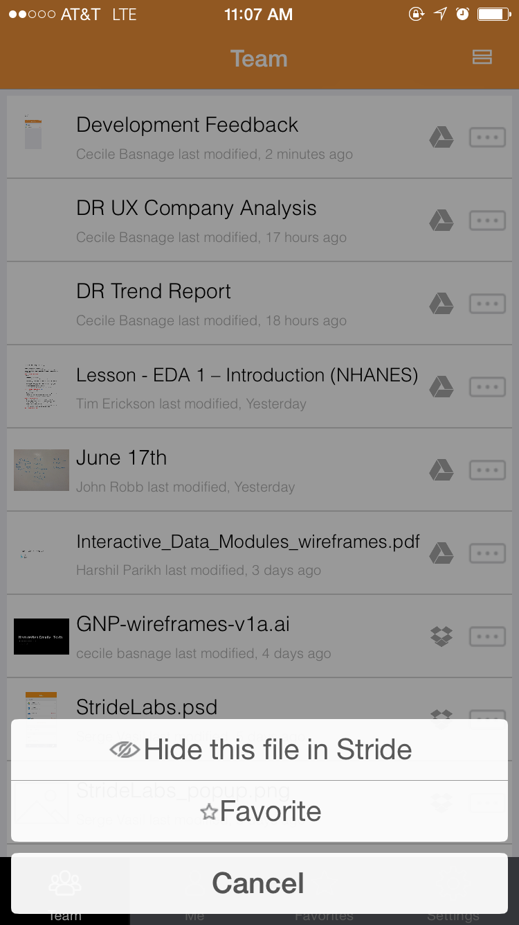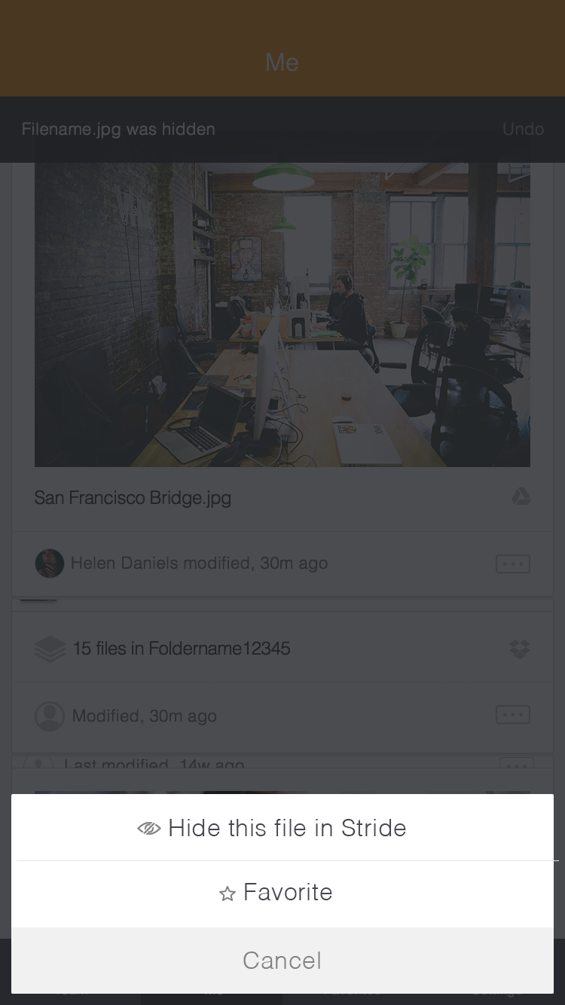

Live Visual Mock Up

Action Sheet

B. **Text**

Font: Helvetica Light

Font Size : 32 px

Hex Value: #44464d

**C. Icons**

Height: 20 px

**D. Padding**

X Distance

Icon to Text: 12px

Y Distance

Text to Top White Box: 30 px

Text to Bottom White Box: 30px