--We will have an awesome, pithy title here
Adriana Solange Garcia de Alford1, Steven Hayden1,
Nicole Wittlin¹, Amy Atwood²
1 Master of Science in Data Science, Southern Methodist University,
Dallas, TX 75275 USA
2 T-Mobile, 3255 160th Avenue SE,
Bellevue, WA 98008 USA
{sgarciadealford, skhayden, nwittlin}@smu.edu
{steven.hayden, amy.atwood}@t-mobile.com

Abstract. summarize the contents of the paper and should contain at least 70 and at most 200 words. It should be set in 9-point font size and should be inset 1.0 cm from the right and left margins. There should be two blank (10-point) lines before and after the abstract. This document is in the required format.
1 Introduction
In today’s age of Big Data, data are driving decision-making in almost every field imaginable. At the foundation of this decision-making is a wide range of algorithms churning through endless data to determine if an individual might be a good employee, a worthy loan candidate, a possible repeat criminal, or the university’s next star graduate. But how are these decisions made? What criteria are considered? What if the outcomes are biased?
These algorithmic processes seem like black box magic to many people. Data scientists, however, have an increasing responsibility to use our knowledge and skill to bring the work out of the shadows and assess machine learning for accuracy and efficiency, as well as for bias and fairness. In fact, over the last few years, “the majority of the machine learning community is finally publicly acknowledging the prevalence and consequences of bias in machine learning models” [Xu, TDS].
Many widely studied and cited examples of bias in machine learning highlight disparity based on race and sex. One of the most frequently noted examples of biased machine learning is COMPAS, a regression model used by judges to predict if a perpetrator was likely to recidivate. The model was proven to double the predicted false positives for recidivism for African American ethnicities than for Caucasian ethnicities [McKenna, AIBus]. Another example from 2018 was discovered in Amazon’s machine learning model built to evaluate candidate resumes for software engineering roles, where the algorithm explicitly penalized resumes with the word “women’s” and downgraded candidates from two all-women’s colleges [EI].
In these cases, and many others, had the data science team considered the ways in which bias might be a factor before employing the algorithms, they might have been able to test different multiple approaches and recreate a model that adjusts for bias. The teams that have been exploring these approaches and models to account for bias have proposed a number of different techniques; one intriguing option is to use adversarial learning to mitigate unwanted bias.
Our team intends to explore the adversarial learning model by assessing age bias in a sample data set. We will use two competing models similar in nature to GANs (generative adversarial networks) [Goodfellow et al. 2014]. Additionally, our team seeks to bring together elements of the best approaches and models related to biased machine learning in a practical framework for data scientists to employ. To demonstrate this framework and how mitigating bias can work, the team will design a common business problem to explore related to age.
In the domain of human resources, employee attrition is both a common and significant business problem. The driving factors of employee attrition have been well studied, and the goal of this work is not to duplicate those efforts. Instead, we seek to explore how age may be influencing employee attrition and whether the framework we propose can reduce bias that may be resulting due to age data in machine learning models. The data set we will use is the IBM Employee Attrition, found on Kaggle.
Age, similar to race and sex, is considered a protected class and should not be used as an influential factor in many situations, particularly those related to employment and the workplace. However, the Equal Employment Opportunity Commission (EEOC) acknowledges that “research on ageist stereotypes demonstrates that most people have specific negative beliefs about aging and that most of those beliefs are inaccurate. These stereotypes often may be applied to older workers, leading to negative evaluations and/or firing, rather than coaching and retraining” [EEOC].
The urgency of issues surrounding age bias is magnified by understanding today’s employee landscape. In 2018, “the Bureau of Labor Statistics estimated that the oldest segments of the workforce – those ages 65 to 74 and 75 and older – are expected to increase the fastest through 2024. This oldest cohort of workers of age 65+ workers is projected to grow by 75 percent by 2050, while the group of workers age 25 to 54 is only expected to grow by 2 percent over this same period” [EEOC]. The lack of mixed-age teams and reverse-age mentoring, coupled with age stereotypes and bias, can cause varying degrees of tension in the workplace between the generations. Ultimately, our goal is to simulate exploring age bias within the context of employee attrition and recommend a methodology to address and reduce bias.
2 Related Research

Overview of Bias in Machine Learning

Should we say why we are not just removing the protected variable?
Lum and Johndrow (2016) “demonstrate that removing the protected variable from the training data fails to yield a debiased model (since other variables can be highly correlated with the protected variable).”

**define Fairness and Bias generally and in the context of Machine Learning here
As mentioned before there are several points where bias can enter and influence algorithm and the implantation of the research. In the past, many data scientist would strive for the highest accuracy for their tool with little regard to how it would impact sub-populations. Much like the example of COMPAS double the predicted false positives for recidivism for African American ethnicities \cite{mckenna_2019}. We will discuss the framework that researchers should consider when they are collecting data, preprocessing, building models, and implementing their tool.

The rate at which data is getting generated is staggering. “By 2025, it’s estimated that 463 exabytes of data will be created each day globally” \cite{desjardins_2019}. Where you get your data or how you collect it is important to help reduce bias. Groups may be excluded or under sampled based on the median used to collect the data. For example, older generation may utilize social media less than younger, and their data will be under sampled compared to the rest of the population. The research should review distribution of the of the protected group in their data and decide if this distribution represent their population or if they need to collect more data for the any under sampled group.

Need to add something about preprocessing bias. (we should settle on a source)

When Pre-processing is not able to take out bias in the data, it may be necessary to rely on techniques while processing. In our experiment we will use adversarial algorithms to remove the remaining bias. The algorithm in our example will predict attrition while the second algorithm predicts bias within the dataset and updates attrition model to reduce the bias in the model. The most import part of the function that we should discus is the loss function that sets up the optimization.

The data has been collected and you have your unbiased results. Now it is time to implement them. A researcher should consider how the results are implemented and the impacts they will have.

All research is different and depending on the situation some or all this framework can be implemented. Note processing might be the step

Examining Gender and Race Bias in Two Hundred Sentiment Analysis Systems
Svetlana Kiritchenko and Saif M. Mohammad
http://saifmohammad.com/WebDocs/EEC/ethics-StarSem-final_with_appendix.pdf

This article looked at bias in sentimental analyses. They created a dataset that was meant to tease out the bias in the algorithms they were testing. They would then compare the accuracy of each model within a confusion matrix that subset the protected group. They found bias in algorithms used by such companies as google. Article gave us the idea to further investigate using confusion matrix as a metric to measure bias pre and post debiasing.

FairML: ToolBox for Diagnosing Bias in Predictive Modeling
by
Julius A. Adebayo
https://dspace.mit.edu/handle/1721.1/108212

The FairML: ToolBox for Diagnosing Bias in Predictive Modeling
They create a package that finds important features through LASSO Logistic regression and then uses those in its Bayesian probability predictions. The idea is that between subgroup within the important features, the perdition should not change. For example. "Pr(f(g) = 1 g E PC) corresponds to the probability of the bank giving an individual a loan given that they do not belong to the protected class, while Pr(f(g) = 1Jg E P) corresponds to the probability of the bank giving a loan to an individual given that such individual is a member of the protected class. The difference between these two probabilities is the bias of the model f"
This idea that that the probability

Mitigating Unwanted Biases with Adversarial Learning \cite{zhang2018mitigating}
By Brian Hu Zhang, Blake Lemoine, and Margaret Mitchell
https://arxiv.org/pdf/1801.07593.pdf

This paper walks through removing bias by using GANs. The algorithms in the paper are very versatile. you can use both regression and classification models as long as they use a gradient based method.

AI 360: start with whether AIF360 should be used at all; then consider metrics; then consider algorithms. Focused on distributive justice (WHAT DOES THAT MEAN??) best used in limited setting – “allocation or risk assessment problems with well-defined projected attributes in which one would like to have some sort of statistical or mathematical notion of sameness.”

How to make decisions:
- Decide on type of fairness trying to achieve
- Decide on appropriate metric depending on fairness and data
- Decide on algorithm to use

Metrics: individual vs. group fairness (or both). Group fairness – “partitions a population into groups defined by protected attributes and seeks for some statistical measure to be equal across groups.” Individual fairness – “seeks for similar individuals to be treated similarly.”
- Individual Fairness: Sample Distortion Metric class metrics
- Group Fairness: Dataset Metric Class (inc Binary Label Dataset Metric), Classification Metric Class
- Both: Generalized Entropy Index (Theil Index, variation of Classification Metric class)

Fairness intervention – 3 different points in machine learning pipeline:
- Preprocessing: Dataset Metric Class
- In Processing: Classification Metric class
- Post Processing

Fairness Views:
- We are all equal (WAE): all groups have similar abilities with respect to task (demographic parity metrics)
- What you see is what you get (WYSIWGY): observations reflect ability with respect to task (equality of odds metrics)

Difference vs Ratio: depends on analyst

Algorithms: where to intervene in machine learning pipeline (AIF 360 recommends earliest intervention, allows most flexibility and opportunity to correct; no one best independent of dataset)
- Pre processing: allowed to modify training data (Reweighing, Disparate Impact Remover, Optimized Pre-Processing, LFR…there are situations where one of these is best)
- In Processing: change learning algorithm (Prejudice Remover, Adversarial Debiasing)
- Post processing: none of the above, black box model (Equalized Odds, Reject Option)

Detailed look at pre processing: https://link.springer.com/content/pdf/10.1007/s10115-011-0463-8.pdf

A Unified Approach to Quantifying Algorithmic Unfairness: (Saved PDF)
Given two unfair algorithms, how decide which is more unfair? Use existing inequality indices from economics to measure how unequally the outcomes of algorithm benefit different individuals or population groups. Considered a family of Generalized Entropy Indices; looked at relationship between individual- and group-level unfairness – to show mitigating (between-)group unfairness can lead to high within-group fairness and high individual unfairness.

A Survey on Fairness and Bias in Machine Learning (Saved PDF) **THIS IS A GREAT OVERVIEW RESOURCE
Context of decision-making: fairness – absence of any prejudice or favoritism toward and individual or group based on their inherent or acquired characteristics.
Unfair algorithm – “one whose decisions are skewed toward a particular group of people.” Bias in data and bias in algorithms –
Data bias:
Algorithm bias:

Define fairness – extensive study in philosophy and psychology, well “before computer science started exploring it” … no universal definition, account for different preferences, outcomes, and cultural contexts. Types of discrimination – direct discrimination, indirect discrimination, systemic discrimination, statistical discrimination, explainable discrimination, unexplainable discrimination.

Definitions of Fairness: equalized odds, equal opportunity, demographic parity, fairness through awareness, fairness through unawareness, treatment equality, test fairness, counterfactual fairness, fairness in relational domains, conditional statistical parity.

Types: individual fairness – similar predictions to similar individuals; group fairness – treat different groups equally; subgroup fairness – “obtain best properties of the group and individual notions of fairness.”

Methods for Fair Machine Learning:

Pre-processing: try to transform the data so underlying bias if removed; if algorithm allowed to modify training data, this appropriate.
In-processing: modify and change state-of-the-art learning algorithms to remove discrimination during model training process; allowed to change learning procedure for machine learning model, use during training, as changes to objective function or imposing constraint
Post-processing: after training, access a holdout set not involved in training, no ability to modify training data or learning algorithm, “labels assigned by black-box model get reassigned based on function during post-processing phase.”

Adversarial Learning – “framework to mitigate bias in models learned from data with stereotypical associations” ;

On Formalizing Fairness in Prediction with Machine Learning (Saved PDF) -- **Good resources with more detailed definitions than article above.

According to IBM’s Artificial Intelligence Fairness 360 toolkit and framework, there are three (3) main points in the lifecycle of a ML model where bias can enter the model and where one can intervene to control bias, see figure 1 below.

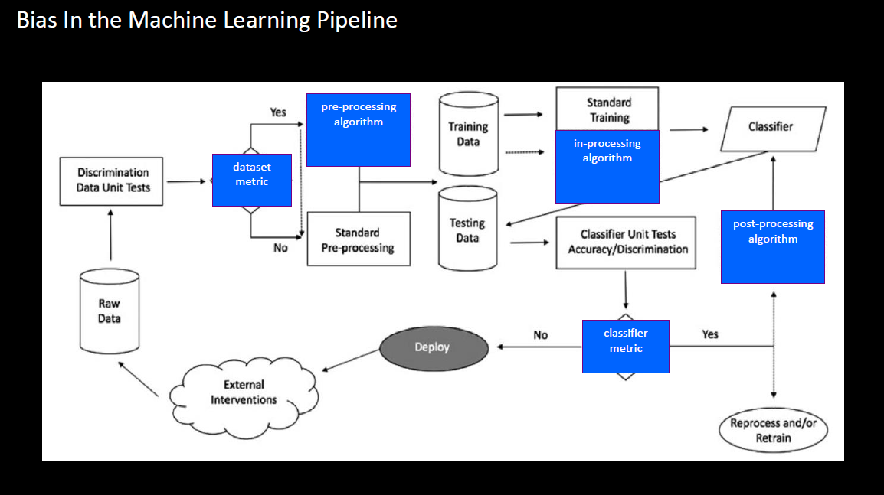
Figure 1 – courtesy of AIF360³

Overview of Attrition Research
The topics of employee turnover and factors influencing attrition are well-studied by both the research community and human resource (HR) practitioners. To understand the evolution of the field, “One Hundred Years of Employee Turnover Theory and Research” by Hom, Lee, Shaw, and Hausknecht is a recommended starting point. They conducted a comprehensive and systematic review of the most seminal publications about employee turnover in the Journal of Applied Psychology over the last 100 years. Additionally, they assessed other key theoretical and methodological contributions to the field as part of the review.
Since 2000 and forward, 21st century theory and research has focused on the idea of embeddedness (DEFINE), the evolution of the job search process, the influences of employee-organization relationships and HR management systems on collective turnover, HR practices impact on good-performers vs bad-performers, and the relationship of collective turnover on organizational performance. The field also saw “significant scholarly attention to employee turnover at the group, team, work unit, and organizational levels” {CITE HERE/Hom, pg 538}.

With a basic, foundational understanding of the field of employee attrition, the team turned to exploring common predictors of turnover. It is important to note that the goal of the work described in this paper is not to predict employee attrition, per say, but rather to understand the role age plays in predicting turnover and whether its influence could be biasing the predictions.

Rubenstein, Eblerly, Lee, and Mitchell followed up the comprehensive work of Hom (et all) to “assess the progress made in research on voluntary employee turnover” {Cite}. They employed a three-step assessment: first, they conducted a meta-analysis of predictors, both known and new; second, they developed and tested select substantive moderators (or more generally, predictors); and lastly, they put forth a high level view of their research to illuminate pressing areas for future research. The first aspect of their work – to understand predictors of employee attrition – is of most value to this team, especially to understand the role of age.

Rubenstein, et all, explored 57 predictors across 1,800 side effects (drawn from a study population of 316 articles). They categorized these specific predictors into several groups: individual attribute predictors (tenure, age, conscientiousness); job aspects (characteristics, security, complexity, as well as traditional characteristics of pay, role ambiguity, role conflict); traditional job attitudes (involvement, satisfaction); newer personal conditions (coping, stress); organizational context (climate, size, prestige); person-context interface (fit, influence, peer/group relations); existing job market (alternatives); attitudinal withdrawal; and employee behavior (absenteeism, performance).

Next, the study tested four meta-analytic hypotheses, which means [AMY, help to define…and summarize the 4]. Each hypothesis included age as a moderating attribute to consider in predicting employee attrition. This study was “the most comprehensive turnover meta-analysis to date and identified those predictors that most meaningfully contribute to individual quitting decisions” {cite/Hom, pg 27}.

This team also reviewed an article in the SMU Data Science Journal authored by fellow graduate students in April 2018. They conducted an analysis on two distinct data sets to determine the predictors of employee attrition in those two populations. The first data set was anonymized information from the U.S. Office of Personnel Management (OPM), reflecting a full year of separation data from October 2014 and September 2015. Attributes of particular interest in this data set were: age data group, captured categorically in 5-year increments; a lower limit age (lower bound for age); and years to retirement (based on the Federal Employee Retirement system eligibility base of 57 years old). The features of the final model with best prediction accuracy included: lower age limit; length of service; various age bins (age 20-24, 40-44, 45-49, 50-54, or 55-59). They also utilized IBM HR Analytics Employee Attrition & Performance data, a fictional data set created by IBM data scientists, to compare the strongest features of that set with the features selected in the OPM model. Ultimately, the model results were comparable for both sets of data with the relationship between length of service, pay scale, and age being strong predictors; however, the IBM data highlighted nuances missed by the OPM data related to measuring job satisfaction, work-life balance, and engagement.

For the purposes of this paper, understanding the evolution of employee turnover research and identifying separate studies that demonstrated the importance of age in predicting attrition both indicate that studying age is a valid path explore how bias may be present in models including age. The hope is that this exploration will positively show bias mitigation as an important consideration as part of the rise of “big data” in organizations.
3 Understanding Generative Adversarial Networks (GANs)
There have been many techniques, such as Deep Neural Networks and Convolutional Neural Network, used to classify images s\cite{gu2019improve}. One technique stands out in image classification and is the foundation for this paper’s approach to reduce bias is Generative Adversarial Networks (GAN). Ian Goodfellow and his colleges published “Generative Adversarial Nets” or GAN in 2014, where they “propose a new framework for estimating generative models via an adversarial process, in which they simultaneously train two models: a generative model G that captures the data distribution, and a discriminative model D that estimates the probability that a sample came from the training data rather than G.” \cite{goodfellow2014generative} The adversarial framework makes this classification into a supervised ML model, since it knows if the data is real or fake.

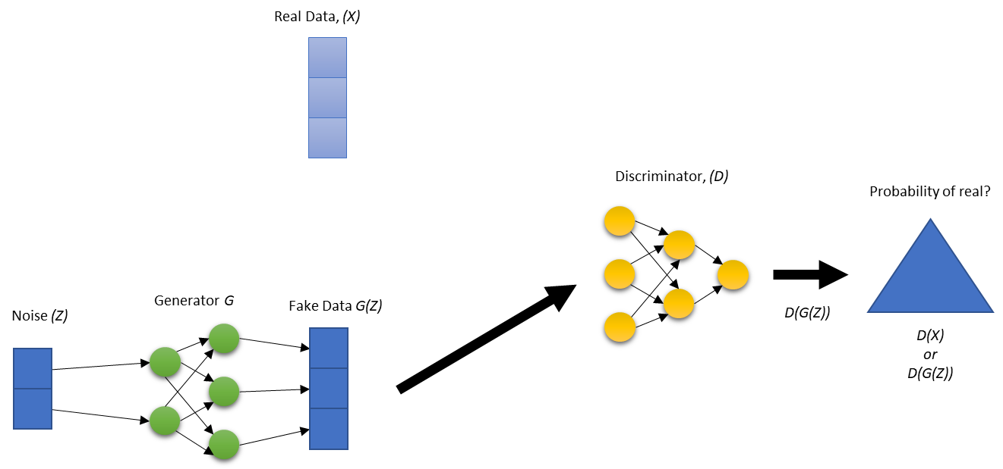Figure 4.1

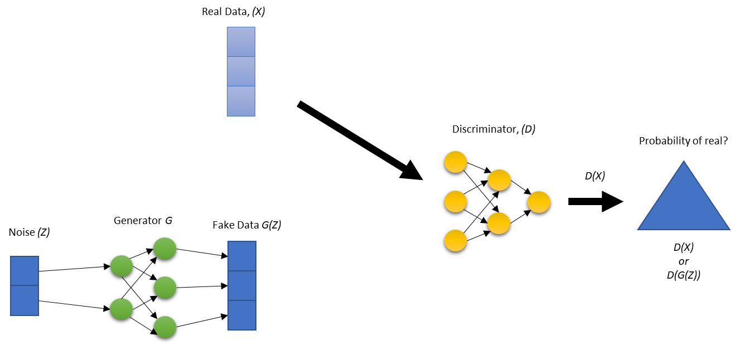 Figure 4.2
Figure 4.1 and Figure 4.2 illustrate the basic structure of GANs in two steps that happen simultaneously. For explanation purposes, each step is described separately. In figure 4.1 you start with real data to get the distribution of the fake data. That is why the vector size is the same for both G(Z) and Data(x). The generator (G) starts with some noise added to it. The generator (G) takes the noise(Z) and transforms using a specific set of parameters. Once it is done generating fake data, it passes FFake Data G(Z) to the discriminator (D). The discriminator (D) calculates the probability that the data is fake or not. Figure 4.2 is the same, but this time the real data (X) gets passed to the discriminator (D).
The discriminator (D) and the generator (G) update their parameters based on the loss function through back propagation iteratively. If the discriminator (D)If the discriminator (D) classified the data correctly as real or fake then the generator (G) gets updated. If the discriminator (D) incorrectly classified the data real or fake, then the discriminator (D) gets updated.

V (D, G) = Ex∼pdata(x) [log D(x)] + Ez∼pz(z) [log(1 − D(G(z)))]

Lets take a look at the loss function. The first term [Ex∼pdata(x) [log D(x)]] represents an expected output of the log of discriminator (G) when the input is from the real data. The second term Ez∼pz(z) [log(1 − D(G(z)))] is the expected value of the log of the quantity of 1 minus the discriminator (G), which is making predictions about the fake samples. This function makes the generator (G) want to minimize the G(Z) and the discriminator (D) maximize it. The conflicting elements of this function make the generator (G) seek to maximize G(Z) while the discriminator (D) works to minimize G(Z). This creates the adversarial “game.”

tTo train the discriminator (D), the process loops? through the data created by the generator (G) and the real data k times before the generator (G) is updated. This allows the discriminator (D) to converge at the point where fake data and real data meet. k is a parameter the is choose prior to training. GANs uses the gradient of the loss function to change the parameters of the discriminator (D) to maximize the loss function that sets up the optimization between both models.

Training the generator (G) takes noise data and then transforms it to get the fake data for k times. This time it allows the generator (G) to converge. The gradient of the loss function is then used to change the parameters of the generator (G) to minimize the loss function. This is a complete iteration of training a GAN model.

In “Generative Adversarial Nets” they also discussed when you should stop training the model. Once the discriminator (D) consistently cannot distinguish between fake or real, data then training is done, or in other words once the distribution of the generator (G) matches the real data. \cite{goodfellow2014generative}

4 Data Set: IBM Employee Attrition Data
A best practice in the lifecycle of a machine learning model is to start with exploratory data analysis (EDA), with the objective of extracting information that unveils trends, feature correlation, group distributions, demographics, and biases, among other characteristics. Specific to this paper, the intent is to consider different scenarios with respect to bias. One scenario of interest is to explore if the data used in training a model to predict attrition contains any biases. Several techniques can be applied to identify biases in the data prior to training a model and metrics can be produced to measure data bias with respect to a protected feature, age, for example. If bias is found, there are several techniques such as reweighing, disparate impact remover and optimized preprocessing to mitigate or eliminate bias in the data. We are running 2 scenarios, applying pre-processing debiasing prior to running the ML model with adversarial debiasing and a second without pre-processing debiasing step.
The data set used for this exploration is fictious employee data simulated by IBM data scientists to demonstrate employee attrition and performance {cite, inseaddataanalytics}. There are approximately 1,500 entries representing a specific employee, with 35 descriptive features, where ‘Attrition’ is the dependent, target feature. ‘Age’ is of interest to the focus of this paper specifically as the protected variable.
Preliminary EDA steps on the data set:
- EDA was executed in Python language and libraries.
- The Python Jupyter notebook is found in the project’s GitHub {cite, do we need to cite our own GitHub?}
- Data was extracted in Excel format and converted to CSV format.
- The data was loaded into a Data Frame to calculate simple statistics for all features.
- Explored the protected Age feature by finding unique age value counts and producing a bar chart to learn the distribution of the employees ages.
- Calculated categorical frequency grouping counts to unveil trends and distributions; for example, 1,043 employees out of the 1,470 total employees rarely traveled. This type of frequency groupings is useful to unveil insights and important relationship within the data.
- As a simplification step, the levels on the ‘Education’ feature were reduced from 5 to 4 by combining levels 4 and 5, since level 5 had a reduced number of employees.
- The data set was one-hot encoded to prepare the data as input to the:
  - ML model and removed original features
  - Correlation Matrix function
- A correlation matrix between features is also provided for analysis purposes.
- A Matplotlib graph chart of the correlation matrix was built for easy visualization.
- Built a preliminary ML model based on the XGBooster algorithm to explore preliminary classification results.

5 Experiment
**NW NOTES: I think we can start this section with an explanation of why we picked the Adversarial Approach. Here’s the research…and how it applies to our problem. SO THE EXPLANATION BELOW ARTICULATES WHAT X, Y are in the process, X are attributes about employees, Y is attrition and Z is protected variable.

“Adversarial Bias Mitigation” takes the principals of GANs to setup two competing models with the goal to mitigate bias. This is accomplished by starting with a model that predict Y given explanatory variables X. This part of the model is similar to the generator(G). The output of the weights W is passed to the adversary model. This model predict the protected variable Z given X. The adversary model is the discriminator(D). \cite{zhang2018mitigating}

∇W LP − proj∇W LA ∇W LP − α∇W LA

Equation 2. is the loss function defined in this approach. This is what sets up the adversary feedback between the two model. The first term (∇W LP ) is the weights of the loss for predictor. “The middle term proj∇W LA ∇W LP prevents the predictor from moving in a direction that helps the adversary decrease its loss” \cite{zhang2018mitigating} The last term is much like the maximization side of the loss function the discriminator(D).
6 Ethics
- Society context, what impact if not done?
- Context related to language, usability
- What else?

From equality to equity … most literature focused on equality, each individual / group given same amount of resources, attention, outcome. Not much attention to equity, each individual or group given resources needed to succeed. (From A Survey on Fairness and Bias in Machine Learning)

https://blog.insightdatascience.com/tackling-discrimination-in-machine-learning-5c95fde95e95
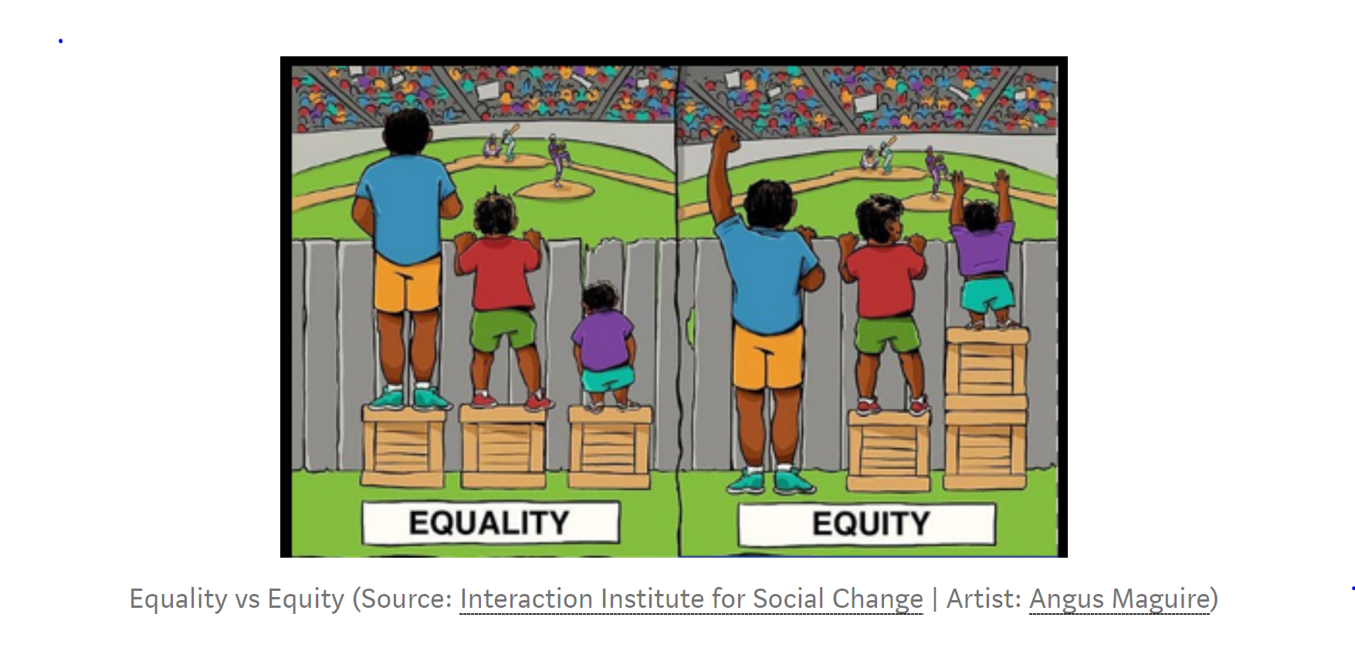
7 Results
8 Conclusions
References
Joyce Xu: https://towardsdatascience.com/algorithmic-solutions-to-algorithmic-bias-aef59eaf6565

Zhang, Lemoine, Mitchell : https://arxiv.org/pdf/1801.07593.pdf (Mitigating Unwanted Biases with Adversarial Learning)

Krishnamurthy: https://towardsdatascience.com/survey-d4f168791e57 (Understanding Data Bias)

[Goodfellow et al. 2014] Goodfellow, I.; Pouget-Abadie, J.; Mirza, M.; Xu, B.; Warde-Farley, D.; Ozair, S.; Courville, A.; and Bengio, Y. 2014. Generative adversarial nets. In Advances in neural information processing systems, 2672– 2680.

Victoria Lipnic, Acting Chair of the US Equal Employment Opportunity Commission; The State of Age Discrimination and Older Workers in the US / 50 Years After the Age Discrimination in Employment Act (ADEA) / June 2018 https://www.eeoc.gov/eeoc/history/adea50th/report.cfm

Weapons of Math Destruction

The Ethical Algorithm

Fair ML

https://aibusiness.com/three-notable-examples-of-ai-bias/

https://arxiv.org/pdf/1606.03490.pdf

Nicole’s References for employee engagement:

Frye, Alex; Boomhower, Christopher; Smith, Michael; Vitovsky, Lindsay; and Fabricant, Stacey (2018) "Employee Attrition: What Makes an Employee Quit?," SMU Data Science Review: Vol. 1 : No. 1 , Article 9.
Available at: https://scholar.smu.edu/datasciencereview/vol1/iss1/9

Rubenstein AL, Eberly MB, Lee TW, Mitchell TR. Surveying the forest: A meta-analysis,
moderator investigation, and future-oriented discussion of the antecedents of voluntary employee turnover.
Personnel Psychology. 2017;00:1–43. https://doi.org/10.1111/peps.12226
Hom, P.W., Lee, T.W., Shaw, J. D., & Hausknecht, J. P. (2017). One hundred years of employee turnover theory and research.
Journal of Applied Psychology. http://psycnet.apa.org/doi/10.1037/apl0000114

Solange References in EDA:
- http://inseaddataanalytics.github.io/INSEADAnalytics/groupprojects/January2018FBL/IBM_Attrition_VSS.html
- Project GitHub: https://github.com/skhayden/SMU-Capstone-Age-Bias-in-Predictive-Modeling-

