**GS 373 Homework 2**

Due April 19th before 1:30 PM on Canvas

* 100 points: 5 bioinformatics questions (80 points), 1 programming assignment (20 points)
* Submit answers to the bioinformatics questions in a Microsoft Word of PDF via Canvas. Your answers do not need to contain the text of the questions, but they need to be clearly labeled (e.g., 1a., 3b., etc.
* Submit the programming assignment as a separate .py file via Canvas. The script should be able to be directly run by Python.

**Bioinformatics Questions (80 points)**

1. (20 points, 3 parts) Complete the dynamic programming matrix and **calculate both the optimal Needleman-Wunsch global and Smith-Waterman local alignment** for the following pair of sequences, using the substitution matrix below and a linear gap penalty of -4. As with last week, please **include the arrows in your matrix** (either by constructing by hand and submitting a photo or by adding the arrows using a program like powerpoint) **as well as the best global and local alignments**.

|  |  |  |  |  |
| --- | --- | --- | --- | --- |
| substitution matrix | | | | |
|  | **A** | **C** | **G** | **T** |
| **A** | 10 | -5 | 0 | -5 |
| **C** | -5 | 10 | -5 | 0 |
| **G** | 0 | -5 | 10 | -5 |
| **T** | -5 | 0 | -5 | 10 |
| **gaps = -4** | | | | |

CATGT and GGTT

1. Global

|  |  |  |  |  |  |
| --- | --- | --- | --- | --- | --- |
|  |  | **G** | **G** | **T** | **T** |
|  |  |  |  |  |  |
| **C** |  |  |  |  |  |
| **A** |  |  |  |  |  |
| **T** |  |  |  |  |  |
| **G** |  |  |  |  |  |
| **T** |  |  |  |  |  |

1. Local

|  |  |  |  |  |  |
| --- | --- | --- | --- | --- | --- |
|  |  | **G** | **G** | **T** | **T** |
|  |  |  |  |  |  |
| **C** |  |  |  |  |  |
| **A** |  |  |  |  |  |
| **T** |  |  |  |  |  |
| **G** |  |  |  |  |  |
| **T** |  |  |  |  |  |

1. Explain why the best global and local alignments are not identical.
2. (10 points) Given the completed dynamic programming matrix below**, write out *all* Smith-Waterman local alignments with the top score**.

|  |  |  |  |  |  |
| --- | --- | --- | --- | --- | --- |
|  |  | **A** | **G** | **T** | **T** |
|  | 0 | 0 | 0 | 0 | 0 |
| **G** | 0 | 0 | 10 | 6 | 2 |
| **T** | 0 | 0 | 6 | 20 | 16 |
| **A** | 0 | 10 | 6 | 16 | 15 |
| **G** | 0 | 6 | 20 | 12 | 11 |

1. (15 points, 3 parts) For each situation below, **state whether it would be more appropriate to perform a global or a local alignment and why**.
   1. Aligning 100-bp sequencing reads to a reference genome
   2. Identifying potential regions of homology between two distantly related bacterial proteins
   3. Comparing an HIV gene sequence isolated from two different infected individuals
2. (15 points, 3 parts) BLOSUM scores. *Please show work for partial credit.*Consider the construction of a BLOSUM matrix given some gene blocks.
   1. The frequency of D in the gene block is 0.02, frequency of G is 0.03, and the half bit score of D-G is 4. **What is the frequency of D-G in the gene block? What is a probabilistic interpretation of the half bit score of 4 in this context?**
   2. **How does the half bit score change if the frequency of D increases to 0.03** (the frequency of G and D-G remains the same)? **How does the half bit score change if the frequency of D decreases to 0.01** (the frequency of G and D-G remains the same)? **Why do the scores change in these directions?**
   3. The half bit score of R-W is 0. **Given example values of the frequency of R, the frequency of W, and the frequency of R-W which could produce this score.**
3. (20 points, 3 parts) Molecular evolution questions.
   1. One measure of evolutionary “distance” is the percent amino-acid identity (normalized hamming distance) of two related sequences. For example, the sequences KAKLI and KWKLV have an amino-acid identity of 60% (3/5 amino acids match). Humans and pigs diverged about ~99 million years ago and their homologs have an average amino-acid identity of ~85%. Homologs from Influenza A Virus strains, which descended from the 1918 pandemic (~100 years ago), *also* have an average amino-acid identity of ~85%. **What could explain this difference?**
   2. Below are three allele trajectories created via simulation. All three simulations share the same parameters *except* forpopulation size. **Label the plots according to population size (1=largest population, 3=smallest population) and explain how you knew**.   
        
      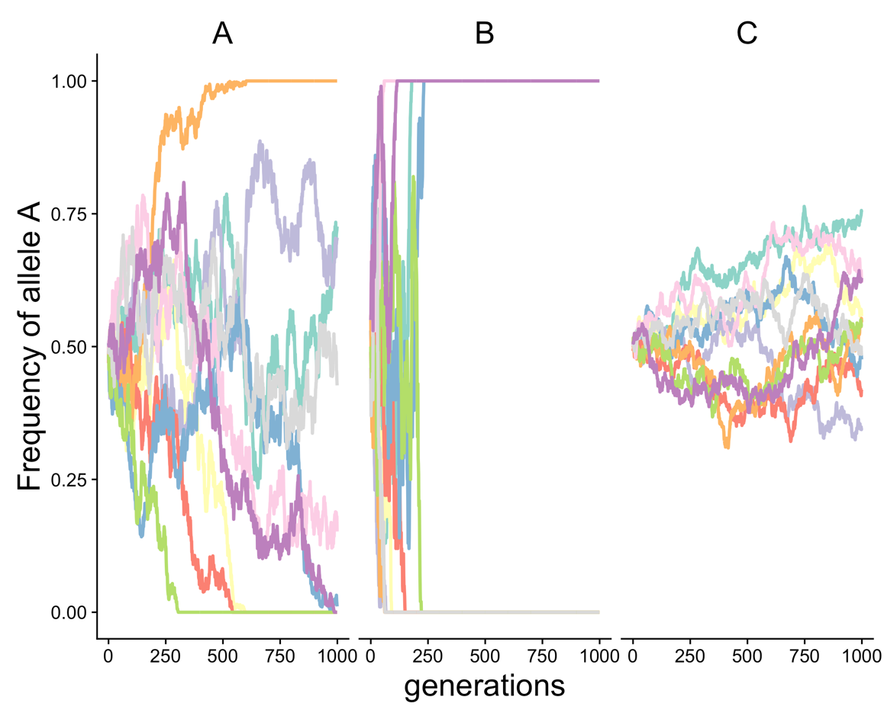
   3. Download and run the script called popsim.py. Feel free to open the script and look at the code. This script simulates allele frequencies for 500 generations and then prints whether allele A fixed, allele a fixed, or neither fixed. You can change the population size, the starting frequency of A, or the fitness of either AA, Aa, or aa using the command line options --pop, --freq, --fAA, --fAa, and --faa, respectively. For example, the call python popsim.py --pop 5000 --freq 0.3 sets the population to 5000 and the starting frequency of A to 0.3. **Run the script a few times and then post two screenshots**: one showing the results of a run with the default parameters and one with a run where either A or a fixed. Make sure the screenshot shows the full output. **Write a short, informal summary of your experiment** (~5 sentences). Are there differences between the runs? If so, what did you change (if anything)? If you made changes, what result did you expect when you made the change and did the results match your expectation? How many times did you run the simulation?

**Programming problem (20 points)**

**Write a Python program that provides information about an RNA codon.**

**Input**:

a 3-nucleotide RNA codon sequence (examples AUG, uuc, Acg)

**Output:**

If the input contains non-valid RNA nucleotides or is not three letters long, print “Error! Invalid input!”

If the input sequence codes for methionine, print “Start”

If the sequence encodes a stop codon it, print “Stop”

If the sequence codes for any other amino acid, print “Amino acid”

**Examples:**

>python homework2_skh.py AaG

Amino acid

>python homework2_skh.py AUG

Start

>python homework2_skh.py AUGILS

Error! Invalid input!

Hints + Notes**:**

* Please save your program in the format homework2_skh.py (where you substitute your initials for skh. **You will get two points just for naming your program correctly!**
* Hint #1: You do not need to write a conditional statement for every codon.
* Hint #2: The Boolean operator **in** can be used to evaluate whether a character is found anywhere in a string, and the operator **not in** evaluates whether a character is missing from a string.