**GS 373 Homework 7**

Due May 23rd before 1:30 PM on Canvas

* (100 points): 4 bioinformatics questions (80 points), 1 programming assignment (20 points).
* Submit answers to the bioinformatics questions in a Microsoft Word document or PDF via Canvas. Your answers do not need to contain the text of the questions, but they need to be clearly labeled (e.g., 1a., 3b., etc.)
* Submit the programming assignment as a separate .py file onto Canvas. The script should be able to be directly run by Python.

**Bioinformatics Questions (80 points)**

1. (30 points) **Consider the hidden Markov model that describes DNA sequences in two different states, AT rich and GC rich.** The numbers above the arrows denote transition probabilities, and the numbers within the boxes denote emission probabilities. Assume the initial probabilities of the two states are the same.

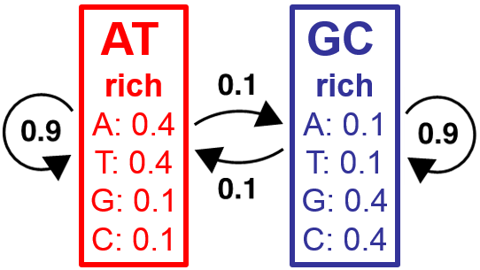

* 1. (15 points) Based on this model, **calculate the joint probability of observing the sequence ACT with each of the following state paths**:
     1. The state path AT-rich, GC-rich, AT-rich
     2. The state path AT-rich, AT-rich, AT-rich
     3. The state path GC-rich, GC-rich, GC-rich
  2. (15 points) **Use the Viterbi algorithm to find the most likely state path for the observed sequence ACAT according to this model**. Show your work and be sure to label the state each base was emitted from.

1. (30 points) **The hidden Markov model below is a variation of the one proposed in class to identify open reading frames in DNA sequence, where the subscripts denote the position of a nucleotide within a codon.** “s” refers to the start codon, “e” refers to the stop codon, and “ORF” refers to the codons between the start and the end. s­1 refers to the first nucleotide in a start codon, ORF2 refers to the 2nd nucleotide in a codon between the start and stop codons, etc.

Intergenic

e1

e2

e3

ORF1

ORF2

ORF3

begin

s1

s2

s3



* 1. (20 points) **What should the emission probabilities of each of the hidden states e1, e2, e3 and s1, s2, s3 be** if we assume that the three stop codons UAA, UAG, and UGA are equally likely in the organism of interest?
  2. (10 points) Suppose you know that a specific nucleotide in an mRNA sequence is part of a coding region because it was shown experimentally to be directly bound by ribosomes. **Describe how you could use the HMM to infer the most likely reading frame for the mRNA sequence.**

1. (20 points) **Train the parameters of an HMM** with the two states A-rich and T-rich that describe sequences of A’s and T’s using the training sequence below, whose state sequence is also known.

|  |  |  |  |  |  |  |  |  |  |  |  |  |  |  |  |  |  |  |  |
| --- | --- | --- | --- | --- | --- | --- | --- | --- | --- | --- | --- | --- | --- | --- | --- | --- | --- | --- | --- |
| Sequence | A | T | T | T | T | A | A | A | A | A | A | A | A | A | A | T | T | T | T |
| State | t | t | t | t | a | a | a | a | t | t | a | a | a | a | a | a | t | t | t |

1. (10 points) **Compute the transition probabilities** for the states learned from the above sequence.
2. (10 points) **Compute the emission probabilities** for the states learned from the above sequence.

**Programming question (20 points)**

**Implement a program that uses a Markov model to generate a string of As and Ts.**

The main part of your program should perform the following steps:

1. read in the transition probabilities and store them in a workable data structure or structures
2. initiate a sequence
3. repeatedly add bases to it until the specified length is reached.

*You will probably want to define a function that performs a single step in the Markov chain based on the previous state.*

Your program should take two inputs as arguments using sys.argv:

1. The **length of the sequence** to be generated
2. An **input file containing transition probabilities** between A’s and T’s.

* This input file should be formatted as shown below. An example transitions.txt file is on the quiz section website. **Each line of the input file corresponds to a transition probability and contains three words separated by a space.** The **first is the name of the starting state**, the **second is the name of the ending state**, and the **third is the probability of transitioning** from the starting state to the ending state.

A A 0.7

A T 0.3

T A 0.2

T T 0.8

* Assume that there is an equal probability that the string with start with either an A or a T.

Below shows how the program should be used and expected output:

python homework7_skh.py 10 transitions.txt

AAATTAAAAT

**Hints:**

As a reminder, you can split a string using the string method split as follows:

>>> probs = "A T 0.9"

>>> probs.split(" ")

['A', 'T', '0.9']

As discussed in quiz section 7, the function random() returns a uniformly distributed random number between 0 and 1.

>>> import random

>>> random.random()

0.31762

Make sure you convert any numeric values that are read in as strings (arguments or from the file) into integers or floats before using them!