

**DESIGN OF A HIGH SPEED MULTI-AXIS MACHINE TOOL**

MOX 410-DESIGN PROJECT REPORT

Initials: SW

Surname: Radebe

Student number: 13087445

Year: 2018

Department: Mechanical and Aeronautical engineering

(C-AIM)

# Abstract

# Acknowledgements

# List of symbols

# Table of contents

# List of figures

# List of tables

# Introduction

## Background

Wide range availability of high speed machine tools enable manufacturing companies to achieve high production rates which may lead to the creating of wealth.

Machine tools currently exist in serial, parallel or hybrid arrangement layout. Serial machine have large masses and workspace while parallel machines have small masses and workspace. Hybrid machine tool arrangements are the combination of the serial and hybrid machine tools.

## Problem statement

Existing machine tools have a limited workspace or large masses and inertias. Machine tools faced with the former issue are restricted to the manufacturing of small size parts, while the latter issue slows down production rates in manufacturing facilities.

## Objectives

Develop a machine tool with a minimum of three axes, with a sufficient workspace to perform a machine operation at adjustable cutting speed and an excellent positioning accuracy.

## User requirements

Client requirements:

* High speed machine tool
* Multi axis machine tool
* Minimum Workspace 150mm X 150mm X 150mm
* Cutting speed > 60 m/min
* Excellent positioning accuracy

Proposed additional requirements:

* Acceptable level of vibration
* Low rates of wear of sliding parts
* Low thermal distortion of machine tool elements
* Low maintenance , repair and manufacturing cost

# Literature study

## Conventional milling machines

Milling machine are machine tools used to machine metals by feeding the work against a rotating multipoint cutter. Milling machines are classified as either vertical (fig.1) or horizontal (fig 2).

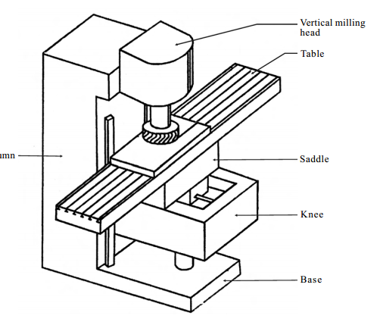

Figure vertical milling machine (Jayakumar et al. 2011)

Figure 1 depicts the conventional, serial type architecture milling machine that normal has large inertias that do not permit high speed machining. The base (fig.1) is usually made of cast iron, it supports the whole machine structure and sometimes used as a cutting fluid reservoir. The column is mounted on the base and permits vertical up/down movement of the knee. The knee supports the saddle which moves in a cross direction.

The table of a milling machine (fig 2) has got a T-slots on the top surface to mount the workpiece or work holding device. The spindle of the milling machine holds the cutter and receives power from the motor.

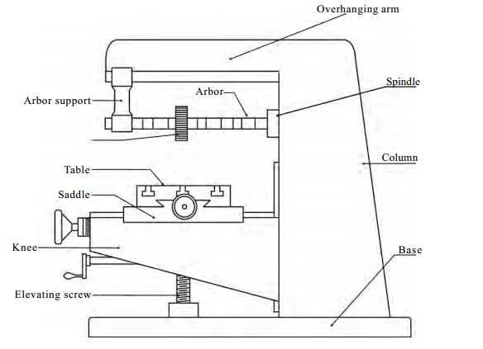

Figure horizontal milling machine (Jayakumar et al. 2011)

There are different types of milling cutters used in a milling machine, a suitable milling cutter is chosen based on the cut requirements. Cutters are usually made using a high speed steel (HSS), high carbon steel, cemented carbide or stellite.

## Serial and Parallel kinematic machines

Machine tools with serial kinematic architecture are arranged in a manner that the each successive axis is mounted on the previous axis, including the joint and actuator. Such architectures normally became unsuitable for high speed machining, due to the heaviness of the resulting machine tool.

Parallel kinematic machine tools are associated with low moving mass and good stiffness making possible for the machine tool to have high feed rates and acceleration.

Performances reached by any mechanism depend upon the topology and dimensions. Mechanism topology refers to the general structural arrangements of joints and links that will describe the kinematics of the structure. Dimensional synthesis refers to the process of finding the appropriate dimensions of the mechanism (Pandilov&Dukovski 2012, p.114).

Machine tool companies has started research on the use of parallel kinematic architecture for their design. More than 80% of the known kinematic machines are machining centres for 3 or 5 axis milling processes (Pandilov&Dukovski 2012, p.114).

## Serial and parallel machine concepts

Heckert Werkzeugmaschinen (fig.1) is one of the parallel machine tool pioneer with the development of the SKM 400 kinematic machine centre founded on the idea on replacing the conventional linear guide rails with revolving joints.

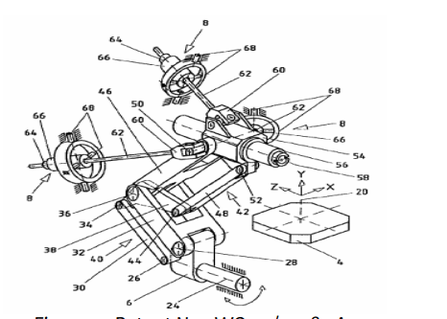

Figure SKM (Pandilov&Dukovski 2012, p.114).

The Genius 500 (fig.2) is a hybrid machine tool with the x-y movements achieved with a parallel scissors kinematics powered by linear drives allow accelerations of up to 15-24m/s2 and feed rates of up to 120-180 m/min.

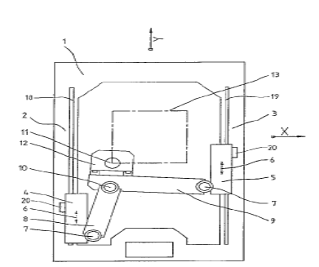

Figure Genius 500 (Pandilov&Dukovski 2012, p.114).

COSMO CENTAR OKUMA PM600 (fig 3) is a five axis milling machine capable of machining at up to 100m/min and 1.5G accelerations. The spindle can tilt up to a maximum of 30°.This machine has 6 set of ball screws each with a hollow rotary encoder and hollow servomotor. The universal joints use a set of pre-tensioned roller bearings. Other performances measures include:

Table 750x750 mm,

Workspace 420x420x420 mm

Floor space 2405x2830 mm

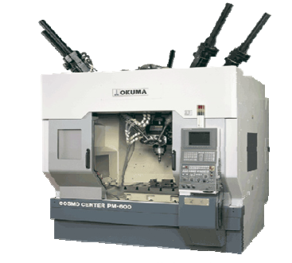

Figure COSMO CENTAR OKUMA 5-axis milling machine

DECKE MAHO pfronten TriCenter DMT100 (fig.4) is a 5 axis milling machine tool with a hybrid architecture. The combination of three parallel axis and 3 two serial axis. The machine can cover 1500x800x700mm at 180m/min and reach an acceleration of 2G.

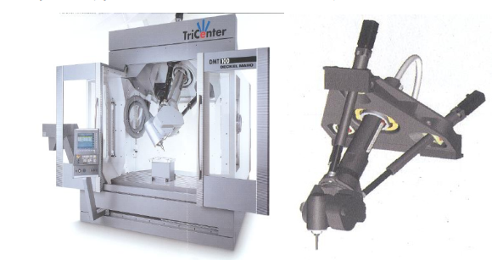

Figure DECKE MAHO pfronten TriCenter DMT100

## Machine tool spindles

Major components required for a high speed milling spindle design include

* Spindle style
* Spindle bearings
* Spindle motor
* Spindle shaft
* Spindle housing

## Spindle style: belt driven

Generally belt driven spindles cost much less than built in spindles. The spindle style should be determined by evaluating the requirements of the machine tool, including the maximum speed, power and stiffness required.

Belt driven transmission systems are the conventional method of torque transmission for spindle designs. The belt driven assembly consists of a spindle shaft, supported by a set of bearings and spindle housing. The spindle shaft houses the tool taper, draw mechanism and tool release system.

Main advantage of a belt driven spindle

* + - Reasonable cost
    - Wide application area
    - Can achieve high power and torque

Disadvantages of belt driven spindle

* Maximum speed is limited
  + Mechanical connections have a limited speed
  + Pulley belts slip
  + Pulley belts produce high levels of vibrations and heat at high speed
* Belts utilize bearing load capacity

Typically belt driven spindles are used up to maximum rotational speed of 12,000-15,000 RPM and maximum power of up to 30HP.

## Integral motor-spindle

Integral motor-spindle uses a built in motor that provides the necessary torque and power within the spindle assembly. The integral spindle assembly is compact and permits high rotational speeds of the shaft.

Complete spindle assembly consist of a motor element, spindle shaft and a tooling system. The shaft is held in position by a set of precision bearings that will generally require a lubrication method, such grease or oil.

## Spindle bearings:

Bearing selection for high speed spindle application requires that the spindle provide high rotational speed, transfer torque and power to the cutting tool and capable of reasonable loading and life. The type of bearings used for high speed spindles include roller, tapered roller and angular contact bearings.

|  |  |  |
| --- | --- | --- |
| **Requirement** | **Best bearing type** | **Design impact** |
| High speed | Small angular contact | Small shaft |
| High stiffness | Large roller | Low Power |
| Axial loading | High contact angle | Low speed |
| Radial loading | Low contact angle | Large shaft |
| High accuracy | ABEC 9, high preload | Low speed |

## Angular and contact ball bearings v/s Tapered roller bearings

Angular contact bearings are the most commonly used bearings, because they offer precision, load carrying capacity and speed for metal cutting spindles. In some application tapered roller bearings are preferred and used due to the fact that they exhibit higher load carrying capacity and greater stiffness. But tapered roller bearings are not suitable for high speed application.

Angular contact ball bearing can offer both radial and axial load support when properly preloaded. A bearing contact angle is defined as the nominal angle between the ball to race contact line and plane through the ball centre, perpendicular to the bearing axis (fig below).The contact angle determines the ratio of the axial to radial load carrying capacity of a bearing. Available bearing contact angles are 12, 15 and 15.The lower the contact angle, the greater the radial carrying capacity. Typical spindle life for very high speed operation should be in the range of 5000-7000 hours assuming machine is used for the intended application.

(Use this in detailed design)

As you can see, there are many factors that determine the final decision. A spindle that is desired to have the highest speed will not have the maximum stiffness possible, and, the spindle with the highest stiffness cannot run at high speeds without sacrificing bearing life. So, as designers, compromises must be made in order to arrive at a final design that will offer the compromise.

Pull stud

Taper

Serial machine tools

Parallel machine tools

Hybrid machine tools

Cutting speed

Motors

Workspace

Accuracy

Spindle sizes

Table 1 gives an overview of the advantages and disadvantage of parallel kinematic machines.

Table advantages and disadvantages of parallel kinematic machines

|  |  |
| --- | --- |
| Parallel kinematic machines | |
| ADVANTAGES | DISADVANTAGES |
| High stiffness | Small and complex workspace |
| No bending forces in struts | Very complex control |
| Small inertia | Susceptible to thermal loads |
| Very high dynamic performance | Inherent danger of strut collision |
| High payload/machine weight ratio | Low workspace/machine size ratio |

In the last sixty years a precision of 1m has been achieved for conventional machining while in ultra-precision a hundredth of a macron is achieved in some cases, Figure 1 vertical milling machine (Jayakumar et al. 2011).

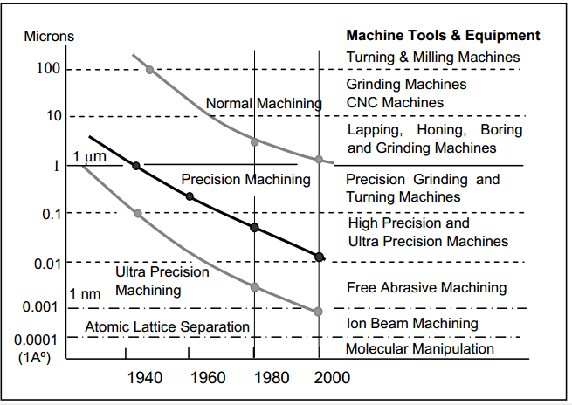

Figure machine precision (de Lacalle & Lamikiz 2009)

A wide variety of milling cutters are readily available on the market (fig 8).

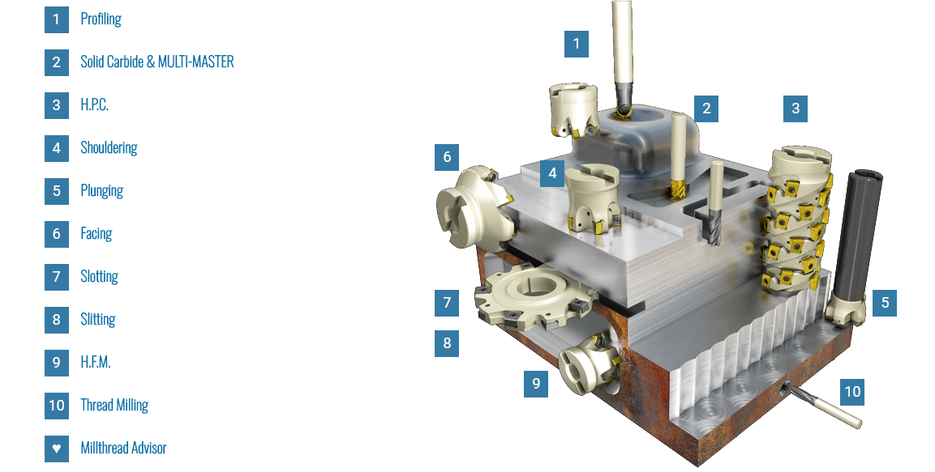

Figure Milling cutters

(<https://www.mmsonline.com/articles/high-speed-spindle-design-and-construction>) accessed 2018/03/06

<https://www.skok.co.za/machine-tools/golden-sun/product/416-cnct-100-630?tmpl=component>(accessed 2018/03/09)

Design of machine tool structure and analysis

Box type housings called structures account for 70-90% of the machine tool’s weight.

Functions of machine tool structures

* To provide rigid support for subassemblies
* To provide housing for individual units or their assemblies
* To support and move the work piece and tool relatively

Machine tool structures must satisfy the following requirements

# Functional analysis



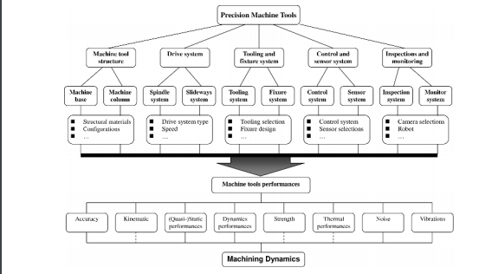

# Design specification

|  |  |  |  |
| --- | --- | --- | --- |
|  | **Design requirements** | **Metric** | **Specification** |
| **1** | Cutting speed | m/min | >60 |
| **2** | Workspace | m3 | >0.15x0.15x0.15 |
| **3** | Excellent positioning accuracy |  |  |
| **4** | Mass | kg |  |
| **5** | Multi-axis |  | >3 |
| **6** |  |  |  |
| **7** |  |  |  |
| **8** |  |  |  |
| **9** |  |  |  |
| **10** |  |  |  |

# Design Concepts

## Concept generation

|  |  |  |  |  |  |
| --- | --- | --- | --- | --- | --- |
|  | Option1 | Option2 | Option3 | Option4 | Option5 |
| Cutting device |  |  |  |  |  |
| Workpiece holder |  |  |  |  |  |
| Power source |  |  |  |  |  |
| Move the workpiece |  |  |  |  |  |
| Transmit torque |  |  |  |  |  |
| Rotate the cutting device |  |  |  |  |  |

## Concept evaluation

## Detailed concept

# Detailed design

* Use Floating bearing to take care of thermal expansion
* Relief groove to reduce stress concentration
* D/d=1.2-1.5 shaft shoulder based on catalogue
* Chamfer at the end of the shaft

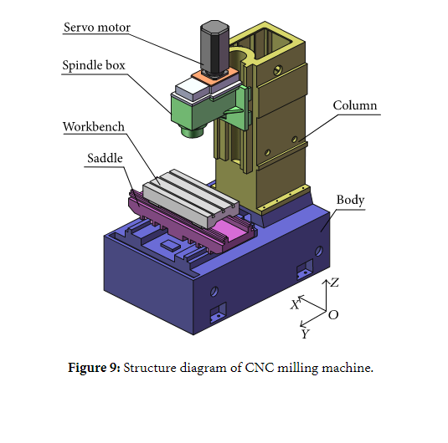

# Manufacturing analysis

# Maintenance analysis

# Cost analysis

# Impact of design

# Reliability analysis

# References

# Manufacturing Drawings

# Appendix

Pandion, Z& Dukovski, V 2012,Parallel kinematic machine tool: overview-from history to the future, *International journal of engineering, vol 1, no 1, pp 111-112*.

Jayakumar, G, Ravivanrman, C, Velayutham, A 2011, *General machinist theory,* Government of Tamilnadu, Chennai.

de Lacalle, LN, & Lamikiz, A 2009, *Machine tools for high performance machining,* Springer, London.