Linux Notes

Sources:
LFS101x – Introduction to Linux (Linux Foundation, edx.org)
Table of Contents
NAVIGATION 2
FILE OPERATION 2
KEYBOARD SHORTCUTS 2
VIRTUAL TERMINALS 3
I/O REDIRECTION 3
PIPES 4
SEARCHING 4
WILDCARDS 4
PROCESSES 5
TERMINATING A PROCESS 6
PROCESS PRIORITY 6
LOAD AVERAGES 7

NAVIGATION
cd : change to home directory
pushd : go to specified directory regardless of
current working directory
popd : go back through directories passed
pwd : display present working directory
tree : view filesystem tree
ls : list files in directory

FILE OPERATION
wc : word count
touch : create/change/modify files
mv : move or rename file
cp : copy file
rm : remove file
mkdir : make directory
rmdir : remove directory
systemctl : query or command system manager
ln : create hard link (not applicable to directories
or special files)
ln -s : create soft (symbolic) link
du : disk usage

KEYBOARD SHORTCUTS
Combine all with Ctrl
L : clear screen
D : exit current shell
Z : suspend current process to bg
C : kill current process
H : same as backspace
A : go to start of line
W : delete word before cursor
U : delete from beginning of line to cursor
E : go to end of line

VIRTUAL TERMINALS
Ctrl + Alt + Function key
// enable virtual terminal when in graphical environemnt

Alt + Function key
// swap virtual terminal

sudo systemctl stop gdm
// stop graphical desktop

sudo systemctl start gdm
// start graphical desktop

I/O REDIRECTION
Standard file streams: standard input, standard output, standard error

File descriptor
Standard input : 0
Standard output : 1
Standard error : 2
Other files : 3 onwards
sampleprogram < input-file
// input source has been changed to input-file

sampleprogram > output-file
// redirect output to output-file

sampleprogram 2 > error-file
// 2 is the file descriptor for standard error
// redirecto error to error-file

sampleprogram > all-output-file 2>&1
or
sampleprogram > all-output-file
// reidrect both output and error to all-output-file

PIPES
Take output from one command or program as input for another
command1 | command2 | command3

SEARCHING
which : locate where programs are installed
whereis : locate source and man files
locate : search for all files matching the argument
find : search down file tree recursively

WILDCARDS
Can be used when substituting for arguments

? : match any single character
* : match any string of characters
[set] : match any character in provided set
[!set] : match any character not in provided set

Search will not be restricted to the working directory if arguments are enclosed in double quotes

PROCESSES
The kernel is in charge of allocating resources to processes in an optimal manner

Process - instance of one or more related tasks (threads)
executing in the computer
- not to be confused with program or command
- a command can start multiple processes
Scheduler - done by the kernel
- shift processes on and off the CPU

Running state - process is waiting for its time slice
or
- currently executing instructions on the CPU
Sleep state - process is waiting for something to happen
before it resumes
Zombie state - child process completes but parent process
hasn't asked about its status
- a process that isn't 'alive' but still
shows up in the system process list
Run queue - queue of processes in running state
Wait queue - queue of processes in sleep state

Process ID - aka PID
- unique to each process, assigned by the kernel
to track process state, CPU usage, memory
use, etc.
Parent Process
ID - aka PPID
- process that started child process
- if this dies, child process gets assigned a
new adoptive parent
Thread ID - aka TID
- same as PID for single-threaded processes
- threads in multi-threaded processes share
the same PID but have different TIDs

TERMINATING A PROCESS
kill -SIGKILL <pid>
or
kill -9 <pid>

A user can only kill their own process unless user is root

PROCESS PRIORITY
Each CPU can only accommodate one task at a time
Priority can be manipulated

Nice value - aka niceness, "The niceness of a process"
- "The nicer the process, the lower the
priority"
- can be modified to set priority
- -20 is the highest priority
- +19 is the lowest priority
Real-time
priority - can be assigned to time-sensitive tasks
- not to be confused with hard real-time
Hard
real-time - process has to be completed within a
well-defined window of time

Commands:
ps : show processes
pstree : show processes in tree form
rnice : change priority of processes

LOAD AVERAGES
Average of the load number for a given period of time
Processes in running and sleeping (uninterruptible sleepers) state are included

w :
top : provide real-time updates about what the system
is doing
uptime : show uptime & load average
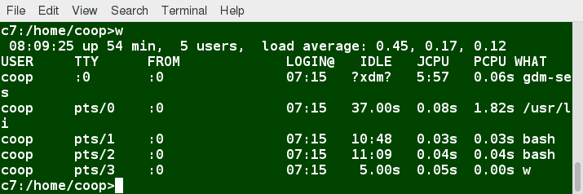

Assume single CPU in the image above. The load average is shown with three numbers
0.45 : in the last minute, the system has been
utilized 45%
0.17 : in the last 5 minutes, the system has been
utilized 17%
0.12 : in the last 15 minutes, the system has been
utilized 12%

If value = 1.00, system is fully utilized
If value > 1.00, system is overutilized

If multiple CPUs, divide load average by number of CPUs

Background and Foreground

