online-banking project SCreenshot

Contents

1.Folder Structure: **2**

2.LOGIN Page: **16**

3.SignUp Page: **16**

4.AFTER-LOGIN Page: **17**

5.OPTION Page: **18**

6.ACCOUNT OPTION Page: **18**

7.Transform Page: **18**

8.AFTER TRANSFER: **20**

9.ADD RECEPTION: **22**

10.APPOINTMENT: 23

21.ADDING RECEPTIONS: 30

22.WITHDRAW: 31

# Folder Structure:

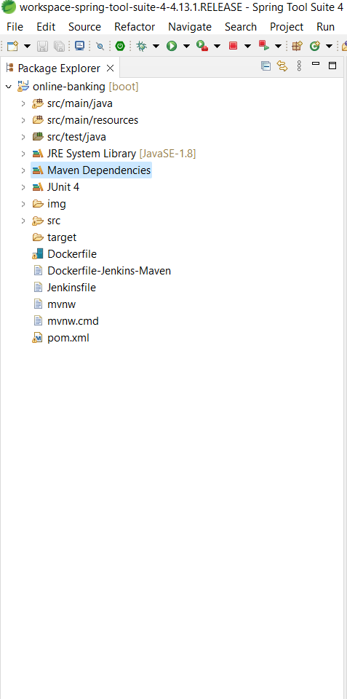

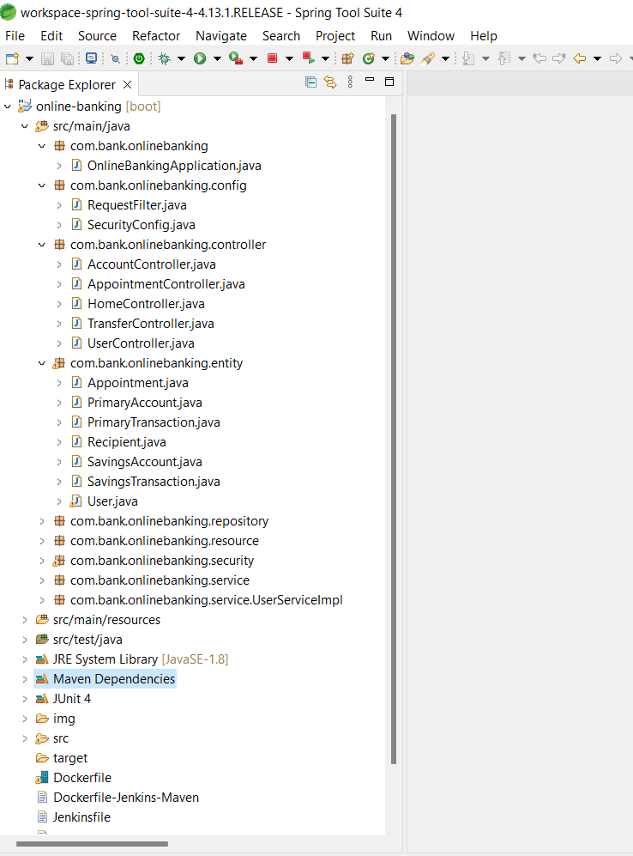

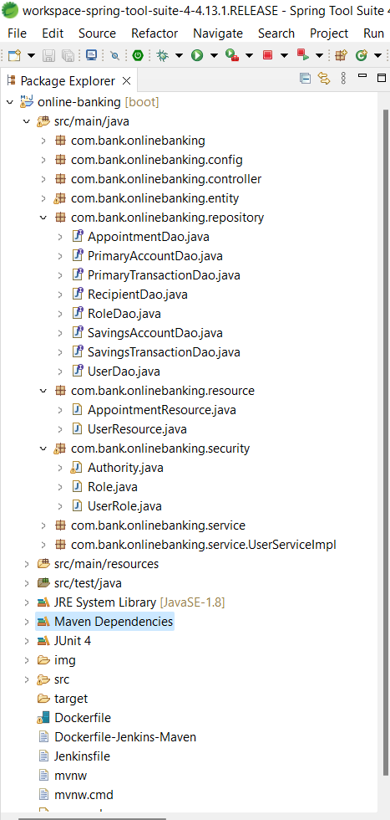

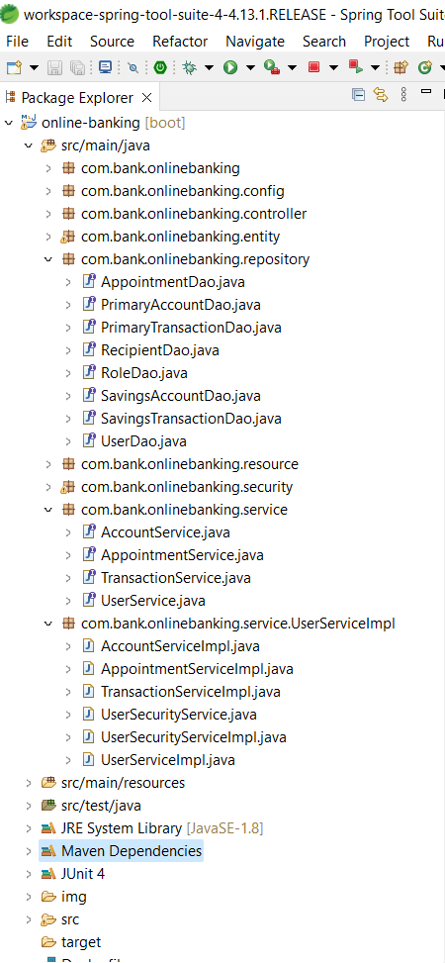

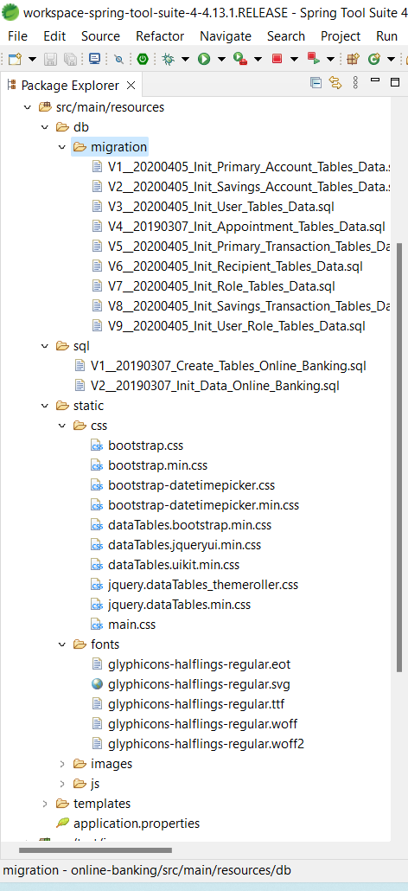

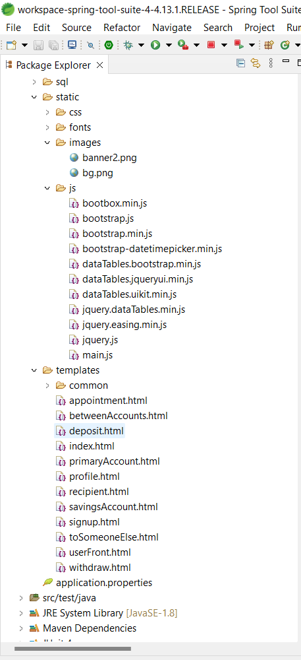

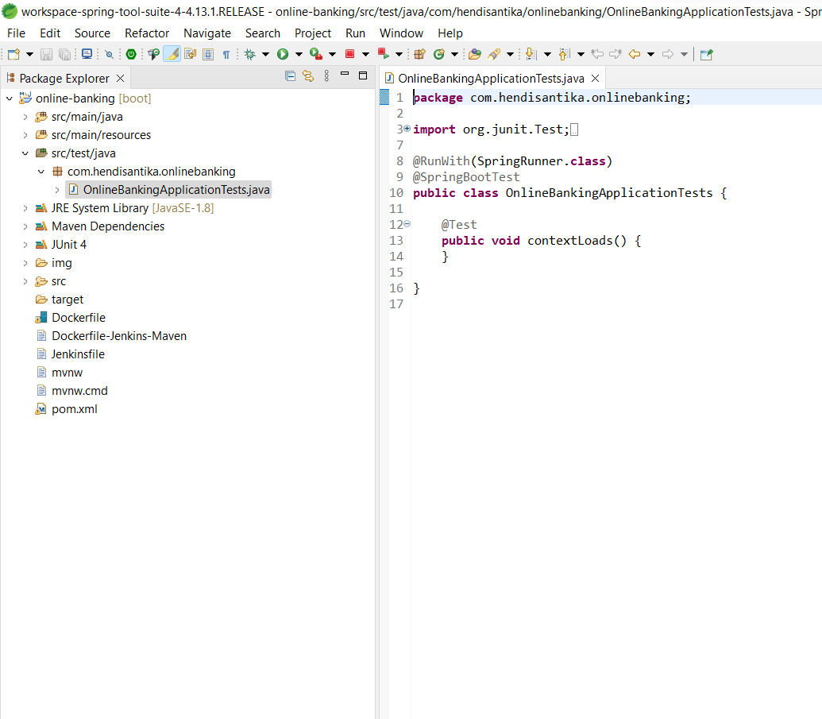

# 

# LOGIN Page:

# 

# SignUp Page:

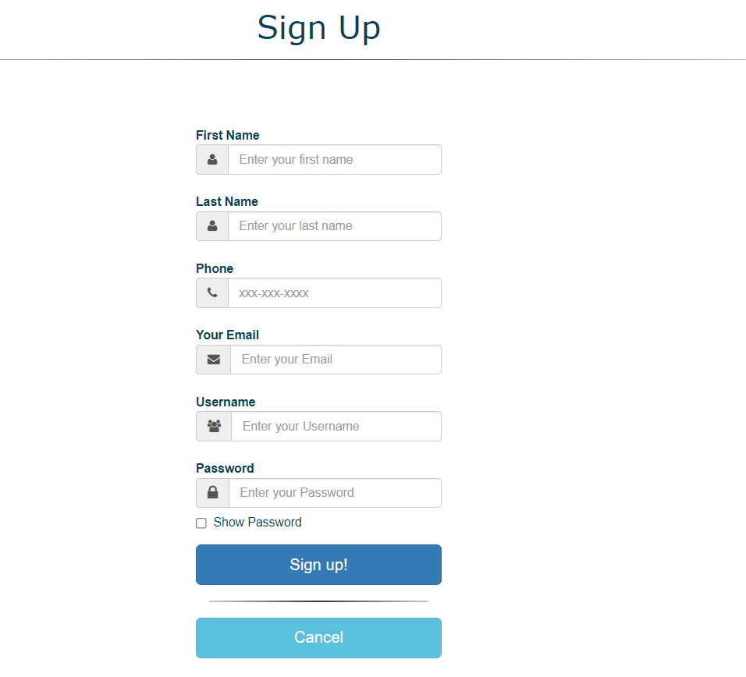

# **AFTER-LOGIN Page:**

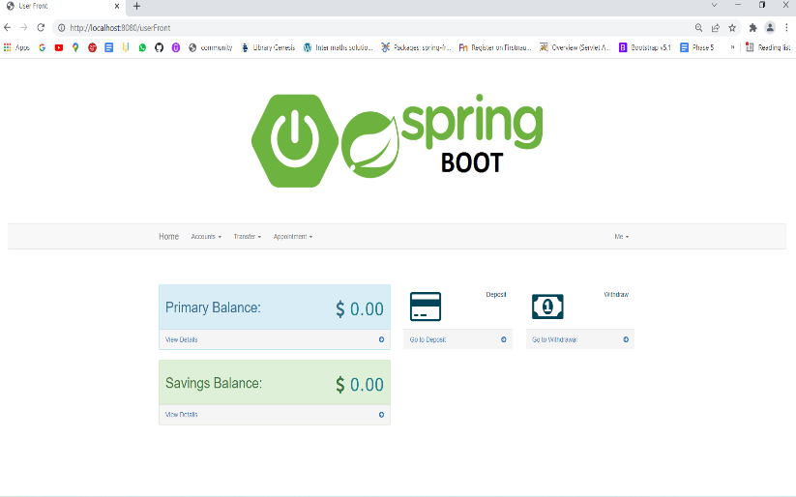

# **OPTION Page:**

# 

# **ACCOUNT OPTION Page:**

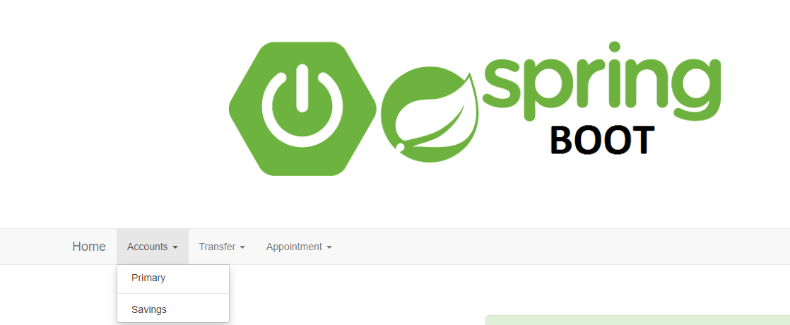

# **Transform Page:**

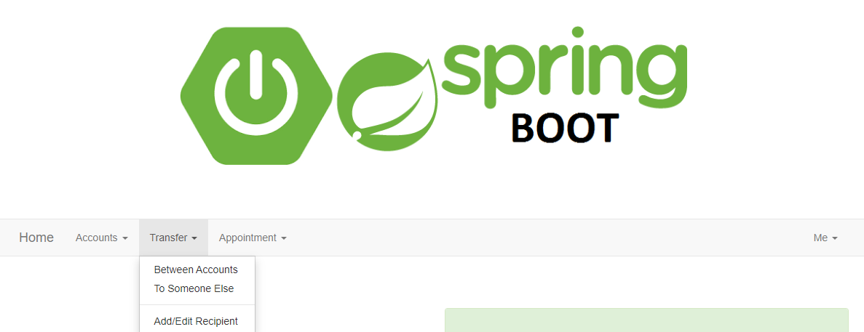

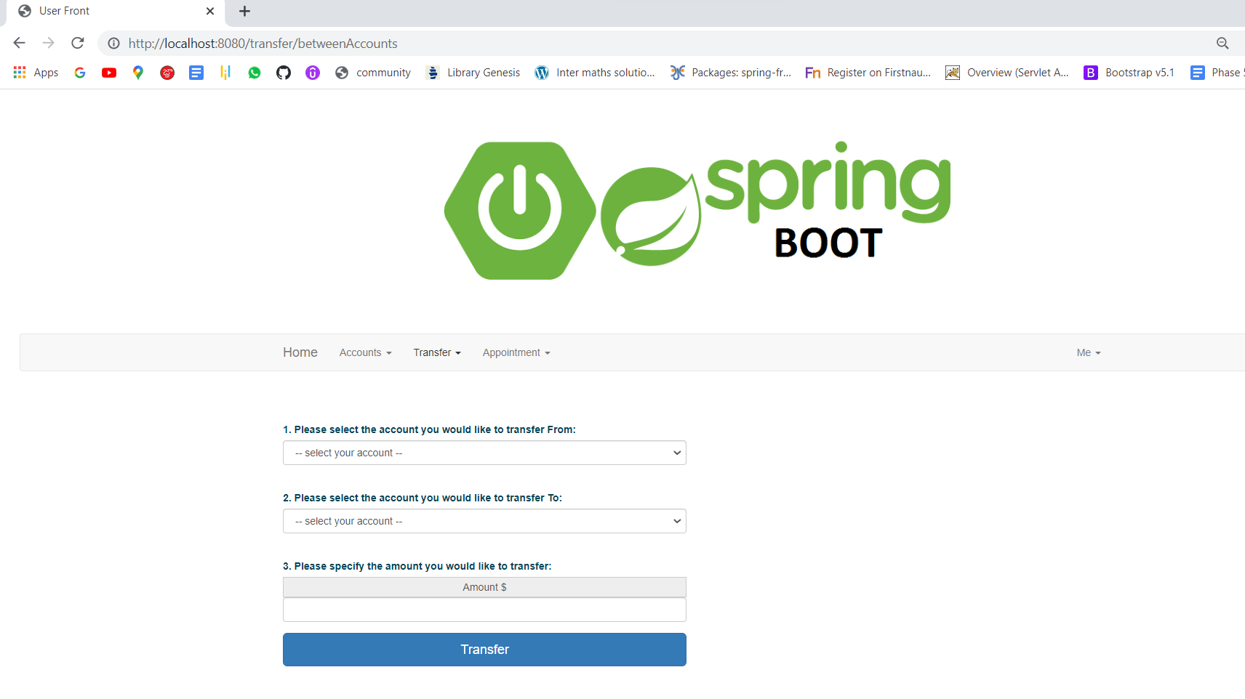

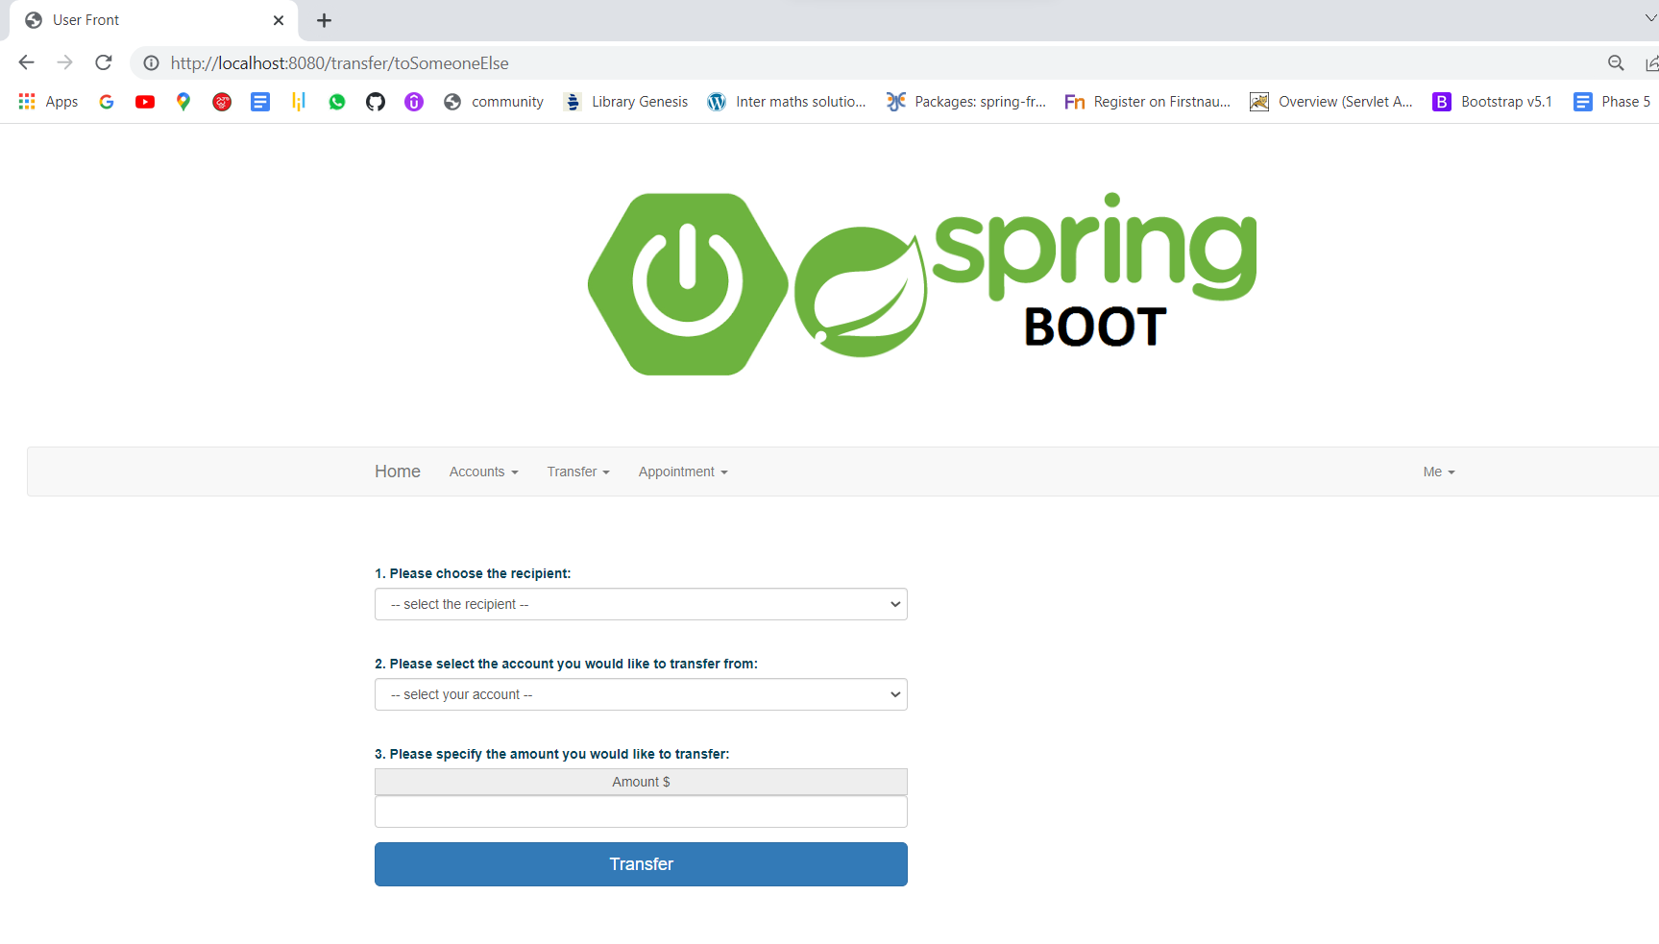

# **AFTER TRANSFER:**

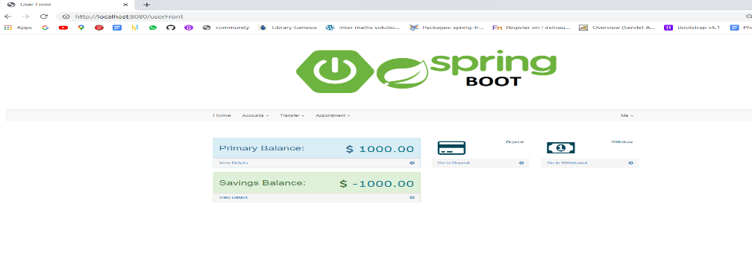

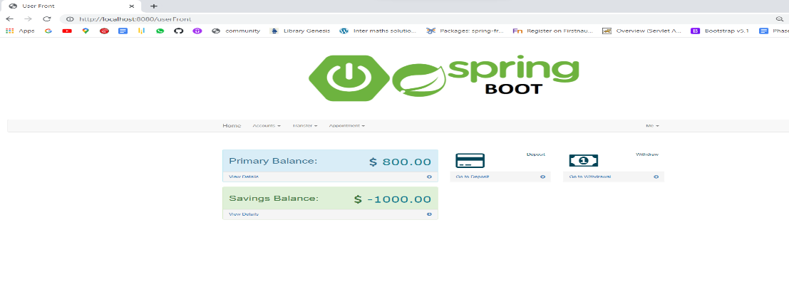

# **ADD RECEPTION:**

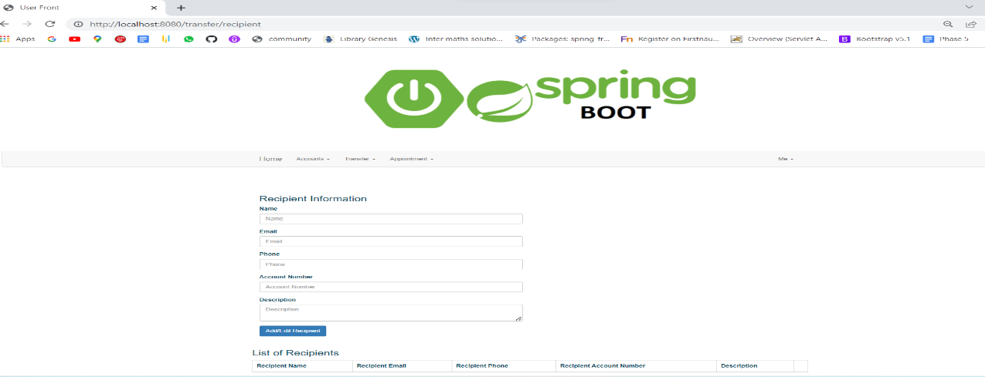

# **APPOINTMENT:**

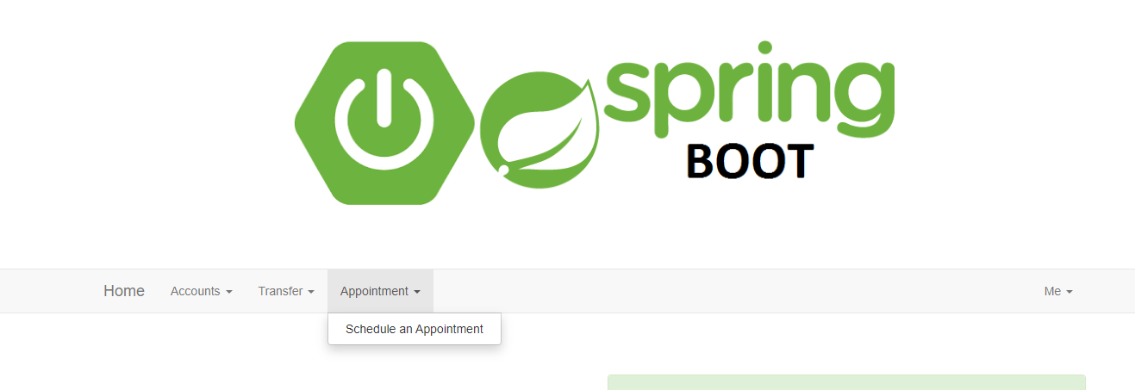

1. **DEPOSITE:**

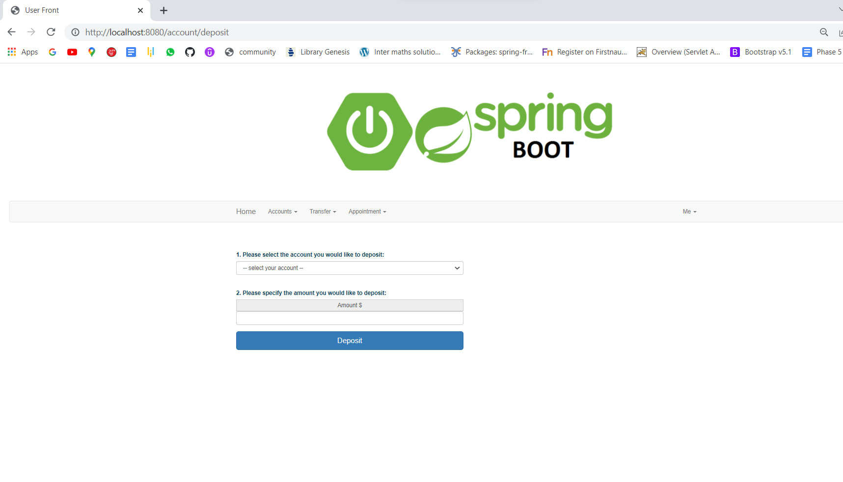

1. **DEPOSITE AFTER:**

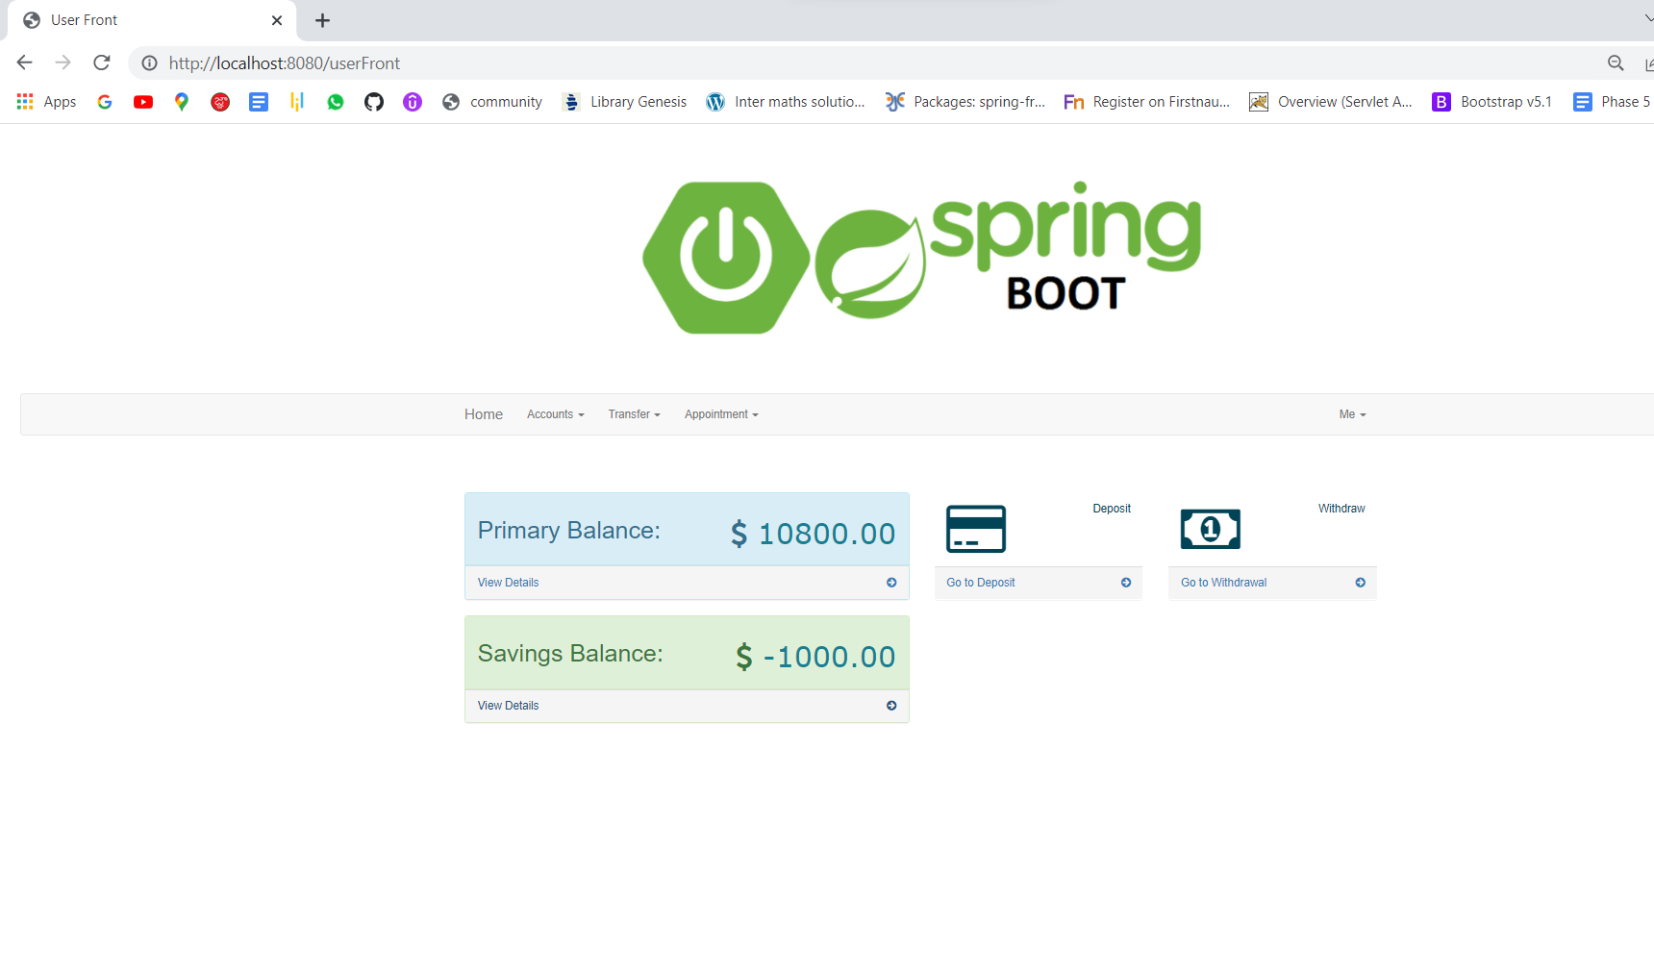

1. **PRIMARY BALANCE:**

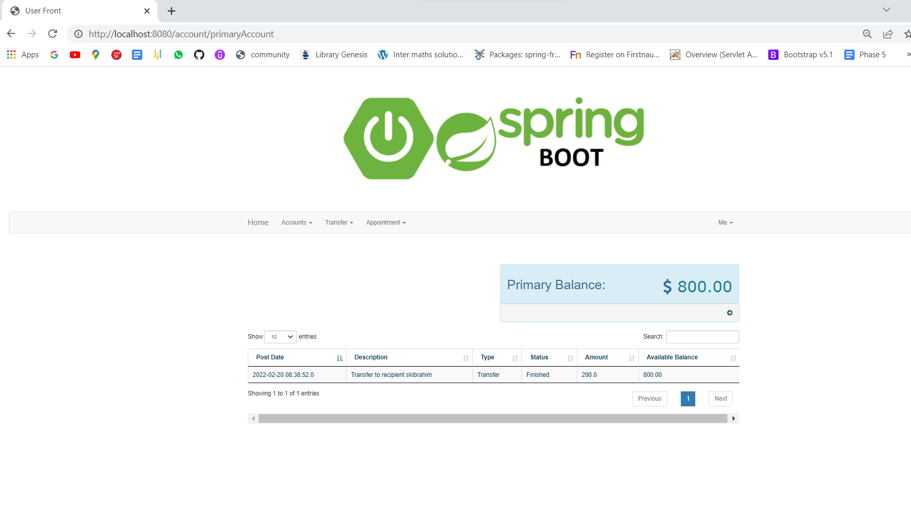

1. **SAVINGS BALANCE:**

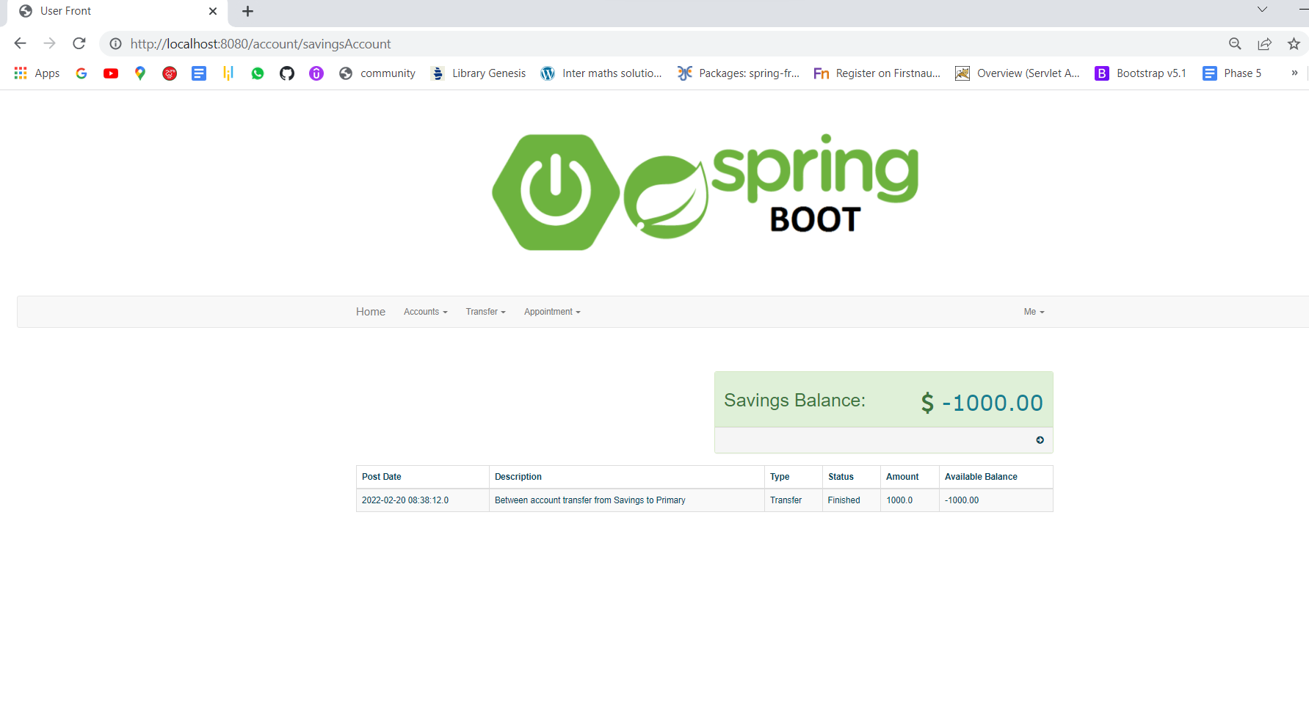

1. **PRIMARY SAVINGS:**

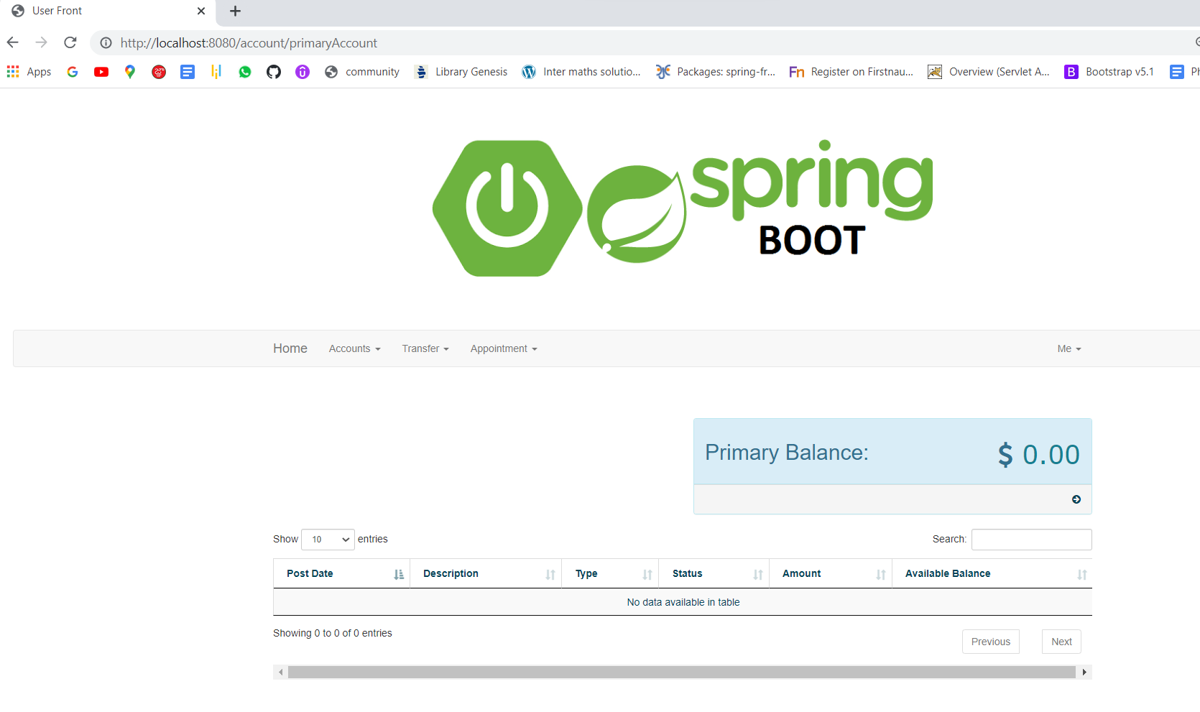

1. **SAVINGS:**

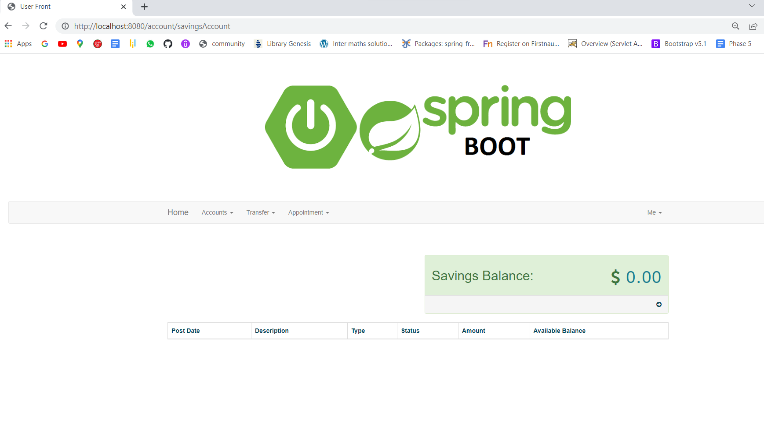

1. **ME OPTION:**

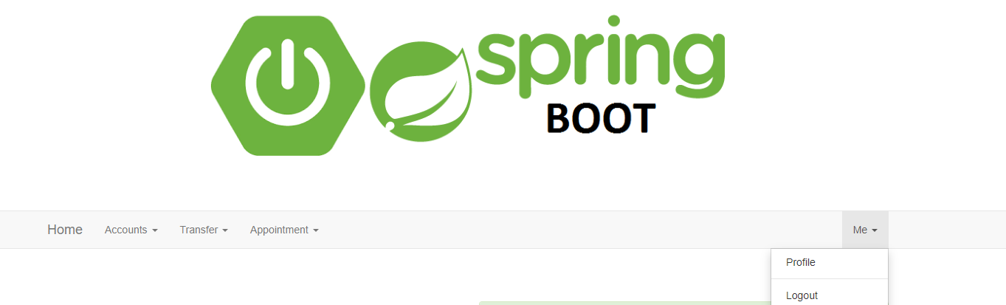

1. **PROFIE:**

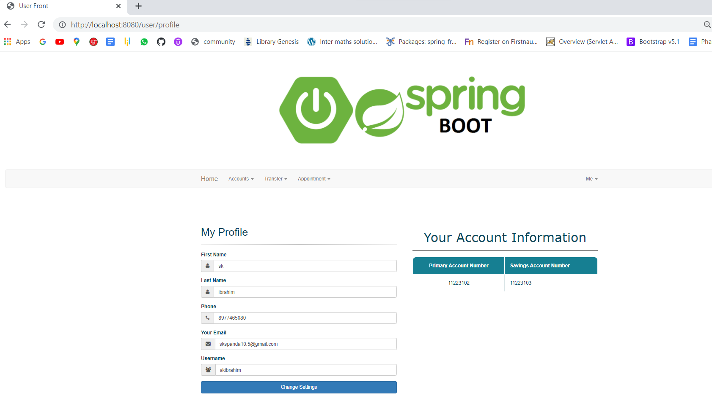

1. **RECEPTION ADDING:**

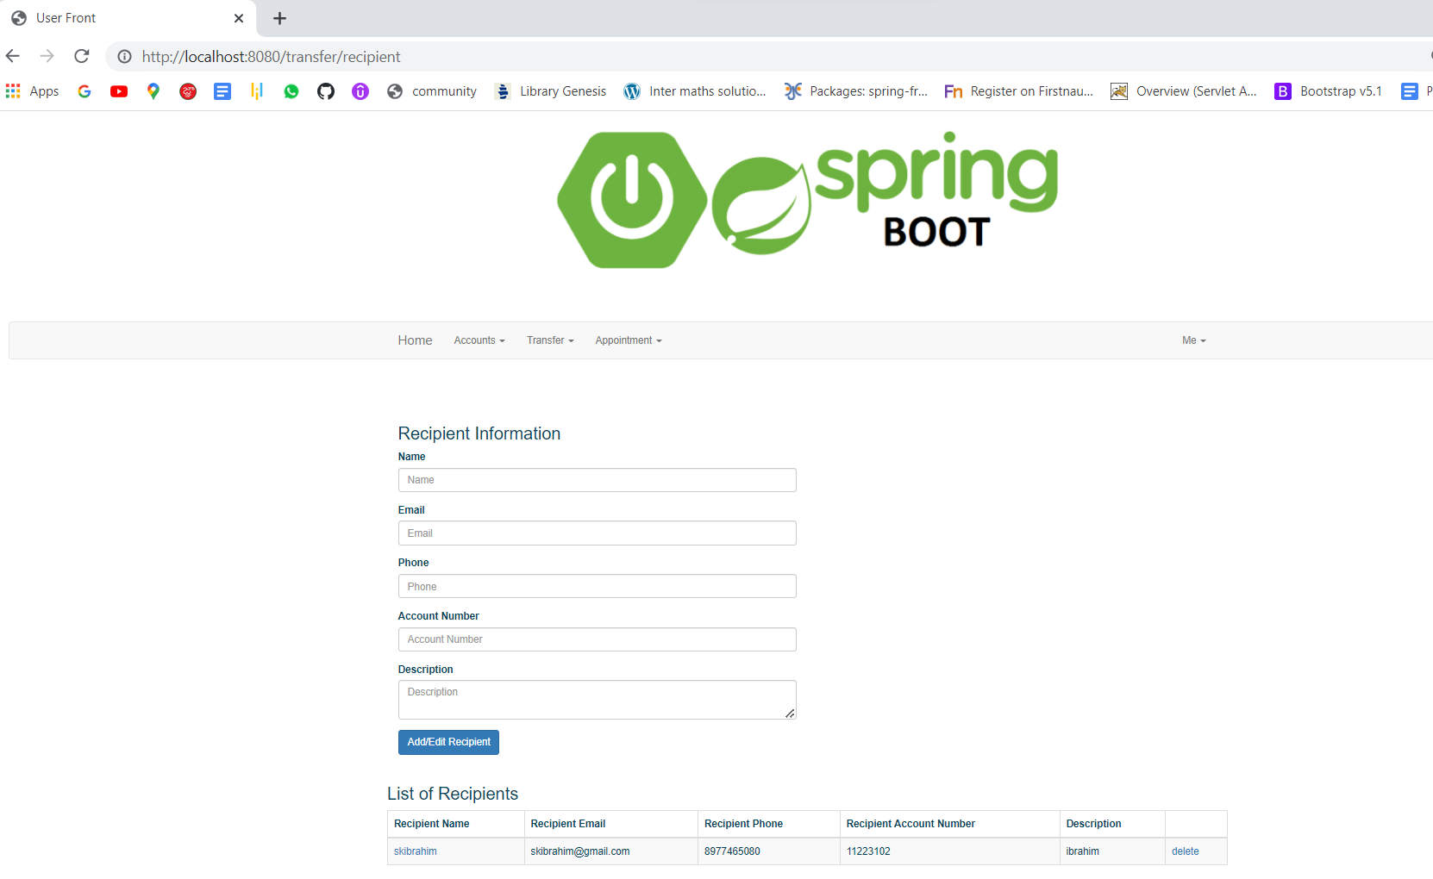

1. **SCHEDULE APPOINTMENT:**

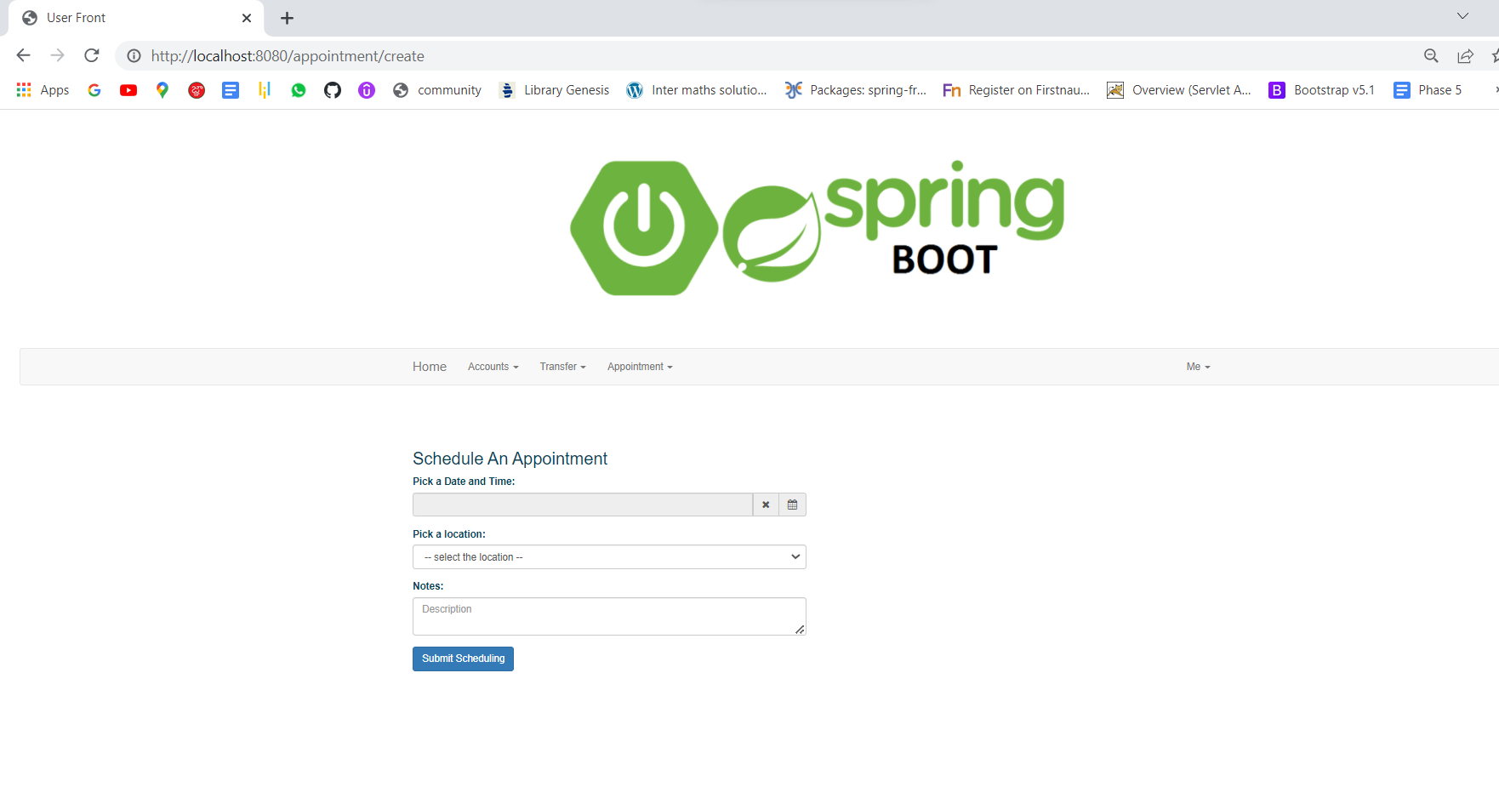

# 21.ADDING RECEPTIONS:

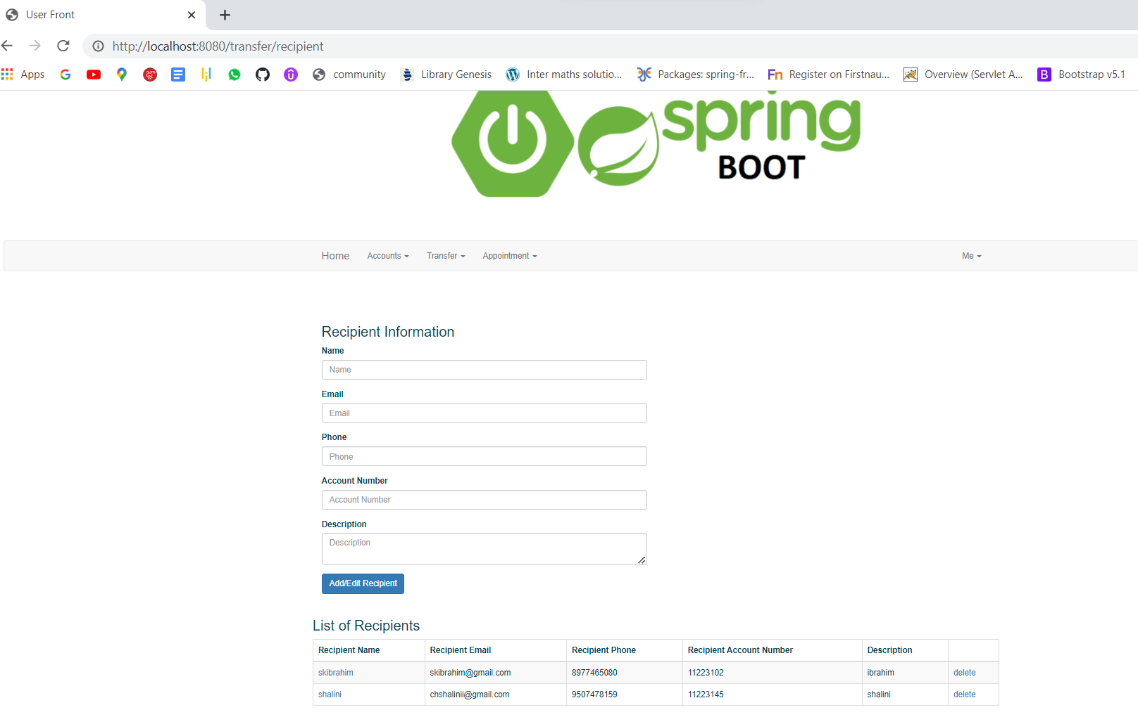

# 22.WITHDRAW:

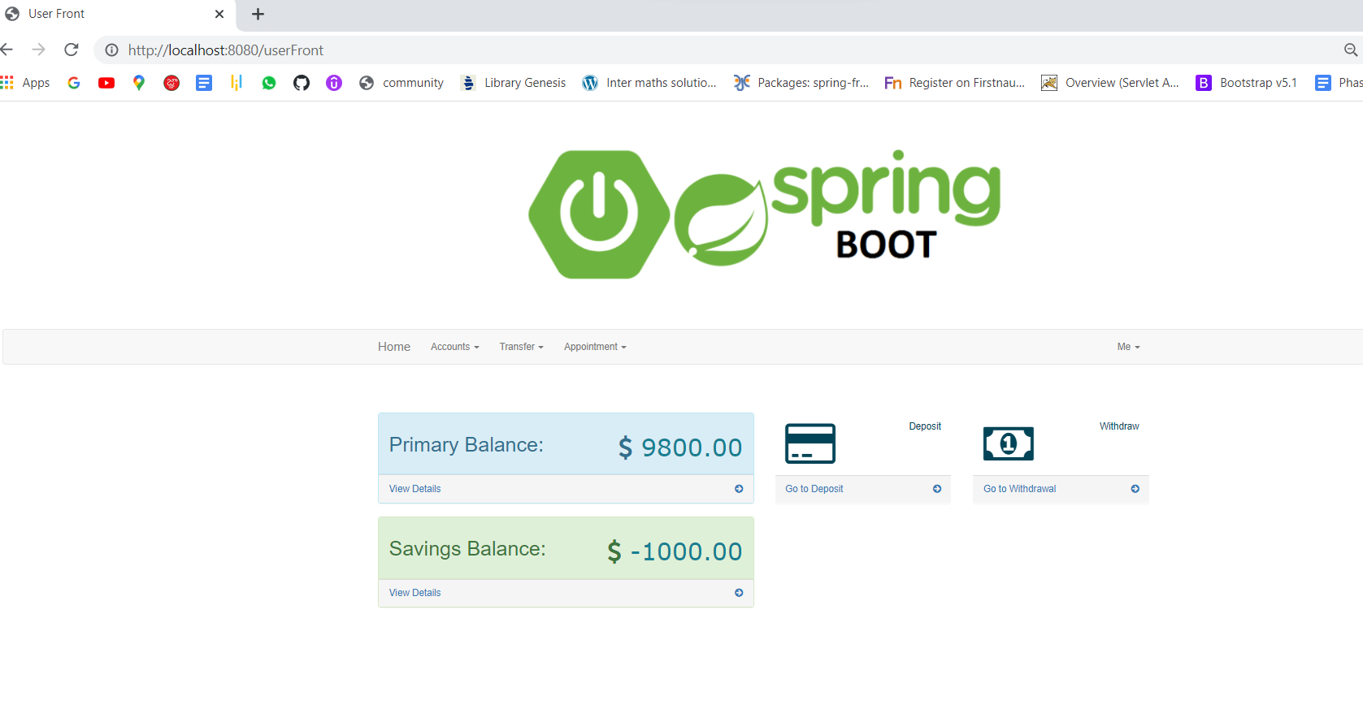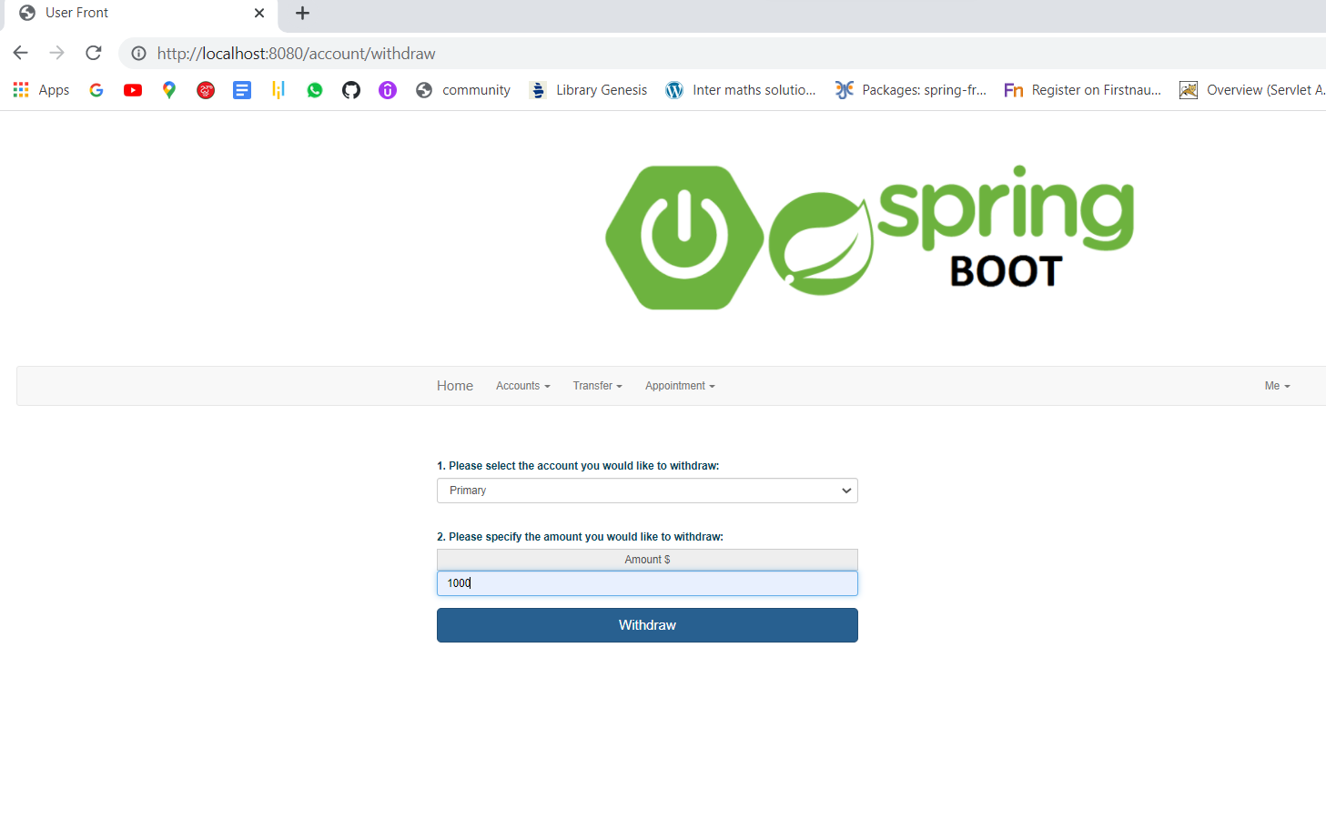

# **--------------------THE END--------------------------**