|  |
| --- |
| **Company Locked**  **(Application Screenshots)** |

**Version History**

|  |  |
| --- | --- |
| **Author** | Ibrahim Sheik |
| **Purpose** | Screenshots of the application |
| **Date** | 11th Aug 2021 |
| **Version** | 1.0 |

Contents

1.Main Menu Screenshot 3

2.Display All Files 4

3.Create A File 5

3.1.After Creating a File 5

4.Delete a File 6

4.1.After Deleted a File 6

5.Search File 7

6.Exit 8

# 1.Main Menu Screenshot

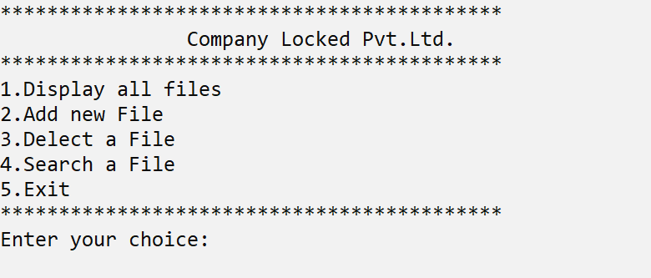

# 2.Display All Files

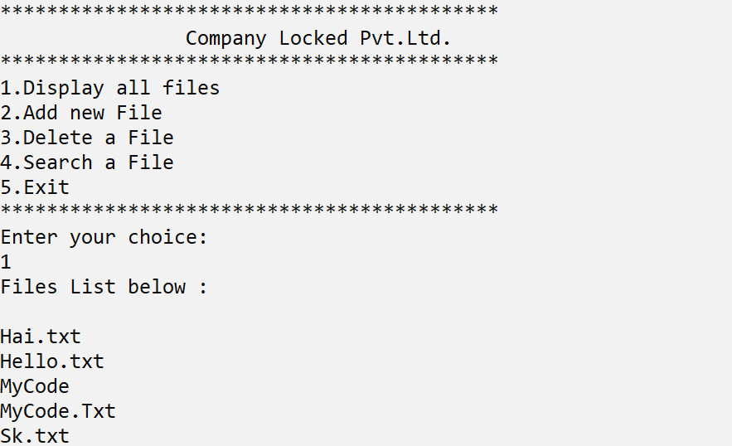

# 3.Create A File

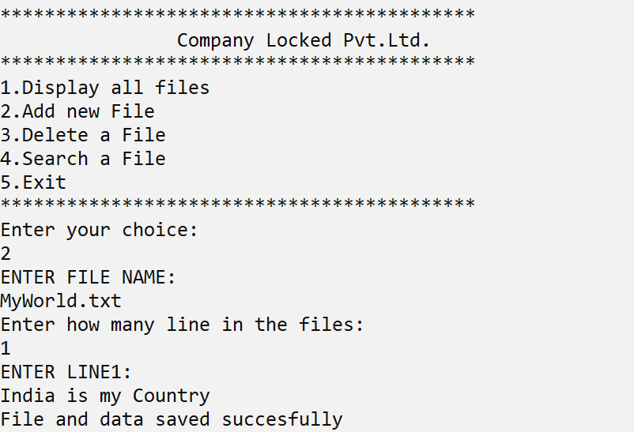

3.1.After Creating a File

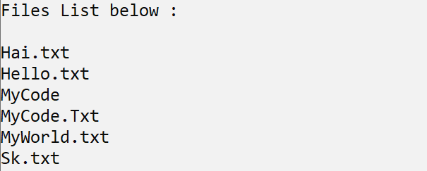

# 4.Delete a File

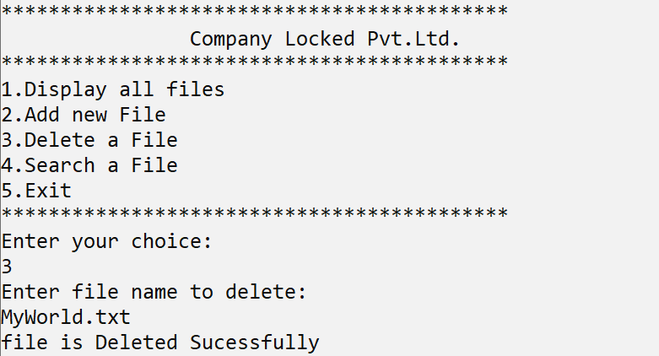

# 4.1.After Deleted a File

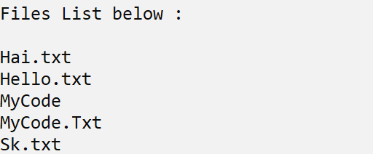

# 5.Search File

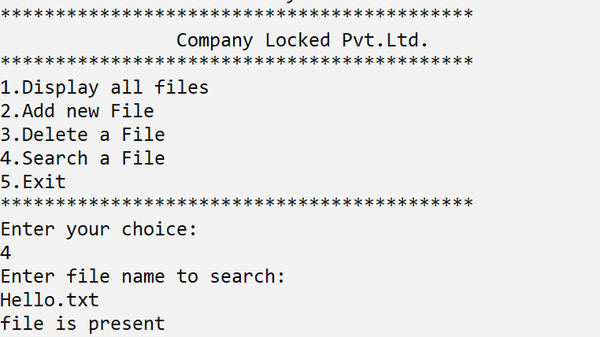

# 6.Exit

