Setup E PAT Rig Effective Sample Size Report
Setup: setup_e
Report timestamp: 20260420_145559
Source notebook: setup_E_PATrig_effective_sample_size.ipynb

Executive summary
Setup E treats the PAT rig as a level-controlled vertical sampling interface in which a half-filled dense powder column moves past a side-window non-contact NIR measurement location. The report separates instantaneous illuminated mass, refreshed new mass, total mass passed the NIR spot footprint, and refresh fraction so that acquisition-time and throughput effects can be interpreted mechanistically for the 25 mm spot geometry rather than as a single aggregate metric.

Key parameters
- Pipe diameter (cm): 10
- Total rig height (cm): 80
- Maintained fill fraction (-): 0.5
- Modeled filled height (cm): 40
- Probe height from bottom (cm): 20
- NIR spot diameter (cm): 2.5
- Measurement depth (cm): 0.1
- Bulk density (g/cm^3): 0.3
- Throughput (kg): 95
- Throughput time (s): 3600
- Acquisition time range (s): 0.1 to 5.0
- Axial length model: spot_diameter

Background
Setup E models a PAT (Process Analytical Technology) rig as a vertical cylindrical sampling interface fed continuously from an upstream manufacturing unit. A rotating outlet valve at the bottom controls discharge, while level sensors along the wall maintain the rig at approximately half full during operation.
The primary NIR instrument views the powder through a side optical window positioned near the lower part of the rig. In the base case used here, the measurement location is placed one-quarter of the rig height above the bottom outlet and the non-contact NIR spot diameter is 25 mm.
Three distinct mass metrics are relevant:
- Instantaneous probed mass (m_inst): mass simultaneously illuminated at any single instant.
- New mass presented per acquisition (m_new): unique material refreshed across the NIR spot during one acquisition time, bounded by the instantaneous mass.
- Mass passed probe footprint (m_pass): total mass that crosses the probe footprint during acquisition and is not bounded by the instantaneous mass.
This notebook treats the occupied lower section of the PAT rig as a first-order dense moving powder column. It uses the maintained fill level to determine whether the probe is covered by powder and then uses throughput-driven axial motion to estimate renewal at the probe position.

Objective
Compute instantaneous probed mass, new mass presented per acquisition, and mass passed the NIR spot footprint for a level-controlled PAT rig configuration. Use a half-filled base case with the measurement window located one-quarter of the rig height from the bottom, sweep acquisition time and throughput, and export results using the standard reporting workflow.

Theory

Level-controlled PAT rig geometry
The PAT rig is modeled as a vertical cylinder of total height Hrig and internal diameter Dpipe. The level-control system maintains an approximately constant filled fraction f_fill, so the modeled filled height is:
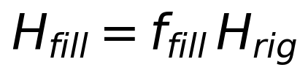
The NIR measurement location is placed at height z_probe above the outlet. A simple coverage indicator is then used:
C_probe = begincases1, & z_probe le H_fill \\ 0, & z_probe > H_fillendcases
In the base case, the probe sits below the maintained fill level, so the optical window is treated as continuously covered by powder.

Throughput-driven axial velocity
Within the occupied lower section of the PAT rig, powder motion near the probe is approximated as a first-order dense moving column. The axial velocity is estimated from throughput and the full cylindrical cross-section:
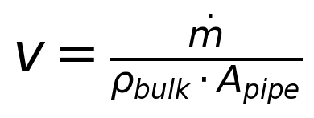
where
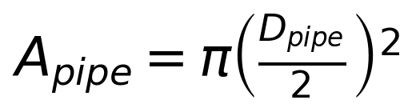
This is still a simplifying assumption: it ignores detailed wall slip, outlet-valve kinematics, and any nonuniform velocity profile near the probe.

Instantaneous probed mass
The non-contact NIR spot is represented as a circular optical footprint with area:
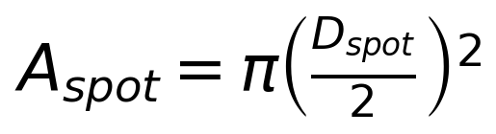
The instantaneous probed mass, if the probe is covered, is:
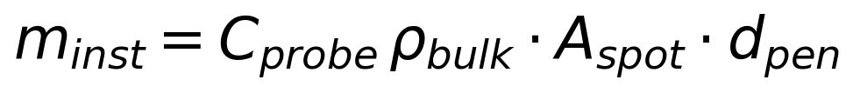

Axial advance and refresh fraction
Axial advance during one acquisition is:
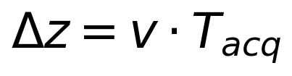
The axial sampling length is represented by a proxy length L_axial. In the base case this is taken as the NIR spot diameter. The refresh fraction is then:
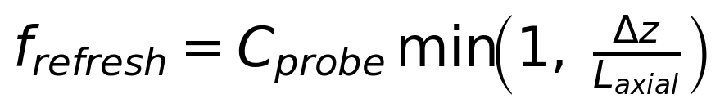

New mass and mass passed
New mass presented per acquisition is:
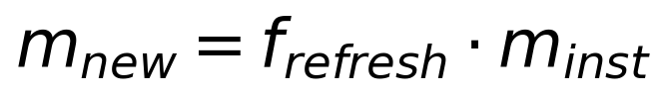
Mass passed the probe footprint during acquisition is:
Symbols and units:
- dotm: mass flow rate [g/s]
- rho_bulk: bulk density [g/cm^3]
- A_pipe: pipe cross-section area [cm^2]
- H_rig: total rig height [cm]
- f_fill: maintained filled fraction [-]
- H_fill: modeled filled height [cm]
- z_probe: probe height above the outlet [cm]
- C_probe: probe coverage indicator [-]
- A_spot: NIR spot area [cm^2]
- D_spot: NIR spot diameter [cm]
- d_pen: measurement (penetration) depth [cm]
- T_acq: spectral acquisition time [s]
- L_axial: axial sampling length proxy [cm]

Assumptions
- vertical cylindrical PAT rig with top feed and bottom discharge through a rotating outlet valve
- level sensors maintain an approximately constant filled fraction during operation
- the occupied lower section is treated as a dense moving powder column near the probe
- powder velocity at the probe is approximated from throughput and full pipe cross-section
- the NIR spot is circular and viewed through a side optical window
- the probe is treated as covered whenever its height is below the modeled fill height
- measurement depth is small relative to pipe diameter
- axial sampling length is approximated by the NIR spot diameter unless overridden
- no explicit outlet-valve kinematics, turbulence, segregation, or wall-slip correction
- no detailed radiative transfer model yet

Compute Effective Sample Size Metrics
Run 1D acquisition-time sweep and 2D throughput × acquisition-time sweep.

Worked example
The baseline case below reports the maintained fill height, probe position relative to the fill level, the instantaneous mass at the probe, the refreshed new mass during one acquisition, the total mass passed the NIR spot footprint, and the resulting refresh fraction.
Quantity | Value
filledheightcm | 40
probeheightfrombottomcm | 20
probesubmergencecm | 20
probeiscovered | 1
velocitymms | 11.1998
acquisitiontimes | 1
refreshfractionper_acq | 0.447992
probemassmg_instant | 147.262
newmassmgperacq | 65.9722
masspassedmgperacq | 1649.31
effectivesamplesize_mg | 65.9722

Model scenarios and sweep design
The Setup E analysis combines a one-dimensional acquisition-time sweep with a two-dimensional throughput-by-acquisition-time sweep. This lets the report distinguish time saturation effects from throughput-driven transport effects while holding the PAT rig geometry and fill level fixed.
- acquisition time swept from 0.1 to 5.0 s
- throughput swept from 10 to 90 kg over the fixed throughput-time basis
- maintained fill fraction fixed at 0.50
- probe height fixed at 20.0 cm from the bottom
- NIR spot diameter fixed at 2.5 cm
- axial sampling length model: spot_diameter
This produces 420 modeled rows across the 1D and 2D sweeps.

Selected results table
The selected table below samples representative acquisition times from the baseline sweep so the reader can compare fill condition, instantaneous illuminated mass, refreshed new mass, passed mass, refresh fraction, and the resulting effective sample-size proxy side by side.
acquisitiontimes | velocitymms | filledheightcm | probeheightfrombottomcm | probeiscovered | probemassmg_instant | newmassmgperacq | masspassedmgperacq | refreshfractionper_acq | effectivesamplesize_mg
0.1000 | 11.1998 | 40.0000 | 20.0000 | True | 147.2622 | 6.5972 | 164.9306 | 0.0448 | 6.5972
0.8737 | 11.1998 | 40.0000 | 20.0000 | True | 147.2622 | 57.6389 | 1440.9722 | 0.3914 | 57.6389
2.4211 | 11.1998 | 40.0000 | 20.0000 | True | 147.2622 | 147.2622 | 3993.0556 | 1.0000 | 147.2622
5.0000 | 11.1998 | 40.0000 | 20.0000 | True | 147.2622 | 147.2622 | 8246.5278 | 1.0000 | 147.2622

Figures
The figures are ordered from one-dimensional mechanism checks to two-dimensional operating maps: refreshed new mass, mass passed the NIR spot footprint, refresh fraction, then the throughput-acquisition heatmaps.
Figure 1. New mass per acquisition versus acquisition time for the half-filled PAT rig base case.
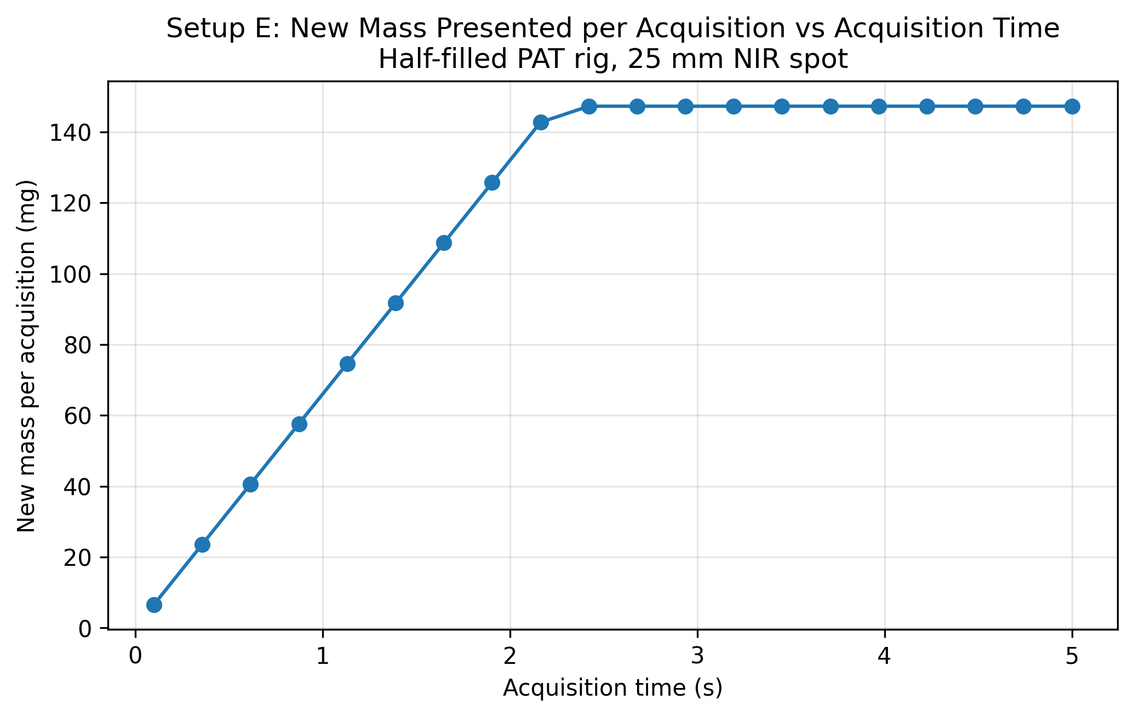
Figure 2. Mass passed the NIR spot footprint versus acquisition time.
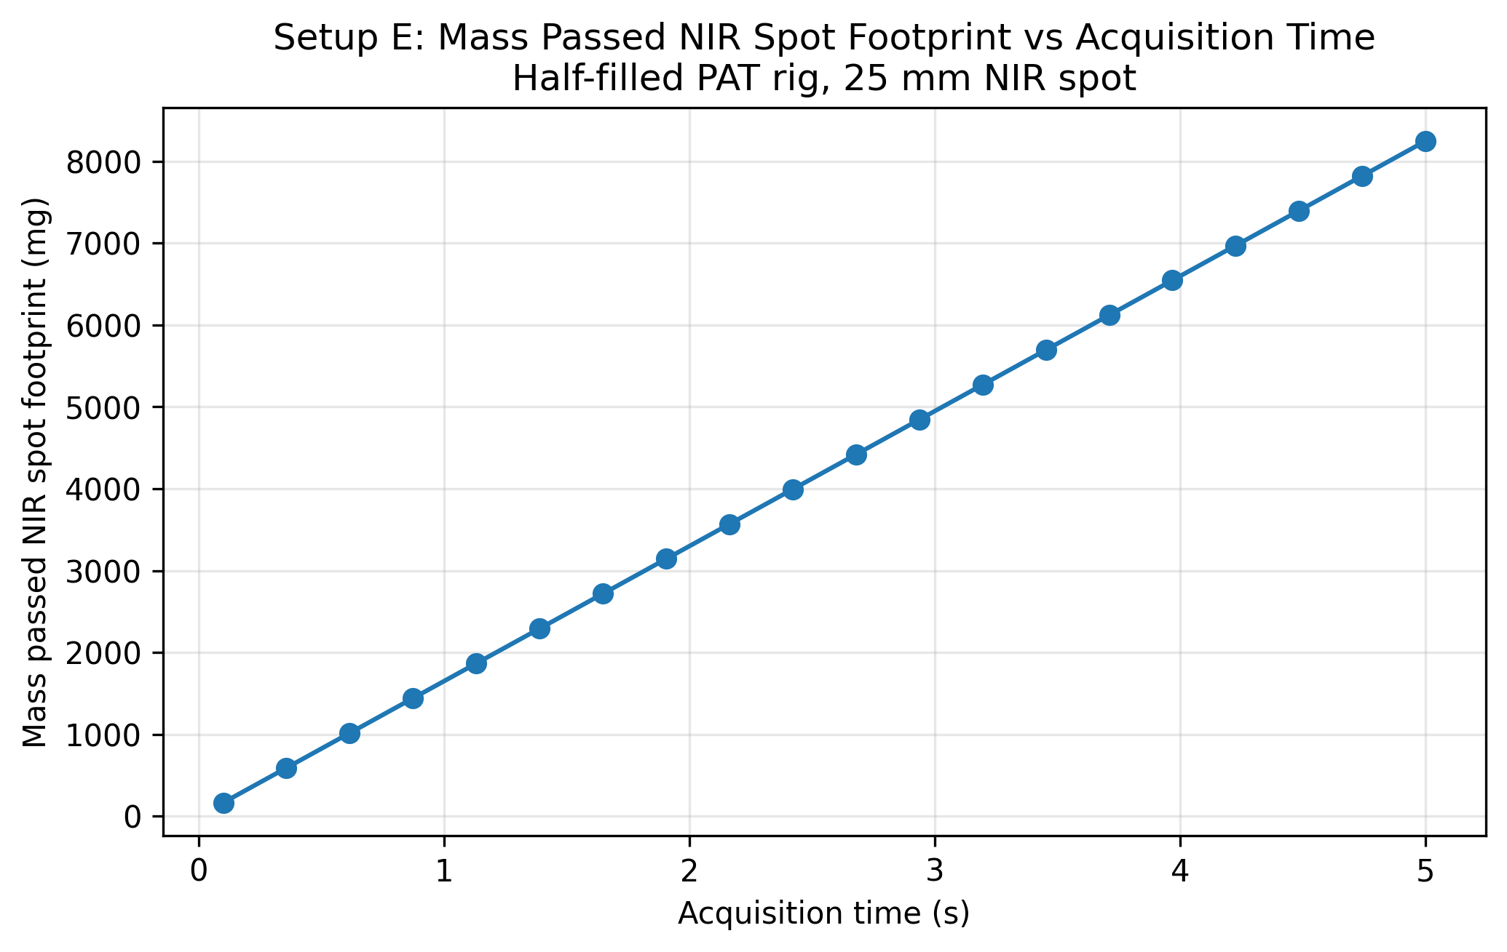
Figure 3. Refresh fraction versus acquisition time for the 25 mm NIR spot.
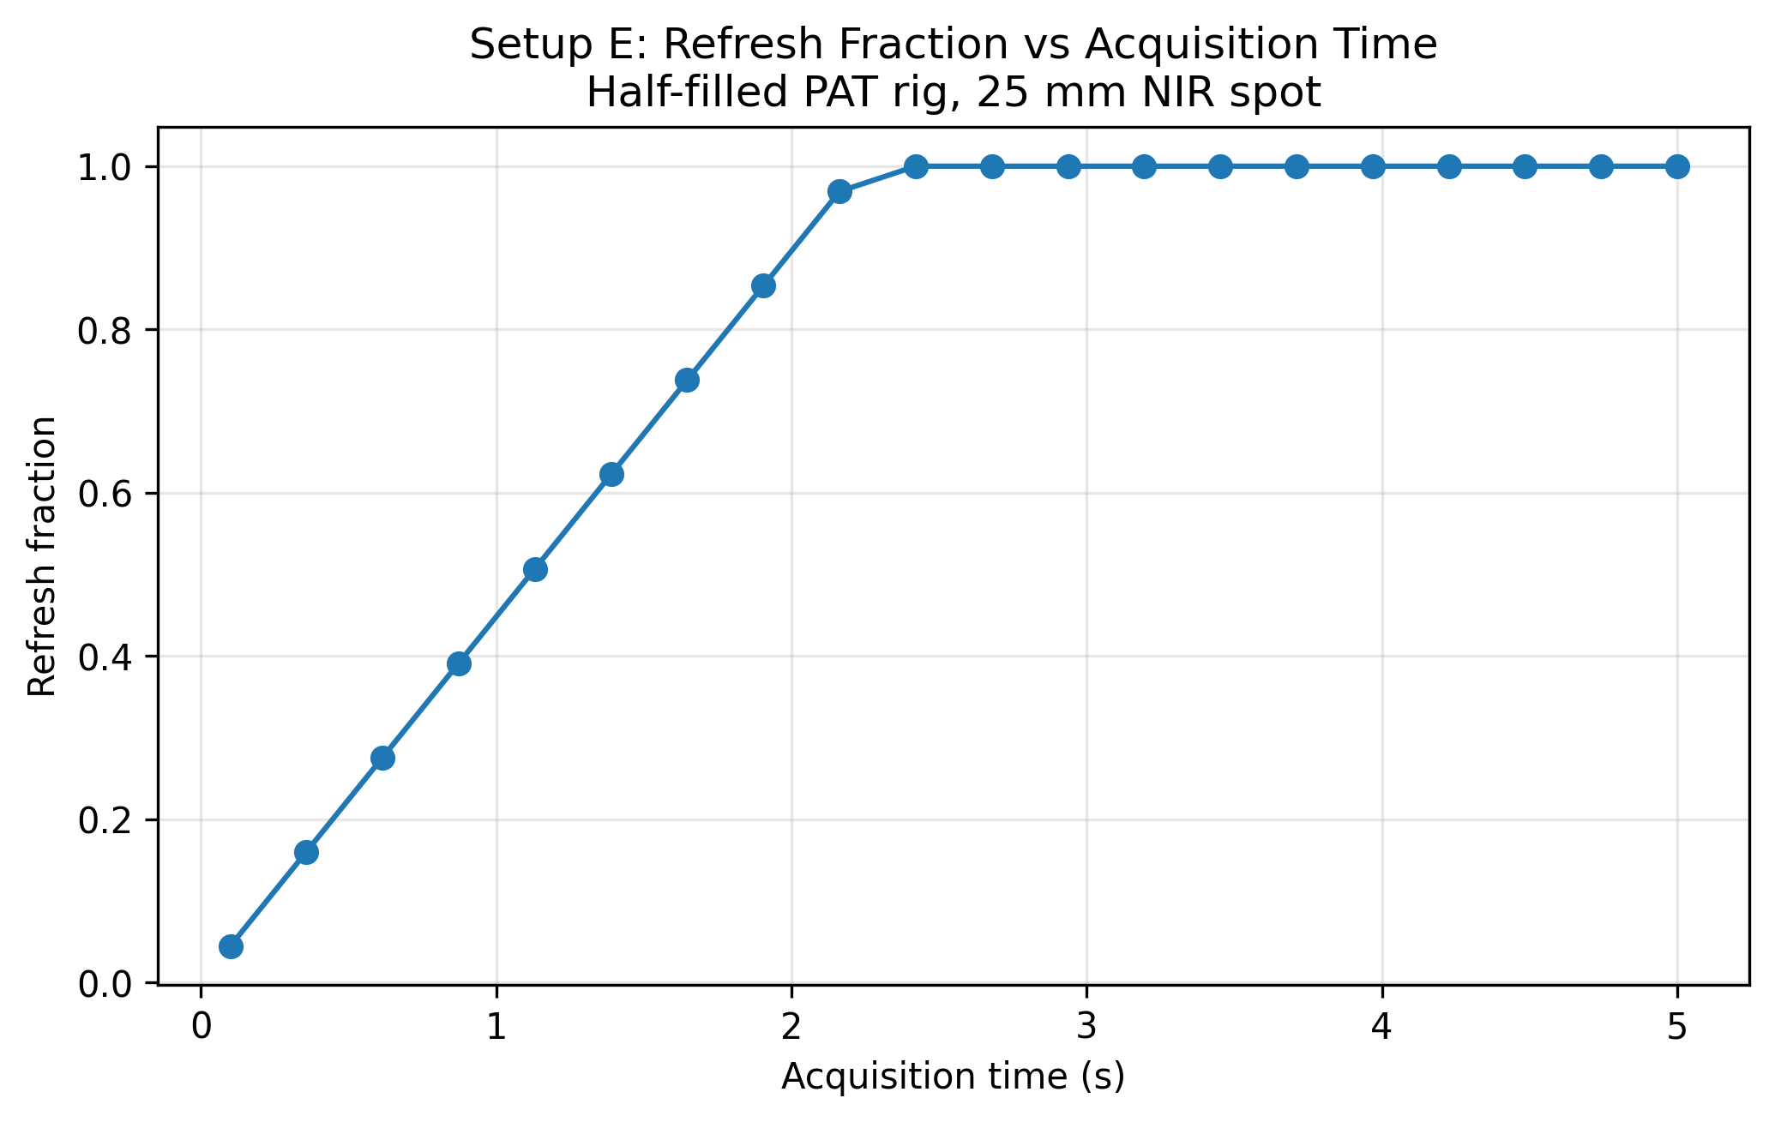
Figure 4. Throughput-acquisition heatmap for the mass passed the NIR spot footprint.
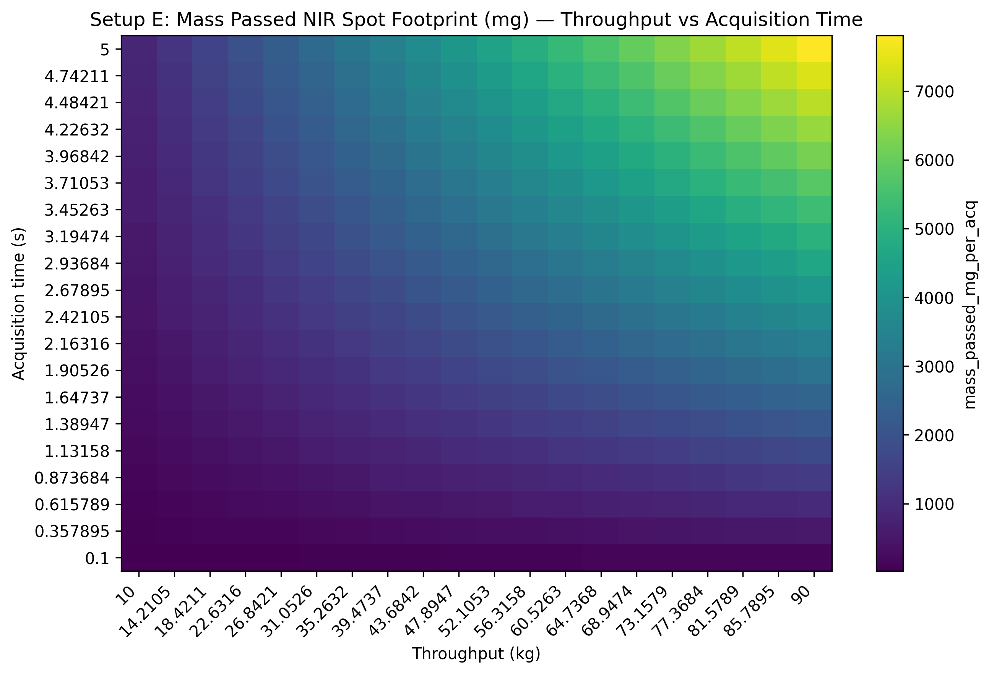
Figure 5. Throughput-acquisition heatmap for the refresh-based new-mass metric.
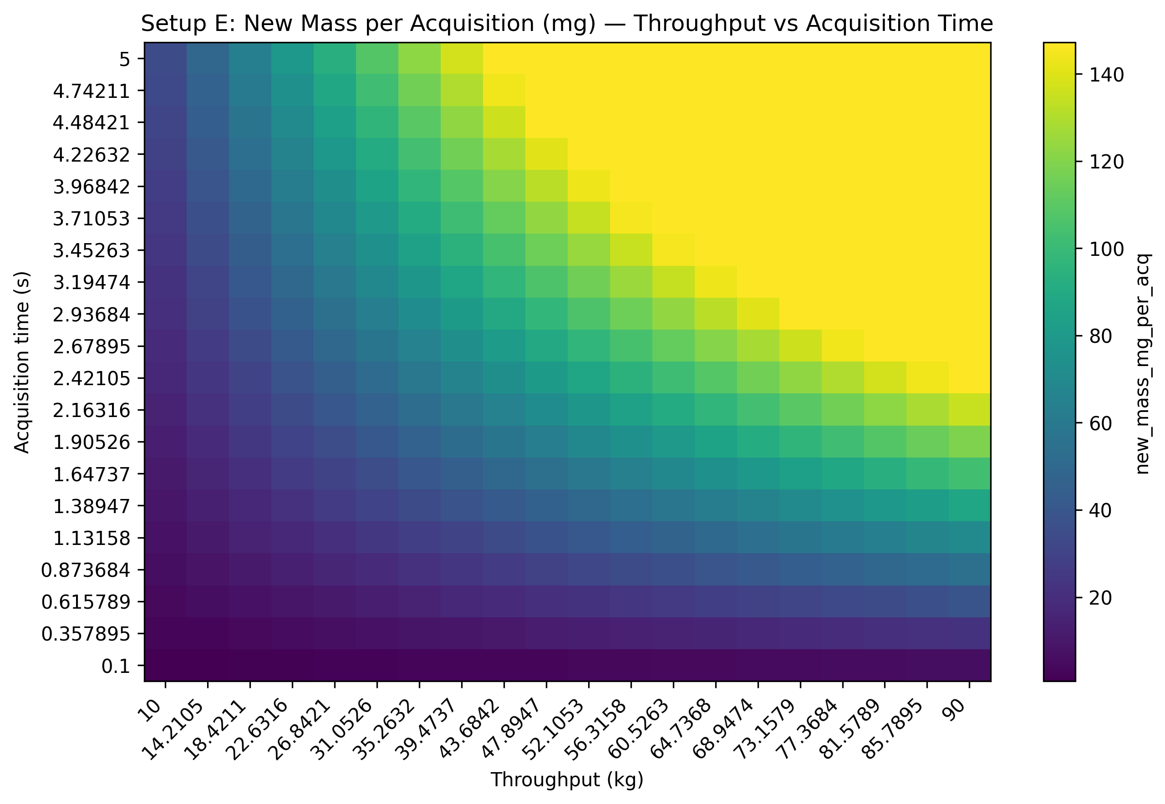

Results Interpretation
- in the half-filled base case, the modeled fill height remains above the measurement location, so the NIR window is treated as continuously covered
- new mass per acquisition saturates once the powder advance exceeds the 25 mm NIR spot diameter
- mass passed the NIR spot footprint grows linearly with both acquisition time and throughput
- at low throughput or short acquisition times, refresh fraction is small and the effective sample size proxy is limited
- the heatmaps reveal the operating envelope where transport renewal is most sensitive to parameter changes

Practical Implications
- acquisition time selection trades off spectral quality against how much unique material is sampled through the side-window NIR measurement
- throughput directly controls powder velocity and therefore refresh rate near the measurement location
- maintaining the rig at approximately half full provides a simple coverage condition: the probe should remain below the fill level during normal operation
- for real-time PAT decisions, understanding whether the probe is covered and how much new material is refreshed is critical

Limitations
- the half-filled condition is represented by a fixed fill fraction, not by an explicit level-control simulation
- the rotating outlet valve is not modeled dynamically
- the local velocity near the probe is approximated from throughput and full pipe cross-section
- no turbulence, wall-slip, or recirculation model is included
- penetration depth is an effective parameter, not a sharp optical boundary
- bulk density is assumed uniform and constant
- no particle-level sampling statistics or optical weighting correction are included

Appendices

Next Logical Extensions
- dynamic level-control and rotating-valve discharge model
- explicit dependence of local velocity on valve operation and bed holdup
- sensitivity analysis for probe height and maintained fill fraction
- uncertainty bands for measurement depth and bulk density
- non-uniform optical weighting functions for the 25 mm NIR spot

Exported artifacts
CSV files
- results_full.csv
- summary_table.csv
- input_summary.csv
Figure files
- plot_01_new_mass_per_acq_vs_acquisition_time.png
- plot_02_mass_passed_vs_acquisition_time.png
- plot_03_refresh_fraction_vs_acquisition_time.png
- plot_04_heatmap_mass_passed_throughput_vs_acquisition.png
- plot_05_heatmap_new_mass_throughput_vs_acquisition.png

