Setup C Effective Sample Size Report

Run Metadata
Setup name: setup_c
Run timestamp: 20260319_125314
Notebook filename: setup_C_spiderwheel_effective_sample_size.ipynb
Run directory: C:\temp files\EFS\reports\setup_c\20260319_125314

Notebook Narrative

Setup C -- Spiderwheel-Based Effective Sampled Mass Estimate
First-order mechanistic approximation for wheel-driven powder renewal and binary probe blocking during one NIR spectral acquisition.

Background
Setup C represents a spiderwheel-driven powder presentation geometry for NIR diffuse reflectance measurement. As in the other notebooks in this series, the interaction region is treated as a shallow near-surface region in front of the probe window, and the sampled mass is approximated from probe footprint, assumed penetration depth, and bulk density.
The key physical difference from Setup B is that Setup B treats each spoon presentation as a static measurement event, whereas Setup C uses wheel motion to actively renew powder at the probe location during a single acquisition. The spiderwheel therefore introduces two competing effects: it can increase the rate at which newly presented powder passes through the probe region, but the fingers can also intermittently block the probe and reduce the usable observation time.
This notebook is therefore positioned as a first-order mechanistic approximation and a deterministic renewal model. It is intended to quantify effective sampled mass trends and blocking trends, not to claim a validated statistical effective sample size or a full radiative-transfer description of the measurement.

Objective
This notebook estimates, for Setup C:
- sampled mass per refresh event
- blocked and unblocked acquisition time during one spectrum
- number of refresh opportunities during one spectrum
- effective sampled mass estimate per spectrum
- sensitivity of the estimate to penetration depth, bulk density, and wheel RPM

Theory
Wheel kinematics at the probe position:
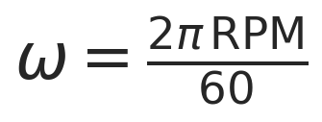
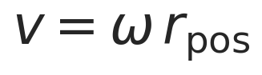
where r_pos is the radial distance from the wheel center to the probe center (not half of the probe diameter).
First-order footprint and sampled mass per refresh event:
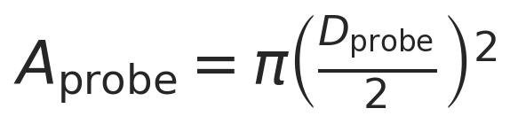

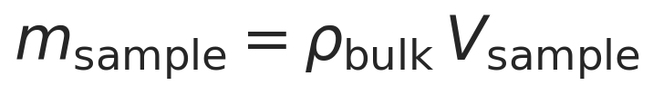
Characteristic renewal time scale:
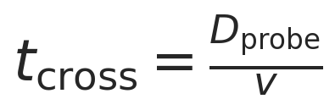
This is the time required for a powder segment moving at the local tangential speed v to traverse one probe diameter. It represents the characteristic time scale on which the material in front of the probe is replaced by newly arriving material, and therefore sets the renewal rate.
Binary blocking geometry:
Each spiderwheel finger has a tangential width wfinger at the probe's radial position. At a distance rpos from the wheel center, the finger and the probe each subtend small angles:
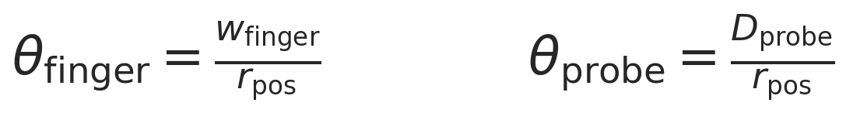
These are chord-over-radius approximations valid when the widths are small compared to r_pos.
Blocking begins when the leading edge of a finger reaches the leading edge of the probe and ends when the trailing edge of the finger clears the trailing edge of the probe. The total overlap angle per finger pass is therefore the sum of both angular widths:
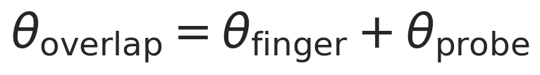
The time blocked by one finger pass at angular speed omega is:
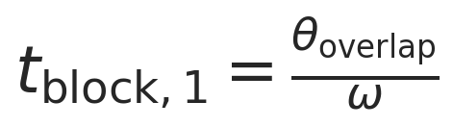
The number of individual finger passes during one acquisition is estimated from the rotation rate and the number of fingers:
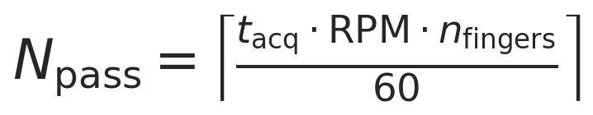
Total blocked time is the sum of all individual blocking events, capped at the acquisition time:
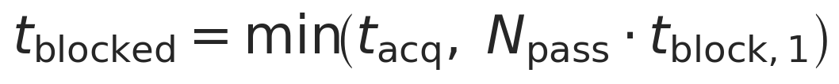
Effective unblocked acquisition time:

Deterministic renewal count:
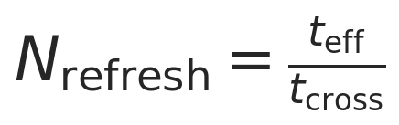
Effective sampled mass estimate during one acquisition:

Symbol definitions and units:
- RPM: wheel rotation rate [rev min^-1]
- omega: angular speed [rad s^-1]
- r_pos: radial distance from wheel center to probe center [cm]
- v: tangential speed at the probe's radial position [cm s^-1]
- D_probe: probe window diameter [cm] in calculations, reported as [mm] in engineering tables and labels
- A_probe: probe footprint area [cm^2]
- d_pen: assumed penetration depth [cm] in calculations, reported as [mm] in engineering tables and labels
- V_sample: sampled volume per refresh event [cm^3]
- rho_bulk: bulk density [g cm^-3]
- m_sample: sampled mass per refresh event [g]
- w_finger: tangential width of one spiderwheel finger at the probe's radial position [cm]
- n_fingers: number of spiderwheel fingers [-]
- thetafinger: angular width of one finger at rpos [rad]
- thetaprobe: angular width of the probe window at rpos [rad]
- theta_overlap: total overlap angle per finger pass [rad]
- t_block,1: time blocked by a single finger pass [s]
- N_pass: number of finger passes during one acquisition [-]
- t_acq: total spectral acquisition time [s]
- t_blocked: total time during which the probe is treated as blocked [s]
- t_eff: effective unblocked acquisition time [s]
- t_cross: characteristic crossing time for one probe diameter of tangential motion [s]
- N_refresh: deterministic renewal count during one acquisition [-]
- m_eff,est: effective sampled mass estimate during one acquisition [g]
The code uses mixed practical engineering units for convenience: geometry is entered mainly in cm and mm, density in g/cm^3, time in s, and reported masses are often shown in mg. The calculations remain internally consistent because the unit conversions are handled explicitly in the code.

Interpretation of the Model
In this notebook, a refresh means the passage of newly presented powder across the probe region due to wheel motion. It is best interpreted as a renewal opportunity for material presented to the probe window, not as proof of a statistically independent new sample.
Tangential speed is evaluated at the probe's radial position on the wheel (rpos) because the local renewal rate should be tied to the wheel speed where the probe actually views the material. The crossing time tcross is then interpreted as a characteristic time scale for a wheel-driven material segment to traverse one probe width.
Blocked time is subtracted because the model uses a binary blocking approximation: when a spiderwheel finger overlaps the probe region, the probe is treated as having no usable access to powder during that interval. The resulting t_eff is therefore an effective observation time rather than the full instrument acquisition time.
Nrefresh should therefore be interpreted as a deterministic renewal count, rather than a demonstrated count of independent samples. Powder recirculation, revisit probability, local residence-time memory, and correlation between successive refresh events are not modeled. For the same reason, meff,est is an effective sampled mass estimate, not yet a validated statistical effective sample size and not a direct estimate of analytical variance.
Despite these simplifications, the model is still useful as a mechanistic engineering tool because it shows how geometry, density, penetration depth, RPM, and blocking assumptions influence the amount of powder that is plausibly renewed in front of the probe during one spectrum.

Assumptions
- circular probe window with area represented by A_probe
- first-order cylindrical sampled volume approximation, Vsample = Aprobe d_pen
- constant bulk density over the sampled region
- constant assumed penetration depth for each simulation condition
- local renewal rate represented by tangential velocity at the probe's radial position on the wheel (r_pos)
- binary blocking behavior when a spiderwheel finger overlaps the probe region
- no partial transmission, partial attenuation, or partial exposure through a finger
- no revisit probability or recirculation correction for previously presented powder
- no depth-wise weighting within the assumed sampling volume
- no stochastic treatment of particle independence or correlation between refresh events
- no explicit radiative-transfer solution

Input Parameters
The baseline geometric, optical, and operating parameters are defined below. Engineering units are retained in variable names, plot labels, and summary tables for readability, while the calculations remain internally consistent in centimeter-gram-second style units.

Imports

Helper Functions

Single-Case Worked Example
The following worked example evaluates one representative operating condition so that the intermediate quantities can be read directly before the full parameter sweep is run. The sequence is intentionally mechanistic: first the sampled mass per refresh event is estimated, then blocking is estimated, then the effective unblocked acquisition time is obtained, and only then is the effective sampled mass estimate calculated through the deterministic renewal count.

Parameter Sweep / Simulation
The simulation sweeps bulk density, wheel RPM, and penetration depth while holding the remaining geometry fixed. Each row in the output table represents one deterministic operating condition for the current first-order model.

Interpretation of Simulation Table
Each row combines one density, one RPM, and one penetration depth. The most important columns are:
- sampledmassperrefreshmg: the first-order sampled mass associated with one renewal opportunity at the probe
- blockedtimes: the portion of the acquisition treated as unavailable because a spiderwheel finger blocks the probe region
- n_refresh: the deterministic renewal count during the unblocked part of the acquisition
- effectivesampledmassestimatemg: the effective sampled mass estimate accumulated over one spectrum
This table should therefore be read as a mechanistic comparison table. It does not demonstrate that the listed renewal opportunities are statistically independent, and it does not by itself establish a validated independent effective sample mass.

Blocked Time Fraction vs RPM
This plot separates the blocking model from the sampled-mass model. It shows how much of the acquisition is estimated to be unavailable because the spiderwheel fingers overlap the probe region under the binary blocking approximation.
The blocked fraction matters because it reduces effective observation time even in cases where wheel speed increases the rate of renewal opportunities.

Sampled Mass per Refresh vs Penetration Depth
This plot shows the sampled mass per refresh event before the renewal-count multiplier is applied. It therefore isolates the sampled-volume approximation from the dynamic renewal approximation.
Reading this plot together with the penetration-depth plot above helps distinguish two quantities that should not be conflated: msample is the per-refresh sampled mass, whereas meff,est is the effective sampled mass estimate accumulated over one acquisition.

Results Interpretation
- increasing bulk density increases the sampled mass per refresh event linearly in this simplified volume model and therefore increases the effective sampled mass estimate proportionally when the renewal count is unchanged
- increasing penetration depth increases the assumed sampled volume linearly and therefore increases the per-refresh sampled mass linearly under the current approximation
- increasing RPM decreases the characteristic crossing time and therefore increases the deterministic number of renewal opportunities, all else being equal
- blocking reduces effective observation time and therefore reduces the effective sampled mass estimate relative to an unblocked case
- these outputs are mechanistically useful for engineering comparison, but they do not by themselves establish statistical independence of refresh events or a validated independent effective sample size

Limitations
- partial blocking, partial transmission, and partial attenuation are not modeled; blocking is treated as binary
- recirculation, revisit probability, and repeated presentation of the same powder increment are not modeled
- particle-scale heterogeneity, segregation, and particle-count statistics are outside the present approximation
- depth-dependent photon weighting is not represented; the sampling region is treated with a uniform first-order volume approximation
- residence-time distributions and local mixing memory near the probe are not modeled
- stochastic independence of refresh events is not modeled, so renewal count is not equivalent to validated independent sample count
- the model does not yet convert effective sampled mass estimate into analytical variance, prediction uncertainty, or a validated statistical effective sample size

Next Logical Extensions
- replace binary blocking with a partial-blocking or partial-exposure model
- include revisit probability or explicit recirculation of powder around the wheel
- resolve the acquisition in time or phase so that exposure depends on wheel angle during the spectrum
- introduce depth-dependent weighting instead of a uniform cylindrical volume approximation
- estimate particle count as well as mass within the refreshed sampling region
- apply a correlation correction between refresh events before interpreting the result as effective sample mass
- link effective sampled mass estimate to analytical variance or prediction precision

Export and Reporting
This export section writes timestamped CSV, PNG, JSON, and Word outputs into the setup-specific reports/ folder. python-docx and nbformat are required for Word export with Markdown rendering.

Purpose
Setup C estimates a first-order effective sampled mass estimate for a spiderwheel presentation by combining sampled mass per refresh with a deterministic renewal count derived from wheel speed and blocked acquisition time.

Assumptions
Uniform bulk density, cylindrical sampling volume, binary full-blocking simplification for wheel fingers, and deterministic refresh counting without revisit, recirculation, partial-blocking, or correlation corrections.

Parameter Summary
- Finger count: 4
- Wheel radius (cm): 3
- Probe radial position (cm): 1.8
- Finger width (cm): 0.3
- Probe diameter (mm): 5
- Acquisition time (s): 1.8
- Density scenarios (g/cm^3): 0.4, 0.5, 0.6
- RPM range: 10 to 35
- Penetration depth range (mm): 0.1 to 2.0

Exported CSV Files
- results_full.csv
- summary_table.csv
- blocking_summary.csv
Detailed tables are saved separately as CSV files in the run folder.

Figures
- plot_01_estimate_vs_penetration_depth.png
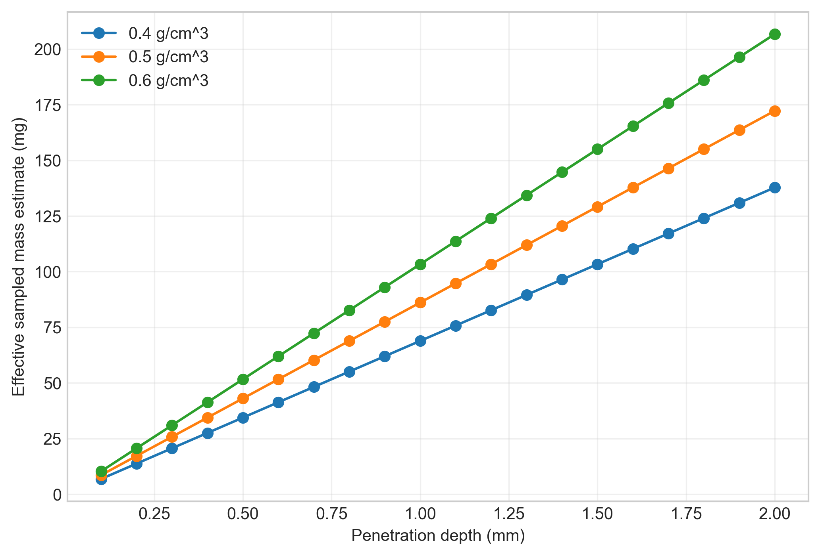
- plot_02_estimate_vs_rpm.png
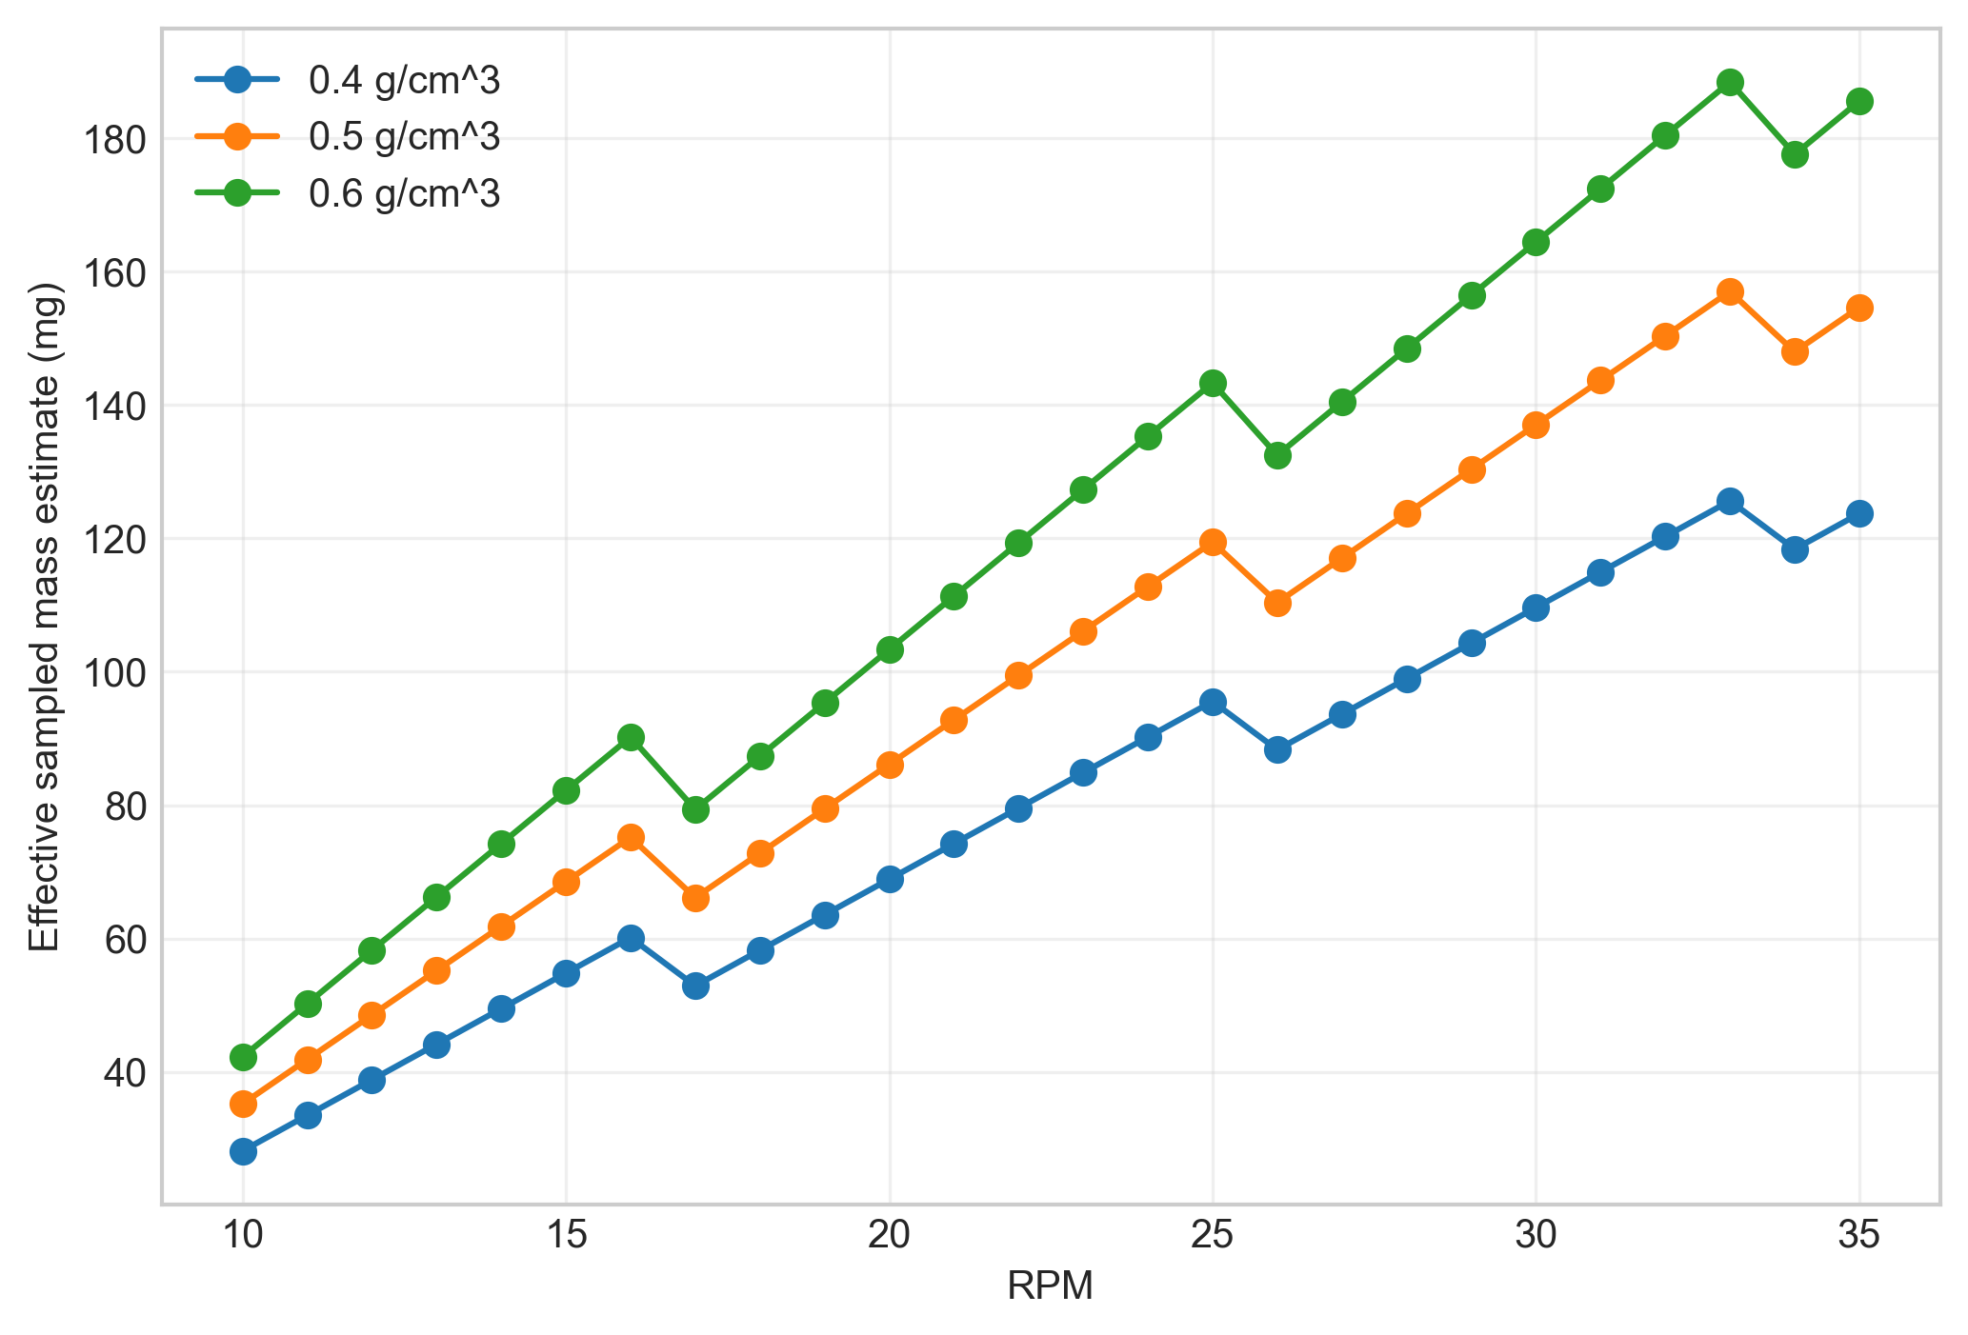
- plot_03_heatmap_density_05.png
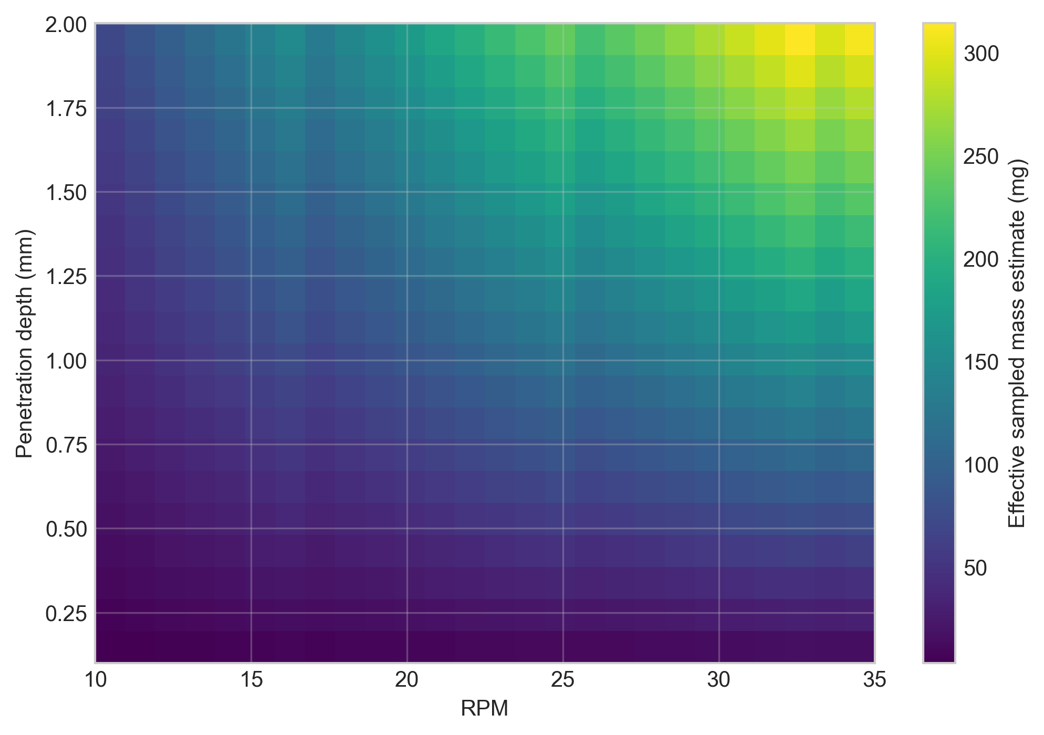
- plot_04_blocked_time_fraction_vs_rpm.png
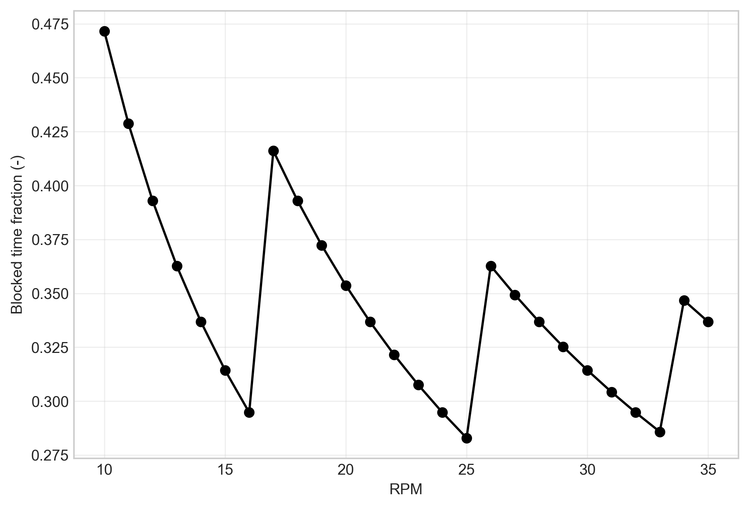
- plot_05_sampled_mass_per_refresh.png
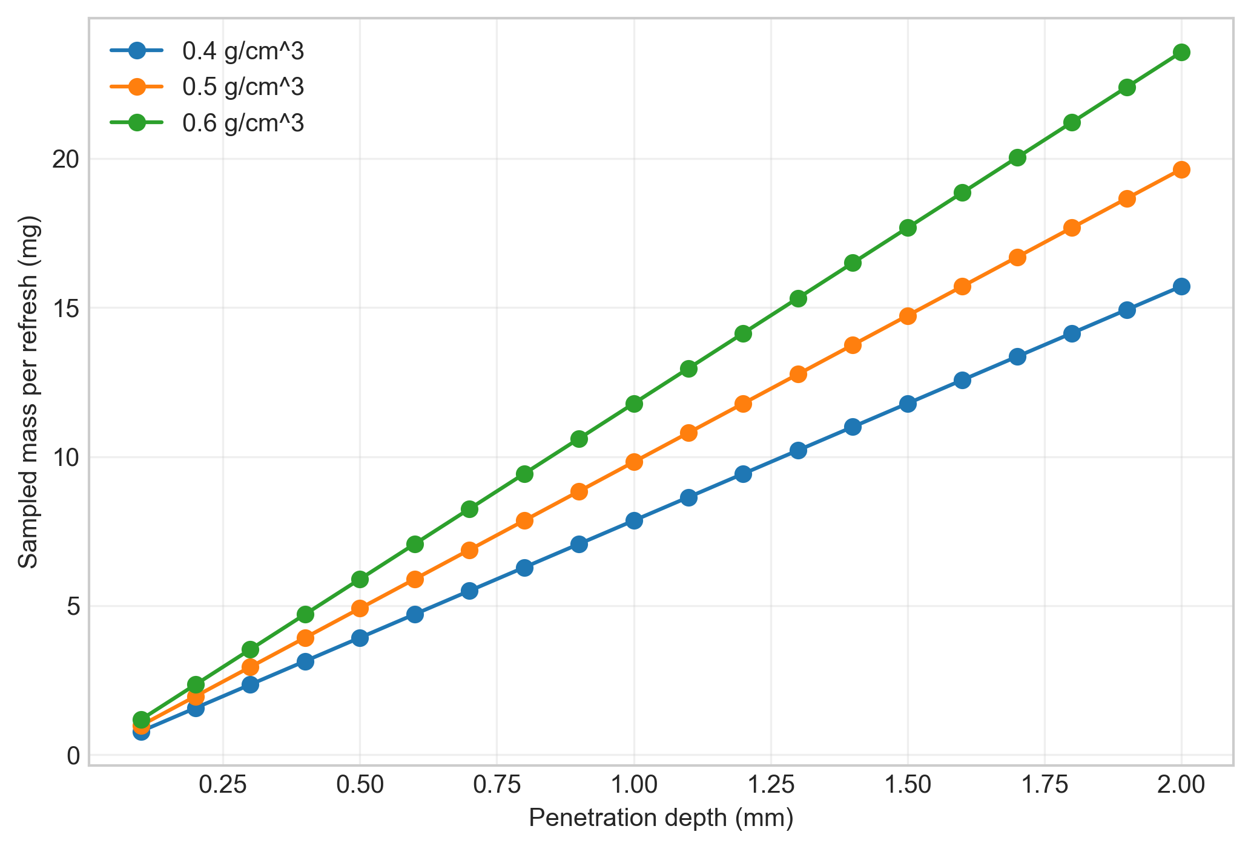
- plot_06_contour_density_06.png
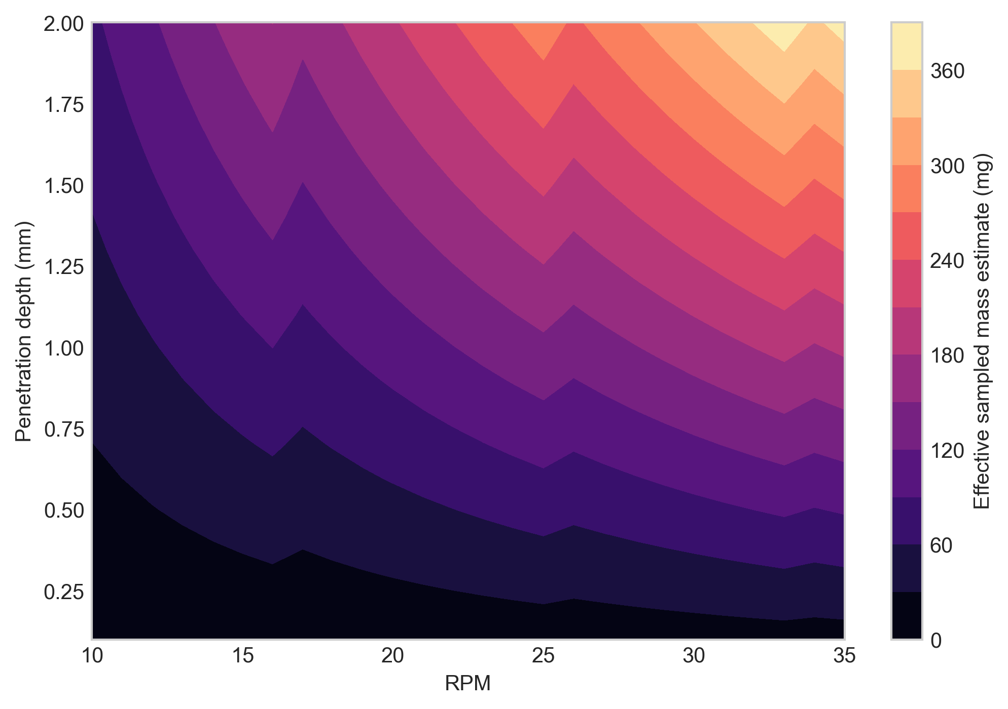

Closing Note
This report captures the notebook narrative, summary metadata, and exported artifacts for this run.

