Setup E Effective Sample Size Report — PAT Rig

Run Metadata
Setup name: setup_e
Run timestamp: 20260317_124743
Notebook filename: setup_E_PATrig_effective_sample_size.ipynb
Run directory: C:\temp files\EFS\reports\setup_e\20260317_124743

Notebook Narrative

Setup E - Effective Sample Size for PAT Rig NIR Measurement
Powder plug-flow through a pipe with a flush-mounted NIR probe, deterministic first-generation model

Background
Setup E models a PAT (Process Analytical Technology) rig scenario where powder flows through a pipe past a flush-mounted diffuse-reflectance NIR probe. Unlike the static Setup A, powder motion during each spectral acquisition creates a dynamic sampling situation.
Three distinct mass metrics are relevant:
- Instantaneous probed mass (m_inst): mass simultaneously illuminated at any single instant.
- New mass presented per acquisition (m_new): unique material refreshed across the probe window during one acquisition time, bounded by the instantaneous mass.
- Mass passed probe footprint (m_pass): total mass that crosses the probe window plane during acquisition — grows linearly with time and is not bounded by instantaneous mass.
This notebook uses plug-flow assumptions to compute these metrics and sweeps key operating parameters (acquisition time, throughput) to examine their sensitivity.

Objective
Compute instantaneous probed mass, new mass presented per acquisition, and mass passed the probe footprint for a PAT rig configuration. Sweep acquisition time and throughput to examine sensitivity, and export results using the standard reporting workflow.

Theory
Powder velocity from throughput and pipe cross-section:
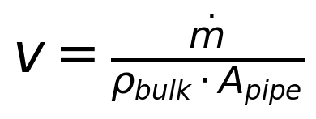
Instantaneous probed mass (mass in view at any instant):
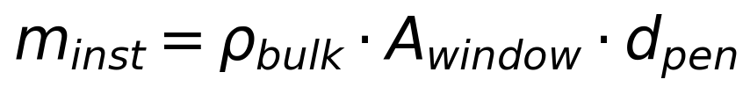
Axial advance during acquisition:
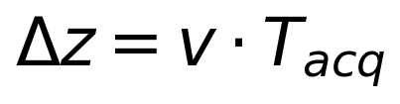
Refresh fraction (fraction of probe volume replaced during acquisition):
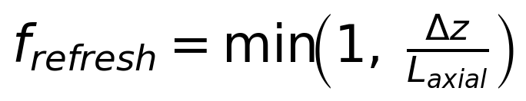
New mass presented per acquisition:
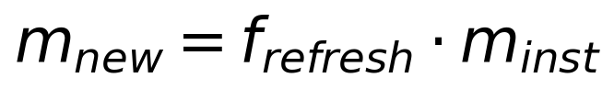
Mass passed the probe footprint during acquisition:
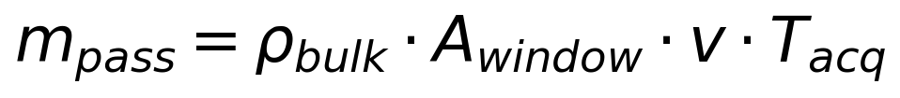
Symbols and units:
- dotm: mass flow rate [g/s]
- rho_bulk: bulk density [g/cm^3]
- A_pipe: pipe cross-section area [cm^2]
- A_window: probe window area [cm^2]
- d_pen: measurement (penetration) depth [cm]
- T_acq: spectral acquisition time [s]
- L_axial: axial sampling length (proxy for probe window diameter) [cm]

Assumptions
- plug-flow velocity profile (uniform across pipe cross-section)
- uniform bulk density
- circular pipe and circular probe window flush-mounted on the pipe wall
- measurement depth is small relative to pipe diameter
- axial sampling length approximated by probe window diameter
- no turbulence, no particle segregation
- no detailed radiative transfer model yet

Input Parameters
Baseline PAT rig configuration:
- pipe diameter: 10.0 cm
- probe window diameter: 0.5 cm (5 mm)
- measurement depth: 0.1 cm (1 mm)
- bulk density: 0.3 g/cm^3
- throughput: 95 kg over 60 min
- acquisition time: 1.0 s
- axial sampling length model: window diameter
Sweeps:
- acquisition time: 0.1 s to 5.0 s (20 points)
- 2D sweep: throughput 10–90 kg × acquisition time 0.1–5.0 s
Internal calculations use CGS units.

Compute Effective Sample Size Metrics
Run 1D acquisition-time sweep and 2D throughput × acquisition-time sweep.

Interpretation of the Simulation Table
Each row corresponds to one combination of operating parameters. Key columns:
- probemassmg_instant: mass simultaneously illuminated at any instant
- newmassmgperacq: unique material refreshed during one acquisition (plateaus at instantaneous mass)
- masspassedmgperacq: total mass crossing the probe window plane during acquisition (grows linearly with time)
- refreshfractionper_acq: fraction of probe volume replaced during acquisition (saturates at 1.0)
- effectivesamplesize_mg: treated as new mass presented per acquisition

Plot 1: New Mass per Acquisition vs Acquisition Time
Shows how the unique mass contributing to a single spectrum changes with acquisition time. At short acquisition times the probe volume is only partially refreshed; at longer times the refresh fraction saturates at 1.0 and new mass plateaus.

Plot 2: Mass Passed Probe Footprint vs Acquisition Time
Unlike new mass, the mass that passes the probe footprint grows linearly with acquisition time and is not bounded by the instantaneous mass.

Plot 3: Refresh Fraction vs Acquisition Time
The refresh fraction indicates what fraction of the probe volume is replaced during one acquisition. It saturates at 1.0 when the powder advances at least one probe-window diameter.

Plot 4: Heatmap — Mass Passed Probe Footprint (Throughput vs Acquisition Time)
2D sensitivity map showing how mass passed the probe footprint depends jointly on throughput and acquisition time.

Plot 5: Heatmap — New Mass per Acquisition (Throughput vs Acquisition Time)
2D sensitivity map for the refresh-based unique-mass metric.

Results Interpretation
- new mass per acquisition saturates once the powder advance exceeds the probe window diameter (full refresh)
- mass passed the probe footprint grows linearly with both acquisition time and throughput
- at low throughput or short acquisition times, refresh fraction is small and the effective sample size is limited
- the heatmaps reveal the operating envelope where effective sampling is most sensitive to parameter changes

Practical Implications
- acquisition time selection trades off spectral quality against how much unique material is sampled
- throughput directly controls powder velocity and therefore refresh rate
- for real-time PAT decisions, understanding whether the probe has seen enough unique material is critical

Limitations
- plug-flow assumption ignores radial velocity profile
- no turbulence or mixing model
- penetration depth is an effective parameter, not a sharp boundary
- bulk density assumed uniform and constant
- no particle-level sampling statistics
- no correction factor for optical weighting yet

Next Logical Extensions
- radial velocity profile (laminar / turbulent)
- particle count estimation from effective sample size
- sensitivity analysis for measurement depth
- uncertainty bands for penetration depth and bulk density
- non-uniform optical weighting functions

Export and Reporting
This export section writes timestamped CSV, PNG, JSON, and Word outputs into the setup-specific reports/ folder. python-docx and nbformat are required for Word export with Markdown rendering.

Purpose
Setup E estimates the effective sample size for a PAT rig configuration where powder flows through a pipe past a flush-mounted NIR probe. It sweeps acquisition time and throughput to examine sensitivity of instantaneous mass, new mass per acquisition, and mass passed the probe footprint.

Assumptions
Plug-flow velocity profile, uniform bulk density, circular pipe and probe window, measurement depth small relative to pipe diameter, axial sampling length approximated by probe window diameter, no turbulence or mixing.

Parameter Summary
- Pipe diameter (cm): 10
- Probe window diameter (cm): 0.5
- Measurement depth (cm): 0.1
- Bulk density (g/cm^3): 0.3
- Throughput (kg): 95
- Throughput time (s): 3600
- Acquisition time range (s): 0.1 to 5.0
- Axial length model: window_diameter

Exported CSV Files
- results_full.csv
- summary_table.csv
- input_summary.csv
Detailed tables are saved separately as CSV files in the run folder.

Figures
- plot_01_new_mass_per_acq_vs_acquisition_time.png
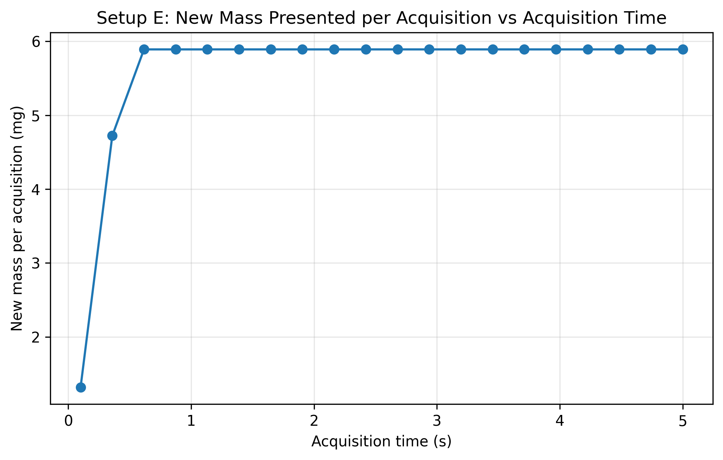
- plot_02_mass_passed_vs_acquisition_time.png
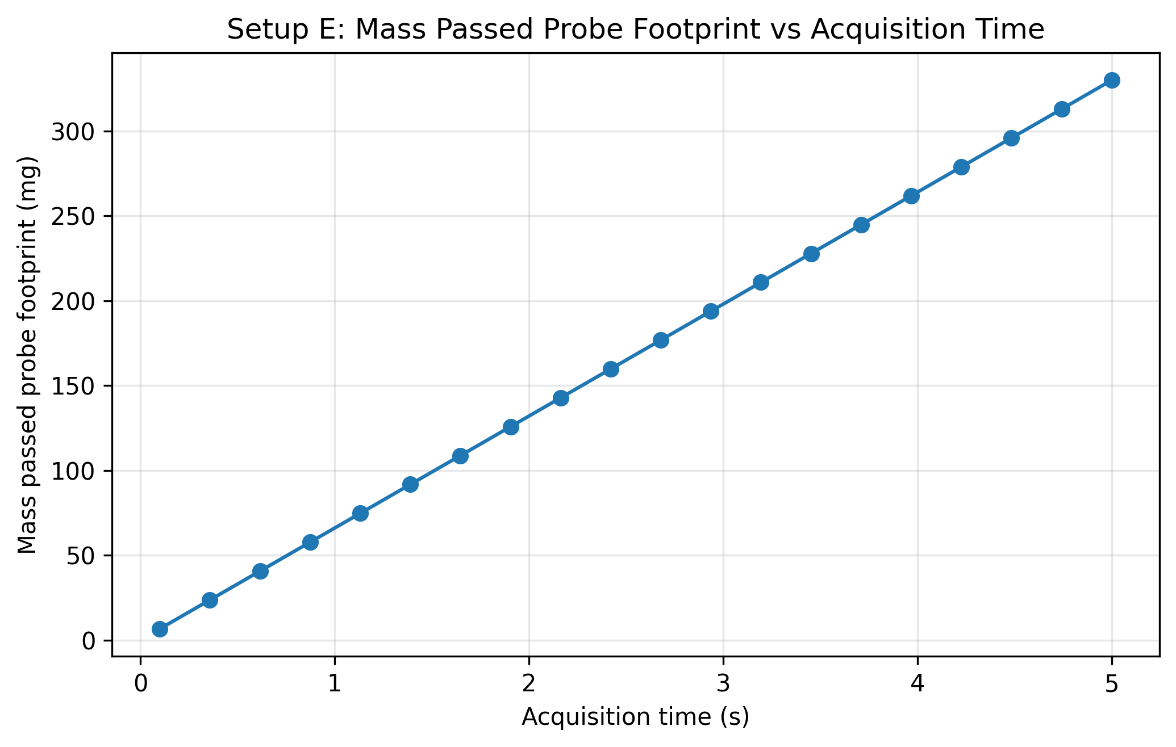
- plot_03_refresh_fraction_vs_acquisition_time.png
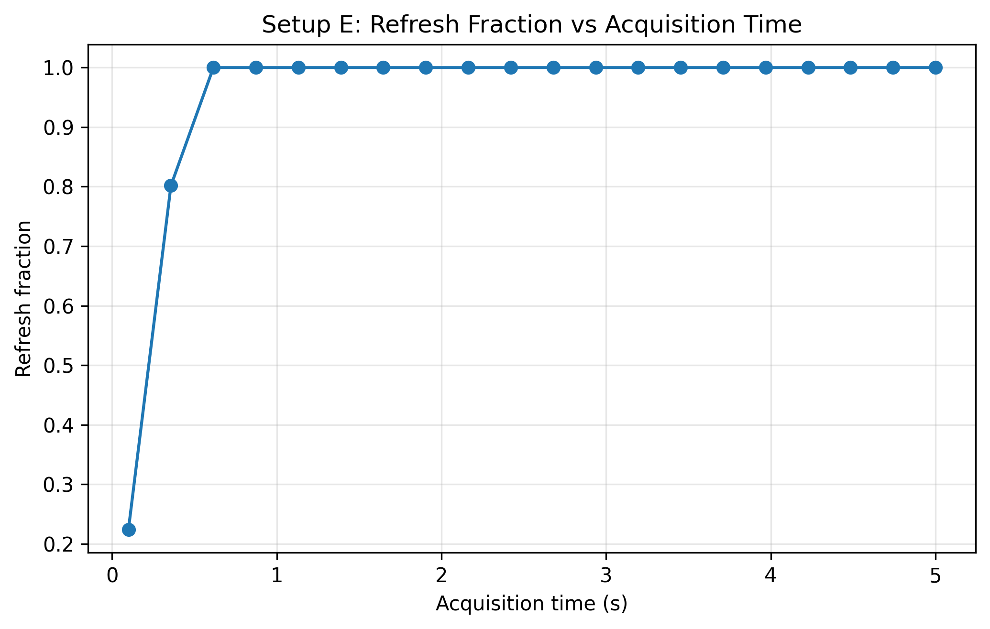
- plot_04_heatmap_mass_passed_throughput_vs_acquisition.png
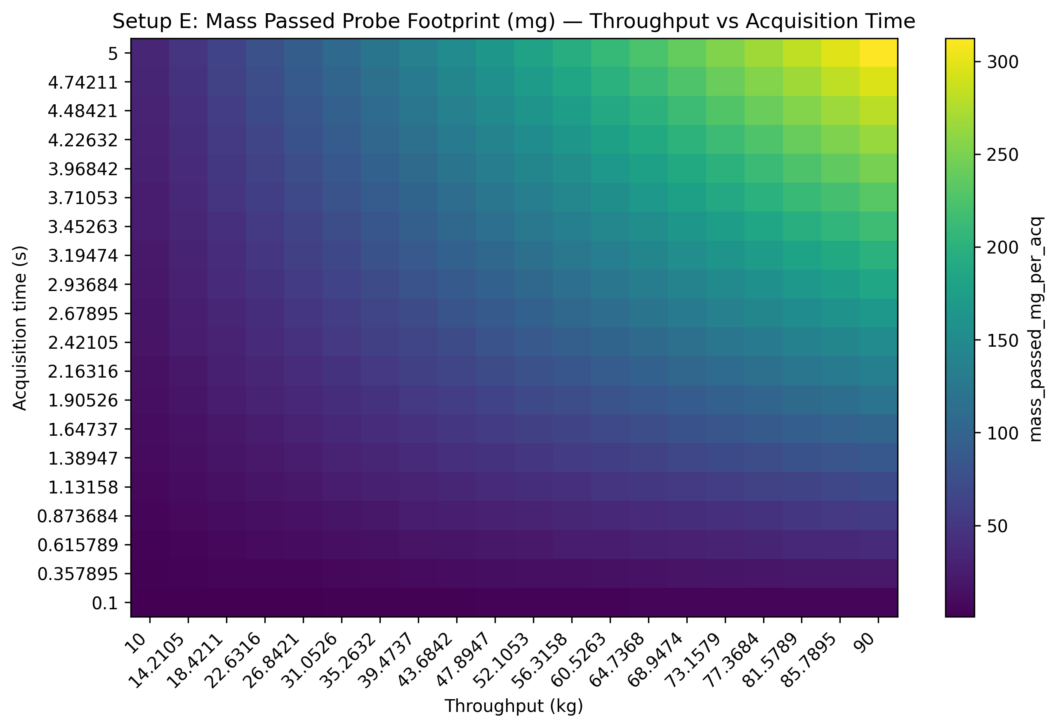
- plot_05_heatmap_new_mass_throughput_vs_acquisition.png
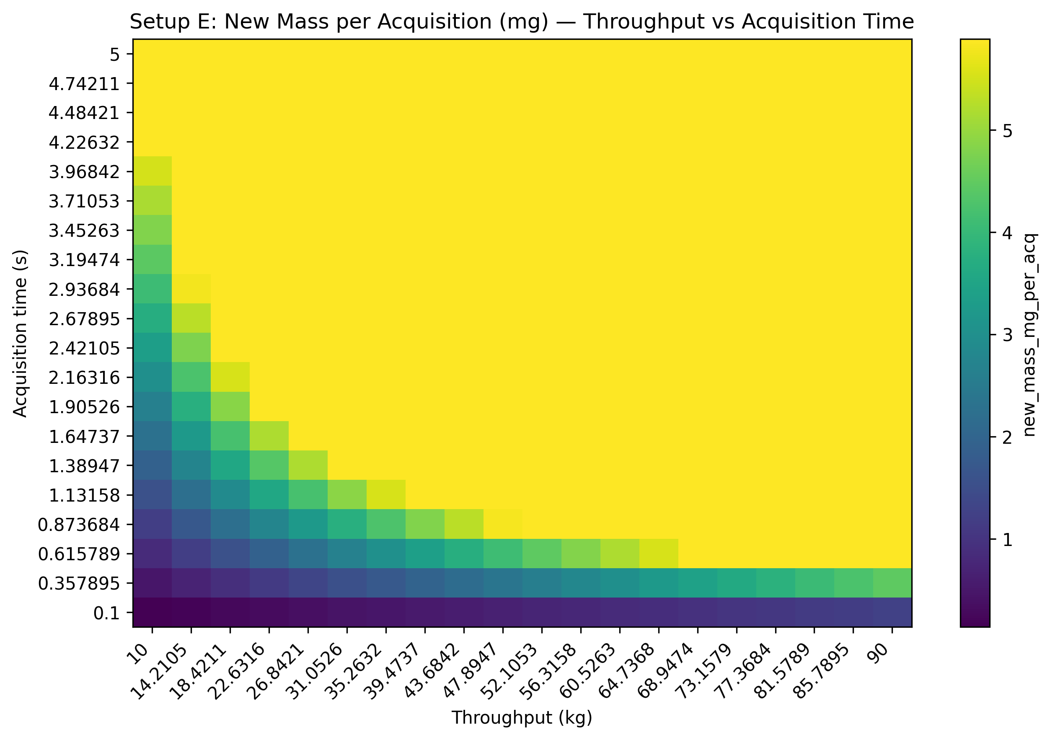

Closing Note
This report captures the notebook narrative, summary metadata, and exported artifacts for this run.

